**ICECAPS-ACE Weekly Report**

November 25 – December 1, 2019

Jess Ackerman

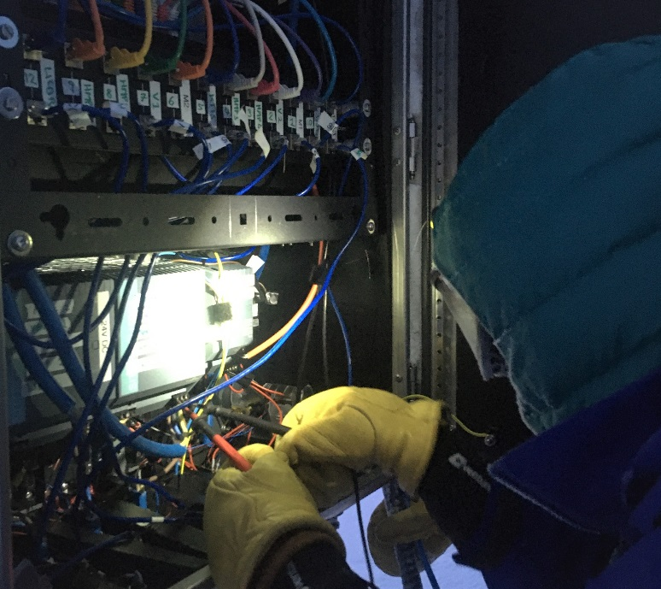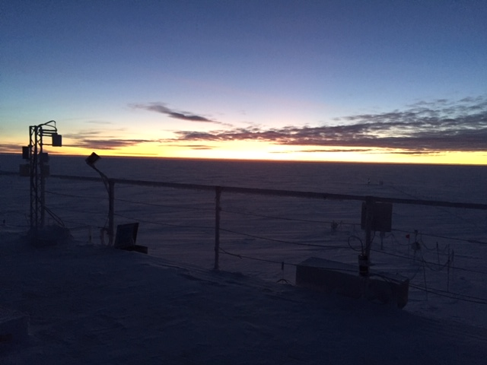

*Left: 2019-11-28: TAWO Tech Holly with hands in the Fluxtower electronics box.*

*Right: 2019-11-25 1224Z: MSF rooftop twilight.*

**General Notes:**

Our big accomplishment this week was finally getting a weather window to do the tedious power supply swop on the Fluxtower! Lots of time, planning, and preparation went into this procedure. On 11/28, with the help of the Station Supervisor Vickie, TAWO Tech Holly and ICECAPS Tech Jess successfully completed the finger and toe-chilling mission in about 4.5 hours. Happy cheers and high-5’s were expressed. Also, this week some beautiful twilight hours were enjoyed, and by the end of the week another high blast of winds maxing out at 50 knots.

**General Weather Observations:**

|  |  |  |  |  |  |  |  |
| --- | --- | --- | --- | --- | --- | --- | --- |
| **Date** | **Time (Z)** | **Wind** | **Weather** | **Visibility** | **Sky** | **Temp** | **Notes** |
| 11-25 | 12 | 208°, 12 kn |  | 4800 | SCT016 | -33 | Stratus |
| 11-26 | 12 | 248°, 14 kn | DRSN | 1600 | BKN016 | -25 |  |
| 11-27 | 12 | 219°, 12 kn |  | 1600 | FEW196 | -39 | Stratus distant |
| 11-28 | 12 | 211°, 7 kn | -SN | 1600 | BKN016 | -38 |  |
| 11-29 | 12 | 214°, 10 kn | FZFG | 400 | FEW000 OVC003 | -33 |  |
| 11-30 | 12 | 220°, 13 kn | -SN, FZFG | 500 | SCT033 | -39 |  |
| 12-01 | 12 | 165°, 28 kn | BLSN | 100 | OVC000 | -28 | 40+ knot winds |

**Significant Weather Observations:**

* 2019-11-27 1254Z: Sun Reflection (pictured below)
* 2019-11-27 1902Z: Rave Ice
* 2019-11-30 1218Z: Rave Ice

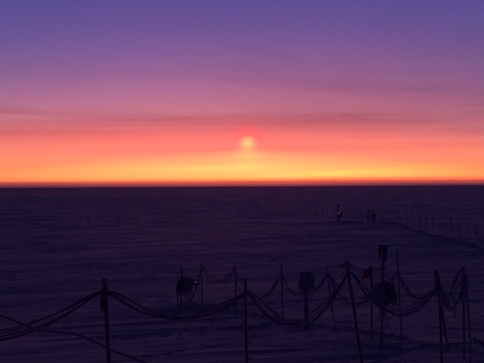*Above: 2019-11-27 1254Z: Sun reflection on horizon.*

**MSF**

* 2019-11-29 1515Z: MSF 3x Temperature Logger data downloaded (performed every 56 days).
* Operating normally.

**ICECAPS-ACE Data Management:**

* 11-25: Stop ArchieveToBoulder at 1224Z.
* 11-26: Stop ArchieveToBoulder at 1134Z.
* 11-27: Stop ArchieveToBoulder at 1159Z.
* 11-28: Stop ArchieveToBoulder at 1528Z.
* 11-29: Stop ArchieveToBoulder at 1105Z.
* 11-30: Stop ArchieveToBoulder at 1216Z.
* 12-01: Stop ArchieveToBoulder at 1148Z.

**TSI:**

* Offline for winter season.

**Radiosonde:**

* Twice daily launches.
* 2019-11-29 1115Z: Complications with U% and RH% due to misty foggy morning causing condensation on sensor. 3rd attempt successful but outside time window. PI notified.
* 2019-11-29 2315Z: “Radiosonde Preparation Failed” message. 2nd sonde prepared and launched within time window. PI notified.
* 2019-11-30 1129Z: Sonde did flip in air upon gentle/normal release apparently damaging sensor and terminated sounding on its own. 2nd launch completed within time window. PI notified.
* Still troubleshooting USB driver issue for Easy Log USB temp logger program on Radiosonde computer.
* See charts below for temperatures outside and inside the Radiosonde cabinet over the last week.

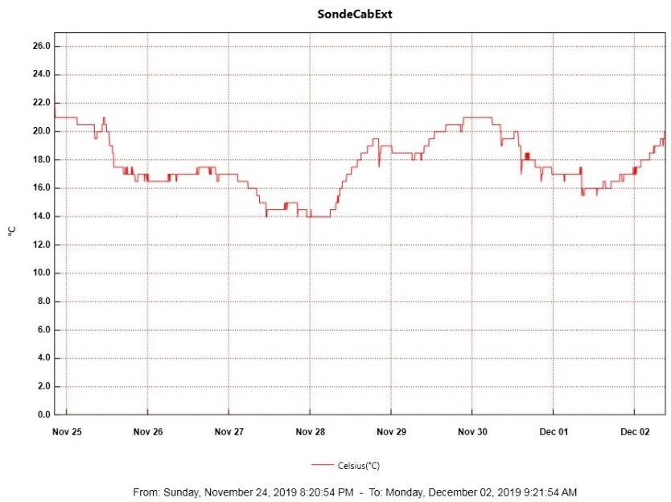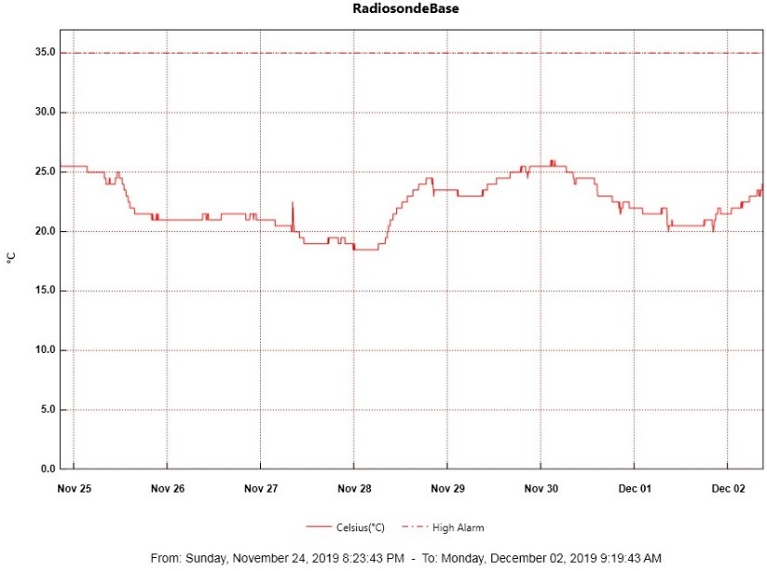

**MWR:**

* 2019-11-27 1215Z: Removed light frost from both windows.
* 2019-11-29 1310Z: Removed light frost from 90% of south-facing windows on 150-90 & HatPro. Fans were clear. Misty foggy morning. Picture documented in MWR Riming Photos folder.
* Operating normally.

**SODAR:**

* 2019-11-26 1414-1433Z: SODAR cleaned.
* Operating normally.

**POSS:**

* 2019-11-26 1222Z: DC Offset errors during cleaning time.
* 2019-11-29 1349Z: DC Offset errors during cleaning time.
* Operating normally.

**MASC:**

* 2019-11-26 1342Z: MASC winter shutdown procedure completed. Data collection will resume in warmer temperatures this spring.

**MMCR:**

* 2019-11-29 1306Z: GPIB interrupted the daily calibration. Errors cleared.
* 2019-11-30 1217Z: Net CDF Errors cleared, and PI notified. Cleared errors again 1344Z.
* 2019-12-01 1224Z: Net CDF Errors cleared. Noticed odd screen images from 1230-1234Z while antenna position was 6 and 38 possibly due to calibration phase. Notified PI and emailed pictures. At 1307Z, cleared CDF Errors again. Reboot imminent.

**CAPABL:**

* 2019-11-29 1329-1340Z: Laser turned off to clear window.
* Operating normally.

**MPL:**

* Operating normally

**VCEIL:**

* Operating normally.

**PAERI:**

* 2019-11-29 1344-1555Z: Fan unplugged and brought inside to defrost while Outside Air Temp Sensor recon was performed. Currently troubleshooting with PI.
* 2019-12-01 1305Z: High winds likely cause of several red flags all night. Mirror cleaned next morning and all is well.
* Operating normally.

**IceCAM:**

* Operating normally.

**IcePIC:**

* No IcePics this week.

**CLASP:**

* Operating normally.

**CPC:**

* 2019-11-27 1840Z: Butanol refilled and condensate emptied.
* 2019-12-01 1315Z: Carbon filter changed.
* Operating normally.

**MSF - OPC:**

* Operating normally.

**TAWO - OPC:**

* 2019-11-29: Removed TAWO OPC from rooftop to thaw out and diagnose data collection issues. Verified fan functioning properly. Troubleshooting continues.

**SKYOPC:**

* Operating normally.

**INP Freezing Assay:**

* 2019-11-27 1341Z: Instrument clock reset for accuracy. Filter samples collected from TAWO, weekly assays run, and data sent. 1344Z: Instrument internal memory downloaded and sent to PI.

**Fluxtower instrument suite:**

* 2019-11-28: Successfully replaced failed power supply powering flux tower instruments KT15, HMP3 (9m temperature sensor), HMP4 (15m temperature sensor), Ventus2 (9m 2D sonic), Metek2 (15m 2D sonic).

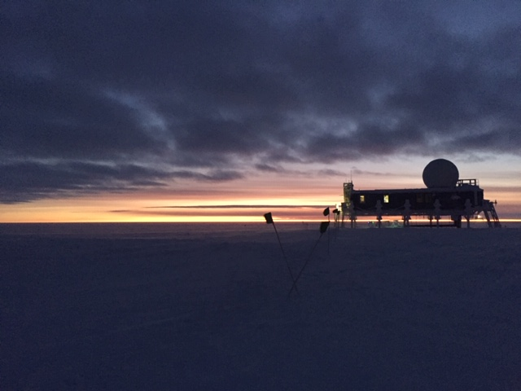

*Above: 2019-11-26 1628Z: Big House twilight.*