**ICECAPS-ACE Weekly Report**

December 2-8, 2019

Jess Ackerman

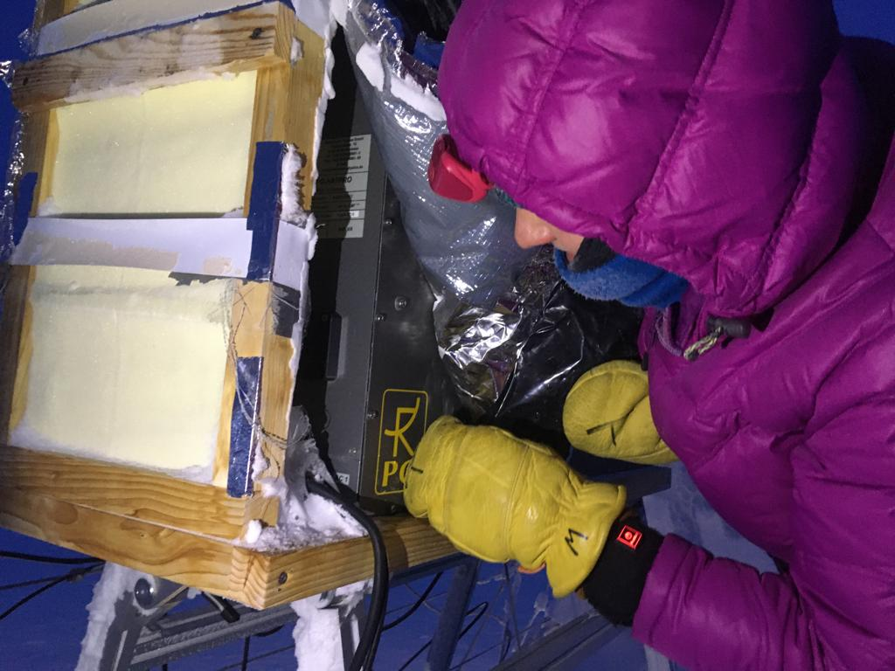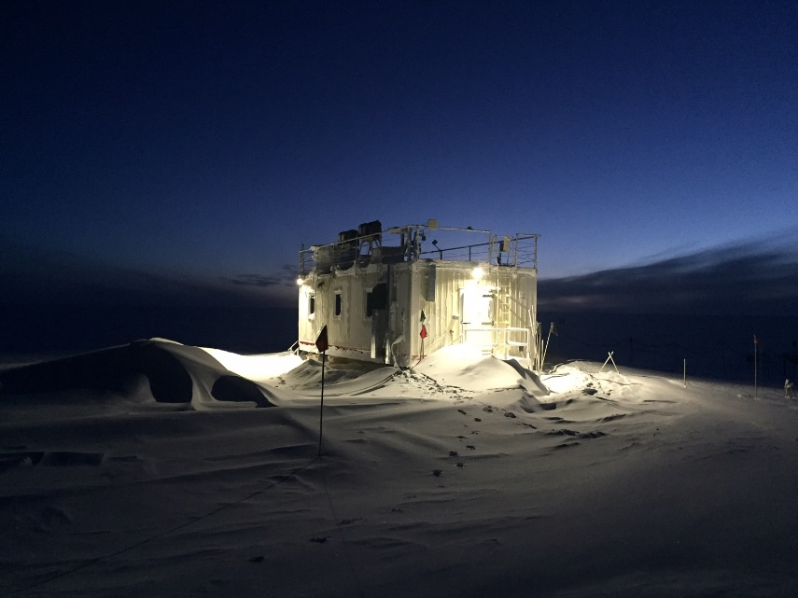

*Left: 2019-12-05: ICECAPS Tech Jess investigating the HATPRO Microwave Radiometer (MWR) connectivity issues.*

*Right: 2019-12-06 1236Z: MSF morning commute in winter twilight.*

**General Notes:**

A busy, eventful, and productive week! Whew! Extensive and helpful troubleshooting with the PIs occurred on a variety of instruments. Started off the week recovering from 50 knot winds, enduring the events of an unplanned power outage, and ended with cold temperatures putting us in Condition 2 weather of -97F windchill. None-the-less, science persevered and a lot was learned and accomplished.

**General Weather Observations:**

|  |  |  |  |  |  |  |  |
| --- | --- | --- | --- | --- | --- | --- | --- |
| **Date** | **Time (Z)** | **Wind** | **Weather** | **Visibility** | **Sky** | **Temp** | **Notes** |
| 12-02 | 12 | 178°, 22 kn | BLSN | 300 | OVC000 | -21 |  |
| 12-03 | 12 | 130°, 22 kn | BLSN | 200 | OVC000 | -23 |  |
| 12-04 | 12 | 60°, 12 kn | -SN | 800 | OVC003 | -30 |  |
| 12-05 | 12 | 113°, 14 kn | -SN, FZFG | 500 | OVC016 | -35 |  |
| 12-06 | 12 | 129°, 13 kn |  | 800 | SCT | -46 |  |
| 12-07 | 12 | 141°, 19 kn | BLSN | 300 | FEW003 | -42 |  |
| 12-08 | 12 | 262°, 11 kn |  | 800 | SCT | -47 |  |

**Significant Weather Observations:**

* 2019-12-03 1732Z: Rave Ice
* 2019-12-04 1250Z: Rave Ice
* 2019-12-05 1215Z: Rave Ice

**MSF**

* 2019-12-02 1256Z: The panel antenna for the WLAN system associated with the Steffen upGPR system rotated out of alignment due to high winds. Rotated it back into rough alignment and awaiting final approval from SRI.
* 2019-12-02 1933Z: Lowered SOLO Controller 2 degrees to 48F due to warmer temps indoors. High winds. Cleared vents. Monitoring.
* 2019-12-02 1936-1943 & 1944-1947Z: Unplanned power outages. No issues with instruments. MSF UPS worked fine. Snow Fox unplugged until 1955Z. Logged times for SKYOPC.
* 2019-12-06 1517Z: Returned SOLO Controller up 2 degrees to 50F. Temps stable within normal range (56-62F).
* 2019-12-08 1512Z: SW Pick-a-Watt wall heater turned down to 40F (previously set at 44F) as I noticed it has come on randomly 3x this week. Potential thermostat issue as it should not be kicking on. Sam notified.

**ICECAPS-ACE Data Management:**

* 12-02: Stop ArchieveToBoulder at 1127Z.
* 12-03: Stop ArchieveToBoulder at 1116Z.
* 12-04: Stop ArchieveToBoulder at 1316Z.
* 12-05: Stop ArchieveToBoulder at 1601Z.
* 12-06: Stop ArchieveToBoulder at 1427Z.
* 12-07: Stop ArchieveToBoulder at 1201Z.
* 12-08: Stop ArchieveToBoulder at 1321Z.

**TSI:**

* Offline for winter season.

**Radiosonde:**

* Twice daily launches.
* 2019-12-02 1220Z: Exterior cabinet filter changed. Interior remains clean. Next scheduled filter change ~6 weeks, mid-January 2020.
* Discuss history of setting sonde on snow vs. stool.
* See charts below for temperatures outside and inside the Radiosonde cabinet over the last week.

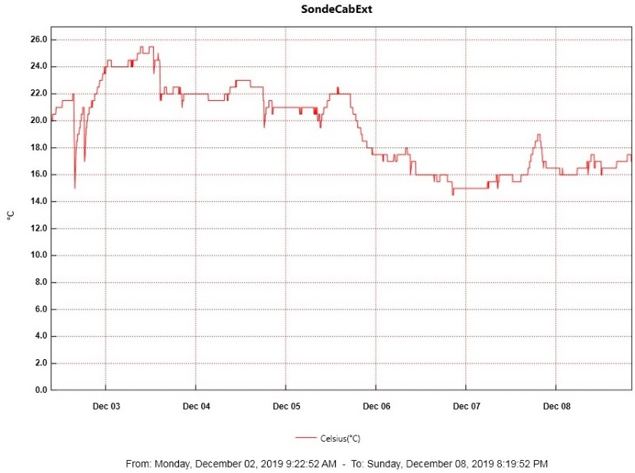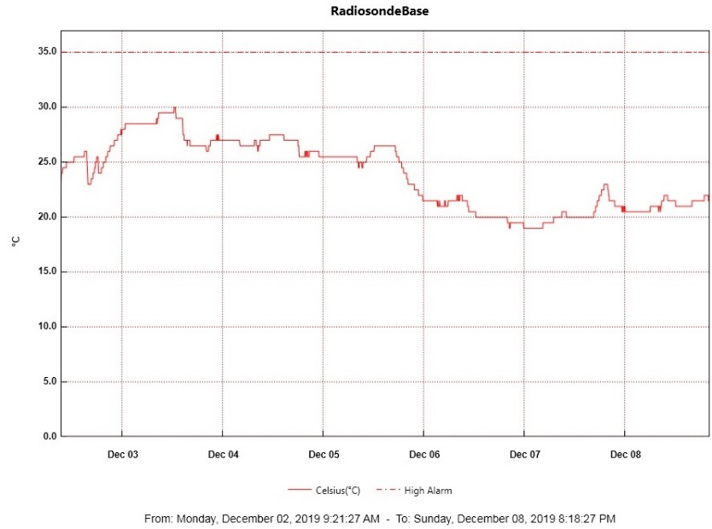

**MWR:**

* 2019-12-02 1238Z: “Radiometer Communication Error.” Extensive troubleshooting all week with PI. New cable installed 2019-12-05 to HATPRO. Lots of power cycles, cable swops, and configuration trials ensued. Troubleshooting still in process.

**SODAR:**

* 2019-12-05 1320-1744Z: Noticed SODAR offline at 1550Z. It was determined that the SODAR was accidentally unplugged during other instrument repairs. While plugging back in, noticed cord damage as it had been previously caught under heavy table leg. Notified PI.
* 2019-12-06 1321-1344Z: SODAR cleaned.

**POSS:**

* Operating normally.

**MASC:**

* Offline for winter season.

**MMCR:**

* 2019-12-02 1245Z: Net CDF errors cleared. 1317Z Net CDF errors not staying cleared. Rebooted 6x! Had trouble getting TWTA Helix Current to be within normal range. Final attempted tried turning UPS key at appropriate moment. Restored 1815Z.

**CAPABL:**

* 2019-12-08 1459-1505Z: Laser turned off for window cleaning after rooftop shoveling.
* Operating normally.

**MPL:**

* 2019-12-06 1258Z: Computer endured “Windows unexpected shutdown” and VNC viewer connection not working remotely for staff. Data collection had stopped ~0800Z. Restarted computer, restarted data collection, and eventually restarted Ultra VNC Server. All good as of 1535Z. PI notified.

**VCEIL:**

* Operating normally.

**PAERI:**

* 2019-12-02 1252-1254Z: PAERI mirror cleaned due to persistent Red Flags in past 24-hours due to high winds.
* 2019-12-03 0700-1600Z: Red Flags due to high winds. Cleared itself.
* Outdoor Temp Sensor still not functioning. Developing plan of action with PI.

**IceCAM:**

* Operating normally.

**IcePIC:**

* No IcePics this week.

**CLASP:**

* 2019-12-08 1455Z: Noticed high pitch sound again *after* I cleaned instrument and while still on the roof shoveling. On a whim, I put my thumb over the air intake tube very briefly and the horrible noise suddenly stopped. Problem solved.
* Operating normally.

**CPC:**

* 2019-12-02 1745: Noticed “Air Pump Problem, Current Too High” alarm. Defrosted exterior tube and resumed data collection 1810Z.
* 2019-12-03 0300Z: Data collection stopped due to “Air Pump Problem, Current Too High” alarm. Noticed at 1725Z. Defrosted exterior tube and resumed data collection 1752Z.
* 2019-12-04 0520Z: Data collection stopped due to “Air Pump Problem, Current Too High” alarm. Noticed at 1223Z. Defrosted exterior tube and resumed data collection 1304Z.

**MSF - OPC:**

* 2019-12-02 1410Z: Data collection restarted after noticing it stopped 2019-12-01 at 1845Z, likely due to high winds. PI notified.
* 2019-12-03 1734Z: Still no data after yesterday’s restart. OPC brought inside to defrost.
* 2019-12-04 1245Z: OPC reconnected and data collection resumed. All is well.

**TAWO - OPC:**

* 2019-12-04: Reassembled and replaced TAWO OPC back on rooftop and reinitialized data logging on flux laptop. Data gaps persist. Troubleshooting ongoing.

**SKYOPC:**

* Operating normally.

**INP Freezing Assay:**

* 2019-12-04 1343Z: Filter samples collected from TAWO, weekly assays run, and data sent. Instrument internal memory downloaded and sent to PI.

**Fluxtower instrument suite:**

* 2019-12-01: Loss in connectivity to flux tower instruments at ~1500Z. Connectivity restored by power cycling power to tower at 1458Z on 2019-12-02.