**ICECAPS-ACE Weekly Report**

December 9-15, 2019

Jess Ackerman

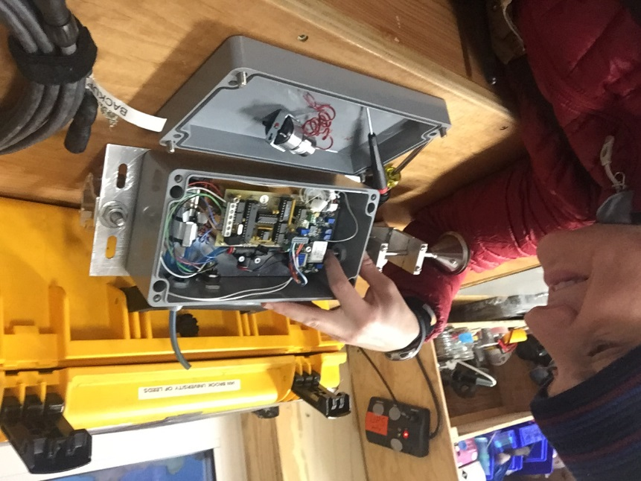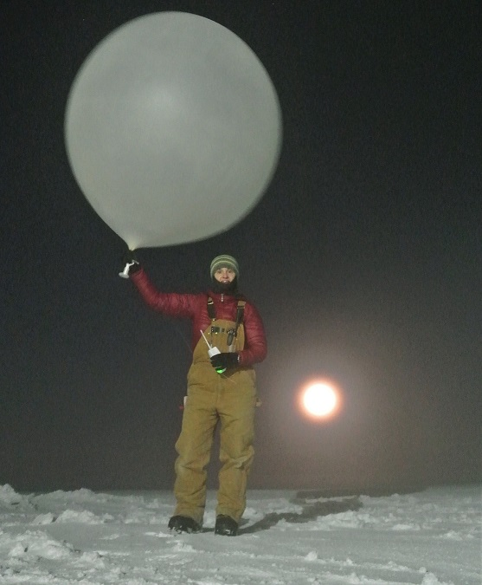

*Left: 2019-12-10: ICECAPS Tech Jess replacing the pump in the CLASP.*

*Right: 2019-12-12 1115Z: Jess and the “moon-balloon.”*

**General Notes:**

Summit Station endured its coldest temperatures of the season yet this week dipping to -105F windchill, -56.7 C. Preparation and planning to remove the HATPRO MWR from the MSF rooftop continues as it will be an all-hands event, to be completed as soon as a weather window allows. CLASP troubleshooting, pump replacement, and calibration also occurred this week. The last full moon of the decade was enjoyed by all on 12/12.

**General Weather Observations:**

|  |  |  |  |  |  |  |  |
| --- | --- | --- | --- | --- | --- | --- | --- |
| **Date** | **Time (Z)** | **Wind** | **Weather** | **Visibility** | **Sky** | **Temp (C)** | **Notes** |
| 12-09 | 12 | 187°, 11 kn |  | 800 | SKC | -52 |  |
| 12-10 | 12 | 187°, 14 kn |  | 800 | FEW033 | -50 |  |
| 12-11 | 12 | 214°, 8 kn |  | 800 | FEW | -54 | Stratus distant |
| 12-12 | 12 | 202°, 17 kn | FZFG | 600 | FEW | -49 | Stratus distant |
| 12-13 | 12 | 195°, 10 kn |  | 800 | FEW131 | -51 |  |
| 12-14 | 12 | 65°, 13 kn | -SN, FZFG | 600 | BKN016 | -42 | North winds, Stratus |
| 12-15 | 12 | 101°, 20 kn | FZFG, BLSN | 500 | BKN066 | -32 |  |

**Significant Weather Observations:**

* 2019-12-15 1127Z: Rave Ice

**MSF**

* 2019-12-10: MSF indoor temperatures were colder than normal for a couple days due to dipping outside temperatures. Some fine tuning of the SOLO controller and fan speed got indoor temperatures back to normal range by 2019-12-12. Dampers were tested and are working sufficiently. This continued to be monitor closely and adjusted as needed throughout the week.

**ICECAPS-ACE Data Management:**

* 12-09: Stop ArchieveToBoulder at 1141Z.
* 12-10: Stop ArchieveToBoulder at 1128Z.
* 12-11: Stop ArchieveToBoulder at 1153Z.
* 12-12: Stop ArchieveToBoulder at 1543Z.
* 12-13: Stop ArchieveToBoulder at 1112Z.
* 12-14: Stop ArchieveToBoulder at 1140Z.
* 12-15: Stop ArchieveToBoulder at 1129Z.

**TSI:**

* Offline for winter season.

**Radiosonde:**

* Twice daily launches.
* 2019-12-11: PM launch had “Radiosonde Preparation Error – radiosonde has rebooted during the ground check process.” Launch of new/2nd sonde successful. I successfully launched the original troublesome sonde the next AM with no issues.
* See charts below for temperatures outside and inside the Radiosonde cabinet over the last week.

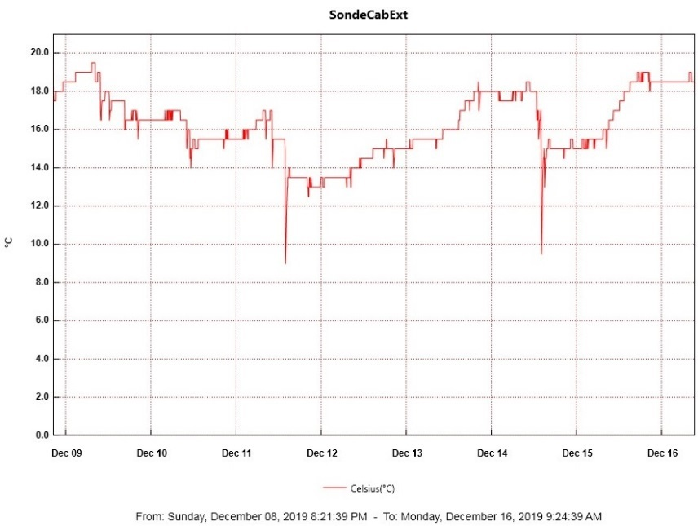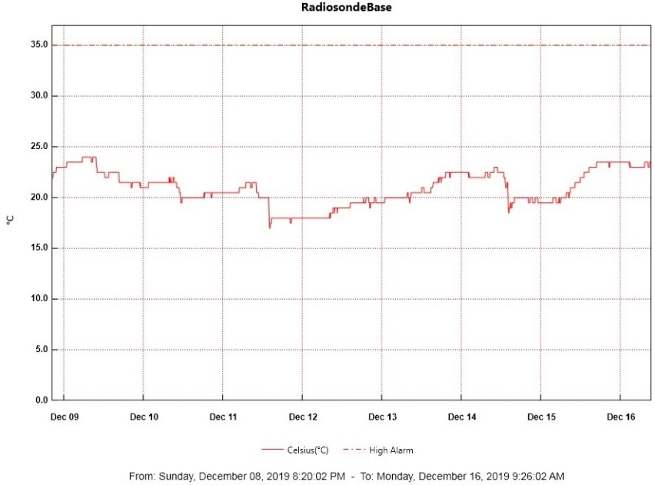

**MWR:**

* 2019-12-09: The HATPRO Microwave Radiometer (MWR) is still offline. The plan is to bring the instrument inside for more diagnostic checks. Preparation and planning to remove the 250 lb. instrument from the MSF rooftop are in progress.

**SODAR:**

* 2019-12-12 1447-1501Z: SODAR cleaned.

**POSS:**

* Operating normally.

**MASC:**

* Offline for winter season.

**MMCR:**

* 2019-12-10 1545Z: Noticed “temperature (outdoor)” value of 30 was out of tolerance consistently on the recent Health Logs. Notified PI. Possibly due to colder temps.
* 2019-12-14 1255Z: Noticed outdoor temperature value was back to 0 meaning within tolerance on the Health Logs dated today. Temps are warmer than -50C. Notified PI.

**CAPABL:**

* Operating normally.

**MPL:**

* 2910-12-14 1333-1352Z: Monthly calibration completed.
* Operating normally.

**VCEIL:**

* Operating normally.

**PAERI:**

* 2019-12-09 1225Z: Unplugged exterior fan briefly due to hum noise and cleared heavy frost from the intake tube. Caused LW and SW Responsivity Red Flags, so cleaned mirror at 1418Z. All is well.
* Operating normally.

**IceCAM:**

* Operating normally.

**IcePIC:**

* No IcePics this week.

**CLASP:**

* 2019-12-10 1306Z: No CLASP pump noise on roof. Data collection stopped at 1915Z the night before. CLASP was re-plugged in hoping to reset but eventually brought inside at 1328Z for pump replacement. Reinstalled on roof same day at 1538Z. Exhaust hose also replaced.
* 2019-12-11 1240Z: Still no consistent data. CLASP brought inside for further diagnostics.
* 2019-12-12 1525Z: Troubleshoot testing indoors with PI commenced.
* 2019-12-13 1500-1615Z: Pump calibration completed. CLASP reinstalled on rooftop 1618Z.
* 2019-12-14 1250Z: No pump noise. Notified PI.

**CPC:**

* 2019-12-11 1520Z: Butanol refilled and condensate emptied.
* 2019-12-12: Chemicals resupplied in MSF flammable cabinet.
* Operating normally.

**MSF - OPC:**

* Operating normally.

**TAWO - OPC:**

* 2019-12-18: Replaced fan motor component in TAWO OPC and placed back on rooftop. When plugging back in, cable cracked due to ~-60F temperatures. Data reinitialization on the flux laptop for the OPC failed as a result. Will replace with a spare cable when warmer temperatures permit.

**SKYOPC:**

* Operating normally.

**INP Freezing Assay:**

* 2019-12-10 1355-1515Z: Autocalibration of cold stages completed.
* 2019-12-11 1342Z: Encountered “error ambient p/T module” msg. Troubleshot with PI. Filter samples collected from TAWO, weekly assays run, and data sent. Instrument internal memory downloaded and sent to PI.
* 2019-12-12: Chemicals resupplied in MSF flammable cabinet.

**Fluxtower instrument suite:**

* 2019-12-08: Loss of power to replaced power supply connecting instruments KT15, HMP3 (9m temperature sensor), HMP4 (15m temperature sensor), Ventus2 (9m 2D sonic), Metek2 (15m 2D sonic).