**ICECAPS-ACE Weekly Report**

December 16-22, 2019

Jess Ackerman

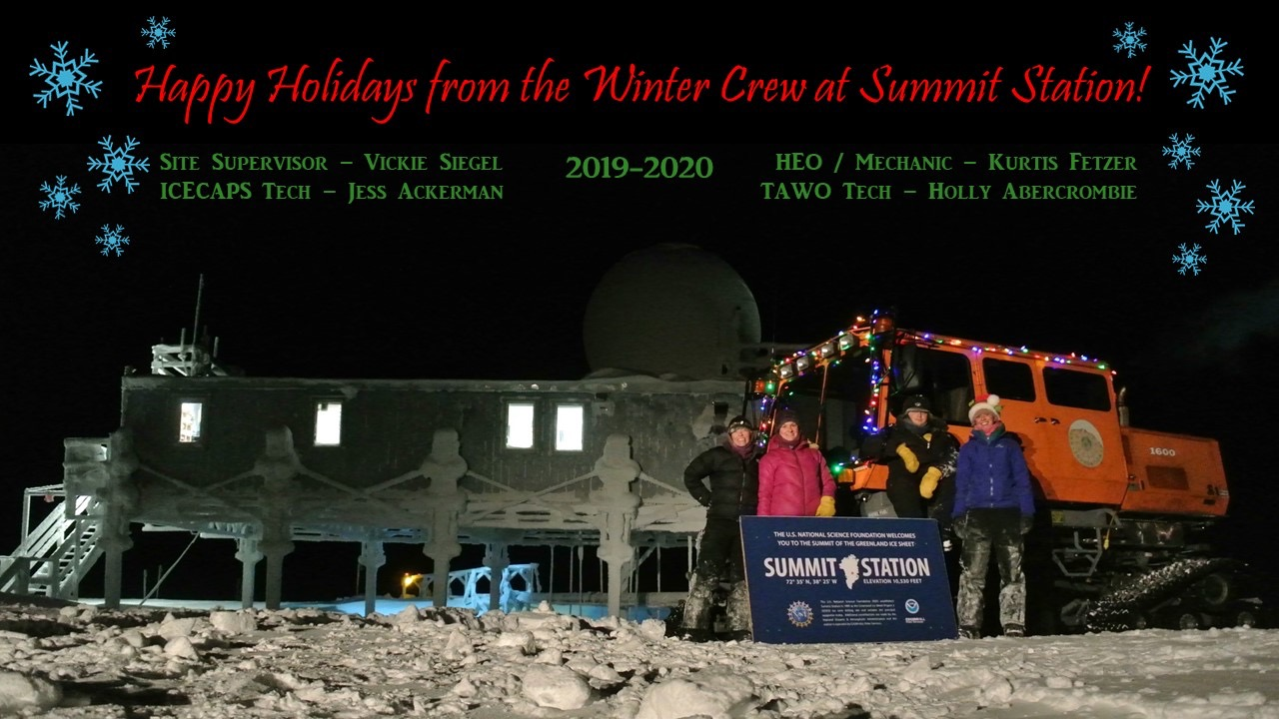

*Above: 2019-12-21: Our holiday card picture taken on the winter solstice.*

**General Notes:**

A break in the weather allowed for all variables (temperature, wind speed, wind direction, twilight hours, moonlight, cloud cover, visibility, etc!) to line up to successfully complete our darkest and coldest ICESAT Traverse of the season. Preparation and planning to remove the HATPRO MWR from the MSF rooftop continues, primarily now waiting for an appropriate weather window. CLASP troubleshooting was ongoing with a 2nd pump replacement, another pump calibration, and continuous collaboration with the PI. Spirits are high with Christmas just around the corner.

**General Weather Observations:**

|  |  |  |  |  |  |  |  |
| --- | --- | --- | --- | --- | --- | --- | --- |
| **Date** | **Time (Z)** | **Wind** | **Weather** | **Visibility** | **Sky** | **Temp (C)** | **Notes** |
| 12-16 | 12 | 178°, 16 kn | FZFG, BLSN | 500 | BKN008 | -36 |  |
| 12-17 | 12 | 242°, 11 kn |  | 800 | FEW013 | -38 | Stratus distant |
| 12-18 | 12 | 47°, 5 kn | FZFG | 600 | SCT000 | -45 | North winds |
| 12-19 | 12 | 94°, 16 kn |  | 800 | SKC | -51 |  |
| 12-20 | 12 | 73°, 14 kn | FZFG | 700 | SKC | -54 |  |
| 12-21 | 12 | 142°, 7 kn |  | 800 | FEW | -48 | Stratus distant |
| 12-22 | 12 | 191°, 14kn |  | 800 | SKC | -45 |  |

**Significant Weather Observations:**

* 2019-12-16 1239Z: Rave Ice

**MSF**

* 2019-12-18 1655Z: Swiss Tower computer was brought inside for program updates, data downloads, and to establish a remote connection for the PI.
* 2019-12-19: MSF indoor temperatures were colder than normal so fine tuning of the SOLO controller and fan speed adjustments were made as needed throughout the week.

**ICECAPS-ACE Data Management:**

* 12-16: Stop ArchieveToBoulder at 1200Z.
* 12-17: Stop ArchieveToBoulder at 1141Z.
* 12-18: Stop ArchieveToBoulder at 1140Z.
* 12-19: Stop ArchieveToBoulder at 1456Z.
* 12-20: Stop ArchieveToBoulder at 1129Z.
* 12-21: Stop ArchieveToBoulder at 1054Z.
* 12-22: Stop ArchieveToBoulder at 1123Z.

**TSI:**

* Offline for winter season.

**Radiosonde:**

* Twice daily launches.
* See charts below for temperatures outside and inside the radiosonde cabinet over the last week.

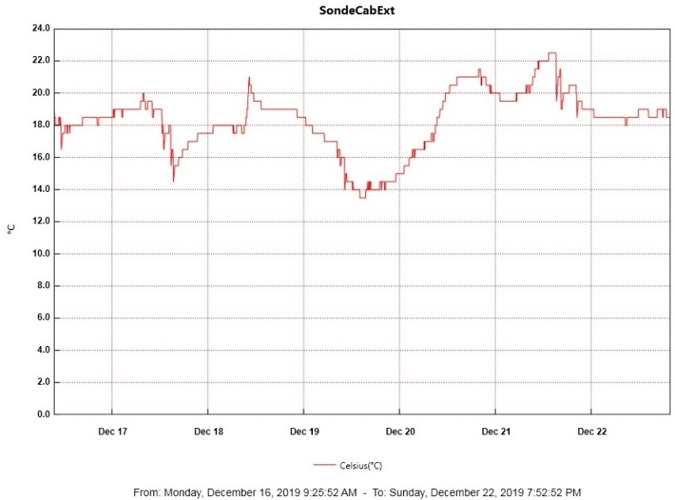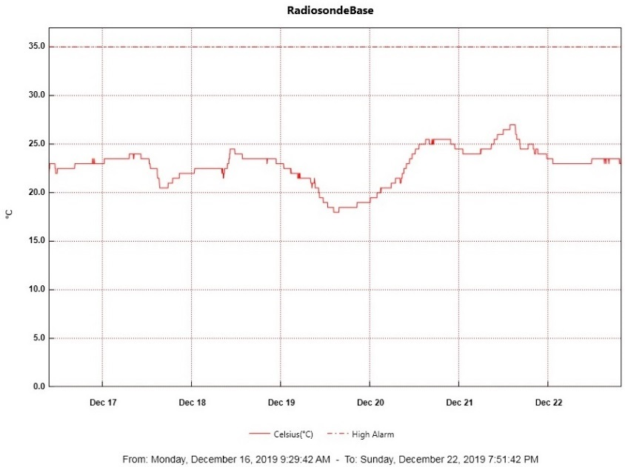

**MWR:**

* 2019-12-09: The HATPRO Microwave Radiometer (MWR) is still offline. The plan is to bring the instrument inside for more diagnostic checks. Preparation and planning to remove the 250 lb. instrument from the MSF rooftop are in progress, primarily waiting for appropriate weather window.

**SODAR:**

* 2019-12-19 1548-1607Z: SODAR cleaned.

**POSS:**

* 2019-12-22: Had a single “DC Offset” error at 1526Z, the exact minute I was cleaning the instrument. Followed by 10x “Max Noise Limit” errors from 1533-1542Z. Returned to normal on its own. PI notified.

**MASC:**

* Offline for winter season.

**MMCR:**

* 2019-12-19 1300Z: Noticed “temperature (outdoor)” value of 30 was out of tolerance again in the recent Health Logs due to outdoor temperatures being colder than -50. PI notified.

**CAPABL:**

* 2019-12-17 1754-1803Z: Offline briefly for laser window cleaning.
* Operating normally.

**MPL:**

* Operating normally.

**VCEIL:**

* Operating normally.

**PAERI:**

* 2019-12-22 1506Z: All blue flags present. Notified PI. Resolved itself next day.

**IceCAM:**

* Operating normally.

**IcePIC:**

* No IcePics this week.

**CLASP:**

* 2019-12-18 1830Z: CLASP troubleshooting continues with PI.
* 2019-12-20: 2nd pump replacement and calibration (1446-1544Z) completed. Instrument reinstalled on roof at 1607Z and collecting data. Cracked cable during installation, secured with mastic tape.

**CPC:**

* Operating normally.

**MSF - OPC:**

* Operating normally.

**TAWO - OPC:**

* 2019-12-11: Cracked cable when placing OPC back on rooftop; waiting for warm weather and assistance to replace with spare cable.

**SKYOPC:**

* Operating normally.

**INP Freezing Assay:**

* 2019-12-18 1345Z: Filter samples collected from TAWO, weekly assays run, and data sent. Instrument internal memory downloaded and sent to PI.

**Fluxtower instrument suite:**

* 2019-12-08: Loss of power to replaced power supply connecting instruments KT15, HMP3 (9m temperature sensor), HMP4 (15m temperature sensor), Ventus2 (9m 2D sonic), Metek2 (15m 2D sonic).
* 2019-12-21: Replaced repaired HMP2 back on tower.

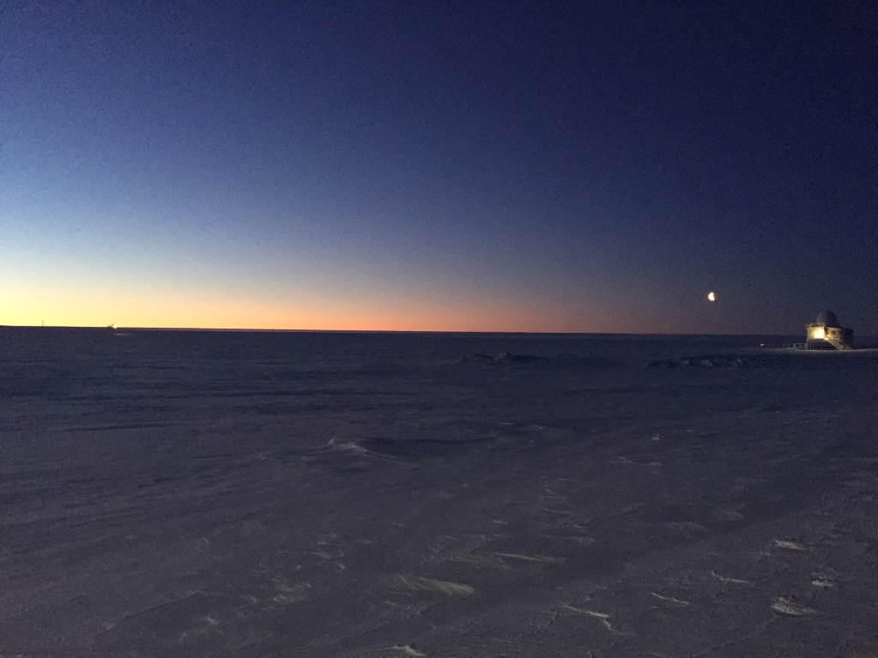

*Above: 2019-12-19 1457Z: Horizon twilight with TAWO barely visible on far left and the moon with Big House on far right.*