**ICECAPS-ACE Weekly Report**

December 23-29, 2019

Jess Ackerman

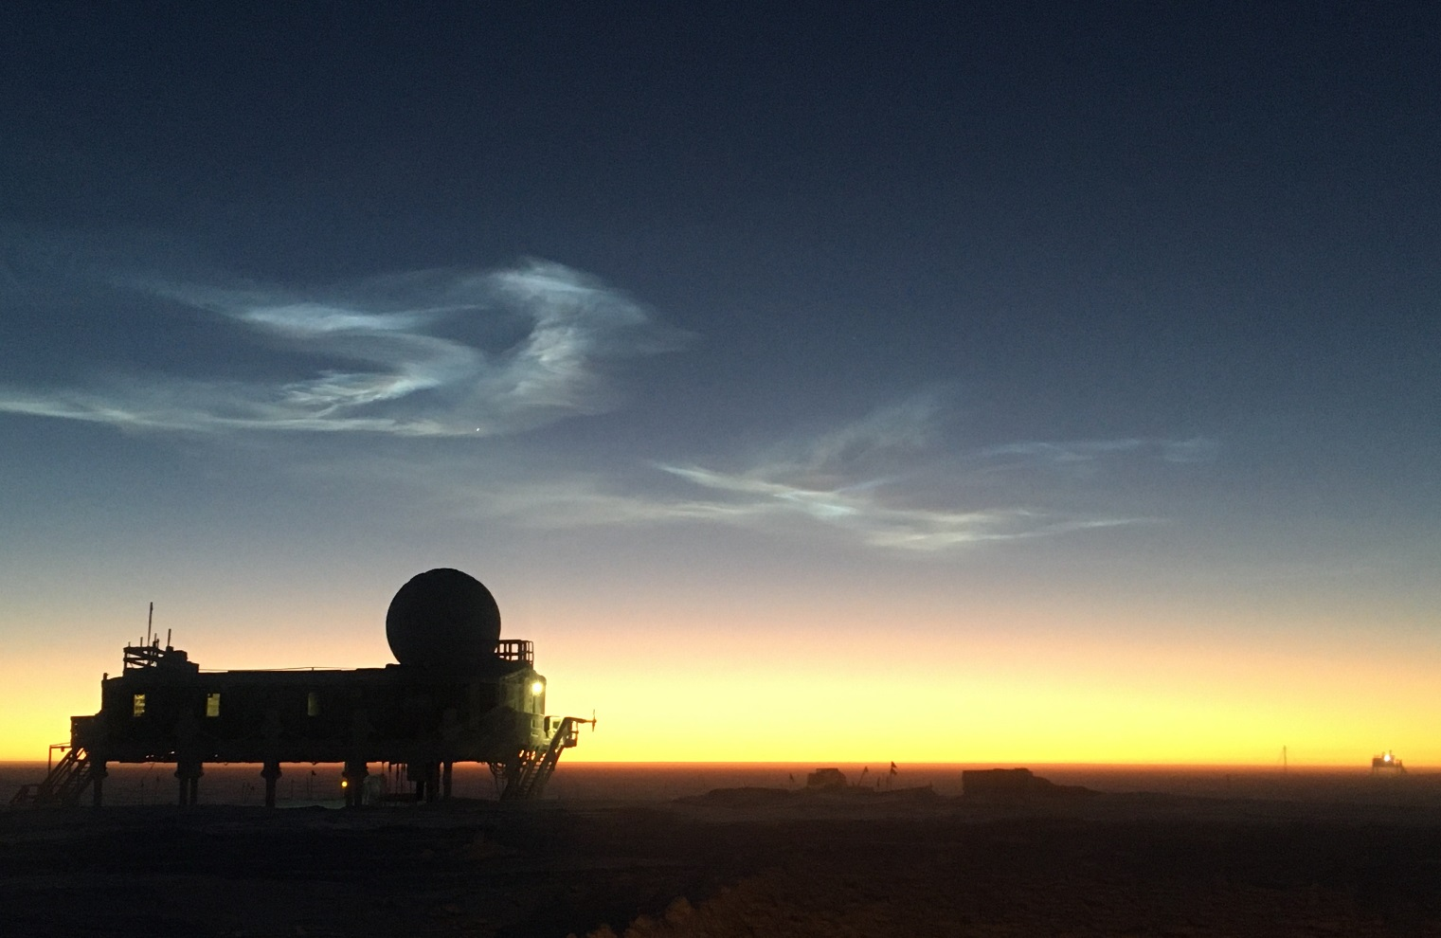

*Above: 2019-12-23 The twilight is steadily returning!*

**General Notes:**

A somewhat calm Christmas week was enjoyed by all. Our helium cylinder exchange occurred on 12/25; a satisfying item to check off the list. The HATPRO MWR removal is still pending on a Con 3 weather window. Christmas for us was celebrated on Friday evening 12/27 which included a nice meal and jolly gift exchange. *Sam*ta left some fun items in our stockings too. We are ready to welcome in the New Year!

**General Weather Observations:**

|  |  |  |  |  |  |  |  |
| --- | --- | --- | --- | --- | --- | --- | --- |
| **Date** | **Time (Z)** | **Wind** | **Weather** | **Visibility** | **Sky** | **Temp (C)** | **Notes** |
| 12-23 | 12 | 177°, 10 kn | FZFG | 300 | BKN008 | -40 |  |
| 12-24 | 12 | 177°, 13 kn | FZFG | 500 | OVC003 | -47 |  |
| 12-25 | 12 | 212°, 13 kn | FZFG | 500 | BKN003 | -46 |  |
| 12-26 | 12 | 236°, 11 kn | FZFG | 600 | SKC | -51 |  |
| 12-27 | 12 | 160°, 14 kn |  | 9999 | SKC | -52 |  |
| 12-28 | 12 | 132°, 16 kn |  | 800 | FEW | -40 | Stratus distant. |
| 12-29 | 12 | 177°, 12 kn | FZFG | 800 | SCT066 | -42 |  |

**Significant Weather Observations:**

* No significant weather this week.

**MSF**

* 2019-12-24 Restarted MSF science tech laptop.
* 2019-12-25 1600Z: Noticed MSF vestibule (DNF) was at -3C. Notified Sam and Martin. Brought the INP DNF water inside the MSF. Vestibule temps being monitored.

**ICECAPS-ACE Data Management:**

* 12-23: Stop ArchieveToBoulder at 1120Z.
* 12-24: Stop ArchieveToBoulder at 1108Z.
* 12-25: Stop ArchieveToBoulder at 1113Z.
* 12-26: Stop ArchieveToBoulder at 1109Z.
* 12-27: Stop ArchieveToBoulder at 1136Z.
* 12-28: Stop ArchieveToBoulder at 1110Z.
* 12-29: Stop ArchieveToBoulder at 1153Z.

**TSI:**

* Offline for winter season.

**Radiosonde:**

* Twice daily launches.
* Green House temp sensor not updating on webpage since 2019-12-25 2347Z.
* See charts below for temperatures outside and inside the radiosonde cabinet over the last week.

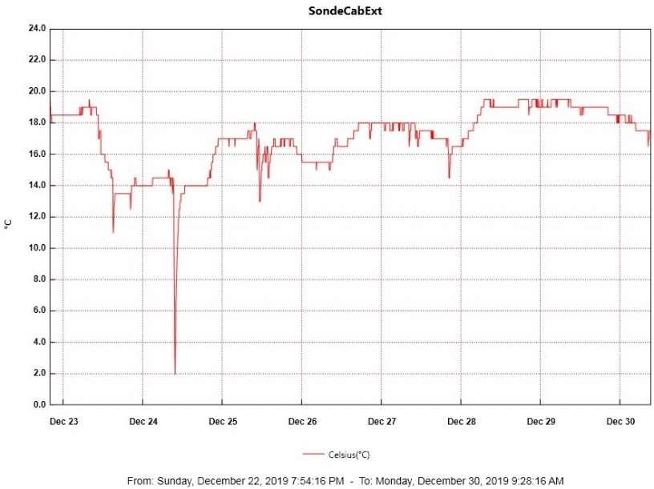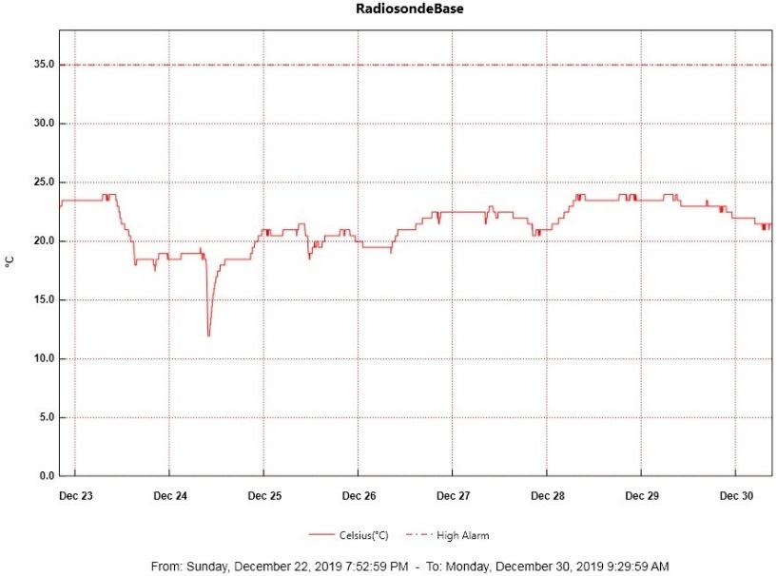

* See monthly picture below of external cabinet filter. Next scheduled change is mid-Jan 2020.

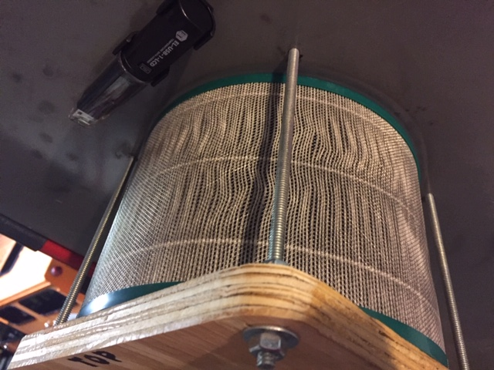

**MWR:**

* 2019-12-09: The HATPRO Microwave Radiometer (MWR) is still offline. The plan is to bring the instrument inside for more diagnostic checks. Preparation and planning to remove the 250 lb. instrument from the MSF rooftop are in progress, primarily waiting for appropriate weather window.

**SODAR:**

* 2019-12-26 1302-1314Z: SODAR cleaned.
* Operating normally.

**POSS:**

* Operating normally.

**MASC:**

* Offline for winter season.

**MMCR:**

* Operating normally.

**CAPABL:**

* Operating normally.

**MPL:**

* Operating normally.

**VCEIL:**

* Operating normally.

**PAERI:**

* 2019-12-25 1215Z: No AERI window present. Notified PI. Resolved itself at midnight reset.

**IceCAM:**

* Operating normally.

**IcePIC:**

* No IcePics this week.

**CLASP:**

* Operating normally.

**CPC:**

* 2019-12-25 1515Z: Butanol refilled, condensate emptied.
* Operating normally.

**MSF - OPC:**

* Operating normally.

**TAWO - OPC:**

* 2019-12-28: Relatively warm weather permitted swapping out the cracked cable connecting the OPC on the TAWO rooftop. Unable to restart data collection on the flux laptop; PI contacted and troubleshooting ongoing.

**SKYOPC:**

* Operating normally.

**INP Freezing Assay:**

* 2019-12-25 1340Z: “Error ambient p/T module” msg again. PI notified. Filter samples unsuccessfully collected from TAWO, unable to run weekly assays, so no data sent. Instrument internal memory downloaded and sent to PI.

**Fluxtower instrument suite:**

* 2019-12-08: Loss of power to replaced power supply connecting instruments KT15, HMP3 (9m temperature sensor), HMP4 (15m temperature sensor), Ventus2 (9m 2D sonic), Metek2 (15m 2D sonic).

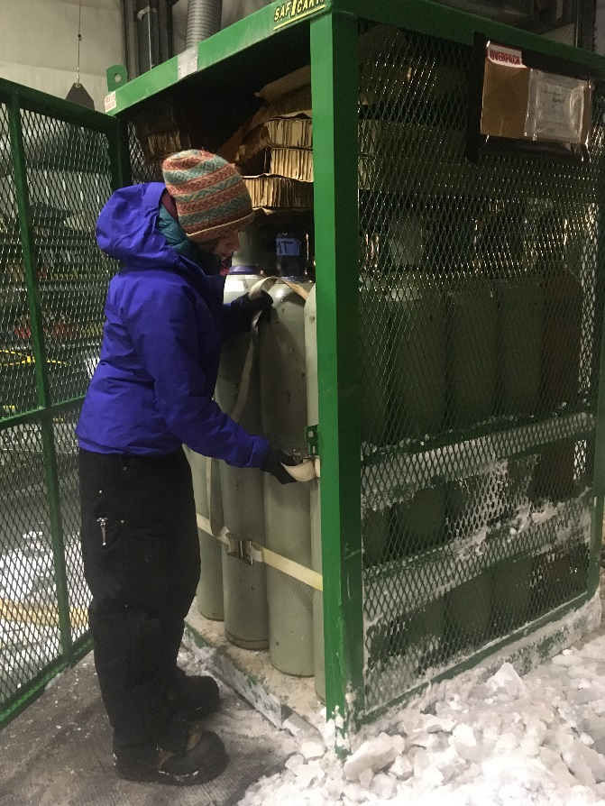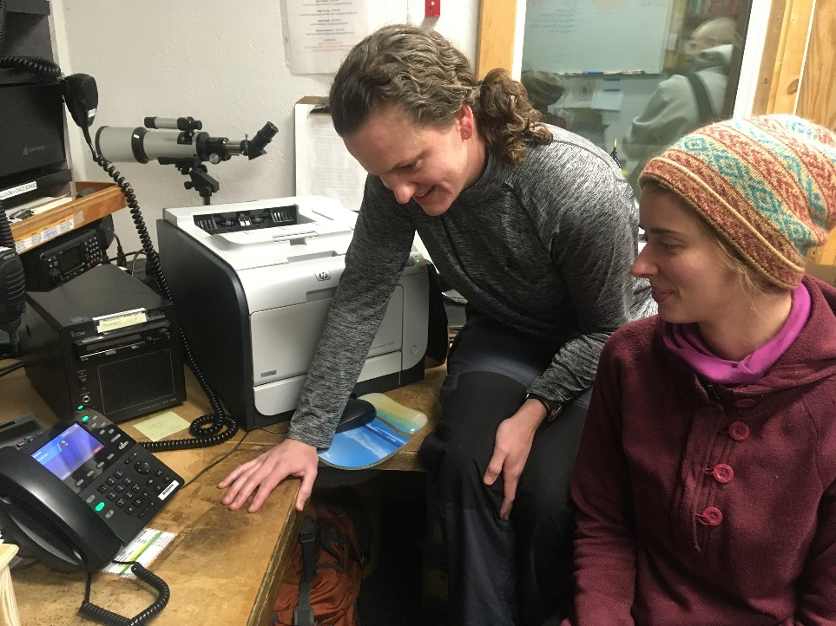

*Left: 2019-12-25: TAWO Tech Holly securing the radiosonde helium cylinders during the Christmas morning cylinder swop.*

*Right: 2019-12-27: Jess and Holly listening to Christmas carols on the speaker phone from PFS staff afar.*