**ICECAPS-ACE Weekly Report**

December 30, 2019 – January 5, 2020

Jess Ackerman

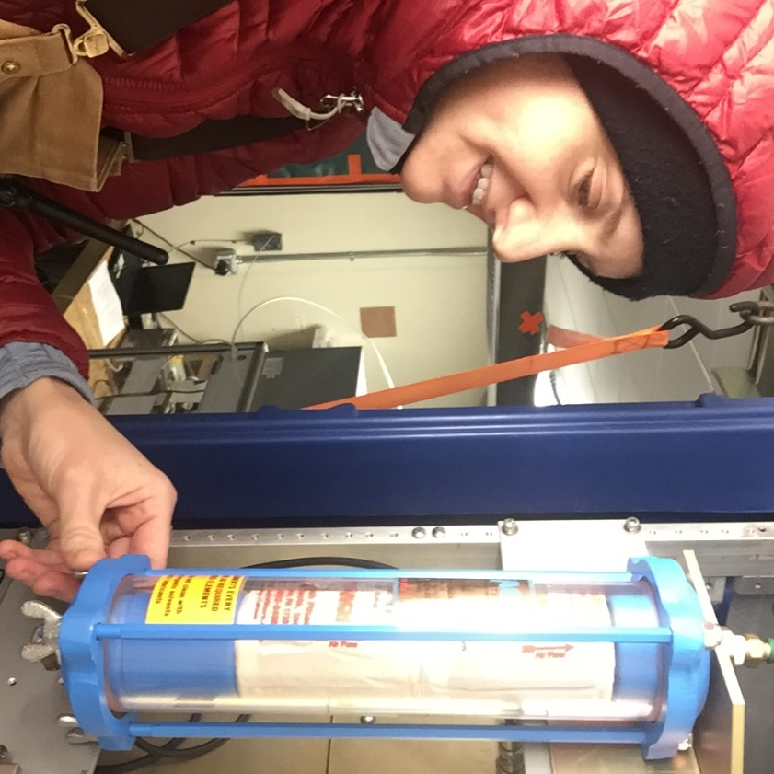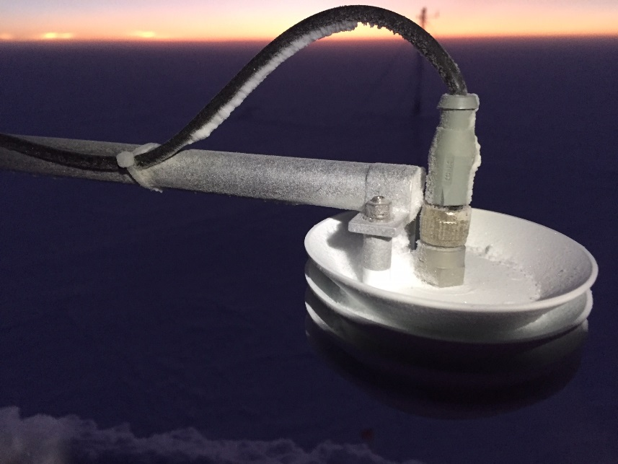

*Left: 2019-12-31: ICECAPS Tech Jess changing out the MMCR desiccant filters.*

*Right: 2020-01-02: Recon mission in the twilight to the TAWO rooftop to investigate the INP P/T sensor.*

**General Notes:**

HAPPY New Year! I think we were all in bed by 9pm. A busy week troubleshooting instruments, rallying seasonal inventory, and withstanding our coldest seasonal temperatures yet. We dipped down to -84F ambient and -132F windchill! Then we had a 50°F temp increase within 24 hours, only to be followed by sustained high winds and low visibility for the rest of the week. Standing by for a weather window to remove the HATPRO MWR from the MSF rooftop. On the horizon includes INP sampler repairs, Swiss Tower computer connectivity improvements, continued CPC troubleshooting, and of course HATPRO MWR diagnostics.

**General Weather Observations:**

|  |  |  |  |  |  |  |  |
| --- | --- | --- | --- | --- | --- | --- | --- |
| **Date** | **Time (Z)** | **Wind** | **Weather** | **Visibility** | **Sky** | **Temp (C)** | **Notes** |
| 12-30 | 12 | 226°, 12 kn | FZFG | 700 | BKN006 | -44 |  |
| 12-31 | 12 | 206°, 12 kn | FZFG | 700 | BKN | -45 |  |
| 01-01 | 12 | 287°, 11 kn | FZFG | 800 | FEW | -55 | Stratus distant. |
| 01-02 | 12 | 314°, 16 kn | FZFG | 800 | FEW | -61 | SMG smog over MSF |
| 01-03 | 12 | 206°, 19 kn | BLSN | 200 | OVC013 | -50 |  |
| 01-04 | 12 | 201°, 17 kn | BLSN | 300 | OVC000 | -36 |  |
| 01-05 | 12 | 134°, 17 kn | BLSN | 300 | OVC003 | -38 |  |

**Significant Weather Observations:**

* No significant weather this week.

**MSF**

* 2019-12-30 0500Z – 2019-12-31 1900Z: Internet outage.
* 2020-01-03: Been battling freezing temps in the DNF vestibule and colder temps inside MSF all week; making adjustments to the SOLO temp controller, HVAC fan speed, adding a space heater to vestibule, and adding wool blankets to cover the outside door leaky weather stripping.

**ICECAPS-ACE Data Management:**

* 12-30: Stop ArchieveToBoulder at 1107Z. Incomplete. Lost internet connection.
* 12-31: Stop ArchieveToBoulder at 0652Z. Incomplete. Lost internet connection.
* 01-01: Stop ArchieveToBoulder at 0139Z Jan 2nd. Catching up.
* 01-02: Stop ArchieveToBoulder at 1104Z.
* 01-03: Stop ArchieveToBoulder at 1228Z.
* 01-04: Stop ArchieveToBoulder at 1214Z.
* 01-05: Stop ArchieveToBoulder at 1306Z.

**TSI:**

* Offline for winter season.

**Radiosonde:**

* Twice daily launches.
* Green House temp sensor not updating on webpage since 2019-12-25 2347Z.
* 2020-01-02: Had to fudge Dew Point (over max value allowed) to make RH acceptable at <100%. Noted in log.
* See charts below for temperatures outside and inside the radiosonde cabinet over the last week.

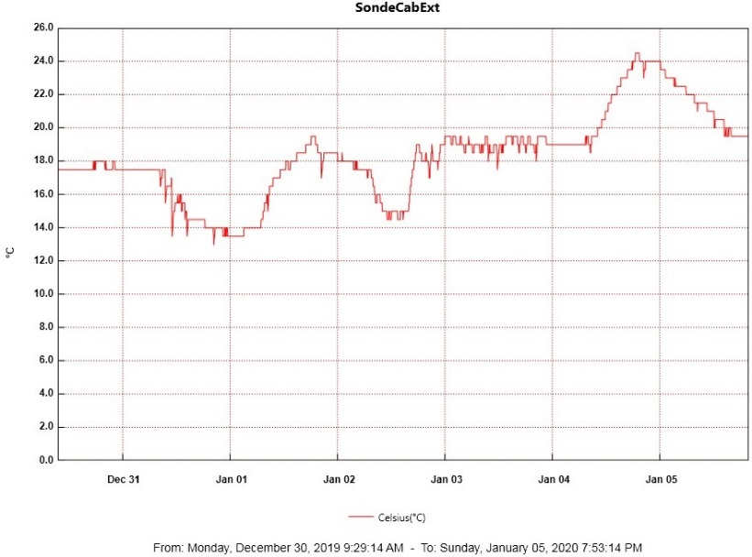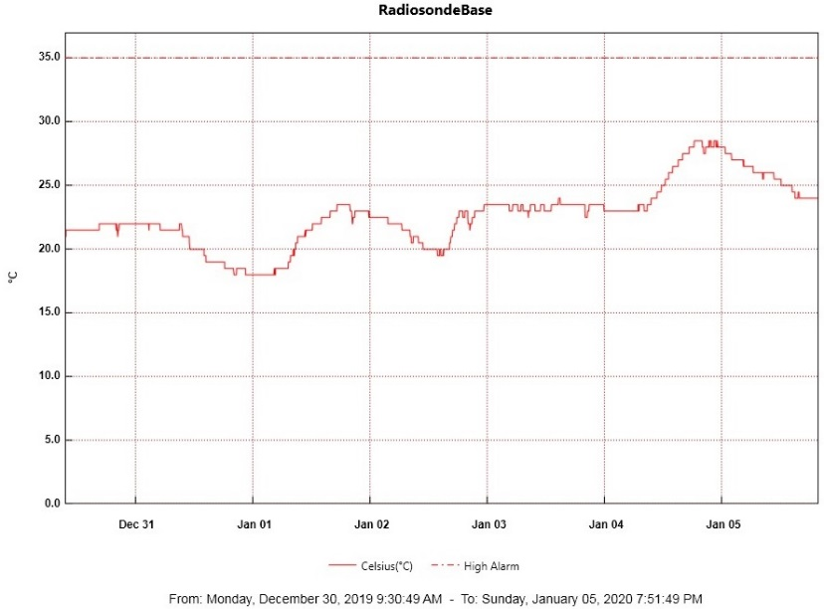

**MWR:**

* 2020-01-01: Awaiting a decent weather window to bring inside the HATPRO MWR for more diagnostic checks.
* 2020-01-04 1529Z: Re-connected and initiated data collection for the 150-90 MWR.

**SODAR:**

* Unable to perform routine weekly cleaning due to weather.
* Operating normally.

**POSS:**

* 2020-01-03 1221Z: “False Alarm” error at time of cleaning. Resolved itself. PI notified.
* Operating normally.

**MASC:**

* Offline for winter season.

**MMCR:**

* 2019-12-31 1515Z: Desiccant filters changed.
* Operating normally.

**CAPABL:**

* 2020-01-04 1442-1452Z: Offline briefly for laser window cleaning.
* Operating normally.

**MPL:**

* Operating normally.

**VCEIL:**

* Operating normally.

**PAERI:**

* 2019-12-31 1320Z: No AERI window present. Notified PI. Resolved itself at midnight reset.
* 2020-01-02: Exterior fan brought inside to thaw due to “Max Sample Std Dev” red flag that started at 2300Z night before.
* 2020-01-03 1220Z: Fan re-installed outside. Flags cleared.

**IceCAM:**

* Operating normally.

**IcePIC:**

* No IcePics this week.

**CLASP:**

* Operating normally.

**CPC:**

* 2019-12-31 1530Z: Carbon filter changed.
* 2020-01-03 1214Z: “Air pump current too high” alarm. Data collection stopped at 2130Z night before. Exhaust tube thawed, errors cleared, and data collection resumed at 1315Z.
* 2020-01-05: Notice data stopped collecting at 0900Z. Power cycled at 1624-1710Z. Troubleshooting continues with PI.

**MSF - OPC:**

* Operating normally.

**TAWO - OPC:**

* 2020-01-01: Successfully restarted OPC data collection on flux laptop after securing cable connection to instrument.
* 2020-01-02: Lost connection, no incoming data.
* 2020-01-04: Re-secured connection and re-initialized data logging.

**SKYOPC:**

* Operating normally.

**INP Freezing Assay:**

* 2020-01-02 1313Z: Sampled filters collected. Connections inspected inside and on rooftop. Still troubleshooting instrument “Error ambient p/T module” and “T-inlet” messages. Instrument internal data downloaded and sent to PI. Currently not sampling until further info gained from manufacturer.

**Fluxtower instrument suite:**

* 2019-12-08: Loss of power to replaced power supply connecting instruments KT15, HMP3 (9m temperature sensor), HMP4 (15m temperature sensor), Ventus2 (9m 2D sonic), Metek2 (15m 2D sonic).
* 2020-01-04: Lost communications from flux tower instruments to TAWO at ~2300 UTC on 2020-01-03 most likely due to high winds. Power cycled comms cable in tower distribution box and restored connectivity.

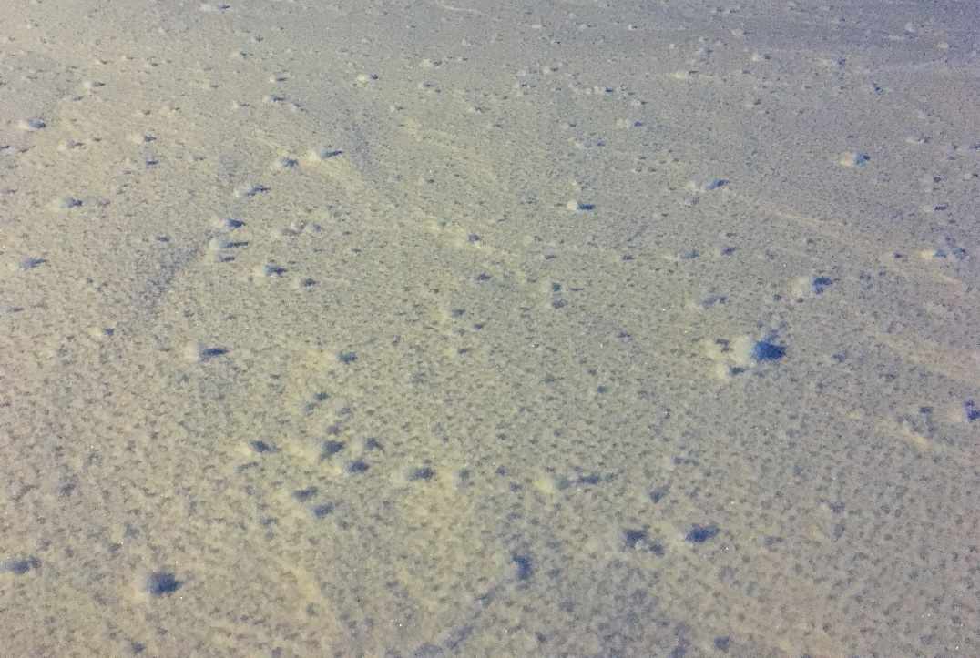

*Above: 2020-01-01 Our first significant yukimarimo event!*

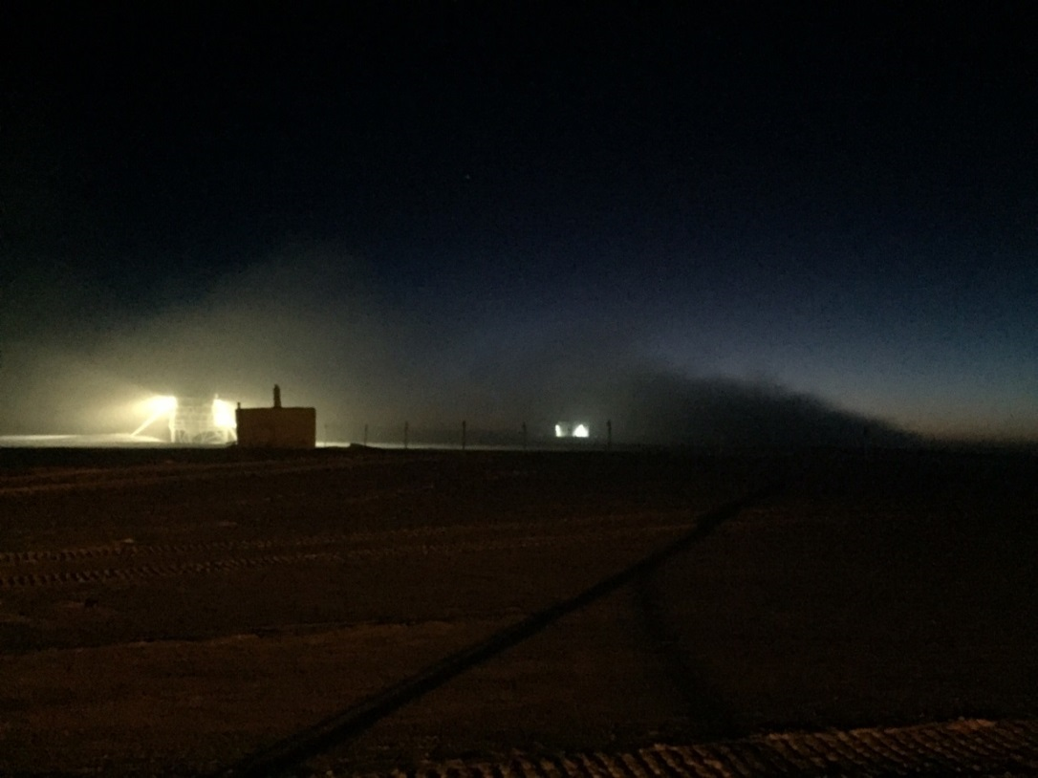

*Above: 2020-01-02 1125Z: SMG exhaust plume smothers MSF (center).*

*Wind direction approximately 320 degrees.*