**ICECAPS-ACE Weekly Report**

January 6-12, 2020

Jess Ackerman

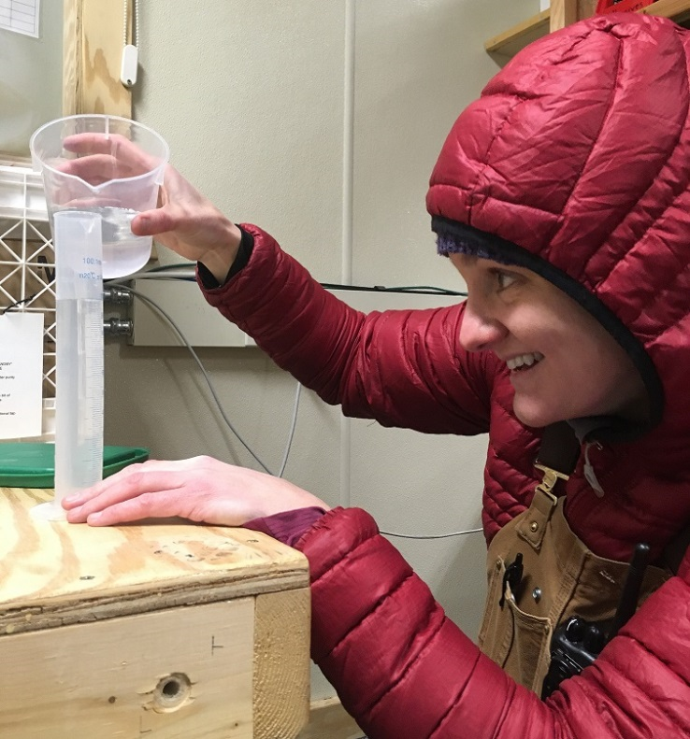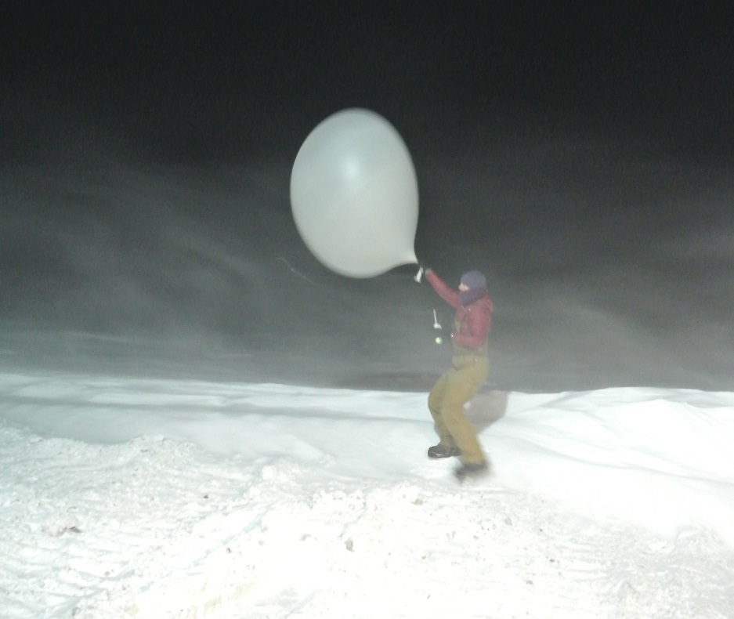

*Left: 2020-01-10: ICECAPS Tech Jess measuring snow melt volume for SnowFox Project.*

*Right: 2020-01-11 1115Z: An exhilarating balloon launch for Jess in 30 knots of wind!*

**General Notes:**

We had an exciting and windy week at Summit, with sustained winds of 45 knots most of the day 01/09 and topping out at 52.7 knots! Lots of shoveling and drift maintenance ensued just to keep access open to the vestibules and doors. The ICESAT window opened on 01/07 so standing by for a decent break in the weather. Lots of collaborating and troubleshooting on a variety of instruments this week including the CLASP, CPC, MWR, PAERI, Ceilometer, Swiss Tower computer, INP sampler, and a lot of SODAR snow drift excavation. Inventories continue to be a work in progress. Turnover is just around the corner.

**General Weather Observations:**

|  |  |  |  |  |  |  |  |
| --- | --- | --- | --- | --- | --- | --- | --- |
| **Date** | **Time (Z)** | **Wind** | **Weather** | **Visibility** | **Sky** | **Temp (C)** | **Notes** |
| 01-06 | 12 | 116°, 23 kn | BLSN | 300 | OVC003 | -35 |  |
| 01-07 | 12 | 101°, 14 kn | DRSN | 800 | FEW | -40 |  |
| 01-08 | 12 | 85°, 24 kn | BLSN | 200 | OVC003 | -32 |  |
| 01-09 | 12 | 55°, 44 kn | BLSN | 50 | OVC000 | -29 |  |
| 01-10 | 12 | 84°, 21 kn | BLSN | 200 | BKN003 | -41 |  |
| 01-11 | 12 | 101°, 30 kn | BLSN | 200 | OVC000 | -38 |  |
| 01-12 | 12 | 117°, 16 kn | DRSN | 500 | OVC008 | -34 |  |

**Significant Weather Observations:**

* 2020-01-06 1520Z: Rave Ice
* 2020-01-08 1246Z: Rave Ice
* 2020-01-11 1220Z: Rave Ice

**MSF**

* 2020-01-08: Swiss Tower computer diagnostics started up again. Windows activation code received 01/10. Troubleshooting continues. Connectivity achieved 01/11.
* 2020-01-09: MSF not visited for dailies due to extreme winds.
* 2020-01-10, 11, &12: HVAC system cleared of snow.
* Operating normally.

**ICECAPS-ACE Data Management:**

* 01-06: Stop ArchieveToBoulder at 1244Z.
* 01-07: Stop ArchieveToBoulder at 1210Z.
* 01-08: Stop ArchieveToBoulder at 1159Z.
* 01-09: Stop ArchieveToBoulder at 1949Z.
* 01-10: Stop ArchieveToBoulder at 1152Z.
* 01-11: Stop ArchieveToBoulder at 1227Z.
* 01-12: Stop ArchieveToBoulder at 1429Z.

**TSI:**

* Offline for winter season.

**Radiosonde:**

* Twice daily launches, except not attempted on 01/09 AM due to high winds (45 knots). The sonde on 01/10 PM terminated itself after successful launch; no re-launch due to high winds.
* See charts below for temperatures outside and inside the radiosonde cabinet over the last week.

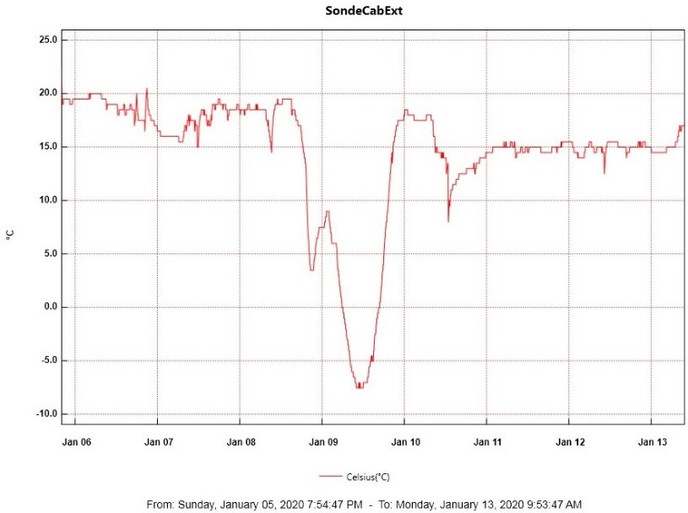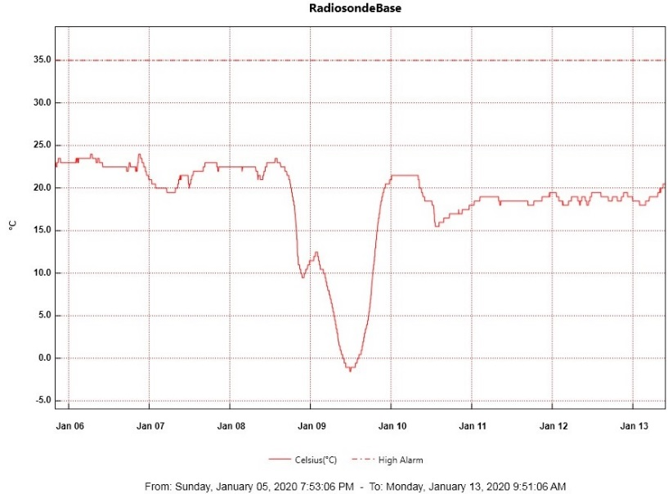

**MWR:**

* 2020-01-01: Awaiting a decent weather window to bring the HATPRO MWR inside for more diagnostic checks. The 90-150 seems to be doing well.

**SODAR:**

* 2020-01-07 1356-1438Z: Cleaned SODAR. North dish was ¼ full. Extensive drift maintenance completed.
* 2020-01-10 & 11: Poor data noted but too windy to clean.
* 2020-01-12 1152-1252Z: Cleaned SODAR. Heavy drifting. Both dishes ½+ full.

**POSS:**

* Operating normally.

**MASC:**

* Offline for winter season.

**MMCR:**

* FYI, spc files on external hard drive are approaching 60%. Another back-up transfer needed?
* Operating normally.

**CAPABL:**

* Operating normally.

**MPL:**

* Operating normally.

**VCEIL:**

* 2020-01-10 1215Z: Lens compartment plugged up with snow. Unable to clean properly (take off outer insulation to access side door) due to high winds. Status Message error: “window contaminated, receiver optical cross-talk compensation poor.” Also, the data files date shows “10” vs. “20” for the year. PI notified and currently troubleshooting.
* 2020-01-12 1325-1353Z: Lens compartment cleared. Errors cleared. All is well.

**PAERI:**

* 2020-01-09 0500Z: Red flags likely due to high winds. Eventually cleared itself at 0900Z.
* 2020-01-10: Red flags started again at 2000 night before. Cleaned mirror at 1218-1225Z and again at 1622Z. Red Responsivity Flags persisted. Mirror cover seemed askew. PI notified. Flags eventually cleared overnight.

**IceCAM:**

* Operating normally.

**IcePIC:**

* No IcePics this week.

**CLASP:**

* 2020-01-06 1520Z: Brought inside to defrost for 24-hr before maintenance.
* 2020-01-07 1445-1530Z: A 2nd calibration was performed on pump #3. Instrument was re-installed on roof and collecting data at 1547Z.
* 2020-01-10: Data stopped collecting at 0900Z. Unplugged/re-plugged in instrument at 1619Z, no change. Brought instrument inside at 1655Z to defrost for maintenance. PI notified.

**CPC:**

* 2020-01-06: Troubleshooting continues with PI. Butanol reservoir topped off and condensate emptied at 1411Z. Instrument was power-cycled at 1420Z.
* 2020-01-07 1343Z: Unplugged instrument from butanol reservoir and attempted to put into “drying mode.” No luck, screen frozen.
* 2020-01-08 1257Z: Powered off and unplugged all cables/tubes to attempt drying out naturally.
* 2020-01-10 1630Z: Re-plugged everything in and warmed-up. Velcro test at 1705Z = responsive. Troubleshooting continues with PI.

**MSF - OPC:**

* Operating normally.

**TAWO - OPC:**

* 2020-01-10: Re-established communications after outage on 2020-01-09.

**SKYOPC:**

* Operating normally.

**INP Freezing Assay:**

* 2020-01-08 1333Z: P/T sensor by-passed manually due to consistent “Error ambient p/T module” error. Plan to replace P/T sensor when weather allows. New samples were started, last week’s samples were run, and data sent to PI.

**Fluxtower instrument suite:**

* 2019-12-08: Loss of power to replaced power supply connecting instruments KT15, HMP3 (9m temperature sensor), HMP4 (15m temperature sensor), Ventus2 (9m 2D sonic), Metek2 (15m 2D sonic).
* 2020-01-07: Lost communications from flux tower instruments to TAWO on 2020-01-06 due to high winds. Power cycled comms cable in tower distribution box and restored connectivity.
* 2020-01-07: Poor quality data streaming in from 2m 2D wind sensor, troubleshooting ongoing.
* 2020-01-10: Lost communications from flux tower instruments to TAWO on 2020-01-09 due to high winds. Power cycled comms cable in tower distribution box and restored connectivity.

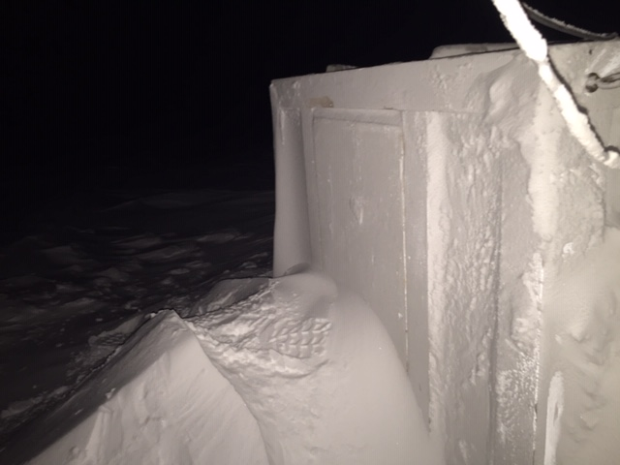 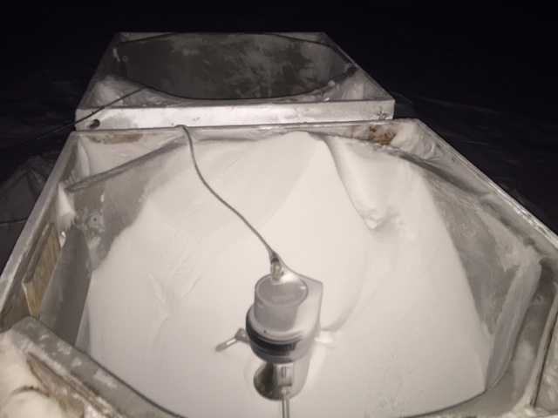

*2020-01-12 1152Z: SODAR heavy drifting (above, left) at the north dish front door, (above, right) facing north looking into south dish, and (below) looking into south dish front door. Lots of shoveling occurred.*

