**ICECAPS-ACE Weekly Report**

January 13-19, 2020

Jess Ackerman

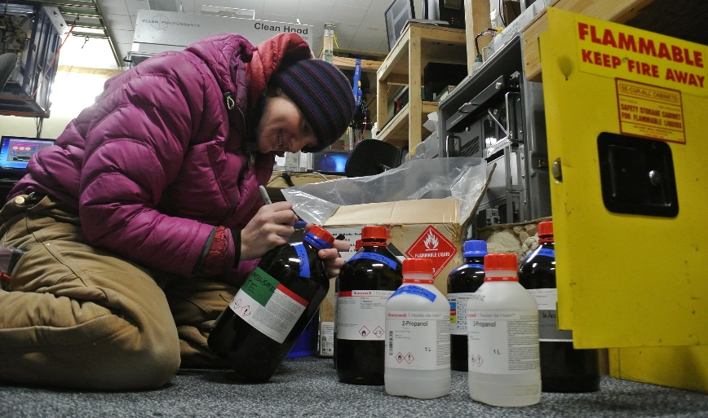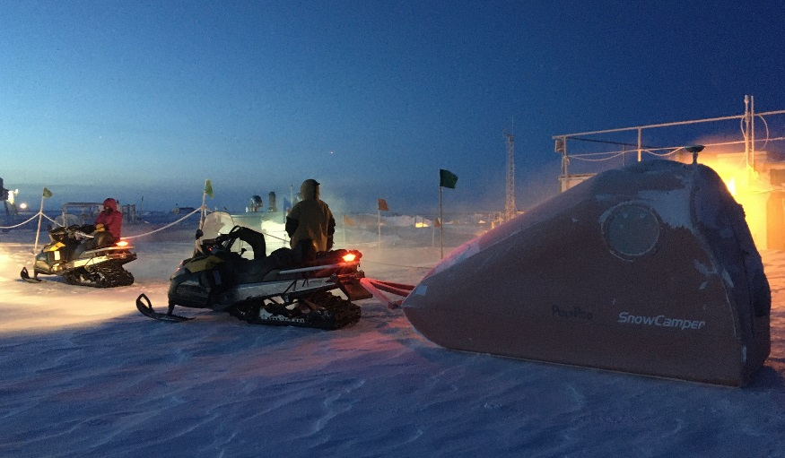

*Left: ICECAPS Tech Jess completing inventory on the MSF flammable storage cabinet.*

*Right: 2020-01-14 Loading up for the ICESAT Traverse.*

**General Notes:**

Our big and satisfying success this week was completing the January ICESAT Traverse on 01-14.

Productive collaboration and troubleshooting occurred with the CPC, CLASP, Swiss Tower instrument suite, Radiosonde Vaisala, and MMCR. The final day of the week brought high winds and poor visibility which continues to add to the demands of shoveling and drift maintenance around camp.

**General Weather Observations:**

|  |  |  |  |  |  |  |  |
| --- | --- | --- | --- | --- | --- | --- | --- |
| **Date** | **Time (Z)** | **Wind** | **Weather** | **Visibility** | **Sky** | **Temp (C)** | **Notes** |
| 01-13 | 12 | 91°, 17 kn |  | 800 | FEW148 | -46 | Stratus distant |
| 01-14 | 12 | 167°, 11 kn |  | 800 | FEW | -48 | Stratus distant |
| 01-15 | 12 | 122°, 20 kn |  | 1600 | SCT197 | -52 |  |
| 01-16 | 12 | 136°, 17 kn |  | 800 | OVC016 | -42 | Stratus |
| 01-17 | 12 | 131°, 25 kn | BLSN, FZFG | 500 | OVC016 | -33 |  |
| 01-18 | 12 | 190°, 10 kn |  | 800 | FEW | -51 |  |
| 01-19 | 12 | 124°, 34 kn | BLSN | 50 | OVC000 | -33 |  |

**Significant Weather Observations:**

* 2020-01-17 1244Z: Rave Ice
* 2020-01-19 1914Z: Rave Ice

**MSF**

* 2020-01-15: Swiss Tower weekly data download unable to be completed due to connectivity issues. PI notified.
* 2020-01-15: Swiss Tower computer diagnostics complete. Waiting for a warmer weather window to reinstall outside at tower as first attempt failed likely due to extreme temperature gradient.
* 2020-01-16: Swiss Tower WLAN antenna secured at tower site.
* Operating normally.

**ICECAPS-ACE Data Management:**

* 01-13: Stop ArchieveToBoulder at 1239Z.
* 01-14: Stop ArchieveToBoulder at 1237Z.
* 01-15: Stop ArchieveToBoulder at 1239Z.
* 01-16: Stop ArchieveToBoulder at 1642Z.
* 01-17: Stop ArchieveToBoulder at 1345Z.
* 01-18: Stop ArchieveToBoulder at 1115Z.
* 01-19: Stop ArchieveToBoulder at 2302Z.

**TSI:**

* Offline for winter season.

**Radiosonde:**

* 2020-01-13: Currently troubleshooting Vaisala connectivity issues with PI since 01-12. No launches 01-13. Last successful launch was 01-14 AM.
* 2020-01-13: Radiosonde cabinet exterior filter changed. Next scheduled change 2020-03-01.
* 2020-01-17: Troubleshooting continues with PI and manufacturer.
* See charts below for temperatures outside and inside the radiosonde cabinet over the last week. (apparently the battery died on the Radiosonde Base temp logger resulting in limited data)

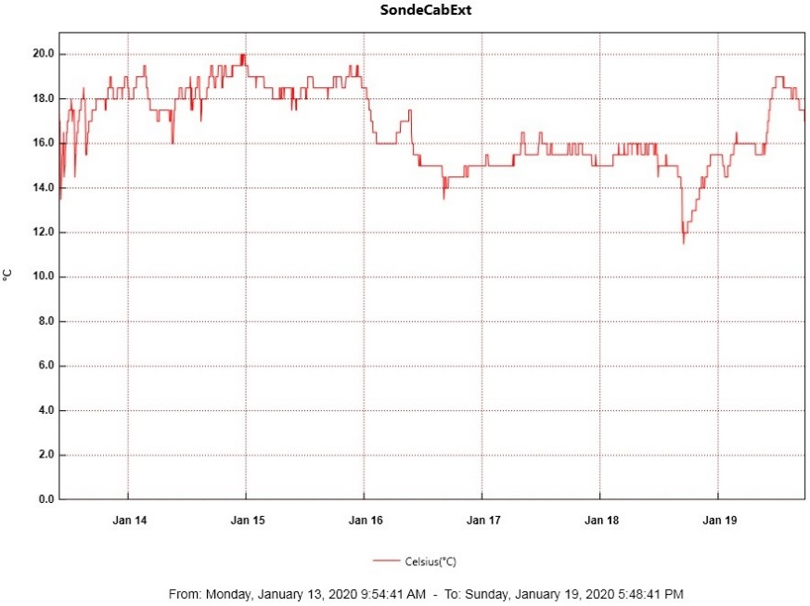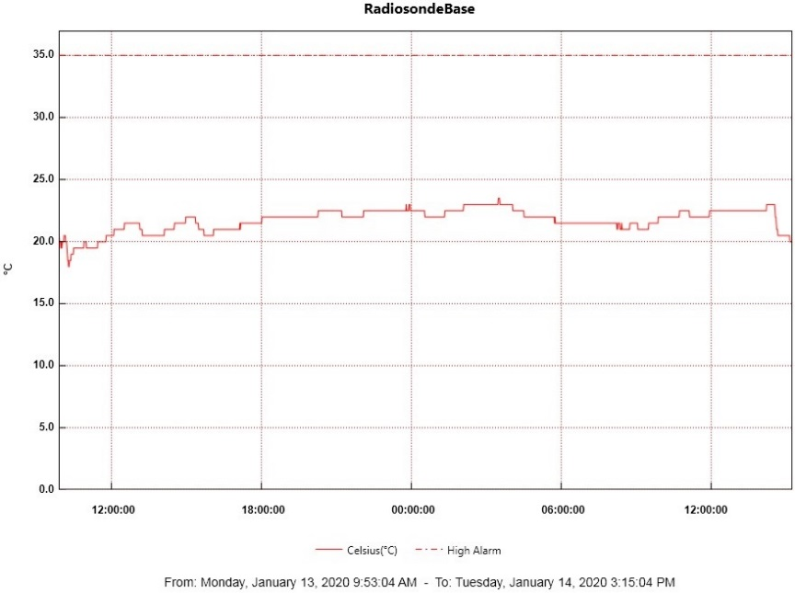

**MWR:**

* 2020-01-13: Awaiting a decent weather window to bring the HATPRO MWR inside for more diagnostic checks. Prep work continues for this operation. The 90-150 is doing well.

**SODAR:**

* 2020-01-19 1934Z: Poor data noted but too windy to clean.

**POSS:**

* Operating normally.

**MASC:**

* Offline for winter season.

**MMCR:**

* FYI, spc files on external hard drive are approx 63%. Another back-up transfer needed?
* 2020-01-14: Persistent NetCDF_Mom and NetCDF_Spec errors. Cleared 3x.
* 2020-01-15: Rebooted 3x. All is well as of 1705Z.
* 2020-01-15: Desiccants filters successfully recharged and sealed for next use.

**CAPABL:**

* Operating normally.

**MPL:**

* 2020-01-16 1503-1525Z: Monthly calibration successfully completed.
* Operating normally.

**CEILOMETER:**

* 2020-01-19 1915Z: Window compartment plugged with snow and “window contaminated” error on status message due to high winds. Cleaned what I could at the time from the top of instrument.

**PAERI:**

* Operating normally.

**IceCAM:**

* Operating normally.

**IcePIC:**

* No IcePics this week.

**CLASP:**

* 2020-01-13: Currently offline and awaiting further troubleshooting. CPC has taken priority.

**CPC:**

* 2020-01-15 2015Z: Finally able to successfully get instrument into “Dryer Mode.”
* 2020-01-16 Dryer mode had stopped. Troubleshot “Please Check Condensate Plug!” alarm. Dryer Mode started again at 1400Z. Troubleshooting continues with PI.
* 2020-01-17: Dryer mode had stopped, started again at 1241Z. No plug alarm this time. No change in condensate or internal butanol levels.
* 2020-01-18: Found in Charge Mode. Powered ON, warmed up, running as of 1711Z. Data still zeros.
* 2020-01-19 1944Z: Running but data still zeros. Minimal change in internal butanol and condensate levels. Notified PI.

**MSF - OPC:**

* Operating normally.

**TAWO - OPC:**

* Operating normally.

**SKYOPC:**

* Operating normally.

**INP Freezing Assay:**

* 2020-01-15 1335Z: P/T sensor still in by-passed mode. Filter samples were successfully run, and both assay data and instrument internal data were sent to PI.

**Fluxtower instrument suite:**

* 2019-12-08: Loss of power to replaced power supply connecting instruments KT15, HMP3 (9m temperature sensor), HMP4 (15m temperature sensor), Ventus2 (9m 2D sonic), Metek2 (15m 2D sonic).

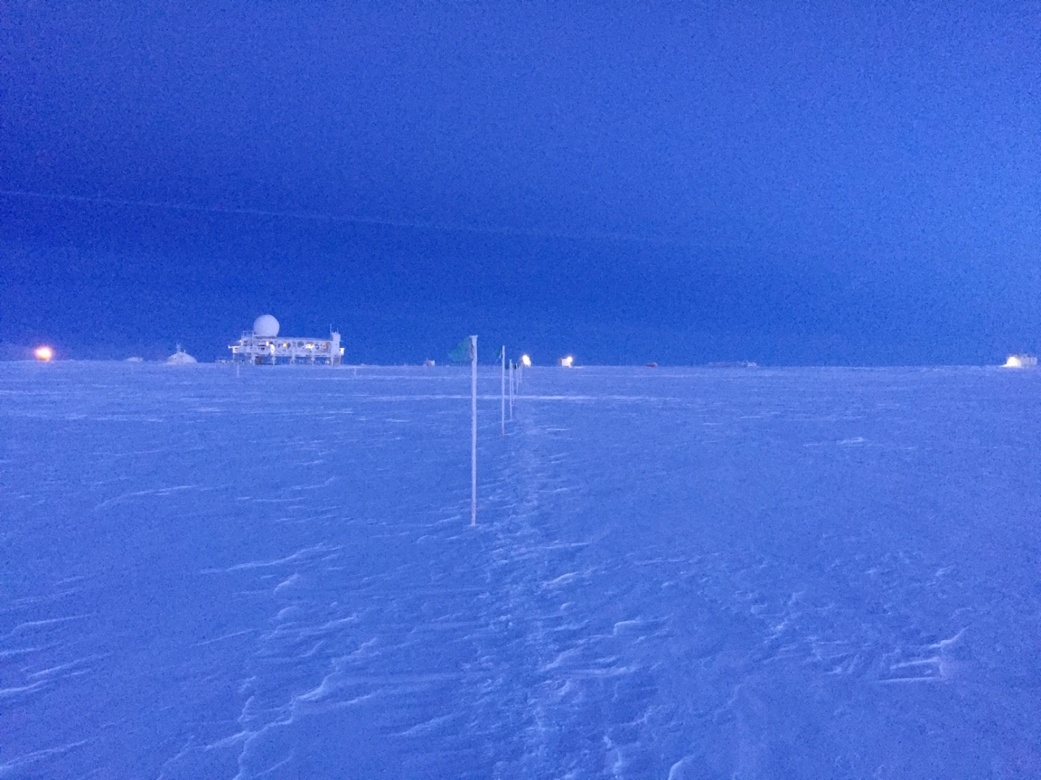

*Above: 2020-01-15 1350Z: View of Summit Station from the South while walking back from TAWO.*