**ICECAPS-ACE Weekly Report**

January 20-26, 2020

Jess Ackerman

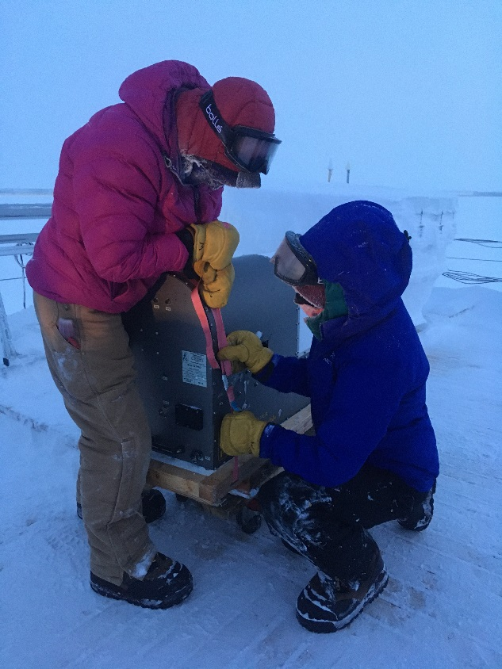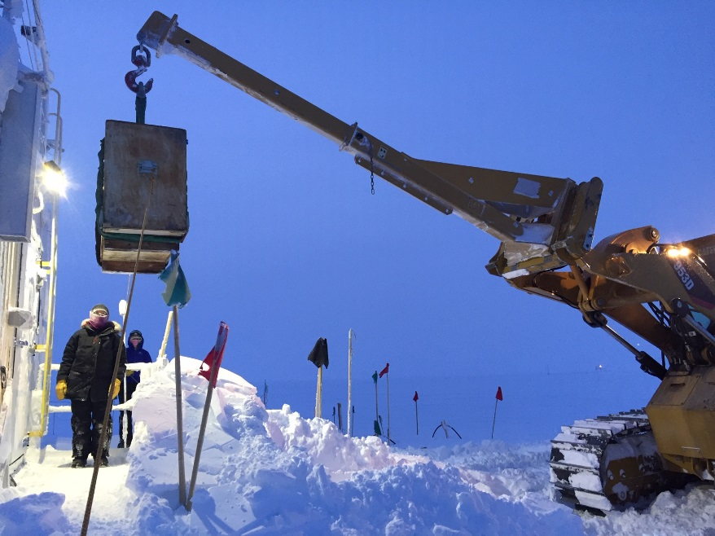

*Left: 2020-01-20 1330Z: Summit Science Techs Jess and Holly secure the HATPRO MWR to its crate base.*

*Right: 2020-01-20 1400Z: The 953 with stinger attachment lowering HATPRO MWR onto MSF front deck.*

**General Notes:**

Hallelujah! We got the HATPRO MWR off the roof safely and inside the MSF for diagnostics. BIG thanks to the entire Summit Station crew for implementing this long awaited and weather pending task. Troubleshooting for the HATPRO has been full-on this week, as well as comms with PIs regarding the Swiss Tower download connection and of course the CPC still. A gnarly rollercoaster weather pattern oscillating between high winds and deep cold spells keeps life around camp interesting and busy.

**General Weather Observations:**

|  |  |  |  |  |  |  |  |
| --- | --- | --- | --- | --- | --- | --- | --- |
| **Date** | **Time (Z)** | **Wind** | **Weather** | **Visibility** | **Sky** | **Temp (C)** | **Notes** |
| 01-20 | 12 | 163°, 6 kn |  | 800 | OVC033 | -42 |  |
| 01-21 | 12 | 189°, 9 kn |  | 800 | SCT | -55 | Cirrus |
| 01-22 | 12 | 130°, 12 kn |  | 600 | OVC016 | -34 |  |
| 01-23 | 12 | 325°, 32 kn | BLSN | 50 | OVC000 | -43 |  |
| 01-24 | 12 | 107°, 21 kn | FZFG, DRSN | 500 | SCT | -46 |  |
| 01-25 | 12 | 130°, 18 kn | FZFG | 500 | OVC115 | -44 |  |
| 01-26 | 12 | 118°, 20 kn | FZFG, DRSN | 500 | OVC | -39 |  |

**Significant Weather Observations:**

* 2020-01-25 1300Z: Rave Ice

**MSF**

* 2020-01-20 1219-1415Z: Heavy Equipment operating near MSF. Noted in instrument logs.
* 2020-01-20 1504Z: Swiss Tower computer re-installation at tower complete. Case closed.
* 2020-01-21: Swiss Tower weekly data download connection still not functioning. Continued troubleshooting with PI this week.
* 2020-01-23: Swiss CR23X rebooted. Data connection re-established. Possible 2-week data loss.
* 2020-01-23: Continued monitoring and adjusting MSF indoor and vestibule temp fluctuations.

**ICECAPS-ACE Data Management:**

* 01-20: Stop ArchieveToBoulder at 1052Z.
* 01-21: Stop ArchieveToBoulder at 1122Z.
* 01-22: Stop ArchieveToBoulder at 1146Z.
* 01-23: Stop ArchieveToBoulder at 1438Z.
* 01-24: Stop ArchieveToBoulder at 1204Z.
* 01-25: Stop ArchieveToBoulder at 1329Z.
* 01-26: Stop ArchieveToBoulder at 1136Z.

**TSI:**

* Offline for winter season.

**Radiosonde:**

* 2020-01-21: Offline and waiting for MPR111 card replacement. Logistics in progress with PI.
* 2020-01-25: Radiosonde blue table cover scrubbed in shower. White plastic covering replaced.
* See charts below for temperatures outside and inside the radiosonde cabinet over the last week. (Missing first 24 hours of data for Radiosonde Base due to battery replacement.)

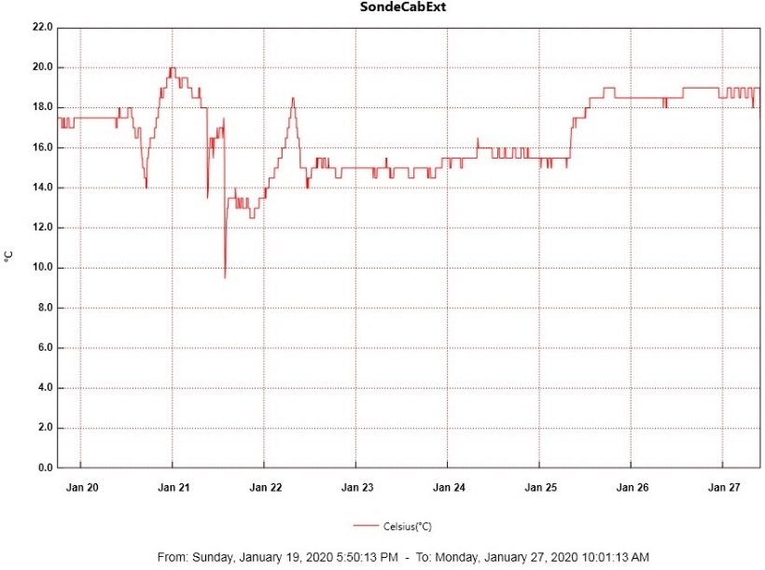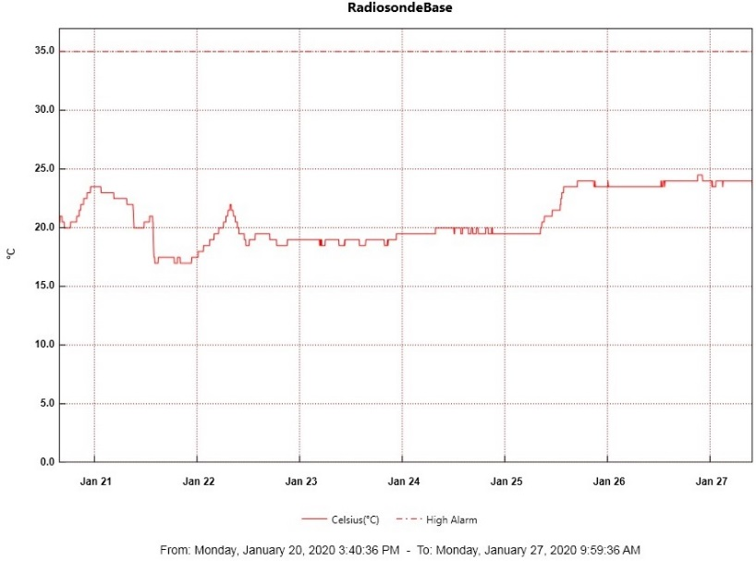

* Monthly picture update of radiosonde cabinet exterior filter. Next scheduled change 2020-03-01.

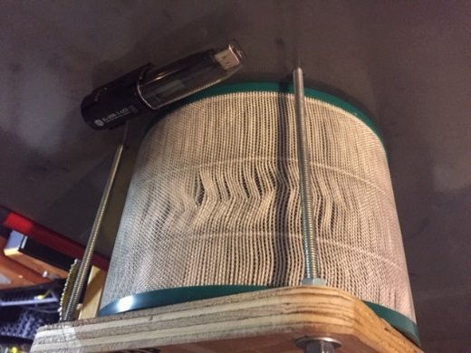

**MWR:**

* 2020-01-20 1430Z: HATPRO finally inside MSF.
* 2020-01-21: Retrieved HATPRO power and signal cable from roof through wall.
* 2020-01-22: HATPRO plugged in and extensive troubleshooting with PI throughout the week. 150-90 MWR offline intermittently from 1657-1921Z for HATPRO testing. PI now has remote access.
* 2020-01-23 & 24: Troubleshooting with PI and manufacturer continue.

**SODAR:**

* 2020-01-20 1640-1704Z: SODAR cleaned.
* 2020-01-23 1300Z: Poor data noted but too windy to clean.
* 2020-01-25 1415-1438Z: SODAR cleaned.

**POSS:**

* Operating normally.

**MASC:**

* Offline for winter season.

**MMCR:**

* Operating normally.

**CAPABL:**

* Operating normally.

**MPL:**

* Operating normally.

**CEILOMETER:**

* Operating normally.

**PAERI:**

* 2020-01-23: Red receptivity flags since 2000Z night before. Cleaned mirror at 1242Z. Cleaned cover, shoot, and mirror extensively at 1521-1532Z. Flags persisted due to poor weather. Monitoring with PI.
* 2020-01-24: Flags cleared at 0500Z.

**IceCAM:**

* Operating normally.

**IcePIC:**

* No IcePics this week.

**CLASP:**

* 2020-01-20: Currently offline and awaiting further troubleshooting. CPC has taken priority.

**CPC:**

* 2020-01-22: Instrument is slowing drying out as desired. Internal butanol levels continue to slowly decrease. Inlet air flow measured and confirmed functional. Continued troubleshooting with PI.

**MSF - OPC:**

* Operating normally.

**TAWO - OPC:**

* Operating normally.

**SKYOPC:**

* Operating normally.

**INP Freezing Assay:**

* 2020-01-21: Inspected clean hood pre-filter = good. Next cold stage autocalibration planned for turnover week 02-11 with incoming tech.
* 2020-01-22 1336Z: P/T sensor still in by-passed mode. Filter samples were successfully run, and both assay data and internal instrument data were sent to PI.

**Fluxtower instrument suite:**

* 2019-12-08: Loss of power to replaced power supply connecting instruments KT15, HMP3 (9m temperature sensor), HMP4 (15m temperature sensor), Ventus2 (9m 2D sonic), Metek2 (15m 2D sonic).
* 2020-01-23: Tested whether a jumper would restore power to the failed power supply and was not successful.

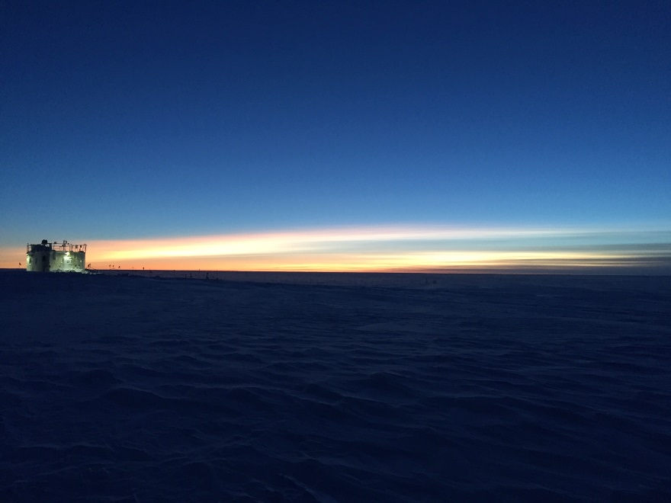

*Above: 2020-01-21 1224Z: MSF twilight. Eagerly awaiting our next sunrise scheduled January 29!*