**ICECAPS-ACE Weekly Report**

January 27 – February 2, 2020

Jess Ackerman

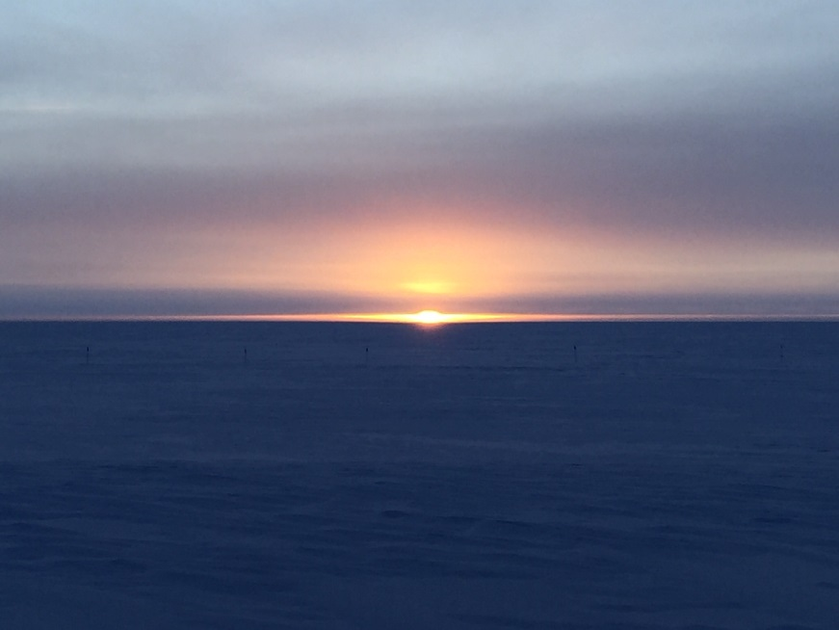

*Left: 2020-01-30 1355Z: The sun is back and we are glad!*

*Right: 2020-01-29 1351Z: ICECAPS tech Jess walking in the white abyss from TAWO to MSF.*

**General Notes:**

Our big news this week is the “big ball of light” is back in our lives and we couldn’t be happier! Started preparing to pack up the HATPRO to be shipped off for repairs the first turnover flight 2020-02-06. The CPC troubleshooting is ongoing. Preparing to have our Summit Station population more than double in less than a week for turnover. Accomplished lots of end of season tasking and reporting.

**General Weather Observations:**

|  |  |  |  |  |  |  |  |
| --- | --- | --- | --- | --- | --- | --- | --- |
| **Date** | **Time (Z)** | **Wind** | **Weather** | **Visibility** | **Sky** | **Temp (C)** | **Notes** |
| 01-27 | 12 | 116°, 25 kn | FZFG, BLSN | 300 | SCT148 | -37 |  |
| 01-28 | 12 | 141°, 19 kn | FZFG, DRSN | 600 | SCT115 | -39 |  |
| 01-29 | 12 | 168°, 15 kn | FZFG, DRSN | 600 | FEW033, SCT131 | -40 |  |
| 01-30 | 12 | 185°, 13 kn | FZFG | 600 | BKN049 | -39 |  |
| 01-31 | 12 | 180°, 16 kn |  | 1600 | FEW | -47 |  |
| 02-01 | 12 | 201°, 14 kn |  | 500 | OVC049 | -42 |  |
| 02-02 | 12 | 222°, 14 kn | FZFG | 400 | OVC098 | -40 |  |

**Significant Weather Observations:**

* No significant weather this week.

**MSF**

* Operating normally.

**ICECAPS-ACE Data Management:**

* 01-27: Stop ArchieveToBoulder at 1148Z.
* 01-28: Stop ArchieveToBoulder at 1414Z.
* 01-29: Stop ArchieveToBoulder at 1157Z.
* 01-30: Stop ArchieveToBoulder at 1439Z.
* 01-31: Stop ArchieveToBoulder at 1151Z.
* 02-01: Stop ArchieveToBoulder at 1059Z.
* 02-02: Stop ArchieveToBoulder at 1153Z.

**TSI:**

* Offline for winter season.

**Radiosonde:**

* 2020-01-28: Offline and waiting for MPR111 card replacement at turnover.
* See charts below for temperatures outside and inside the radiosonde cabinet over the last week.

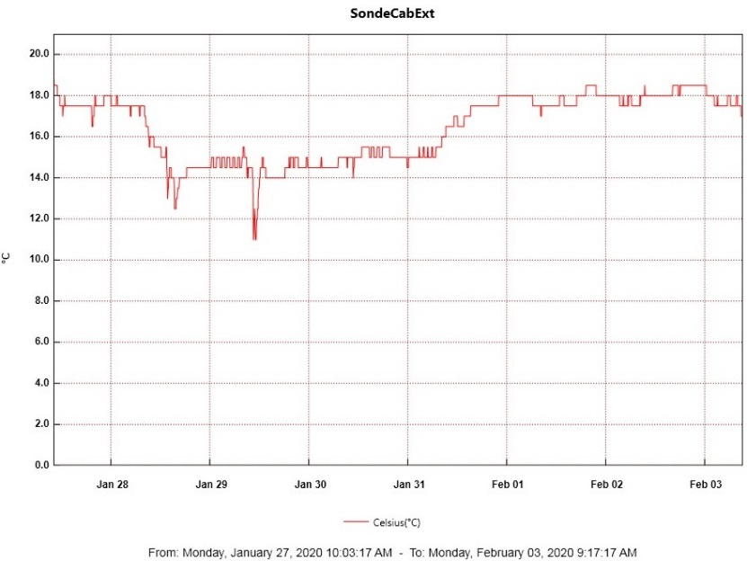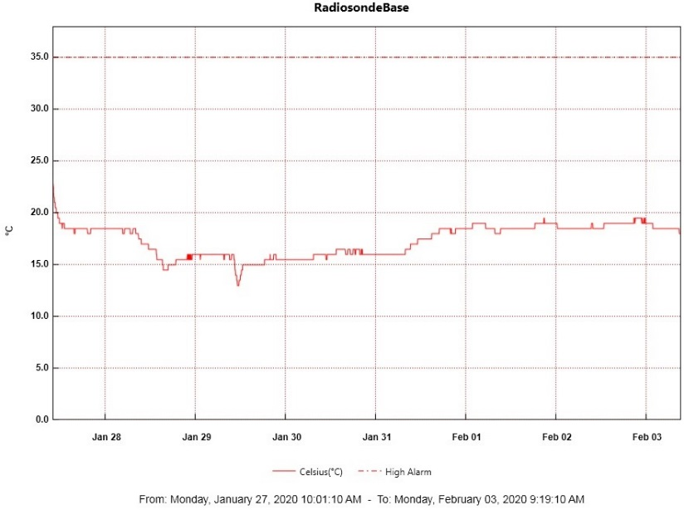

**MWR:**

* 2020-01-28: Preparing to package up the HATPRO and sent it off station for repairs on the first turnover flight 2020-02-06. The 150-90 seems to be running smooth.

**SODAR:**

* 2020-01-30 1442-1502Z: SODAR cleaned.
* Operating normally.

**POSS:**

* Operating normally.

**MASC:**

* Offline for winter season.

**MMCR:**

* Operating normally.

**CAPABL:**

* Operating normally.

**MPL:**

* Operating normally.

**CEILOMETER:**

* Operating normally.

**PAERI:**

* 2020-02-01 0200-0800Z: Red responsivity flags present, cleared itself.

**IceCAM:**

* Operating normally.

**IcePIC:**

* 2020-02-01: IcePICs optics cleaned.

**CLASP:**

* 2020-01-27: Currently offline and awaiting further troubleshooting.
* 2020-01-31: Planning to send out for repairs on 2nd turnover flight 02-14.

**CPC:**

* 2020-01-27: Instrument is slowing drying out as desired. Internal butanol levels continue to steadily decrease. Continued troubleshooting with PI.
* 2020-01-30 1430Z: Carbon filter changed.
* 2020-01-31: Extensive diagnostics with PI, good progress. Exposed saturator sensor and felt.

**MSF - OPC:**

* Operating normally.

**TAWO - OPC:**

* Operating normally.

**SKYOPC:**

* Operating normally.

**INP Freezing Assay:**

* 2020-01-29 1337Z: P/T sensor still in by-passed mode. Filter samples were successfully run, and both assay data and internal instrument data were sent to PI.

**Fluxtower instrument suite:**

* 2019-12-08: Loss of power to replaced power supply connecting instruments KT15, HMP3 (9m temperature sensor), HMP4 (15m temperature sensor), Ventus2 (9m 2D sonic), Metek2 (15m 2D sonic).