**ICECAPS-ACE Weekly Report**

February 3-9, 2020

Jess Ackerman

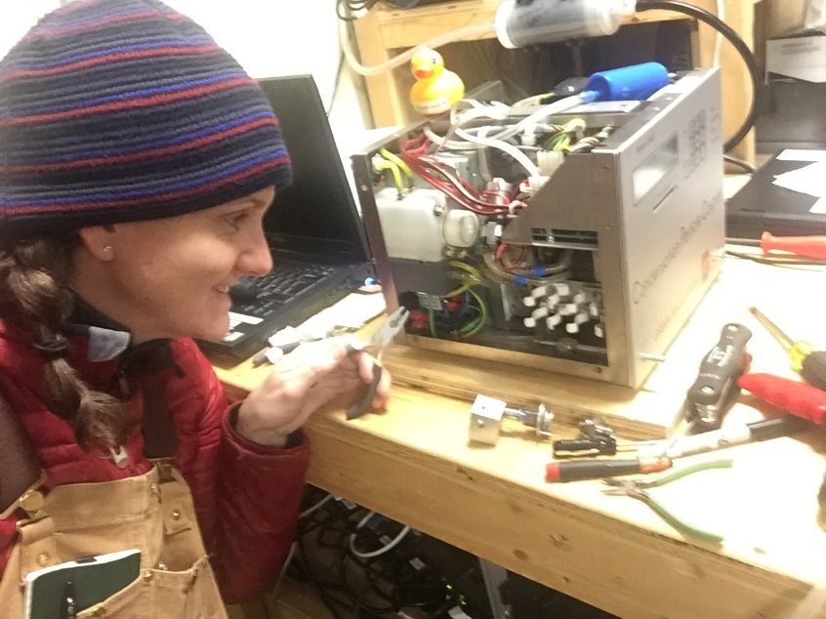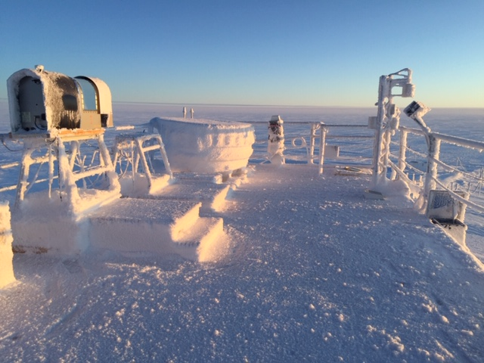

*Left: 2020-02-07: ICECAPS Tech Jess diving into the CPC troubleshooting. Progress was made!*

*Right: 2020-02-04 1356Z: A sunny, yukimarimo-filled morning on the MSF rooftop.*

**General Notes:**

The first turnover flight was schedule to arrive Thursday 2020-02-06, but 35 knot winds put a stop to that. The replacement crew has a couple of ill people so it was determined to wait until Monday 2020-02-10 at the earliest to try again. This week brought “warmer” but windy weather, and on the calmer days the temp dipped significantly. The MWR was successfully packed up and staged in the SMG for the upcoming flight. The Dataman RAID hard drives were successfully switched out. CPC troubleshooting continues and its fate is yet to be determined.

**General Weather Observations:**

|  |  |  |  |  |  |  |  |
| --- | --- | --- | --- | --- | --- | --- | --- |
| **Date** | **Time (Z)** | **Wind** | **Weather** | **Visibility** | **Sky** | **Temp (C)** | **Notes** |
| 02-03 | 12 | 237°, 12 kn | FZFG | 700 | BKN016 | -46 |  |
| 02-04 | 12 | 162°, 11 kn |  | 1600 | FEW | -52 |  |
| 02-05 | 12 | 202°, 12 kn | FZFG | 500 | OVC008 | -36 |  |
| 02-06 | 12 | 123°, 35 kn | BLSN | 50 | OVC000 | -28 |  |
| 02-07 | 12 | 206°, 17 kn | DRSN | 500 | OVC008 | -39 |  |
| 02-08 | 12 | 102°, 25 kn | BLSN | 25 | OVC000 | -26 |  |
| 02-09 | 12 | 70°, 13 kn |  | 800 | OVC016 | -33 | Northwinds |

**Significant Weather Observations:**

* No significant weather this week.

**MSF**

* Operating normally.

**ICECAPS-ACE Data Management:**

* 02-03: Stop ArchieveToBoulder at 1211Z.
* 02-04: Stop ArchieveToBoulder at 1419Z.
* 02-05: Stop ArchieveToBoulder at 1228Z. First RAID hard drive swap completed.
* 02-06: Stop ArchieveToBoulder at 0351Z. (inaccurate time?) Second RAID hard drive swap completed.
* 02-07: Stop ArchieveToBoulder at 0037Z on 8th. (inaccurate time?) Permission Denied errors. Notified PI.
* 02-08: Stop ArchieveToBoulder at 1128Z. Permission Denied errors persist. Data appears to have sent.
* 02-09: Stop ArchieveToBoulder at 1216Z. Permission Denied errors persist. Data appears to have sent.

**TSI:**

* Offline for winter season.

**Radiosonde:**

* 2020-02-07: Awaiting the arrival of the replacement MRP111 card on the next flight.
* See chart below for temperatures inside the radiosonde cabinet over the last week. (The cabinet exterior temp logger did not collect more than 1 minute of data for unknown reasons, not shown.)

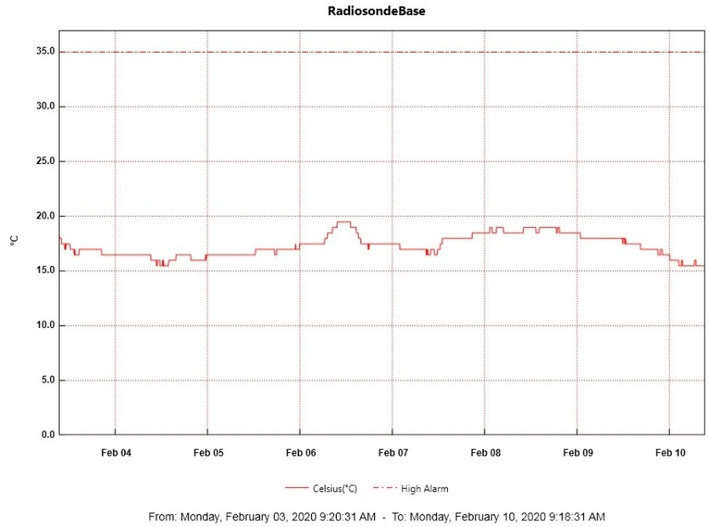

**MWR:**

* 2020-02-07: HATPRO MWR to be sent out for repairs on the next flight. The 150-90 is online.

**SODAR:**

* 2020-02-07 1345-1411Z: SODAR cleaned.
* Operating normally.

**POSS:**

* Operating normally.

**MASC:**

* Offline for winter season.

**MMCR:**

* Operating normally.

**CAPABL:**

* Operating normally.

**MPL:**

* Operating normally.

**CEILOMETER:**

* 2020-02-06 1640Z: Window contamination error due to extreme weather.
* 2020-02-07 1223Z: Window cleared; error cleared.

**PAERI:**

* 2020-02-06 1629Z: Outside fan unplugged itself in high winds. Waited to remove fan until weather improved.
* 2020-02-07 1256Z: Brought fan inside to defrost. Attempted to clear snow at base of shoot from rooftop (unsafe drifting at base). Cleaned mirror at 1256-1257Z. Fan returned at 1417Z. Added Velcro to secure power cord connection.

**IceCAM:**

* Operating normally.

**IcePIC:**

* No IcePICs this week.

**CLASP:**

* 2020-02-07: Awaiting its fate, TBD by plan of action for CPC.

**CPC:**

* 2020-02-07: Troubleshooting continues, TBD if needs to be sent out for repairs.

**MSF - OPC:**

* Operating normally.

**TAWO - OPC:**

* 2020-02-05 to 2020-2-07: TAWO OPC offline possibly due to higher winds shifting the cable connection to the instrument. Repositioned the cable on the 7th and re-established data connection.

**SKYOPC:**

* Operating normally.

**INP Freezing Assay:**

* 2020-02-05 1338Z: P/T sensor still in by-passed mode. Filter samples were successfully run, and both assay data and internal instrument data were sent to PI.

**Fluxtower instrument suite:**

* 2019-12-08: Loss of power to replaced power supply connecting instruments KT15, HMP3 (9m temperature sensor), HMP4 (15m temperature sensor), Ventus2 (9m 2D sonic), Metek2 (15m 2D sonic).