**ICECAPS-ACE Weekly Report**

February 10-16, 2020

Jess Ackerman

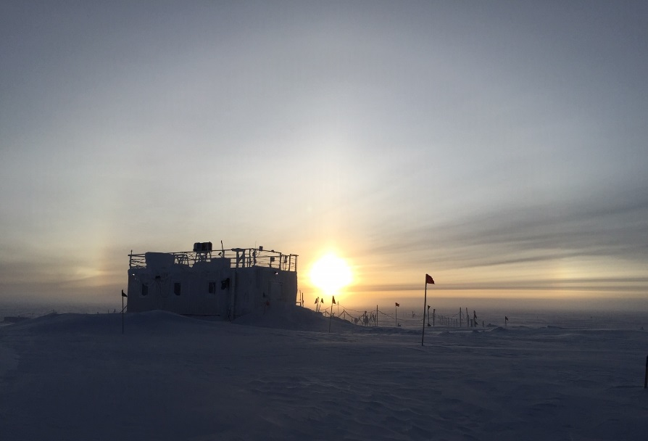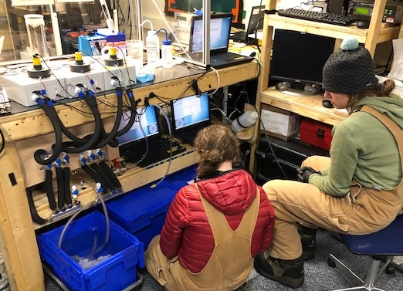

*Left: 2020-02-15 1257Z: MSF wrapped in a sundog.*

*Right: 2020-02-12: ICECAPS Tech Jess teaching incoming TAWO Tech Mara about the INP experiment.*

**General Notes:**

Our first turnover flight arrived 2020-02-11. It was a wonderful reunion and Summit has been in full-on turnover mode ever since. The incoming crew is acclimatizing well, but 2 members were quite ill and stayed behind in Iceland to heal before coming to elevation. One of them being the incoming ICECAPS Tech Nate, so we’ll have a “high-five turnover” early this coming week. The ICESat Traverse was successfully completed on 2020-02-10. The MRP111 card was successfully replaced in the Vaisala radiosonde equipment and our first balloon launch occurred 2020-02-13 PM. Fabulous troubleshooting and progress occurred with the CPC this week. Data collection was resumed and spirits were high!

**General Weather Observations:**

|  |  |  |  |  |  |  |  |
| --- | --- | --- | --- | --- | --- | --- | --- |
| **Date** | **Time (Z)** | **Wind** | **Weather** | **Visibility** | **Sky** | **Temp (C)** | **Notes** |
| 02-10 | 12 | 96°, 14 kn |  | 1600 | BKN016 | -36 |  |
| 02-11 | 12 | Variable°, 1 kn |  | 4000 | FEW049 | -46 | Cirrus |
| 02-12 | 12 | 109°, 14 kn |  | 3200 | BKN098 | -49 | Cirrus |
| 02-13 | 12 | 253°, 9 kn |  | 1600 | SCT164 | -47 |  |
| 02-14 | 12 | 97°, 18 kn | FZFG | 800 | BKN164 | -46 |  |
| 02-15 | 12 | 124°, 20 kn | FZFG, DRSN | 800 | SCT082 | -42 |  |
| 02-16 | 12 | 92°, 16 kn | FZFG | 800 | BKN115 | -46 |  |

**Significant Weather Observations:**

* No significant weather this week.

**MSF**

* 2020-02-11 1513-1559Z: Flight ops noted in instrument logs.
* 2020-02-14: Sam completed lots of reorganization of tech supplies and improvements at MSF.
* Operating normally.

**ICECAPS-ACE Data Management:**

* 02-10: Stop ArchieveToBoulder at 1156Z.
* 02-11: Stop ArchieveToBoulder at 1142Z.
* 02-12: Stop ArchieveToBoulder at 1426Z.
* 02-13: Stop ArchieveToBoulder at 1704Z.
* 02-14: Stop ArchieveToBoulder at 1443Z
* 02-15: Stop ArchieveToBoulder at 1243Z.
* 02-16: Stop ArchieveToBoulder: still not completed by 1615Z when report sent.

**TSI:**

* Offline for winter season.

**Radiosonde:**

* 2020-02-13 2315Z: Successful replacement of MRP111 card and software reconfiguration resulted in our first balloon launch. Twice daily launches are back on schedule.
* See charts below for temperatures inside and outside the radiosonde cabinet over the last week.

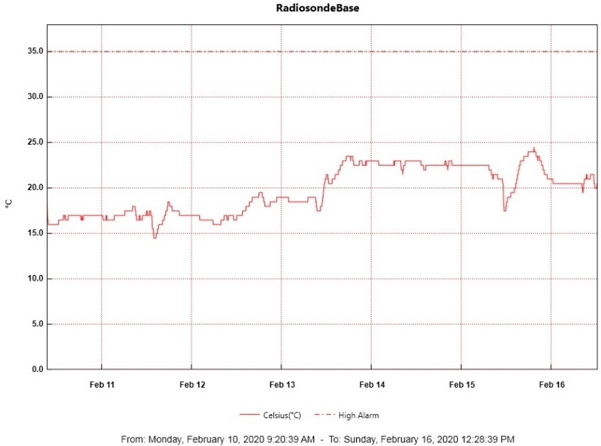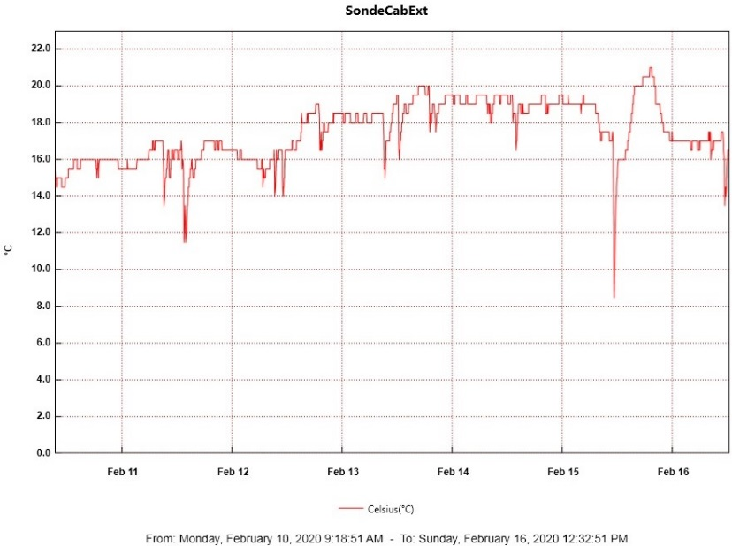

**MWR:**

* 2020-02-11: The HATPRO MWR was successfully sent out for repairs. The 150-90 is online.

**SODAR:**

* 2020-02-13 1732-1808Z: SODAR cleaned and drift maintenance completed.
* Operating normally.

**POSS:**

* Operating normally.

**MASC:**

* Offline for winter season.

**MMCR:**

* Operating normally.

**CAPABL:**

* 2020-02-11 1254-1303Z: Offline briefly for laser window cleaning.
* Operating normally.

**MPL:**

* 2020-02-14 1514-1536Z: Monthly calibration completed.
* Operating normally.

**CEILOMETER:**

* Operating normally.

**PAERI:**

* 2020-02-13 1245Z: Red responsivity and HBB flags noted since 0100Z. Mirror and shoot all clear. Mirror cover rotating abnormally and not lining up properly. PI notified. Self-reboot ~1900Z. All was well.

**IceCAM:**

* Operating normally.

**IcePIC:**

* No IcePICs this week.

**CLASP:**

* 2020-02-14: Offline and removed.

**CPC:**

* 2020-02-13: Cleaning of sensor head and felt tube; reassembly unsuccessful due to broken connector.
* 2020-02-14: Connector bypassed and hole patched. Reassembled and warm-up started at 1347Z. Inlet filter test and Velcro test completed, outside air reconnected to sample inlet, external butanol reservoir reconnected, and data collection started at 1538Z. Huge success!

**MSF - OPC:**

* Operating normally.

**TAWO - OPC:**

* Operating normally.

**SKYOPC:**

* Operating normally.

**INP Freezing Assay:**

* 2020-02-11 1320-1415Z: Cold stage calibrations completed and data sent to PI.
* 2020-02-12 1341Z: Weekly experiment was successfully completed and taught to incoming TAWO tech. Assay data and internal instrument data were sent to PI. P/T sensor still in by-passed mode.

**Fluxtower instrument suite:**

* 2019-12-08: Loss of power to replaced power supply connecting instruments KT15, HMP3 (9m temperature sensor), HMP4 (15m temperature sensor), Ventus2 (9m 2D sonic), Metek2 (15m 2D sonic).
* 2020-02-15: LiCOR instrument not logging data as of 02-14; PI contacted and troubleshooting ongoing.

*Thanks everyone for a great winter season at Summit! I really enjoyed working with you all and learned so much. I super appreciate everyone’s responsiveness and support. It’s been an honor to be apart of the ICECAPS program and something I will never forget. Sorry the timing didn’t work out to say a proper farewell on an ICECAPS conference call. No doubt Nate will transition with ease into this role. Please keep up your awesomeness and strength as a team contributing to invaluable science!*

*Best wishes,*

*Jess Ackerman*

*ICECAPS Technician*

*Winter 2019-2020*