**ICECAPS-ACE Weekly Report**

February 17-23, 2020

Nate Bowker

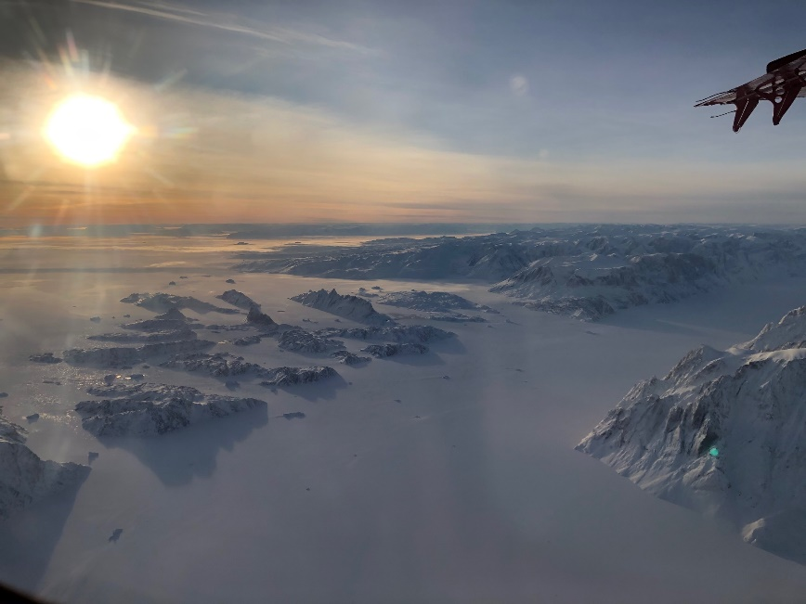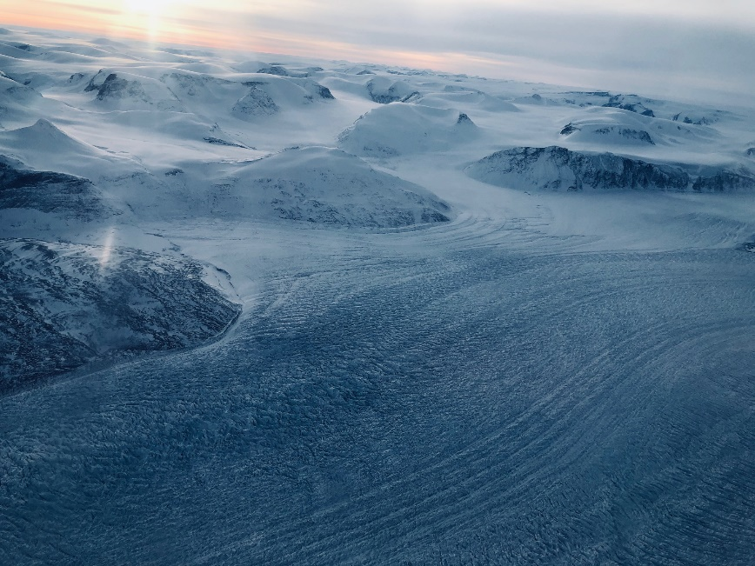

*East Greenland icescapes. Photos: Nate Bowker*

**General Notes:**

The winter crew departed on Monday 2020-02-17, and the last two members of the spring crew arrived on station. This week’s focus has been on acclimatization and getting settled back into work and life at Summit Station for the spring crew.

**General Weather Observations:**

|  |  |  |  |  |  |  |  |
| --- | --- | --- | --- | --- | --- | --- | --- |
| **Date** | **Time (Z)** | **Wind** | **Weather** | **Visibility** | **Sky** | **Temp (C)** | **Notes** |
| 02-17 | 12 | 12kt from 180 | BR | 4800 | FEW140 FEW230 | -41 |  |
| 02-18 | 12 | 10kt from 220 | FZFG | 400 | FEW130 | -44 |  |
| 02-19 | 12 | 11kt from 080 | BR | 4800 | FEW110 | -48 |  |
| 02-20 | 12 | 16kt from 096 | BR | 3200 | FEW032 FEW096 | -51 |  |
| 02-21 | 12 | 11kt from 195 | BR | 4800 | BKN016 | -53 |  |
| 02-22 | 12 | 13kt from 312 |  | 9999 | FEW096 | -52 |  |
| 02-23 | 12 | 5kt from 314 | BR | 4800 | FEW128 | -48 |  |

**Significant Weather Observations:**

* No significant weather this week.

**MSF**

* The roof needs a cleaning presently, but otherwise the MSF is in great shape.

**ICECAPS-ACE Data Management:**

* 02-16: Stop ArchieveToBoulder at 1629Z. (Missed on previous report due to turnover.)
* 02-17: Stop ArchieveToBoulder at 1503Z.
* 02-18: Stop ArchieveToBoulder at 1548Z.
* 02-19: Stop ArchieveToBoulder at 1226Z.
* 02-20: Stop ArchieveToBoulder at 1259Z.
* 02-21: Stop ArchieveToBoulder at 1302Z.
* 02-22: Stop ArchieveToBoulder at 1344Z.
* 02-23: Stop ArchieveToBoulder at 1439Z.

**TSI:**

* Offline for winter season.

**Radiosonde:**

* Very cold temps this week have resulted in generally low burst altitudes. Average burst altitude for this week = 15833.5m, with burst altitudes ranging from 12187m on 2/23 to 21371m on 2/19.
* See charts below for temperatures inside and outside the radiosonde cabinet over the last week.

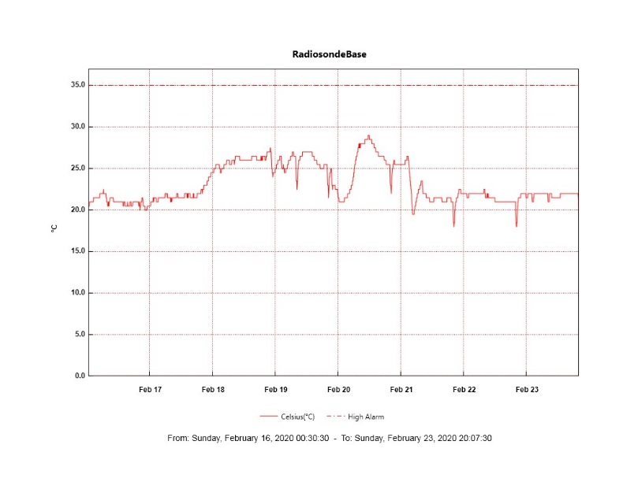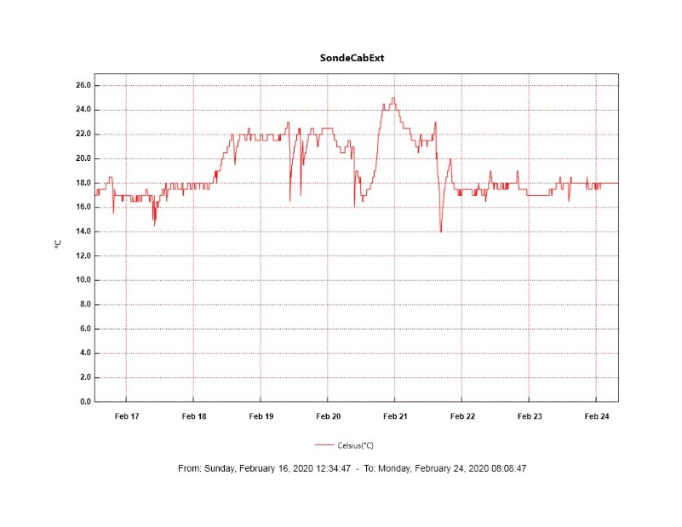

**MWR:**

* HATPRO offsite for repairs. 150-90 online and operating normally.

**SODAR:**

* Operating normally.

**POSS:**

* Operating normally.

**MASC:**

* Offline for winter season.

**MMCR:**

* 2020-02-17 1230Z: MMCR hung up with DwellControl_Calibration error. Cleared on 2020-02-18. No errors have occurred since.
* Operating normally.

**CAPABL:**

* 2020-02-19 ~2000Z: CAPABL’s computer crashed and hung on reboot with the error “disk boot failure”. Power cycled computer to restart cleanly, then had to perform a full restart of all components in order to get the LabView software to run without crashing.
* Operating normally.

**MPL:**

* Operating normally.

**CEILOMETER:**

* Operating normally.

**PAERI:**

* 2020-02-22 ~1800Z: Found that the PAERI fan enclosure was loose in its mounting track and had managed to vibrate itself away from the building and instrument enclosure several inches such that the fan was no longer blowing air through the enclosure. Pushed the fan back in and installed two wood shims to take up the play in the enclosure and hold it firmly in place.

**IceCAM:**

* Operating normally.

**IcePIC:**

* No IcePICs this week.

**CLASP:**

* Offline

**CPC:**

* 2020-02-23 ~1840Z: Instrument went down and is fully unresponsive. The issue appears to be electrical and internal to the instrument, such as a blown fuse. More investigation is necessary and will be forthcoming.

**MSF - OPC:**

* 2020-02-20 ~1400Z: Found sample inlet to be fully obstructed with frost (logging only zeros for number of particle counts) and brought inside to thaw out. Upon thawing out discovered that the USB A to USB B cable had been compromised. Also found that the sample inlet was loose and that a fine white particulate was collecting near the top of the inlet where it interfaces with the instrument. Replaced USB cable, cleaned and dried the sample inlet, reassembled and reinstalled on 2020-02-22 at ~1330Z and the instrument appears to be working well.
* Operating normally.

**TAWO - OPC:**

* Operating normally.

**SKYOPC:**

* 2020-02-23: Three interesting data spikes present between 1300Z on 2/23 and 0200Z on 2/24. Having trouble correlating these anomalies with any activity on station.
* Operating normally.

**INP Freezing Assay:**

* 2020-02-19: Weekly experiment was completed. Assay data and internal instrument data were sent to PI.

**Fluxtower instrument suite:**

* New power supply is onsite and needs to be installed.
* 2020-02-17: Pressed the “reset” button inside the LiCOR instrument box and reseated the head connector. Communication restored, yet instrument outages persist due to frosty conditions.