**ICECAPS-ACE Weekly Report**

February 24 – March 1, 2020

Nate Bowker

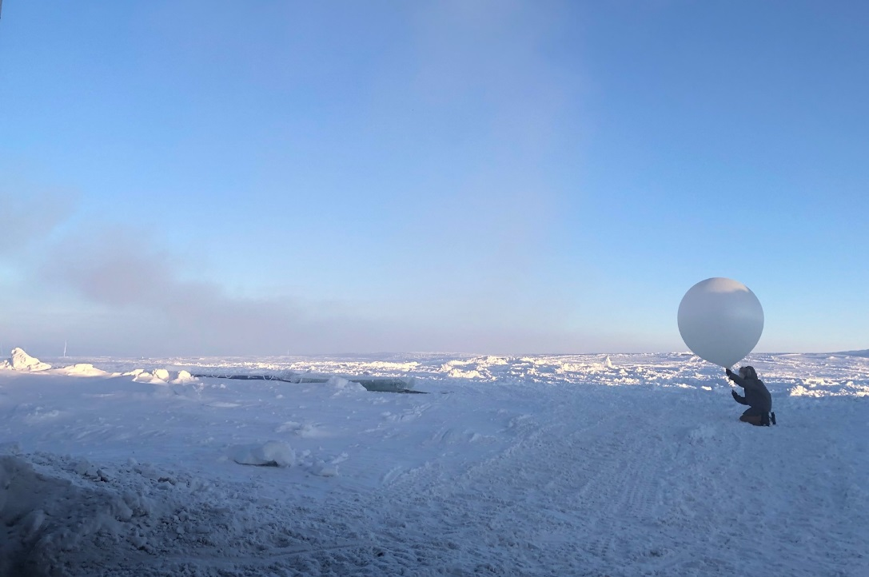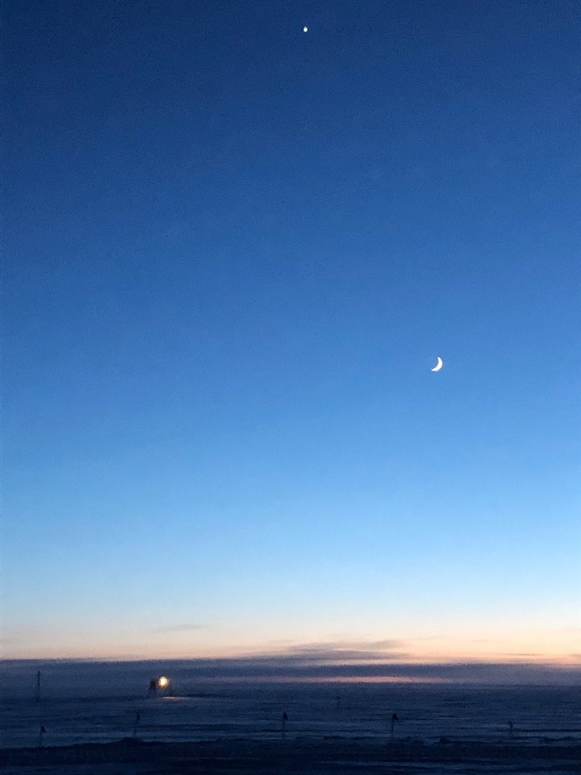

*Left: Station Manager Kathy Schroeder launching a radiosonde. Photo - Mara Menahan*

*Right: TAWO, Venus, and waxing crescent moon. Photo – Nate Bowker*

**General Notes:**

Nate is still recovering from a second round of illness, so has been operating on a reduced schedule and has been unable to tackle much outdoor work in the past week.

Big thanks to Station Manager Kathy Schroeder for taking over morning balloon launches last week to allow Nate much needed rest and recovery time.

Daylight savings occurs: in the United States on Sunday, March 8th, in Greenland and the UK on Sunday, March 29th. This means that starting next week and for the following three weeks the standard time difference between the US and the UK/Greenland will be reduced by one hour.

**General Weather Observations:**

|  |  |  |  |  |  |  |  |
| --- | --- | --- | --- | --- | --- | --- | --- |
| **Date** | **Time (Z)** | **Wind** | **Weather** | **Visibility** | **Sky** | **Temp (C)** | **Notes** |
| 02-24 | 12 | 7kt from 188 | FZFG | 500 | FEW032 | -56 |  |
| 02-25 | 12 | 4kt from 293 |  | 9999 | FEW065 | -46 | Clouds distant, height estimated |
| 02-26 | 12 | 19kt from 123 | BR | 4800 | FEW065 | -56 | Clouds distant, height estimated |
| 02-27 | 12 | 11kt from 194 |  | 9999 | FEW065 | -58 | Clouds distant, height estimated |
| 02-28 | 12 | 6kt from 207 | BR | 4000 | FEW065 | -60 | Clouds distant, height estimated |
| 02-29 | 12 | 7kt from 165 | BR | 4800 | FEW065 | -62 | Clouds distant, height estimated |
| 03-01 | 12 | 19kt from 125 | BLSN | 700 | BKN032 | -47 |  |

**Significant Weather Observations:**

* No significant weather this week.

**MSF**

* Operating normally

**ICECAPS-ACE Data Management:**

* 02-24: Stop ArchieveToBoulder at 1437Z.
* 02-25: Stop ArchieveToBoulder at 0133Z on 02-26.
* 02-26: Stop ArchieveToBoulder at 1710Z.
* 02-27: Stop ArchieveToBoulder at 1826Z.
* 02-28: Stop ArchieveToBoulder at 2214Z.
* 02-29: Stop ArchieveToBoulder at 1657Z.
* 03-01: Stop ArchieveToBoulder at 1244Z.

**TSI:**

* Offline for winter season.

**Radiosonde:**

* Summit experienced a number of days this week in which temperatures exceeded the low-end limit (-60C) of the NOAA dewpoint temperature sensor that we use for entering our radiosonde surface observations. It was concluded that the best strategy to work around this limitation was to use the RH value provided by the equilibrated sonde itself as a substitute during times when the NOAA sensor is operating outside of its measurement range.
* 2020-02-28: 0000Z and 1200Z flights reprocessed to reflect the above workaround.
* 2020-02-28: Radiosonde computer restarted.
* See charts below for temperatures inside and outside the radiosonde cabinet over the last week. Note: High temp of 30.5C inside sonde computer cabinet.

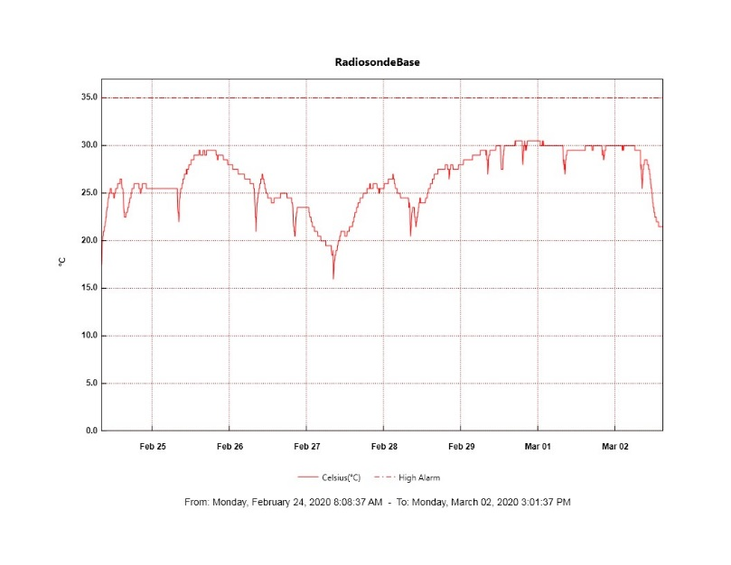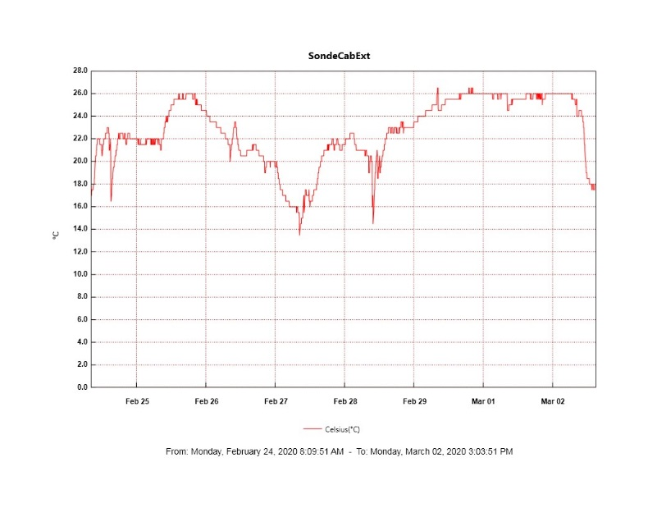

**MWR:**

* HATPRO offsite for repairs. 150-90 online and operating normally.

**SODAR:**

* Operating normally.

**POSS:**

* Operating normally.

**MASC:**

* Offline for winter season.

**MMCR:**

* Occasional NetCDF and dwellControl_calibration errors occurring, which can be cleared without issue.
* Operating normally.

**CAPABL:**

* Operating normally.

**MPL:**

* Operating normally.

**CEILOMETER:**

* Operating normally.

**PAERI:**

* 2020-02-26 ~0500Z: PAERI fan failed. Removed fan enclosure for defrosting at ~1500Z. Replaced fan and reinstalled fan enclosure at ~1930Z.
* 2020-02-27 through 2020-02-29: Experienced a number of red flags for maxSampleStdDev relating to very cold outside temperatures.
* Operating normally

**IceCAM:**

* Operating normally.

**IcePIC:**

* No IcePICs taken this week.

**CLASP:**

* Offline

**CPC:**

* Instrument is still offline with an electrical issue. Awaiting further troubleshooting instructions from the manufacturer.

**MSF - OPC:**

* 2020-02-24 1350Z: MSF OPC shut down unexpectedly. Restarted at 2007Z on 2-25.
* Operating normally.

**TAWO - OPC:**

* 2020-02-29: Cable became disconnected during cleaning heavy frost accumulation. Waited for temperatures to rise before attempting to reconnect.
* Operating normally.

**SKYOPC:**

* Operating normally.

**INP Freezing Assay:**

* 2020-02-26: Weekly experiment was completed. Assay data and internal instrument data queued for transfer on 02-27.

**Fluxtower instrument suite:**

* New power supply is onsite and needs to be installed.