**ICECAPS-ACE Weekly Report**

March 2 – March 8, 2020

Nate Bowker

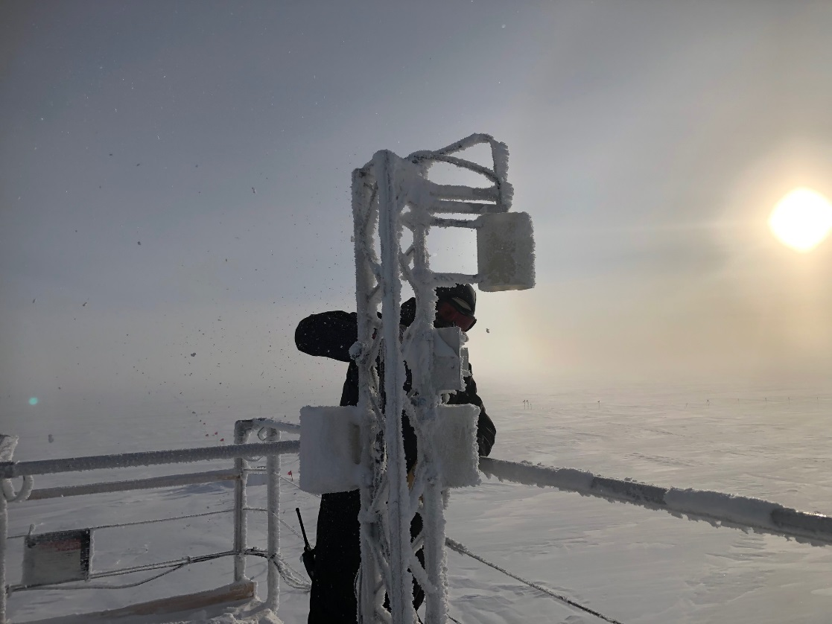

*Nate removing frost from ACE instruments on a somewhat windy day. Photo Kathy Schrader*

**General Notes:**

Nate is finally starting to get back to normal levels of energy and productivity, and is looking forward to completing tasking that has been on hold for the past few weeks.

Once again, the time to plan for summer work and resupply is upon us. Please let Nate know if you have any questions about the quantity of consumable supplies currently on-site for your instrument(s).

**General Weather Observations:**

|  |  |  |  |  |  |  |  |
| --- | --- | --- | --- | --- | --- | --- | --- |
| **Date** | **Time (Z)** | **Wind** | **Weather** | **Visibility** | **Sky** | **Temp (C)** | **Notes** |
| 03-02 | 12 | 20kt from 145 | BLSN | 300 | OVC000 | -31 |  |
| 03-03 | 12 | 22kt from 150 | BLSN | 300 | OVC001 | -36 |  |
| 03-04 | 12 | 14kt from 141 | FZFG | 300 | VV009 | -40 |  |
| 03-05 | 12 | 8kt from 192 | BR | 1600 | FEW100 | -41 | Clouds distant, height estimated |
| 03-06 | 12 | 13kt from 177 | FZFG | 500 | SCT032 BKN192 | -44 |  |
| 03-07 | 12 | 16kt from 188 | FZFG | 400 | SCT032 SCT064 BKN128 | -42 |  |
| 03-08 | 12 | 10kt from 221 |  | 9999 | FEW100 | -50 | Clouds distant, height estimated |

**Significant Weather Observations:**

* 2020-03-06 ~1230-1600Z: Faint 22 degree halo and diamond dust.
* 2020-03-08: 2-4cm yukimarimo formed overnight.

**MSF**

* 2020-03-03: Cleaned out HRV exterior ductwork and inspected HRV for snow infiltration.
* Operating normally

**ICECAPS-ACE Data Management:**

* 03-02: Stop ArchieveToBoulder at 1232Z.
* 03-03: Stop ArchieveToBoulder at 1356Z.
* 03-04: Stop ArchieveToBoulder at 1328Z.
* 03-05: Stop ArchieveToBoulder at 1943Z.
* 03-06: Stop ArchieveToBoulder at 1326Z.
* 03-07: Stop ArchieveToBoulder at 1354Z.
* 03-08: Stop ArchieveToBoulder at 1355Z.

**TSI:**

* Offline for winter season.

**Radiosonde:**

* 2020-03-06, 07, 08: Several recent radiosondes terminated due to “Excessive missing data frames” and “Excessive missing GPS height”, perhaps due to loss of radio signal from the sonde after becoming sufficiently distant from station.
* See charts below for temperatures inside and outside the radiosonde cabinet over the last week.

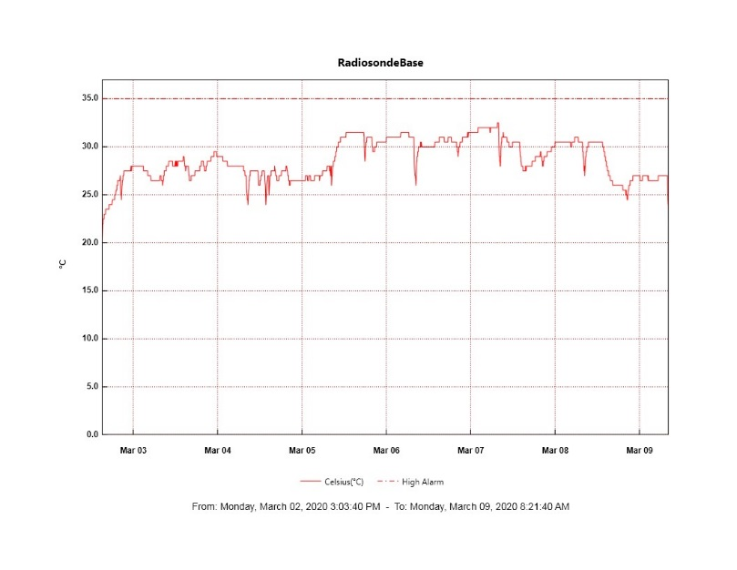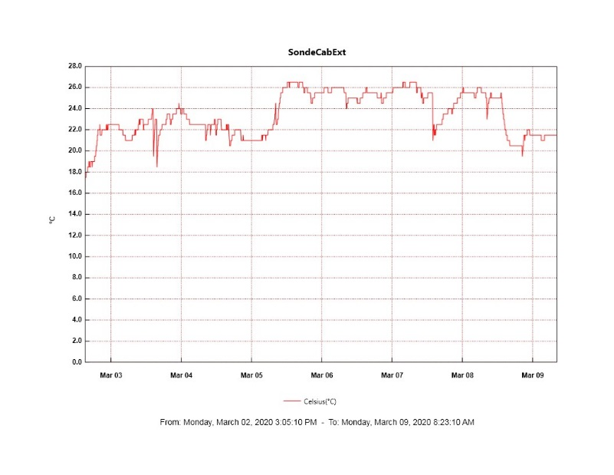

**MWR:**

* HATPRO offsite for repairs. 150-90 online and operating normally.

**SODAR:**

* 2020-03-04 1947-2002Z: Cleaned and leveled SODAR.
* Operating normally.

**POSS:**

* Operating normally.

**MASC:**

* Offline for winter season.

**MMCR:**

* Occasional NetCDF and dwellControl_calibration errors occurring, which can be cleared without issue.
* 2020-03-04 ~1700-2200Z: Observed a 2-3 watt drop in transmitter power that lasted roughly 5 hours.
* Operating normally.

**CAPABL:**

* Operating normally.

**MPL:**

* Operating normally.

**CEILOMETER:**

* Operating normally.

**PAERI:**

* 2020-03-02: SW and LW responsivity flags present due to high winds and BLSN. Resolved without intervention.
* 2020-03-06: Replaced bearings in fan #1. Fan #1 ready for future reinstallation.
* Operating normally

**IceCAM:**

* Operating normally.

**IcePIC:**

* 2020-03-06: Cleaned out photo booth. Installed, tested, and tuned up IcePICs gear. Ready for use.
* No IcePICs taken this week.

**CLASP:**

* Offline

**CPC:**

* Instrument is still offline with an electrical issue. Awaiting further troubleshooting instructions from the manufacturer.

**MSF - OPC:**

* Operating normally.

**TAWO - OPC:**

* 2020-03-02: Reseated cable connection and restarted but data is still sparse. Coordinated with PI’s to bring instrument indoors for defrosting.
* Operating normally.

**SKYOPC:**

* Operating normally.

**INP Freezing Assay:**

* 2020-03-04: Weekly experiment was completed. Assay data and Low Volume Sampler meta data transferred to Leeds.

**Fluxtower instrument suite:**

* 2020-03-06: Removed failed power supply from tower. Conducted initial testing which indicates failure relates to a blown internal fuse on the AC power input side of the unit.