**ICECAPS-ACE Weekly Report**

March 9 – March 15, 2020

Nate Bowker

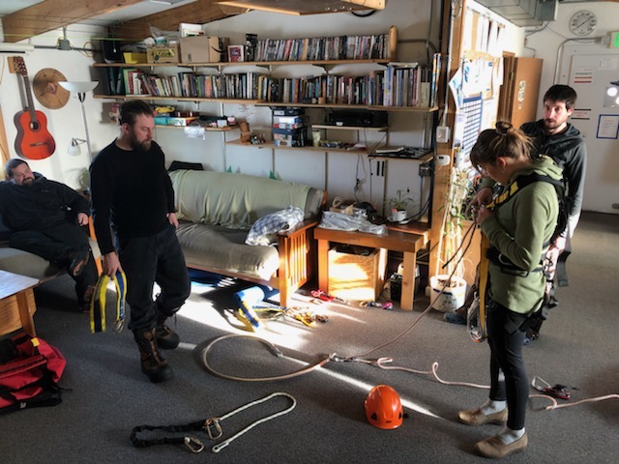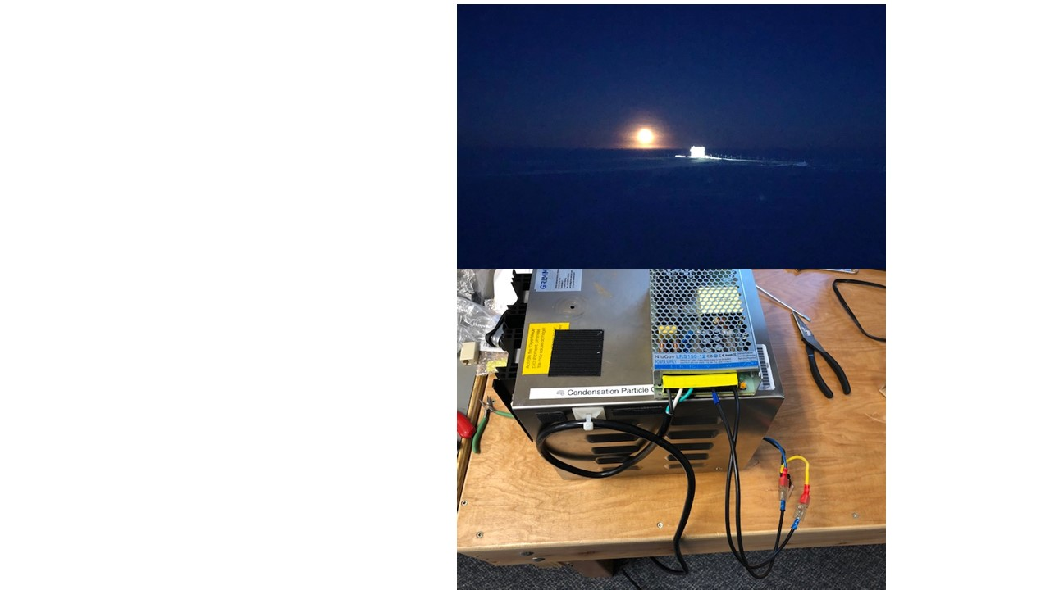

*CW from left: Spring crew reviews tower rescue gear in preparation for work on the fluxtower in the coming week. Photo Kathy Schrader; full moon rising behind the MSF; and CPC rewired with external power supply. Photos Nate Bowker*

**General Notes:**

Interior workspace cleanup and manual snow removal around the MSF continues.

Travel restrictions related to COVID-19 will impact springfly twin otter and FP1 schedule.

Once again, the time to plan for summer work and resupply is upon us. Please let Nate know if you have any questions about the quantity of consumable supplies currently on-site for your instrument(s).

**General Weather Observations:**

|  |  |  |  |  |  |  |  |
| --- | --- | --- | --- | --- | --- | --- | --- |
| **Date** | **Time (Z)** | **Wind** | **Weather** | **Visibility** | **Sky** | **Temp (C)** | **Notes** |
| 03-09 | 12 | 15kt from 195 | FZFG | 500 | SCT016 | -41 |  |
| 03-10 | 12 | 12kt from 224 | FZFG | 300 | SCT032 SCT240 | -43 |  |
| 03-11 | 12 | 11kt from 223 | BR | 4800 | SCT128 | -51 |  |
| 03-12 | 12 | 6kt from 220 | BR | 4800 | FEW065 | -54 |  |
| 03-13 | 12 | 8kt from 224 | BR FZFG | 3200 | SCT060 | -54 | Pockets of FZFG |
| 03-14 | 12 | 7kt from 309 | BR | 4800 | FEW064 SCT128 | -47 |  |
| 03-15 | 12 | 15kt from 44 | BR | 3200 | FEW065 | -58 | Clouds distant, height estimated |

**Significant Weather Observations:**

* None

**MSF**

* 2020-03-09: Drift mitigation performed around building entrances.
* 2020-03-11: Wind shifted overnight causing building temps to drop steadily. Wall heaters did not kick on at 50F setpoint resulting in interior temps in the mid-40sF. Turned one wall heater on between 1228 – 1550z to stabilize temps in the mid-50sF.
* 2020-03-12: Removed snow and frost from MSF roof.
* Operating normally

**ICECAPS-ACE Data Management:**

* 03-09: Stop ArchieveToBoulder at 1345Z.
* 03-10: Stop ArchieveToBoulder at 1036Z.
* 03-11: Stop ArchieveToBoulder at 1604Z.
* 03-12: Stop ArchieveToBoulder at 1802Z.
* 03-13: Stop ArchieveToBoulder at 1359Z.
* 03-14: Stop ArchieveToBoulder at 1400Z.
* 03-15: Stop ArchieveToBoulder at 1350Z.

**TSI:**

* Offline for winter season.

**Radiosonde:**

* Several soundings this week terminated for the following reasons: “excessive missing data frames”, “excessive missing GPS height”, and “weak or fading signal”. Mean range of these flights was 121km from station. Mean height at termination was 22.5km.
* 2020-03-15 0000Z: Flight processed with incorrect surface dew point temperature.
* See charts below for temperatures inside and outside the radiosonde cabinet over the last week.

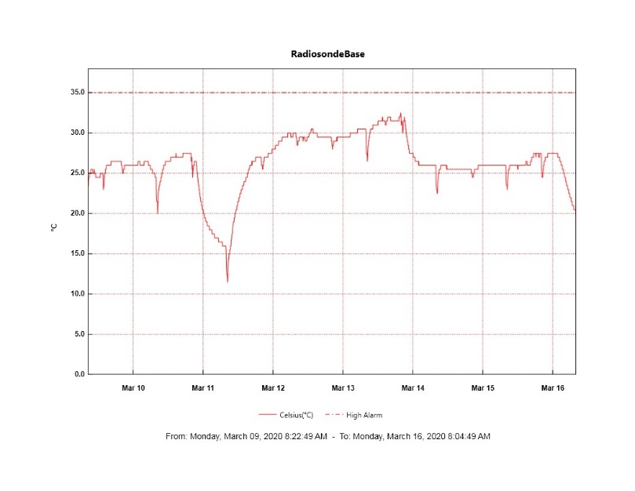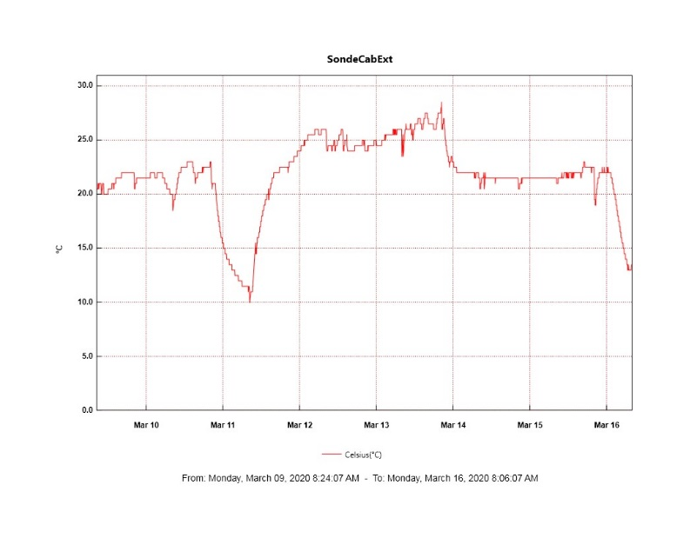

**MWR:**

* HATPRO offsite for repairs. 150-90 online and operating normally.

**SODAR:**

* Operating normally.

**POSS:**

* Operating normally.

**MASC:**

* 2020-03-10: Verified MASC heaters are still functional in anticipation of restarting the instrument next month.
* Offline for winter season.

**MMCR:**

* 2020-03-09 1309-1445z: Restarted MMCR. Three attempts were necessary.
* Operating normally.

**CAPABL:**

* 2020-03-12 1503-1515: Shut down briefly to remove frost from window.
* Operating normally.

**MPL:**

* Operating normally.

**CEILOMETER:**

* Operating normally.

**PAERI:**

* Operating normally

**IceCAM:**

* Operating normally.

**IcePIC:**

* No IcePICs taken this week.

**CLASP:**

* Offline

**CPC:**

* 2020-03-09: Performed additional troubleshooting on CPC electrical system.
* 2020-03-13: Rewired CPC with an external DC power supply.

**MSF - OPC:**

* Operating normally.

**TAWO - OPC:**

* 2020-03-09 to 11: Instrument brought inside for defrosting and inlet inspection.
* Operating normally.

**SKYOPC:**

* Operating normally.

**INP Freezing Assay:**

* 2020-03-11: Weekly experiment completed.

**Fluxtower instrument suite:**

* 2020-03-10: Established a path forward for further inspection and troubleshooting to diagnose the failure mode for the 24V power supply that was removed last week, and also finalized a game plan for the installation of new power supplies and bringing instruments back online.
* Instruments with power operating normally.