**ICECAPS-ACE Weekly Report**

March 16 – March 22, 2020

Nate Bowker

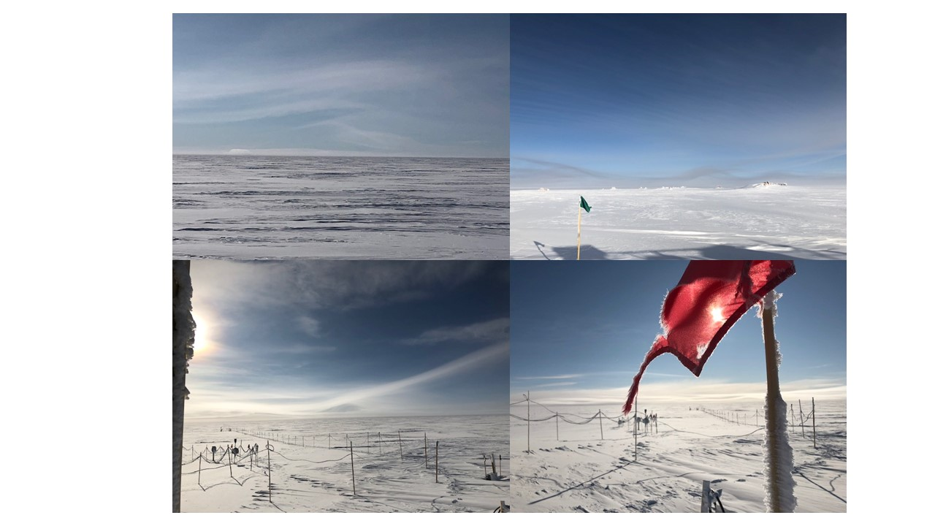

*Various undulating stratiform clouds. Photos Nate Bowker*

**General Notes:**

The scope of impacts from COVID-19 to this summer’s science plans continues to expand.

**General Weather Observations:**

|  |  |  |  |  |  |  |  |
| --- | --- | --- | --- | --- | --- | --- | --- |
| **Date** | **Time (Z)** | **Wind** | **Weather** | **Visibility** | **Sky** | **Temp (C)** | **Notes** |
| 03-16 | 12 | 25kt from 84 | BLSN | 300 | FEW128 SCT190 | -48 |  |
| 03-17 | 12 | 16kt from 132 |  | 9999 | SCT032 BKN148 | -45 |  |
| 03-18 | 12 | 10kt from 238 | BR | 3200 | FEW032 | -53 | Clouds distant, height estimated |
| 03-19 | 12 | 12kt from 167 | BR | 1600 | SCT060 | -46 |  |
| 03-20 | 12 | 16kt from 117 | -SN DRSN | 1600 | OVC020 | -30 |  |
| 03-21 | 12 | 6kt from 245 | BR | 1600 | FEW032 | -47 | Clouds distant, height estimated |
| 03-22 | 12 | 17kt from 048 |  | 9999 | FEW032 | -48 | Clouds distant, height estimated |

**Significant Weather Observations:**

* 2020-03-19 ~1200-1600Z: 22 degree halo and diamond dust.

**MSF**

* 2020-03-17: Secured loose SODAR and POSS cables coming off the MSF roof.
* Operating normally

**ICECAPS-ACE Data Management:**

* 03-16: Stop ArchieveToBoulder at 1342Z.
* 03-17: Stop ArchieveToBoulder at 1321Z.
* 03-18: Stop ArchieveToBoulder at 1405Z.
* 03-19: Stop ArchieveToBoulder at 1737Z.
* 03-20: Stop ArchieveToBoulder at 1353Z.
* 03-21: Stop ArchieveToBoulder at 1519Z.
* 03-22: Stop ArchieveToBoulder at 1332Z.

**TSI:**

* Offline for winter season.

**Radiosonde:**

* Evening balloons experiencing low burst heights. Average burst height of 0000Z flights for the past week was 14370m, as compared to an average of 23686m for the 1200Z flights over the same period. This is likely due to seasonally cold upper air temps, with morning balloons benefiting from solar gain that is not present for the evening balloons.
* See charts below for temperatures inside and outside the radiosonde cabinet over the last week.

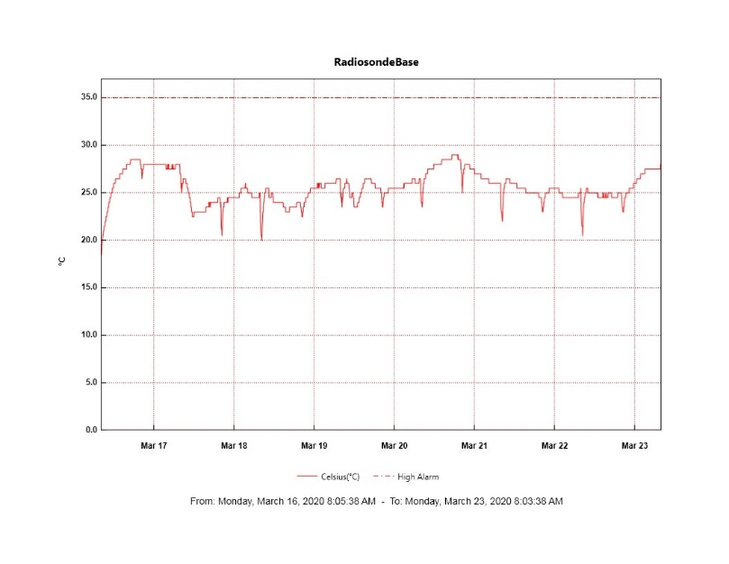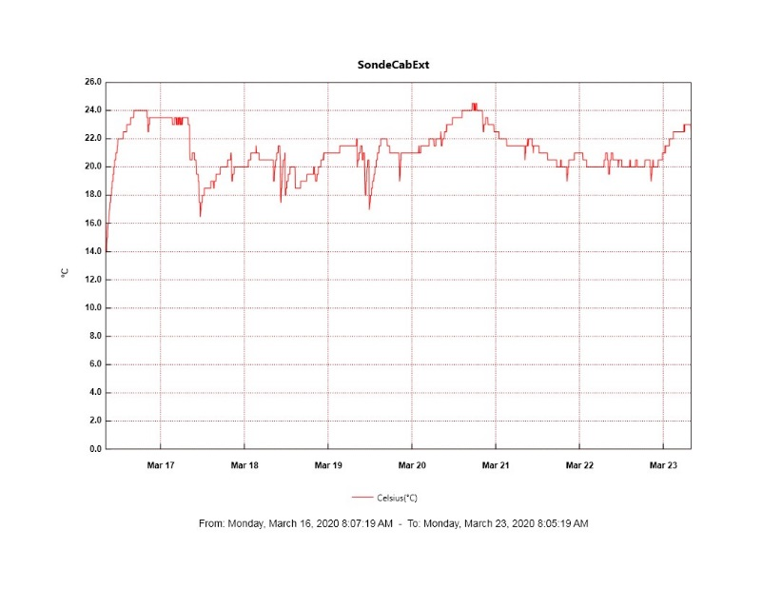

**MWR:**

* HATPRO offsite for repairs. 150-90 online and operating normally.

**SODAR:**

* 2020-03-18 1936-1950Z: Cleaned SODAR and checked level.
* 2020-03-21 1405-1411Z: Cleaned SODAR after wind.
* Operating normally.

**POSS:**

* Operating normally.

**MASC:**

* Offline for winter season.

**MMCR:**

* Experiencing intermittent fluctuations in transmitter power of 2-3 watts.
* Operating normally.

**CAPABL:**

* Operating normally.

**MPL:**

* 2020-03-16: Monthly afterpulse calibration performed.
* Operating normally.

**CEILOMETER:**

* Operating normally.

**PAERI:**

* Operating normally

**IceCAM:**

* Operating normally.

**IcePIC:**

* 2020-03-19: Photographed diamond dust associated with 22 degree halo. Pics transferred on 03-20.

**CLASP:**

* Offline

**CPC:**

* 2020-03-16: Restarted CPC.
* Operating normally.

**MSF - OPC:**

* Operating normally.

**TAWO - OPC:**

* 2020-03-16 ~0730-1330z: Instrument dropped out due to high winds and loose USB connection.
* Operating normally.

**SKYOPC:**

* Operating normally.

**INP Freezing Assay:**

* 2020-03-18: Weekly experiment completed.

**Fluxtower instrument suite:**

* Instruments with power operating normally.