**ICECAPS-ACE Weekly Report**

March 23 – March 29, 2020

Nate Bowker

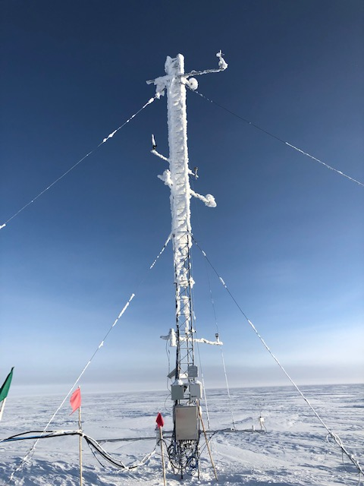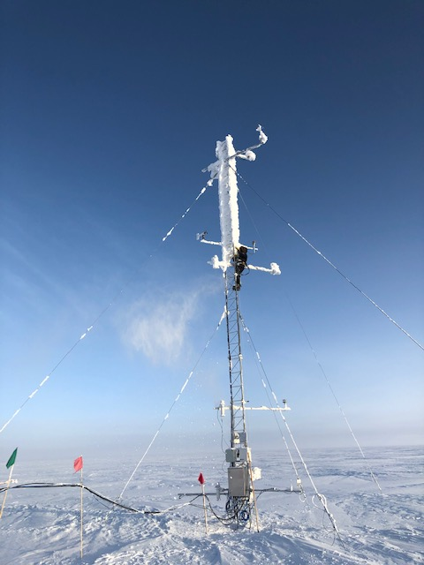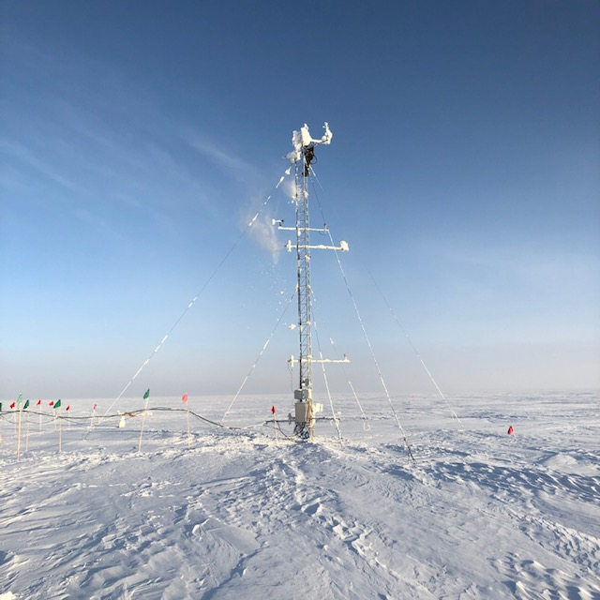

*Mara cleans the TAWO tower in order to investigate flux instrument cables. Photos Nate Bowker*

**General Notes:**

Summer science plans continue to evolve based on the impacts of COVID-19.

Greenland and the UK are now caught back up to the US with daylight savings.

**General Weather Observations:**

|  |  |  |  |  |  |  |  |
| --- | --- | --- | --- | --- | --- | --- | --- |
| **Date** | **Time (Z)** | **Wind** | **Weather** | **Visibility** | **Sky** | **Temp (C)** | **Notes** |
| 03-23 | 12 | 15kt from 119 | BR DRSN | 3200 | FEW020 | -40 |  |
| 03-24 | 12 | 3kt from 215 |  | 9999 | FEW032 | -48 | Clouds distant, height estimated |
| 03-25 | 12 | 13kt from 210 | BR IC | 1600 | FEW128 SCT192 | -47 |  |
| 03-26 | 12 | 6kt from 334 | BR | 3200 | FEW060 SCT115 | -42 |  |
| 03-27 | 12 | 14kt from 204 | BR | 4800 | SKC | -51 |  |
| 03-28 | 12 | 24kt from 225 | BLSN | 100 | VV003 | -27 |  |
| 03-29 | 12 | 29kt from 209 | BLSN | 100 | VV003 | -18 |  |

**Significant Weather Observations:**

* 2020-03-25 ~1200z: 22 degree halo observed.
* 2020-03-26 ~1800z: 22 degree halo observed.

**MSF**

* Operating normally

**ICECAPS-ACE Data Management:**

* 03-23: Stop ArchieveToBoulder at 1324Z.
* 03-24: Stop ArchieveToBoulder at 1259Z.
* 03-25: Stop ArchieveToBoulder at 1241Z.
* 03-26: Stop ArchieveToBoulder at 1611Z.
* 03-27: Stop ArchieveToBoulder at 1309Z.
* 03-28: Stop ArchieveToBoulder at 1237Z.
* 03-29: Stop ArchieveToBoulder at 1615Z.

**TSI:**

* Offline for winter season.

**Radiosonde:**

* 2020-03-24 0000Z: The sonde that was prepped initially terminated inexplicably prior to launch. Prepped and launched a second sonde within the usual launch window.
* 2020-03-26 1200Z: Retried the sonde that had failed on 03/24 with the same results. Retired this sonde to the “box of broken dreams”.
* 0000Z sondes continue to have lower burst heights than 1200Z sondes, including some burst heights below 15km.
* See charts below for temperatures inside and outside the radiosonde cabinet over the last week.

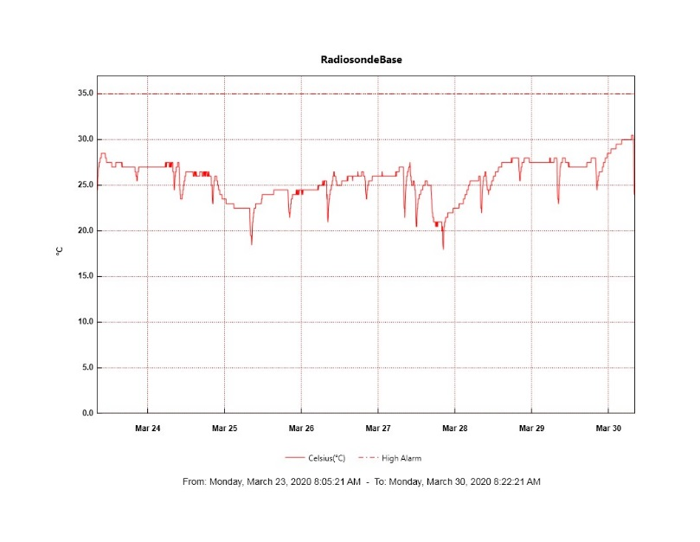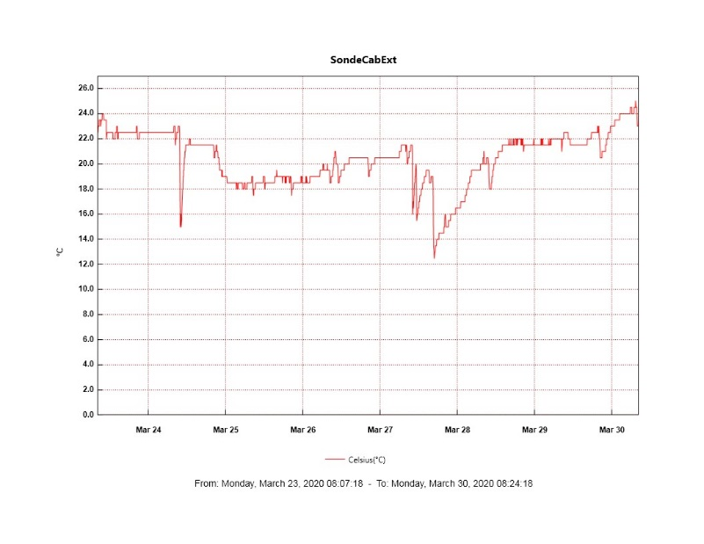

**MWR:**

* HATPRO offsite for repairs. 150-90 online and operating normally.

**SODAR:**

* Operating normally.

**POSS:**

* Operating normally.

**MASC:**

* Offline for winter season.

**MMCR:**

* Experiencing intermittent fluctuations in transmitter power of 2-3 watts.
* Operating normally.

**CAPABL:**

* 2020-03-28 1326-1336Z: Shut down in order to remove snow from the window.
* Operating normally.

**MPL:**

* Operating normally.

**CEILOMETER:**

* 2020-03-24 1734z: Restarted ceilometer computer in an effort to stop it from downloading hundreds of MBs every day. Initially this seemed to be successful but in recent days this behavior has resumed. Downloads, however, appear to be occurring overnight, so impacts to our bandwidth during the workday are minimal.
* Operating normally.

**PAERI:**

* Operating normally

**IceCAM:**

* 2020-03-23 ~0100-1300Z: Photos fully obscured by frost.
* Operating normally.

**IcePIC:**

* None taken this week.

**CLASP:**

* Offline

**CPC:**

* 2020-03-23: Performed some basic investigations related to having observed butanol condensate pooling in the sample outlet line. It seems possible that the new power supply is not supplying quite enough voltage which is causing the condenser to go through short periods where it is not quite cool enough to remove all the butanol from the sample, but more feedback from the manufacturer is necessary.
* 2020-03-28: Emptied condensate reservoir.
* Operating normally.

**MSF - OPC:**

* Operating normally.

**TAWO - OPC:**

* Operating normally.

**SKYOPC:**

* Operating normally.

**INP Freezing Assay:**

* 2020-03-23: Completed physical installation of new pressure/temperature sensor on the LVS
* 2020-03-25: Weekly assays completed.
* 2020-03-25: Attempted to bring the new p/T sensor online but was unable to establish a good connection to the sampler. Also, managed to accidentally disconnect the inlet heater cable in the process of trying to troubleshoot and was unable to reconnect it.
* 2020-03-26: Was able to get the LVS inlet heater plugged back in by removing a section of the TAWO roof deck. Also, managed to get the new p/T sensor connected, but the sensor failed soon after connecting it. Suspect a possible short in the cable run, but further investigation will be necessary to determine the cause of this failure.

**Fluxtower instrument suite:**

* 2020-03-23 and 2020-03-26: Performed multiple tower climbs to inspect instruments, junction boxes, and cabling for damage that could cause a power supply failure.
* Still trying to track down materials to provide protection for the AC power input to the new power supplies.
* Instruments with power operating normally.