**ICECAPS-ACE Weekly Report**

March 30 – April 05, 2020

Nate Bowker

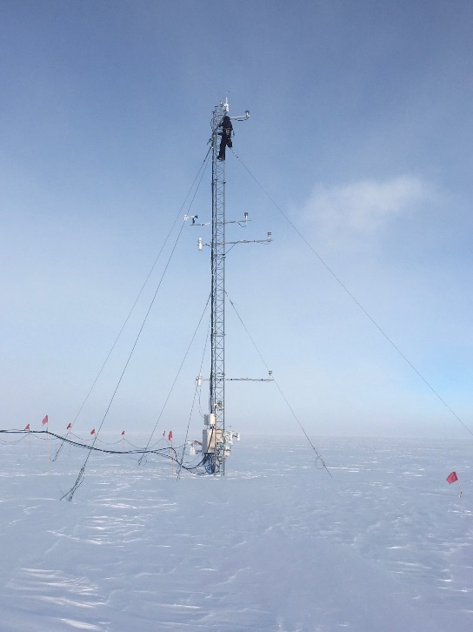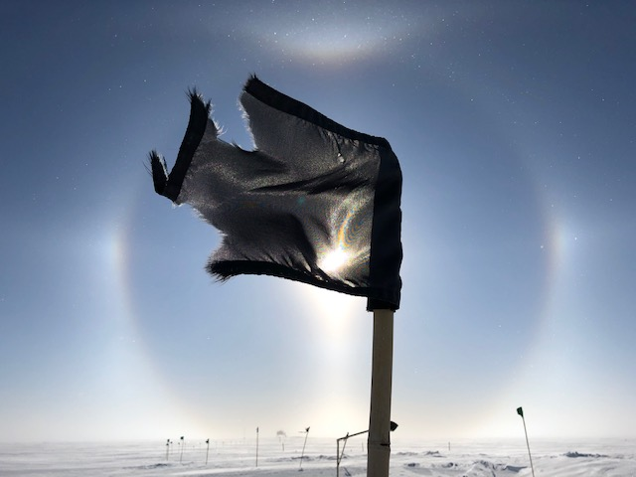

*Left: Nate continues inspection of fluxtower systems. Photo Mara Menahan. Right: Solar optics on 2020-03-30. Photo Nate Bowker*

**General Notes:**

Last call for consumable resupply items needed at Summit for the summer season. Please contact Jessy Jenkins regarding any last minute shipments.

Summit Science PM Sam Dorsi welcomed a healthy baby boy, Joseph Winchester Dorsi, into the world this week and will be on paternity leave until 2020-04-15. Congratulations Sam!

**General Weather Observations:**

|  |  |  |  |  |  |  |  |
| --- | --- | --- | --- | --- | --- | --- | --- |
| **Date** | **Time (Z)** | **Wind** | **Weather** | **Visibility** | **Sky** | **Temp (C)** | **Notes** |
| 03-30 | 12 | 18kt from 225 | BLSN | 0100 | VV003 | -25 |  |
| 03-31 | 12 | 15kt from 221 | DRSN BR | 1600 | OVC006 | -34 |  |
| 04-01 | 12 | 22kt from 008 | BLSN | 0300 | VV009 | -43 |  |
| 04-02 | 12 | 20kt from 326 | DRSN FZFG | 800 | SCT190 | -32 |  |
| 04-03 | 12 | 17kt from 035 | BR | 4800 | BKN160 | -44 |  |
| 04-04 | 12 | 21kt from 034 | DRSN FZFG | 800 | SCT064 BKN165 | -41 |  |
| 04-05 | 12 | 15kt from 060 | BR | 4800 | FEW060 | -43 |  |

**Significant Weather Observations:**

* 2020-03-30 ~1700Z: 22 degree halo, 46 degree halo, and upper tangent arc observed.
* 2020-04-03: Yukimarimo observed.

**MSF**

* Operating normally

**ICECAPS-ACE Data Management:**

* 03-30: Data transfer completed at 1335Z.
* 03-31: Data transfer completed at 1256Z.
* 04-01: Data transfer completed at 1401Z.
* 04-02: Data transfer completed at 1740Z.
* 04-03: Data transfer completed at 1302Z.
* 04-04: Data transfer completed at 1538Z.
* 04-05: Data transfer completed at 1308Z.

**TSI:**

* Offline for winter season.

**Radiosonde:**

* See charts below for temperatures inside and outside the radiosonde cabinet over the last week.

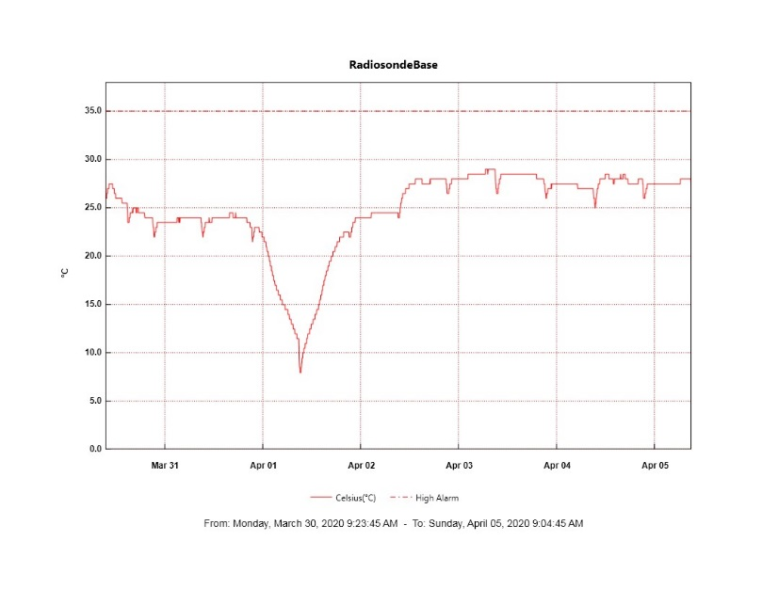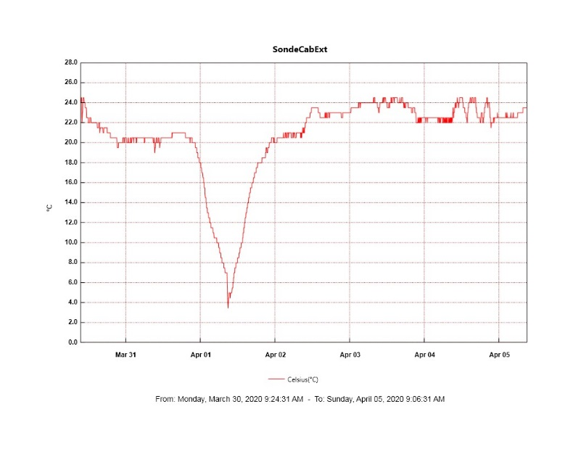

**MWR:**

* HATPRO offsite for repairs. 150-90 online and operating normally.

**SODAR:**

* 2020-04-05 1146 – 1157Z: Cleaned SODAR dishes and checked level.
* Operating normally.

**POSS:**

* Operating normally.

**MASC:**

* Offline for winter season.

**MMCR:**

* Transmitter power fluctuation have not been present this week. The last fluctuation observed was on 2020-03-29.
* Operating normally.

**CAPABL:**

* 2020-03-28 1326-1336Z: Shut down in order to remove snow from the window.
* 2020-04-01 1202-1218Z: Performed full system reboot in order to correct depol measurement.
* Operating normally.

**MPL:**

* Operating normally.

**CEILOMETER:**

* Operating normally.

**PAERI:**

* 2020-03-30: Exterior power connection for the enclosure fan came unplugged in high winds. Fashioned a new retainer clip for this connection.
* 2020-04-01: Scene mirror rotated out of alignment 30 degrees when cleaning. Performed reboot to correct this.
* Operating normally

**IceCAM:**

* Operating normally.

**IcePIC:**

* 2020-03-30 1718-1759Z: Photographed diamond dust coinciding with solar optics including a 22 degree halo, 46 degree halo, and upper tangent arc. Transferred on 2020-03-31.

**CLASP:**

* Offline

**CPC:**

* 2020-04-02, 4-03, 04-04, and 04-05: Butanol pooling in outlet line during northwinds.
* 2020-04-02: Emptied condensate reservoir.
* 2020-04-03: Filled butanol reservoir.
* Operating normally.

**MSF - OPC:**

* Operating normally.

**TAWO - OPC:**

* Operating normally.

**SKYOPC:**

* Operating normally.

**INP Freezing Assay:**

* 2020-04-01: Weekly assays completed.

**Fluxtower instrument suite:**

* 2020-03-31: Performed tower climb to inspect instruments, junction boxes, and cabling for damage that could cause a power supply failure.
* Still trying to track down materials to provide protection for the AC power input to the new power supplies.
* Instruments with power operating normally.

**Solar Instruments:**

* 2020-03-30: Completed weekly data download
* 2020-03-30: Solar tracker is off track on both azimuth and elevation. Troubleshooting ongoing.