**ICECAPS-ACE Weekly Report**

April 13 – April 19, 2020

Nate Bowker

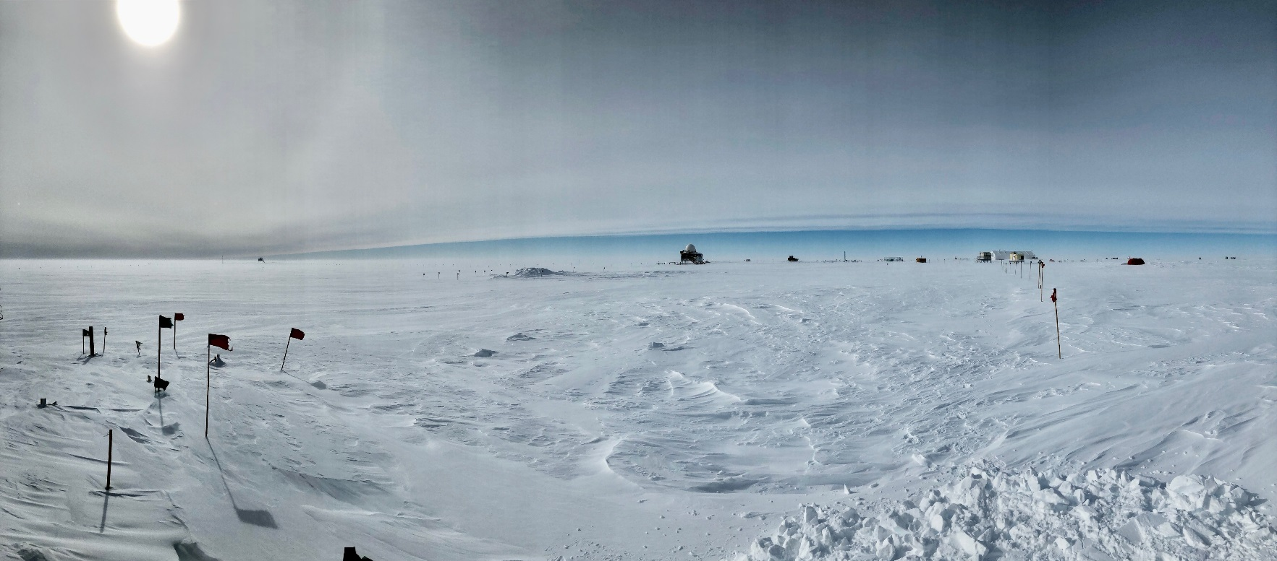

*Stratus clouds moving over station. Photos Nate Bowker*

**General Notes:**

Preparations are currently underway for a crew turnover and station resupply in mid-May. This turnover will be supported by a KBA Basler via Thule.

**General Weather Observations:**

|  |  |  |  |  |  |  |  |
| --- | --- | --- | --- | --- | --- | --- | --- |
| **Date** | **Time (Z)** | **Wind** | **Weather** | **Visibility** | **Sky** | **Temp (C)** | **Notes** |
| 04-13 | 12 | 13kt from 243 | SN DRSN | 800 | OVC016 | -23 |  |
| 04-14 | 12 | 16kt from 343 | FZFG DRSN | 600 | SCT020 | -28 |  |
| 04-15 | 12 | 11kt from 099 |  | 9999 | FEW032 FEW098 SCT130 | -33 |  |
| 04-16 | 12 | 13kt from 162 | BR | 1600 | OVC032 | -23 |  |
| 04-17 | 12 | 26kt from 164 | BLSN | 200 | VV007 | -22 |  |
| 04-18 | 12 | 42kt from 153 | BLSN | 50 | VV002 | -17 |  |
| 04-19 | 12 | 20kt from 192 | FZFG DRSN | 500 | BKN060 | -28 |  |

**Significant Weather Observations:**

* 2020-04-13 ~1230-1930Z: 22 degree halo, parhelia, 46 degree halo, sun pillar.

**MSF**

* Operating normally

**ICECAPS-ACE Data Management:**

* 04-13: Data transfer completed at 0442Z.
* 04-14: Data transfer completed at 0509Z.
* 04-15: Data transfer completed at 0442Z.
* 04-16: Data transfer completed at 0459Z.
* 04-17: Data transfer completed at 0443Z.
* 04-18: Data transfer completed at 0444Z.
* 04-19: Data transfer completed at 0432Z.

**TSI:**

* Offline for winter season.

**Radiosonde:**

* 2020-04-10*: Replaced radiosonde cabinet air filter. *Forgot to include on last week’s report.
* 2020-04-18: 0000Z and 1200Z sonde launches failed due to winds > 40kt.
* See charts below for temperatures inside and outside the radiosonde cabinet over the last week.

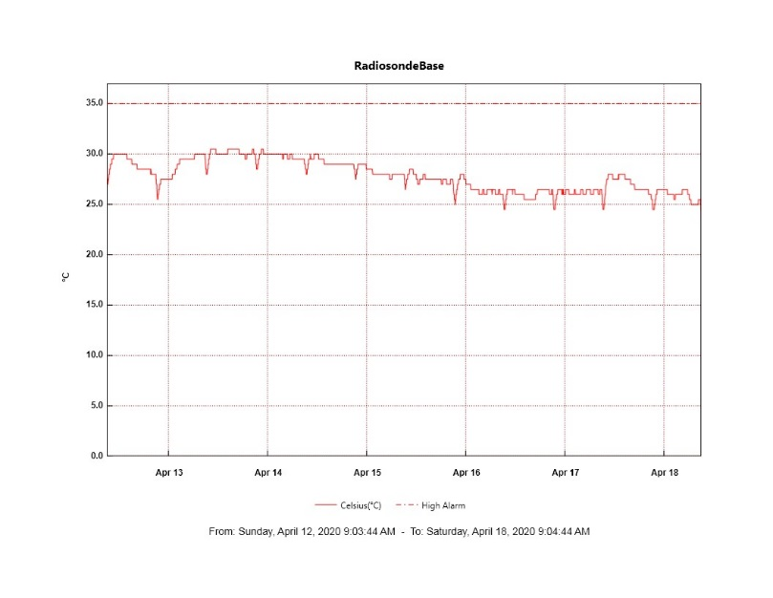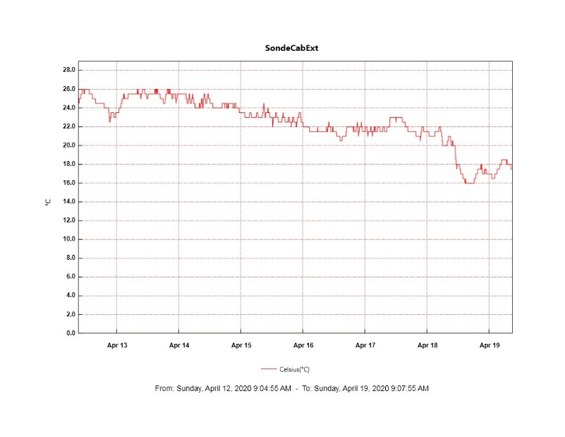

**MWR:**

* HATPRO offsite for repairs. 150-90 online and operating normally.

**SODAR:**

* 2020-04-13 1315-1336Z: Cleaned SODAR dishes.
* 2020-04-13: Raised cable supports.
* Operating normally.

**POSS:**

* Operating normally.

**MASC:**

* Offline for winter season.

**MMCR:**

* 2020-04-13: Observed transmitter power fluctuation at around 0000Z, lasting for ~3 hours.
* Operating normally.

**CAPABL:**

* 2020-04-19 1147-1200: Shut down to remove snow from window. Had to reboot meadowlark.
* Operating normally.

**MPL:**

* 2020-04-17 1302-1321Z: Performed monthly afterpulse calibration.
* Operating normally.

**CEILOMETER:**

* Operating normally.

**PAERI:**

* Operating normally

**IceCAM:**

* Operating normally.

**IcePIC:**

* No photos taken this week.

**CLASP:**

* Offline

**CPC:**

* 2020-04-14: Liquid level alarm persistent but instrument still collecting data.
* 2020-04-16: Topped up butanol reservoir and emptied condensate reservoir.
* 2020-04-17 1130-1202Z: Status error 3 caused a short interruption in data collection. Cleared error and normal operation resumed.
* 2020-04-19: Data collection stopped due to persistent status error 3 and liquid level alarms. Unable to clear alarms so powered down instrument at ~1230Z.
* Operating normally.

**MSF - OPC:**

* 2020-04-18 1832Z: Restarted after high winds caused the instrument to go offline.
* Operating normally.

**TAWO - OPC:**

* Operating normally.

**SKYOPC:**

* Operating normally.

**INP Freezing Assay:**

* 2020-04-14: Auto-calibrated cold stages.
* 2020-04-15: Weekly assays completed.

**Fluxtower instrument suite:**

* Instruments with power operating normally.

**Solar Instruments:**

* 2020-04-14: Completed weekly data download
* 2020-04-19: Solar tracker got off-track during stormy conditions while in “sun mode”.
* Operating normally.