**ICECAPS-ACE Weekly Report**

April 20 – April 26, 2020

Nate Bowker

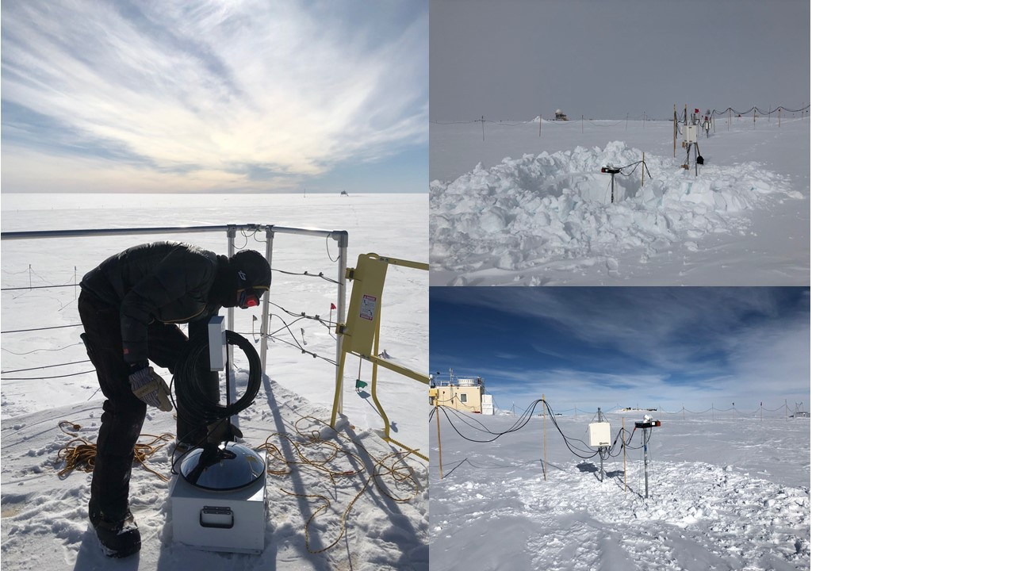

*Left: Nate prepares to place the TSI onto its mount. Photo Kathy Schroeder*

*Right: Raising the MASC and its enclosure. Photos Nate Bowker*

**General Notes:**

Onsite crew turnover is scheduled to occur from 2020-05-08 to 05-13. Tele-training/orientation with the incoming crew is currently underway and will continue through their quarantine period which ends on 2020-05-06when they depart for Summit. Due to the abbreviated onsite turnover this tele-training will include a basic video-call based orientation to the MSF and ICECAPS instruments for Ian, the incoming ICECAPS tech. Also, Ian hopes to join our ICECAPS call on 2020-05-05 for a general introduction with the ICECAPS team and to the weekly call format.

The data management computer experienced a malfunction in the early hours of 2020-04-25 which prevented the daily data transfer to Boulder from 2020-04-25 through 2020-04-27. The system has since been successfully rebooted and appears to be functioning normally.

**General Weather Observations:**

|  |  |  |  |  |  |  |  |
| --- | --- | --- | --- | --- | --- | --- | --- |
| **Date** | **Time (Z)** | **Wind** | **Weather** | **Visibility** | **Sky** | **Temp (C)** | **Notes** |
| 04-20 | 12 | 14kt from 152 |  | 9999 | SCT060 | -33 | Clouds distant, height estimated |
| 04-21 | 12 | 19kt from 202 | DRSN FZFG | 1000 | VV006 | -19 | Solar optics – see below for details |
| 04-22 | 12 | 10kt from 135 | BR | 3200 | BKN128 | -21 |  |
| 04-23 | 12 | 12kt from 177 |  | 9999 | FEW065 SCT262 | -19 |  |
| 04-24 | 12 | 13kt from 53 |  | 9999 | SCT144 | -22 |  |
| 04-25 | 12 | 10kt from 186 |  | 9999 | BKN012 | -18 |  |
| 04-26 | 12 | 14kt from 186 | BR | 1600 | BKN096 | -22 |  |

**Significant Weather Observations:**

* 2020-04-21 ~1200-1400Z: 22 degree halo, parhelia, partial 46 degree halo, circumzenithal arc, parhelic circle, and 120 degree parhelia.

**MSF**

* Operating normally

**ICECAPS-ACE Data Management:**

* 04-20: Data transfer completed at 0441Z.
* 04-21: Data transfer completed at 0438Z.
* 04-22: Data transfer completed at 0445Z.
* 04-23: Data transfer completed at 0503Z.
* 04-24: Data transfer completed at 0540Z.
* 04-25: Data transfer did not occur.
* 04-26: Data transfer did not occur.

**TSI:**

* 2020-04-24: Instrument reinstalled for the summer season. It was rotated 180 degrees from how it was last installed for better access and serviceability in its new location. The software was reconfigured to reflect this change in orientation.
* Operating normally.

**Radiosonde:**

* 2020-04-23 1200Z: Sounding terminated due to “excessive missing GPS height” at a range of 70.5km from station.
* 2020-04-26 0000Z: Sounding terminated due to “excessive missing GPS height” at a range of 67.7km from station.
* See charts below for temperatures inside and outside the radiosonde cabinet over the last week.

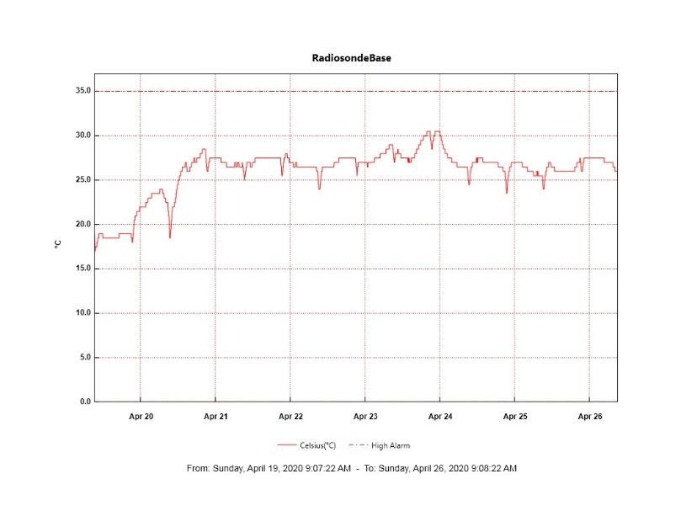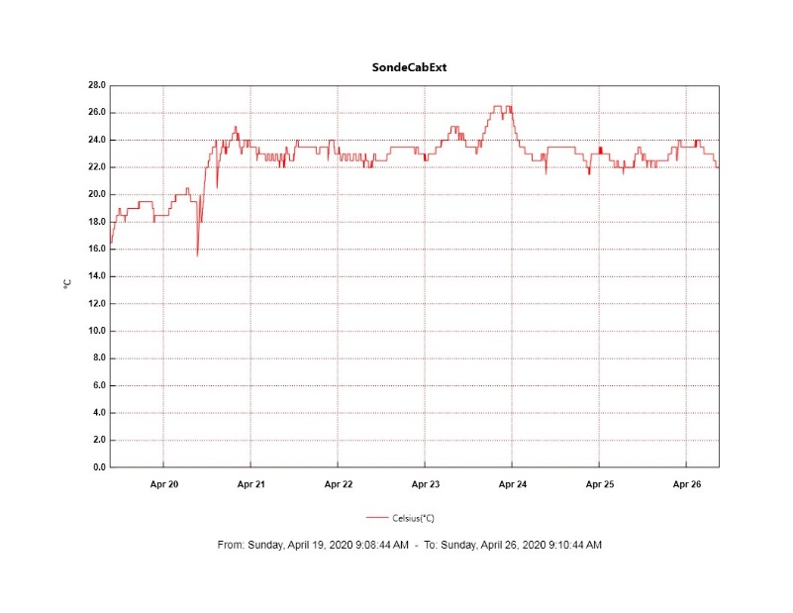

**MWR:**

* HATPRO offsite for repairs. 150-90 online and operating normally.

**SODAR:**

* 2020-04-20 1354-1414Z: Cleaned and leveled SODAR dishes.
* Operating normally.

**POSS:**

* 2020-04-25 1630Z to 2020-04-27 1143Z: Offline due to dataman computer issue.
* Operating normally.

**MASC:**

* 2020-04-23: Raised MASC mount and power box.
* 2020-04-24: Brought camera inside for troubleshooting due to communication issue.
* 2020-04-25: Found that a Firewire repeater which connects the camera to its computer had failed. A replacement will be brought up on the turnover flight on 2020-05-08.
* Offline for winter season.

**MMCR:**

* 2020-04-21: Began receiving NetCDF radar errors hourly. These errors can be cleared without issue.
* 2020-04-21 ~1730-2030Z: Observed transmitter power fluctuation.
* 2020-04-25 ~1700-2100Z: Observed transmitter power fluctuation.
* Operating normally.

**CAPABL:**

* Operating normally.

**MPL:**

* Operating normally.

**CEILOMETER:**

* Operating normally.

**PAERI:**

* Operating normally

**IceCAM:**

* 2020-04-25 0115Z to 2020-04-27 1145Z: Offline due to dataman computer issue.
* Operating normally.

**IcePIC:**

* No photos taken this week.

**CLASP:**

* Offline

**CPC:**

* 2020-04-20 1333Z: Restarted CPC.
* 2020-04-25 1145Z: CPC shut down due to persistent “Error Liquid” alarm state. Investigated compensator (glycol coolant) reservoir and found it to be low. Found a potentially suitable equivalent coolant on station and we are awaiting approval from the instrument manufacturer to use this for refilling the reservoir.
* Operating normally

**MSF - OPC:**

* Operating normally.

**TAWO - OPC:**

* Operating normally.

**SKYOPC:**

* Operating normally.

**INP Freezing Assay:**

* 2020-04-22: Weekly assays completed.

**Fluxtower instrument suite:**

* 2020-04-22: Installed two new power supplies, with fused protection on the line and load sides of each, to replace the power supply that had failed in February. Brought the KT, HMP3, HMP4, M2, and V2 instruments back online and all are working well so far.
* 2020-04-25: The snow depth sensor did not come back online happily after powering down the tower for the power supply installation on 2020-04-22. Troubleshooting is ongoing.
* Operating normally.

**Solar Instruments:**

* 2020-04-20: Completed weekly data download
* 2020-04-20: Corrected issue where solar tracker got off-track during stormy conditions while in “sun mode”. Tracker now running in “clock mode”.
* Operating normally.