**ICECAPS-ACE Weekly Report**

April 27 – May 3, 2020

Nate Bowker

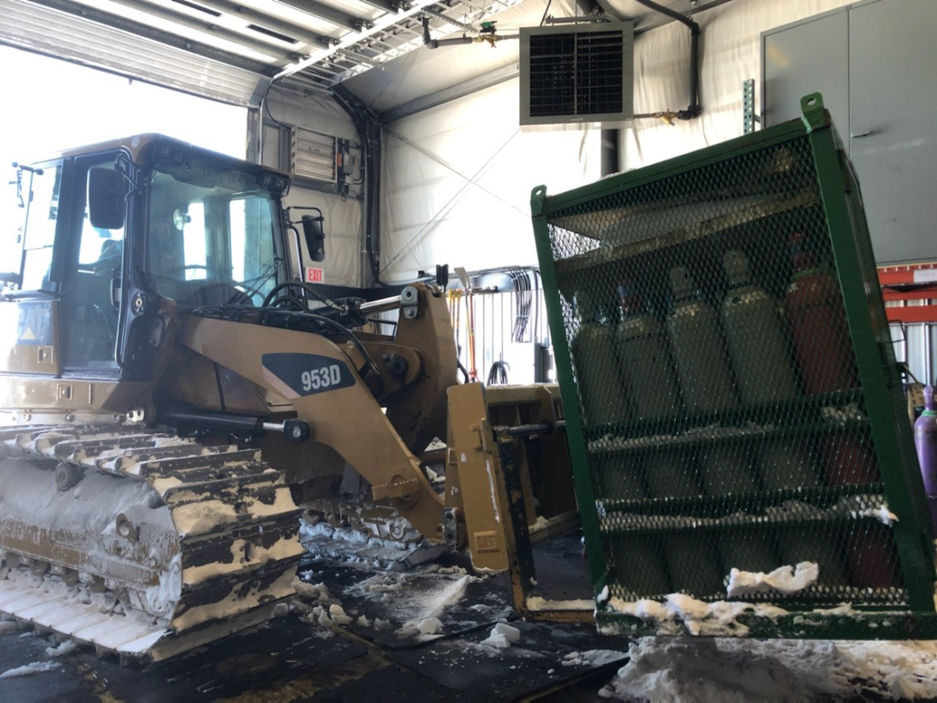

*Moving empty helium cylinders out of the SMG in preparation for next week’s incoming helium shipment.*

*Photo Kathy Schroeder*

**General Notes:**

Preparation for the arrival of the incoming summer crew is in full swing. In addition to preparing workspaces and documentation for a smooth turnover, a number of successful video-call based trainings have been conducted this week in an effort to familiarize incoming ICECAPS tech, Ian Geraghty, with ICECAPS instrumentation and data management systems.

**General Weather Observations:**

|  |  |  |  |  |  |  |  |
| --- | --- | --- | --- | --- | --- | --- | --- |
| **Date** | **Time (Z)** | **Wind** | **Weather** | **Visibility** | **Sky** | **Temp (C)** | **Notes** |
| 04-27 | 12 | 20kt from 173 | SN DRSN FZFG | 500 | OVC032 | -16 |  |
| 04-28 | 12 | 24kt from 213 | DRSN FZFG | 800 | BKN032 | -17 |  |
| 04-29 | 12 | 5kt from 315 | BR | 1600 | FEW020 | -33 |  |
| 04-30 | 12 | 8kt from 254 |  | 9999 | FEW032 | -33 |  |
| 05-01 | 12 | 10kt from 207 |  | 9999 | FEW064 | -30 |  |
| 05-02 | 12 | 6kt from 241 |  | 9999 | FEW018 FEW060 | -32 |  |
| 05-03 | 12 | 25kt from 184 | BLSN | 400 | OVC012 | -22 |  |

**Significant Weather Observations:**

* None.

**MSF**

* Operating normally

**ICECAPS-ACE Data Management:**

* 04-27: Data transfer did not occur.
* 04-28: Data transfer completed at 0837Z. Caught up from the weekend.
* 04-29: Data transfer completed at 0451Z.
* 04-30: Data transfer completed at 0506Z.
* 05-01: Data transfer completed at 0516Z.
* 05-02: Data transfer completed at 0444Z.
* 05-03: Data transfer completed at 0658Z.

**TSI:**

* Operating normally.

**Radiosonde:**

* 2020-04-28 1200Z: Sounding terminated due to “excessive missing data frames”. Distance from station at termination: 107.9km.
* 2020-04-30: Removed 50 empty helium cylinders from the SMG and brought the last 25 full helium cylinders on station into the SMG.
* See charts below for temperatures inside and outside the radiosonde cabinet over the last week.

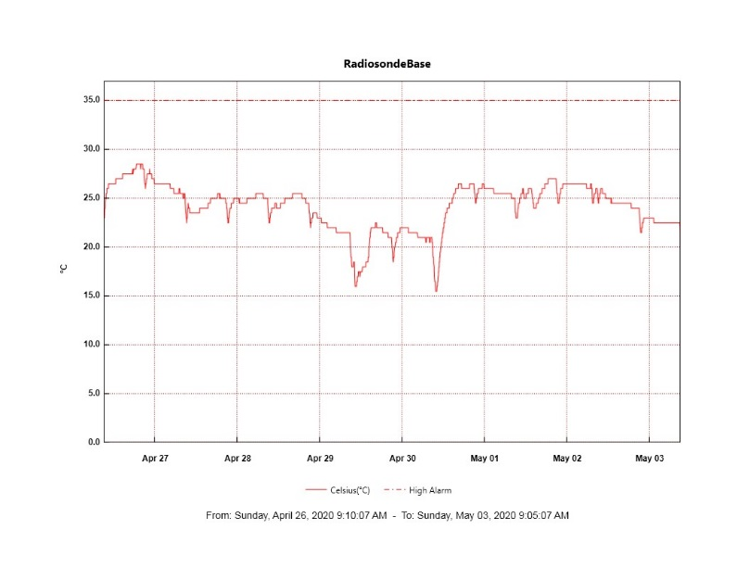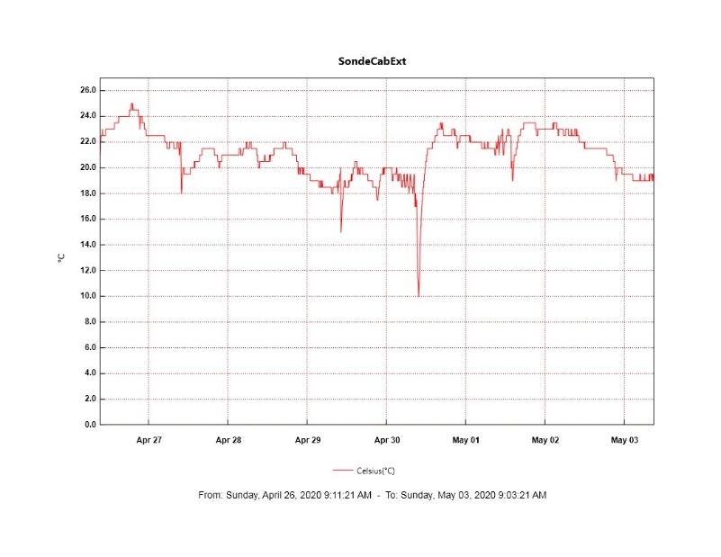

**MWR:**

* HATPRO offsite for repairs. 150-90 online and operating normally.

**SODAR:**

* 2020-04-29 1703–1716Z: Removed snow from SODAR dishes.
* Operating normally.

**POSS:**

* 2020-04-27: POSS restarted at 1138Z and again at ~2100Z due to dataman computer reboots.
* 2020-04-29: Received errors “Gunn current low”, “not used”, “Gunn voltage”, “min noise limit”, “+5V”, and “-12V”.
* 2020-04-30: Received error message “no good poss packets in xx minutes” where xx is a number incrementing by one each minute.
* Offline

**MASC:**

* 2020-04-28: Replacement Firewire repeater shipped.
* Offline for winter season.

**MMCR:**

* 2020-04-21: Began receiving NetCDF radar errors hourly. These errors can be cleared without issue.
* 2020-05-01: First occurrence of LabView file not found warning since last reboot.
* Operating normally.

**CAPABL:**

* Operating normally.

**MPL:**

* 2020-05-03: Tracking gradual decrease in laser energy.
* Operating normally.

**CEILOMETER:**

* Operating normally.

**PAERI:**

* Operating normally

**IceCAM:**

* 2020-04-27 0000-1145Z: Offline due to dataman computer issue.
* Operating normally.

**IcePIC:**

* No photos taken this week.

**CLASP:**

* Offline

**CPC:**

* 2020-04-28: Refilled compensator reservoir and attempted to restart instrument but received persistent Status Error 3 alarm.
* Offline

**MSF - OPC:**

* 2020-04-30: Restarted instrument after it went out during a period of high winds on 4/28.
* Operating normally.

**TAWO - OPC:**

* Operating normally.

**SKYOPC:**

* Operating normally.

**INP Freezing Assay:**

* 2020-04-29: Weekly assays completed.

**Fluxtower instrument suite:**

* 2020-04-28: Fluxtower laptop rebooted.
* 2020-05-01 1140-1210Z: Fluxtower enclosure powered down for troubleshooting of the snow depth sensor. Damaged cable for snow depth sensor repaired but a communications issue still exists and is ongoing.
* Operating normally.

**Radiometers*:**

* **\*Note:** This section of the report was formerly called “Solar Instruments”, but it was determined that this nomenclature did not accurately describe the data being collected. The name was thus changed to better reflect the fact that the range of data being collected includes both shortwave and longwave radiation.
* 2020-04-27: Completed weekly data download
* 2020-05-01 1220-1245Z: Improved tracker alignment by making a small adjustment to software azimuth correction.
* Operating normally.