**ICECAPS-ACE Weekly Report**

May 4 – May 10, 2020

Nate Bowker

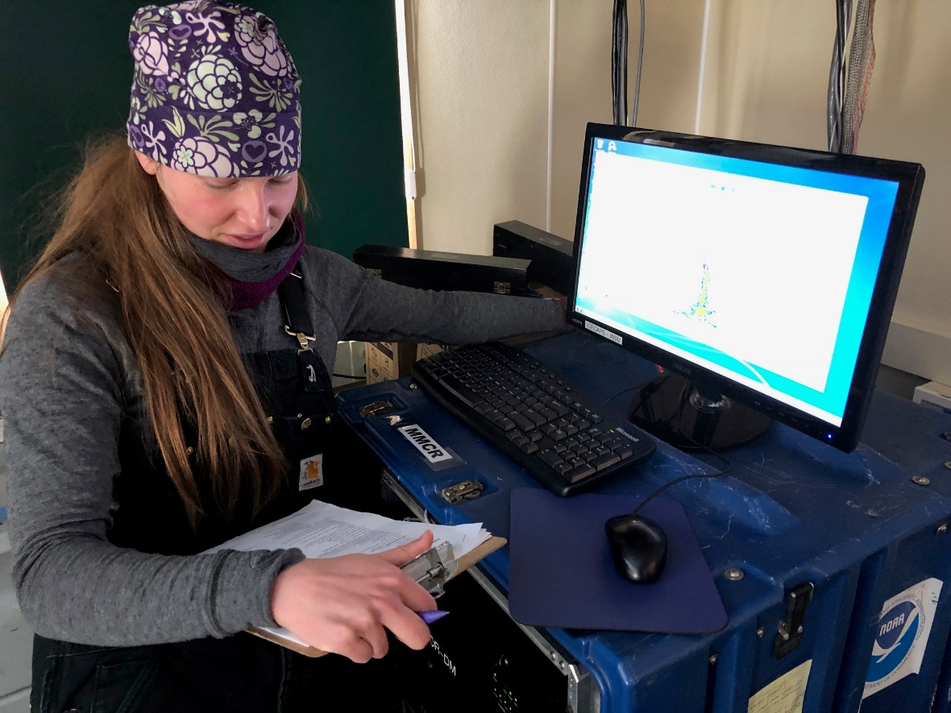

*Mara Menahan conducting daily rounds in the MSF as part of turnover cross-training. Photo Nate Bowker*

**General Notes:**

The incoming summer crew made it to Thule according to plan, however, the first flight of turnover, which was due in on Friday, 2020-05-08, did not arrive on schedule and further attempts to get a flight into Summit have been hampered by bad weather. As a result of this delay, further video call based training with incoming tech, Ian, as well as cross-training with TAWO tech, Mara, have been a primary focus this week.

**General Weather Observations:**

|  |  |  |  |  |  |  |  |
| --- | --- | --- | --- | --- | --- | --- | --- |
| **Date** | **Time (Z)** | **Wind** | **Weather** | **Visibility** | **Sky** | **Temp (C)** | **Notes** |
| 05-04 | 12 | 6kt from 228 | FZFG | 500 | OVC008 | -24 |  |
| 05-05 | 12 | 5kt from 278 |  | 9999 | FEW032 | -33 | Clouds distant, height estimated |
| 05-06 | 12 | 14kt from 209 |  | 9999 | FEW032 | -30 | Clouds distant, height estimated |
| 05-07 | 12 | 11kt from 263 | BR | 1600 | FEW065 | -32 | Clouds distant, height estimated |
| 05-08 | 12 | 10kt from 273 |  | 9999 | SCT032 | -33 | Clouds distant, height estimated |
| 05-09 | 12 | 16kt from 228 | BR | 3200 | BKN065 | -26 |  |
| 05-10 | 12 | 23kt from 267 | BLSN | 100 | VV005 | -16 |  |

**Significant Weather Observations:**

* None.

**MSF**

* Operating normally

**ICECAPS-ACE Data Management:**

* 05-04: Data transfer completed at 0444Z.
* 05-05: Data transfer completed at 0449Z.
* 05-06: Data transfer completed at 0438Z.
* 05-07: Data transfer completed at 0522Z.
* 05-08: Data transfer completed at 0446Z.
* 05-09: Data transfer completed at 0449Z.
* 05-10: Data transfer completed at 0451Z.

**TSI:**

* Operating normally.

**Radiosonde:**

* 2020-05-05 0000Z: Experienced SPS connectivity issue.
* 2020-05-05 1200Z: Experienced SPS connectivity issue.
* 2020-05-06: Started shutting down SPS in between soundings.
* 2020-05-10 1200Z: Sonde failed preparation. No reason listed.
* 2020-05-10 1200Z: Sounding terminated at 13747m due to temperature sensor failure likely related to a rough launch in 35kt winds.
* See charts below for temperatures inside and outside the radiosonde cabinet over the last week.

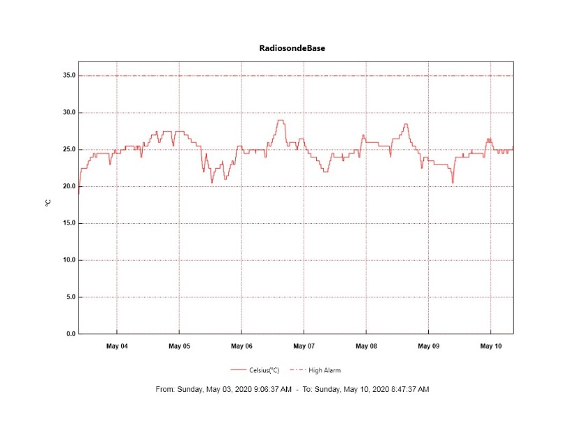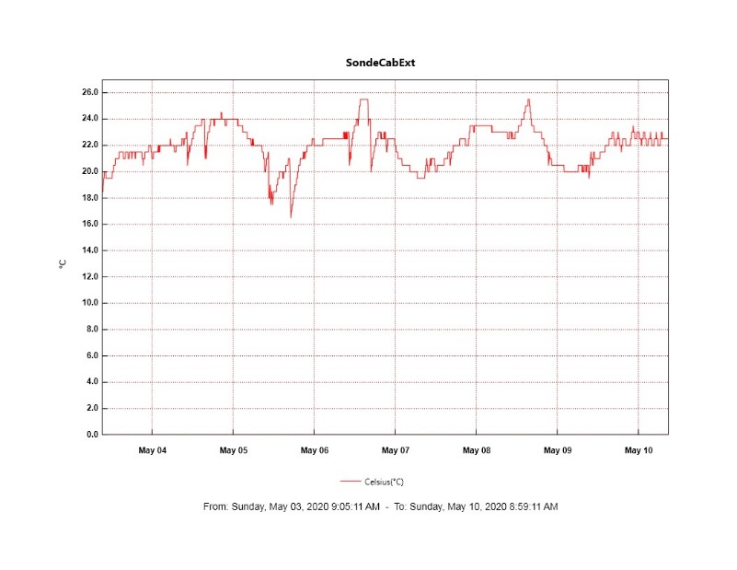

**MWR:**

* HATPRO offsite for repairs. 150-90 online and operating normally.

**SODAR:**

* Operating normally.

**POSS:**

* 2020-05-05: Inspected all POSS cabling and found it to be in good shape.
* 2020-05-06: Replaced heat light bulb found to be burnt out in POSS enclosure.
* Offline

**MASC:**

* The replacement Firewire repeater has arrived in Thule.
* Offline for winter season.

**MMCR:**

* 2020-04-21: Began receiving NetCDF radar errors hourly which can be cleared without issue.
* 2020-05-06: Second occurrence of LabView file not found warning since last reboot.
* 2020-05-08: NetCDF radar errors corrected via remote intervention.
* 2020-05-10: Third occurrence of LabView file not found warning since last reboot.
* Operating normally.

**CAPABL:**

* 2020-05-04: Shut down briefly to remove frost from window. Had to power cycle meadowlark and licel twice to get things to come back up normally.
* Operating normally.

**MPL:**

* Operating normally.

**CEILOMETER:**

* Operating normally.

**PAERI:**

* Operating normally

**IceCAM:**

* Operating normally.

**IcePIC:**

* No photos taken this week.

**CLASP:**

* Offline

**CPC:**

* Offline

**MSF - OPC:**

* 2020-05-04 1152Z: Restarted after outage beginning at 1733Z on 05-03.
* Operating normally.

**TAWO - OPC:**

* Operating normally.

**SKYOPC:**

* Operating normally.

**INP Freezing Assay:**

* 2020-05-06: Weekly assays completed.

**Fluxtower instrument suite:**

* Troubleshooting of snow depth sensor is ongoing.
* Operating normally.

**Radiometers:**

* 2020-05-04: Completed weekly data download
* Operating normally.