**ICECAPS-ACE Weekly Report**

May 18 – May 24, 2020

Nate Bowker

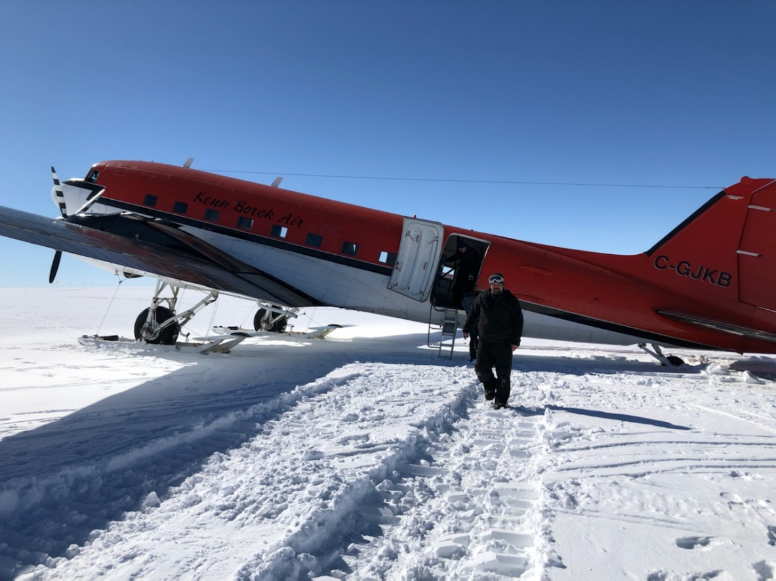

*KBA Basler on deck at Summit on 2020-05-18. Photo Kathy Schroeder*

**General Notes:**

Though not technically part of this reporting period, the most significant news of late is the arrival of the summer crew at Summit on Monday 2020-05-18. Nate and Ian are in the process of making the most of what looks to be a ~24 hour turnover period before Nate departs mid-day on 05-19.

**General Weather Observations:**

|  |  |  |  |  |  |  |  |
| --- | --- | --- | --- | --- | --- | --- | --- |
| **Date** | **Time (Z)** | **Wind** | **Weather** | **Visibility** | **Sky** | **Temp (C)** | **Notes** |
| 05-11 | 12 | 24kt from 265 | BLSN | 300 | VV005 | -16 |  |
| 05-12 | 12 | 22kt from 276 | DRSN FZFG | 600 | BKN006 OVC032 | -12 |  |
| 05-13 | 12 | 14kt from 301 | DRSN FZFG | 1000 | BKN005 | -17 |  |
| 05-14 | 12 | 6kt from 303 | BR | 1600 | BKN003 | -18 |  |
| 05-15 | 12 | 7kt from 239 |  | 9999 | SCT096 | -16 |  |
| 05-16 | 12 | 14kt from 062 | FZFG | 800 | BKN000 | -15 |  |
| 05-17 | 12 | 8kt from 195 | FZFG | 800 | BKN000 BKN065 | -17 |  |

**Significant Weather Observations:**

* None.

**MSF**

* Operating normally

**ICECAPS-ACE Data Management:**

* 05-11: Data transfer completed at 0444Z.
* 05-12: Data transfer completed at 0444Z.
* 05-13: Data transfer completed at 0444Z.
* 05-14: Data transfer completed at 0501Z.
* 05-15: Data transfer completed at 0441Z.
* 05-16: Data transfer completed at 0438Z.
* 05-17: Data transfer completed at 0443Z.

**TSI:**

* 2020-05-11: Found instrument computer had crashed. Upon restart it ran through a file recovery and then rebooted normally. The TSI software was restarted without issue and data collection was resumed at 1246Z.
* 2020-05-12: Computer crashed again restarted at 1827Z.
* 2020-05-13: Computer crashed again. Found with “operating system not found” error.
* 2020-05-14: Installed TSI software on the ceilometer computer. TSI is now collecting images on that machine.
* 2020-05-14: After about 4 hours of running fine on the ceilometer computer, the TSI software started to get hung up persistently, particularly when trying to view the current image. Software was shut down and left off awaiting more troubleshooting advice.
* Offline.

**Radiosonde:**

* 2020-05-11: Further SPS errors seen during particularly warm conditions in the SMG and correlated to the failure of one of the sonde cabinet cooling fans. Fan was replaced.
* 2020-05-16: Changed balloon table plastic.
* 2020-05-16: Further SPS errors were noted during another particularly warm period in the SMG.
* See charts below for temperatures inside and outside the radiosonde cabinet over the last week.

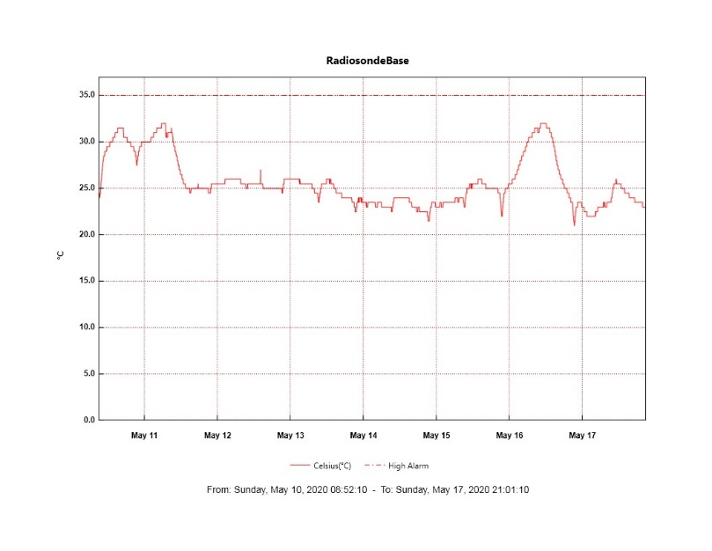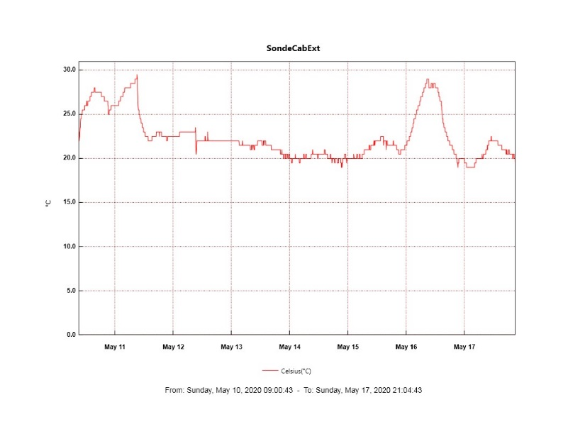

**MWR:**

* HATPRO offsite for repairs. 150-90 online and operating normally.

**SODAR:**

* 2020-05-11 1832-1854Z: Cleaned and leveled SODAR dishes.
* Operating normally.

**POSS:**

* 2020-05-05: Inspected all POSS cabling and found it to be in good shape.
* 2020-05-06: Replaced heat light bulb found to be burnt out in POSS enclosure.
* 2020-05-13: Installed USB temp logger inside the POSS enclosure. When the enclosure was opened the light bulb (heater) was observed to be on but then promptly burst and burned out when exposed to the colder outside air. No replacement was installed.
* 2020-05-14: Removed USB temp logger with ~20 hrs of temperature data from inside the POSS enclosure.
* Offline

**MASC:**

* Offline for winter season.

**MMCR:**

* 2020-05-13 ~2300-2359Z: Small transmitter power fluctuation observed.
* 2020-05-14: Received LabView file not found error.
* 2020-05-15: LabView error caused data after 1900Z not to populate in the ARM folder as usual. This backlog of data was populated on 5/16 after the error was cleared.
* Operating normally.

**CAPABL:**

* 2020-05-16 1700-1712Z: Shut down in order to remove old Steffen radio cables from roof deck above window. Also removed snow from deck around window.
* Operating normally.

**MPL:**

* 2020-05-16 1021-1039Z: Performed monthly afterpulse calibration.
* Operating normally.

**CEILOMETER:**

* Operating normally.

**PAERI:**

* Operating normally

**IceCAM:**

* Operating normally.

**IcePIC:**

* No photos taken this week.

**CLASP:**

* Offline

**CPC:**

* Offline

**MSF - OPC:**

* 2020-05-11 1720Z: Restarted after outage beginning at 1120Z on 05-10.
* Operating normally.

**TAWO - OPC:**

* Operating normally.

**SKYOPC:**

* Operating normally.

**INP Freezing Assay:**

* 2020-05-13: Weekly assays completed.

**Fluxtower instrument suite:**

* Troubleshooting of snow depth sensor is ongoing.
* Operating normally.

**Radiometers:**

* 2020-05-11: Completed weekly data download
* Operating normally.