**ICECAPS-ACE Weekly Report**

May 18 – May 24, 2020

Ian Geraghty



*22° halo with parhelia and parhelic circle observed on May 22, 2020. Photo Ian Geraghty*

**General Notes:**

This week has primarily been spent getting familiarized with Summit in general, the MSF, and the regular checks/tasks for the ICECAPS instrumentation. There haven’t been any critical issues that have come up since turnover which has made this process stress-free and enjoyable!

**General Weather Observations:**

|  |  |  |  |  |  |  |  |
| --- | --- | --- | --- | --- | --- | --- | --- |
| **Date** | **Time (Z)** | **Wind** | **Weather** | **Visibility** | **Sky** | **Temp (C)** | **Notes** |
| 05-18 | 12 | 5kt from 39 | BR | 4800 | FEW032 | -20 |  |
| 05-19 | 12 | 5kt from 220 |  | 9999 | FEW032 | -21 |  |
| 05-20 | 12 | 9kt from 115 |  | 9999 | FEW032 | -20 |  |
| 05-21 | 12 | 12kt from 122 |  | 9999 | SCT065  SCT130  SCT230 | -19 |  |
| 05-22 | 12 | 12kt from 244 | IC FZFG DRSN | 800 | BKN000 | -19 |  |
| 05-23 | 12 | 11kt from 337 | _-SN FZFG DRSN | 1600 | SCT000  SCT015  BKN032 | -16 |  |
| 05-24 | 12 | 8kt from 96 |  | 9999 | FEW032  SCT164 | -22 |  |

**Significant Weather Observations:**

* 22° halo with parhelia observed on 05/22/2020 0945 – 1830Z.
* Kelvin-Helmholtz clouds seen to the south on 05/22/2020 1325 – 1335Z.
* Parhelic circle and diamond dust occurred on 05/22/2020 1400 – 1830Z. Parhelic circle encircled entire sky.

**MSF**

* Operating normally

**ICECAPS-ACE Data Management:**

* 05-18: Data transfer completed at 0440Z.
* 05-19: Data transfer completed at 0441Z.
* 05-20: Data transfer completed at 0440Z.
* 05-21: Data transfer completed at 0442Z.
* 05-22: Data transfer completed at 0444Z.
* 05-23: Data transfer completed at 0444Z.
* 05-24: Data transfer completed at 0440Z.

**TSI:**

* Offline.

**Radiosonde:**

* Operating normally. No SPS errors occurred.
* 2020-05-21: Verified that the 3 internal SPS fans were working.
* See charts below for temperatures inside and outside the radiosonde cabinet over the last week.

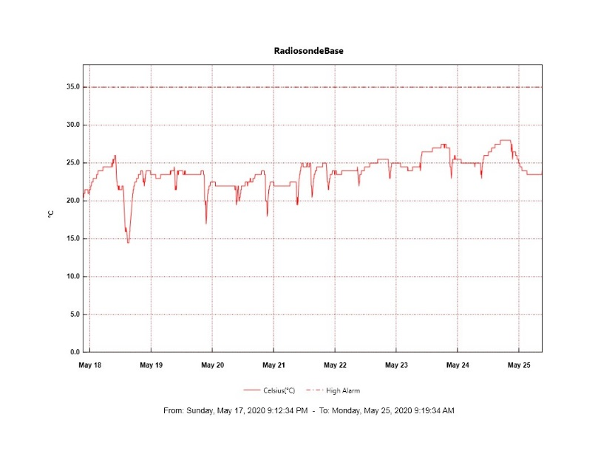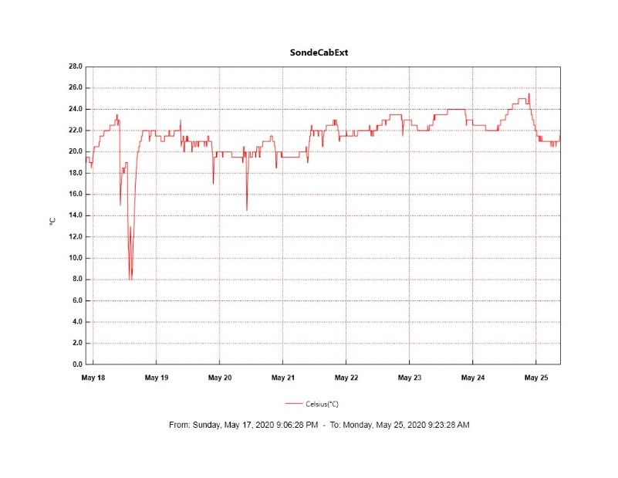

**MWR:**

* HATPRO offsite for repairs. 150-90 online and operating normally.

**SODAR:**

* 2020-05-21 1904-1945Z: Cleaned SODAR dishes.
* 2020-05-22 1831-2022Z: Cleaned and leveled receiver dish.
* Operating normally.

**POSS:**

* Offline

**MASC:**

* 2020-05-24 1907Z: Data acquisition restarted after replacing firewire repeaters. Snow dropped through decagon to test functionality and images were recorded.

**MMCR:**

* 2020-05-19: Received LabView file not found error. Error caused data after 1600Z not to populate in ARM folder until error was cleared at ~1900Z.
* Operating normally. No sudden transmitter power drops observed.

**CAPABL:**

* Operating normally.

**MPL:**

* Operating normally.

**CEILOMETER:**

* Operating normally.

**PAERI:**

* Operating normally

**IceCAM:**

* Operating normally.

**IcePIC:**

* 05/22/2020: Attempt made to take samples at ~1600Z but no good photos collected.

**CLASP:**

* Offline

**CPC:**

* Offline

**MSF - OPC:**

* Operating normally.
* 2020-05-23: Sporadic spikes in particle counts observed between 0730 – 1930Z. Possibly due to NW winds and snowmobile/SMG activity (not as prominent as in SKYOPC data).

**TAWO - OPC:**

* Operating normally.

**SKYOPC:**

* Operating normally.
* 2020-05-23: Sporadic spikes in particle counts observed between 0730 – 1930Z. Possibly due to NW winds and snowmobile/SMG activity.

**INP Freezing Assay:**

* 2020-05-13: Weekly assays completed.
* 2020-05-20: Additional filters added to sampler.

**Fluxtower instrument suite:**

* Troubleshooting of snow depth sensor is ongoing.
* Operating normally.

**Radiometers:**

* 2020-05-11: Completed weekly data download.
* Operating normally.