**ICECAPS-ACE Weekly Report**

May 25 – May 31, 2020

Ian Geraghty

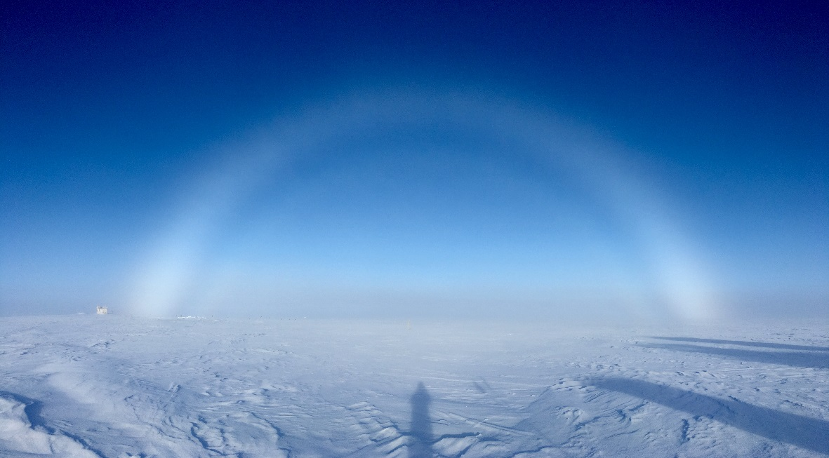

*Fog bow observed on May 31, 2020. Photo Ian Geraghty*

**General Notes:**

Troubleshooting of offline instruments such as the TSI and POSS were the major tasks for this week.

**General Weather Observations:**

|  |  |  |  |  |  |  |  |
| --- | --- | --- | --- | --- | --- | --- | --- |
| **Date** | **Time (Z)** | **Wind** | **Weather** | **Visibility** | **Sky** | **Temp (C)** | **Notes** |
| 05-25 | 12 | 10kt from 124 | IC | 9999 | BKN032 | -22 |  |
| 05-26 | 12 | 4kt from 159 | IC | 9999 | BKN032 | -24 |  |
| 05-27 | 12 | 4kt from 212 | IC | 9999 | FEW032  SCT080 | -22 |  |
| 05-28 | 12 | 8kt from 153 | -SN BR | 3200 | SCT015  BKN080 | -20 |  |
| 05-29 | 12 | 17kt from 137 | IC BR | 4800 | BKN015  BKN080 | -16 | 22˚ halo |
| 05-30 | 12 | 15kt from 155 | IC BR BLSN | 1600 | SCT000  SCT015  BKN032 | -14 | Faint 22˚ halo |
| 05-31 | 12 | 6kt from 280 | IC BR | 4800 | SCT050  SCT164 | -14 | 22˚ halo |

**Significant Weather Observations:**

* 2020-05-31: Fog bow observed from 2315 – 0100Z

**MSF**

* 2020-05-28: Greenheck fan speed increased from 80% to 95% to combat rising temperatures.
* Operating normally.

**ICECAPS-ACE Data Management:**

* 05-25: Data transfer completed at 0440Z.
* 05-26: Data transfer completed at 0440Z.
* 05-27: Data transfer completed at 0439Z.
* 05-28: Data transfer completed at 0440Z.
* 05-29: Data transfer completed at 0729Z.
  + Unexpected network outage between 0357 and 0546Z.
* 05-30: Data transfer completed at 0448Z.
* 05-31: Data transfer completed at 0446Z.

**TSI:**

* 2020-05-29 1325Z: Data acquisition started on ceilometer computer.
* 2020-05-31: Remounted to dataman computer.
* Operational. Monitoring issues with image processing.

**Radiosonde:**

* 2020-05-29: SPS lost communications multiple times during the 1000Z hour. Temperature in the radiosonde cabinet was 31˚C. Mara was able to quickly cool down SMG which resolved SPS errors for the 1200Z launch.
* 2020-05-30: 0000Z radiosonde terminated at 13404m due to temperature sensor failure.
* See charts below for temperatures inside and outside the radiosonde cabinet over the last week.

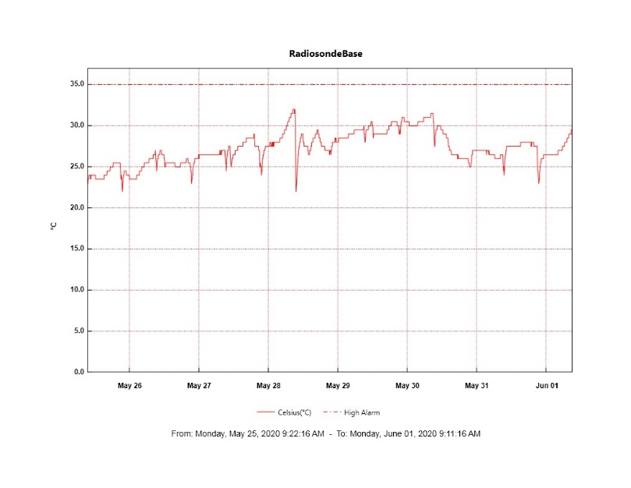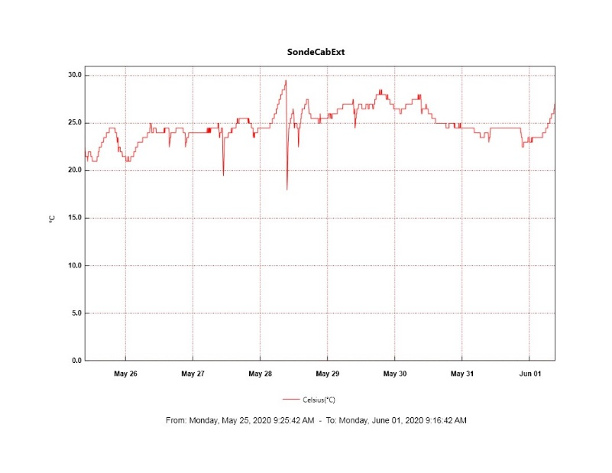

**MWR:**

* HATPRO offsite for repairs. 150-90 online and operating normally.

**SODAR:**

* 2020-05-29 1814 – 1848Z: Cleaned SODAR dishes.
* Operating normally.

**POSS:**

* 2020-05-30 1720 – 1731Z: Power cycled the POSS and Telebyte.
* Offline. Troubleshooting with manufacturer ongoing.

**MASC:**

* Operating normally.

**MMCR:**

* 2020-05-25 1257Z: Received LabView file not found error.
* 2020-05-26 2353Z: Received LabView error that resulted in the MMCR Radar Monitor program being restarted.
* 2020-05-28 2340Z: Received LabView file not found error.
* Operational. Monitoring transmitter power fluctuations between 175 and 178.5 W.

**CAPABL:**

* Operating normally.

**MPL:**

* Operating normally.

**CEILOMETER:**

* Operating normally.

**PAERI:**

* Operating normally.

**IceCAM:**

* Operating normally.

**IcePIC:**

* No IcePICs taken this week.

**CLASP:**

* Offline.

**CPC:**

* Offline.

**MSF - OPC:**

* Operating normally.

**TAWO - OPC:**

* Operating normally.

**SKYOPC:**

* Operating normally.

**INP Freezing Assay:**

* 2020-05-28: Weekly experiments completed

**Fluxtower instrument suite:**

* Troubleshooting of snow depth sensor is ongoing.
* Operating normally.

**Radiometers:**

* 2020-05-25: Completed weekly data download.
* Operating normally.