**ICECAPS-ACE Weekly Report**

June 1 – June 7, 2020

Ian Geraghty

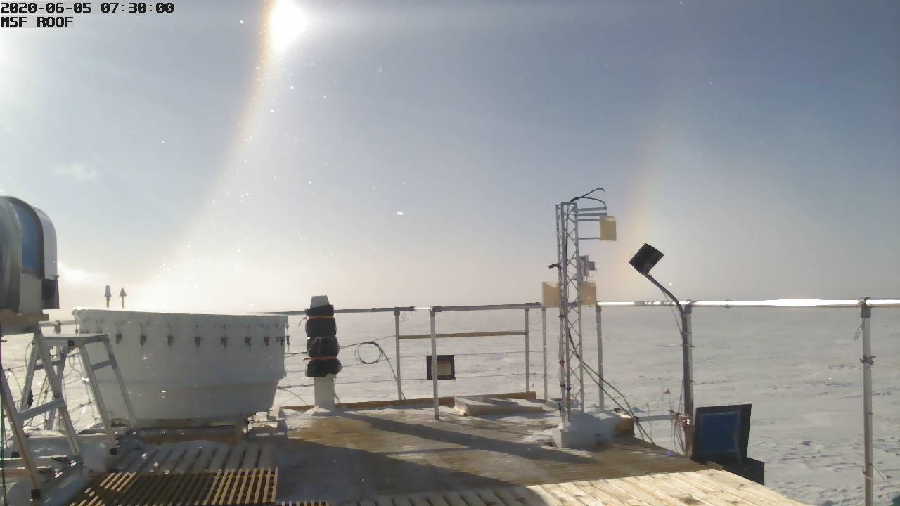

*22° halo with parhelia and a faint 46° halo seen on ICECam photos from June 5.*

**General Notes:**

With flight period 4 officially cancelled, we are thinking proactively about what tasks we can tackle this summer to ensure a smooth winter season.

**General Weather Observations:**

|  |  |  |  |  |  |  |  |
| --- | --- | --- | --- | --- | --- | --- | --- |
| **Date** | **Time (Z)** | **Wind** | **Weather** | **Visibility** | **Sky** | **Temp (C)** | **Notes** |
| 06-01 | 12 | 4kts from 241 | FZFG | 800 | BKN000 | -20 |  |
| 06-02 | 12 | 5kts from 239 | IC | 9999 | SCT032  BKN100 | -17 |  |
| 06-03 | 12 | 7kts from 235 | BR | 4800 | SCT065 | -17 |  |
| 06-04 | 12 | 12kts from 257 | -SN | 1200 | OVC016 | -18 |  |
| 06-05 | 12 | 10kts from 264 | IC | 9999 | FEW032 | -25 |  |
| 06-06 | 12 | 12kts from 225 | -SN | 3200 | OVC015 | -11 |  |
| 06-07 | 12 | 10kts from 216 | -SN | 1600 | SCT015  SCT032 | -13 |  |

**Significant Weather Observations:**

* 2020-06-05 0700 – 0830Z: 22° and 46° halo seen in IceCAM photos.

**MSF**

* Operating normally.

**ICECAPS-ACE Data Management:**

* 06-01: Data transfer completed at 0448Z.
* 06-02: Data transfer completed at 0443Z.
* 06-03: Data transfer did not occur. Older MASC file sent one of the dataman scripts into an infinite loop until computer could be rebooted. Matt made adjustments to code.
* 06-04: Included 06-02 and 06-03 data. Data transfer started at 2232Z and finished at 0616Z.
* 06-05: Data transfer completed at 0525Z.
* 06-06: Data transfer completed at 0450Z.
* 06-07: Data transfer completed at 0537Z.

**TSI:**

* 2020-06-01 1428Z: TSI Manager software rebooted to reinitialize image processing.
* 2020-06-02 1258Z: TSI Manager software rebooted to reinitialize image processing.
* 2020-06-03 1350Z & 2336Z: TSI manager software rebooted to reinitialize image processing.
* Operating normally. No reboots necessary since 2020-06-03.

**Radiosonde:**

* 2020-06-03: 1200Z radiosonde was terminated due to excessive missing GPS heights at 26437m.
* See charts below for temperatures inside and outside the radiosonde cabinet over the last week.

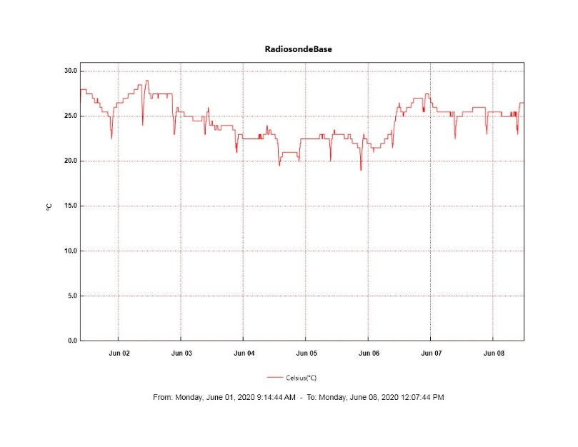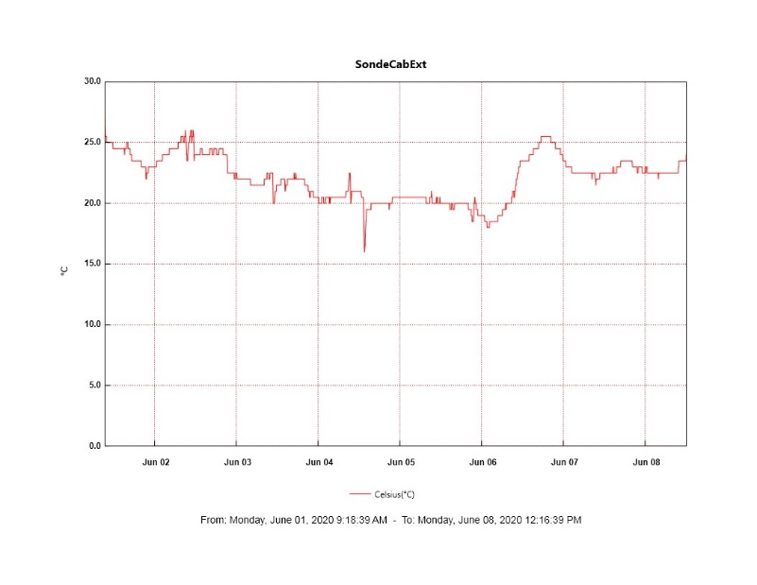

**MWR:**

* HATPRO offsite for repairs. 150-90 online and operating normally.

**SODAR:**

* Operating normally.

**POSS:**

* 2020-06-04: Noticed that the Telebyte display was showing that it was connected to POSS and transmitting data every minute. Still no data coming through in POSACQ software.
* 2020-06-05 1545 - 1732Z: Tried restarting POSACQ, power cycling Telebyte, and checking connections between Telebyte and PC, but still no data coming through in POSACQ.
* Offline. Troubleshooting with manufacturer ongoing.

**MASC:**

* 2020-06-02: Remounted to dataman PC to enable data transfers.
* 2020-06-05 1327Z: Watchdog stopped updating and camera 1 started missing images at 2125Z on 2020-06-04. Issue was resolved after software was restarted.
* Operating normally.

**MMCR:**

* Operating normally. Monitoring transmitter power fluctuations.

**CAPABL:**

* Operating normally.

**MPL:**

* Operating normally.

**CEILOMETER:**

* Operating normally.

**PAERI:**

* Operating normally.

**IceCAM:**

* 2020-06-03: Images for 0130 – 1100Z were missed due to dataman PC issue.
* Operating normally.

**IcePIC:**

* No IcePICs taken this week.

**CLASP:**

* Offline.

**CPC:**

* Offline.

**MSF - OPC:**

* Operating normally.

**TAWO - OPC:**

* Operating normally.

**SKYOPC:**

* Operating normally.

**INP Freezing Assay:**

* 2020-06-03: Weekly experiments completed.

**Fluxtower instrument suite:**

* 2020-06-06: Snow depth sensor cable repaired.
* Operating normally.

**Radiometers:**

* 2020-06-01: Completed weekly data download.
* Operating normally.