**ICECAPS-ACE Weekly Report**

June 8 – June 14, 2020

Ian Geraghty



*00Z radiosonde launch on June 12. Photo by Gene Kornman.*

**General Notes:**

High winds and cloudy skies prevented the PAERI thermistor replacement and CAPABL flashlamp change from occurring this week.

**General Weather Observations:**

|  |  |  |  |  |  |  |  |
| --- | --- | --- | --- | --- | --- | --- | --- |
| **Date** | **Time (Z)** | **Wind** | **Weather** | **Visibility** | **Sky** | **Temp (C)** | **Notes** |
| 06-08 | 12 | 13kts from 226 | DRSN | 9999 | BKN015 | -10 |  |
| 06-09 | 12 | 12kts from 139 | FZFG | 800 | OVC000 | -11 |  |
| 06-10 | 12 | 17kts from 192 | BR | 1600 | BKN000  BKN064 | -8 |  |
| 06-11 | 12 | 13kts from 233 | BR DRSN | 4800 | SCT015  BKN032 | -12 |  |
| 06-12 | 12 | 23kts from 297 | BR BLSN | 700 | BKN015 | -17 |  |
| 06-13 | 12 | 15kts from 106 |  | 9999 | BKN032 | -17 |  |
| 06-14 | 12 | 16kts from 136 | BR DRSN | 4800 | SCT032  BKN180 | -18 |  |

**Significant Weather Observations:**

* None.

**MSF**

* Temperature gradient developed across the MSF on 2020/06/08 and increased gradually until it collapsed on 2020/06/12. The cause of this anomaly is unknown. HVAC system is being monitored closely.

**ICECAPS-ACE Data Management:**

* 06-08: Data transfer completed at 0455Z.
* 06-09: Data transfer completed at 0454Z.
* 06-10: Data transfer completed at 0451Z.
* 06-11: Data transfer completed at 0530Z.
* 06-12: Data transfer completed at 0514Z.
* 06-13: Data transfer completed at 0451Z.
* 06-14: Data transfer completed at 0459Z.

**TSI:**

* Operating normally. No reboots necessary since 2020-06-03.

**Radiosonde:**

* 2020-06-13: SPS was found disconnected prior to 1200Z launch. Temperature in the cabinet was ~30˚C. SPS reconnected after Mara power cycled it.
* 2020-06-14: Data from 0000Z launch failed to be transferred to DMI. Possibly due to a brief network outage.
* See charts below for temperatures inside and outside the radiosonde cabinet over the last week.

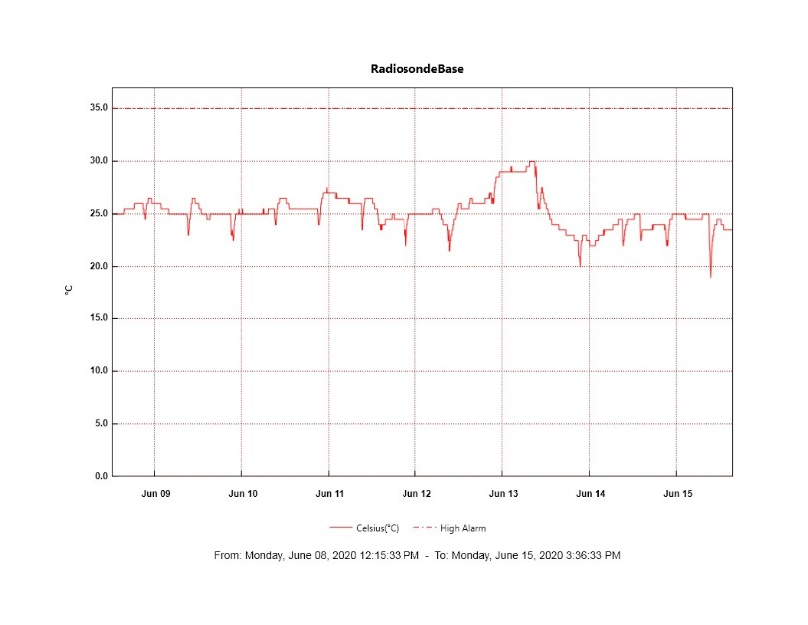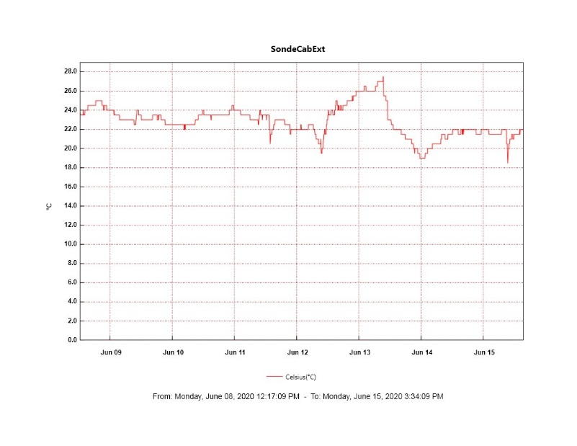

**MWR:**

* HATPRO offsite for repairs. 150-90 online and operating normally.

**SODAR:**

* 2020-06-07 1803 – 1841Z: SODAR dishes cleaned.
* 2020-06-13 1716 - 1802Z: SODAR dishes cleaned after high winds.
* Operating normally.

**POSS:**

* Offline. Troubleshooting with manufacturer ongoing.

**MASC:**

* Operating normally.

**MMCR:**

* Operating normally. Monitoring transmitter power fluctuations.

**CAPABL:**

* Operating normally.

**MPL:**

* Operating normally. Monitoring laser energy fluctuations.

**CEILOMETER:**

* Operating normally.

**PAERI:**

* Operating normally.

**IceCAM:**

* Operating normally.

**IcePIC:**

* No IcePICs taken this week.

**CLASP:**

* Offline.

**CPC:**

* Offline.

**MSF - OPC:**

* Operating normally.

**TAWO - OPC:**

* Operating normally.

**SKYOPC:**

* 2020-06-13 ~1900Z: Pump failure. Replacement to be installed this week.

**INP Freezing Assay:**

* 2020-06-10: Weekly experiments completed.

**Fluxtower instrument suite:**

* 2020-06-10: Snow depth sensor back online after wiring repairs.
* 2020-06-10 0700 – 1254Z: 3D sonic wind anemometers experienced communications issue. Back online after flux laptop reboot.
* Operating normally.

**Radiometers:**

* 2020-06-08: Completed weekly data download.
* Operating normally.