**ICECAPS-ACE Weekly Report**

June 15 – June 21, 2020

Ian Geraghty

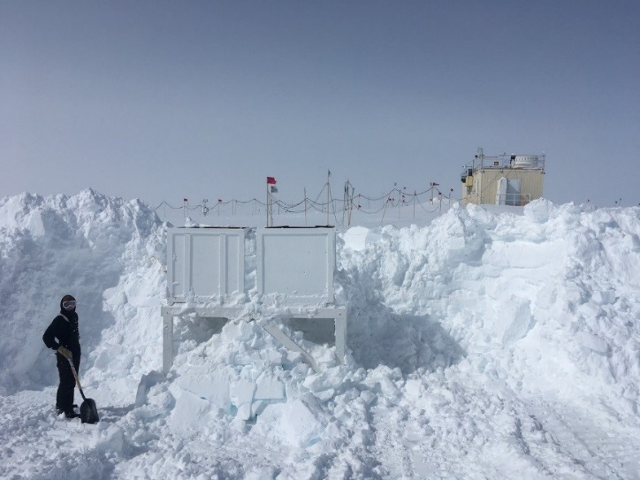 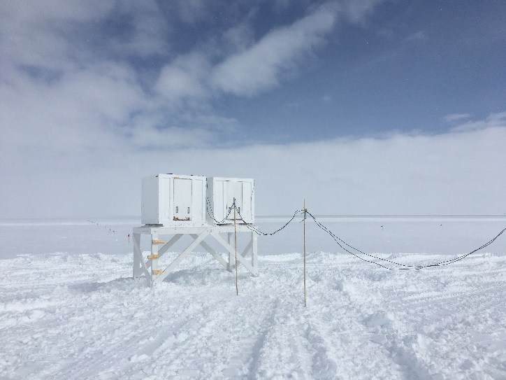

*Raising the SODAR stand on June 19, 2020. Photos by Austin Danicic.*

**General Notes:**

The raising of the SODAR and the completion of other minor tasks made for a productive week. The raising of tower instruments will be the primary focus for the next couple of weeks.

**General Weather Observations:**

|  |  |  |  |  |  |  |  |
| --- | --- | --- | --- | --- | --- | --- | --- |
| **Date** | **Time (Z)** | **Wind** | **Weather** | **Visibility** | **Sky** | **Temp (C)** | **Notes** |
| 06-15 | 12 | 21kts from 112 | BR DRSN | 4800 | SCT015  BKN050  BKN130 | -15 |  |
| 06-16 | 12 | 18kts from 109 | BR DRSN | 1600 | SCT000  SCT032  BKN130 | -13 |  |
| 06-17 | 12 | 10kts from 172 |  | 9999 | BKN023 | -15 |  |
| 06-18 | 12 | 10kts from 163 | IC | 9999 | FEW008 | -15 | 22° halo with parhelic circle |
| 06-19 | 12 | 11kts from 144 | BR | 4800 | SCT015 | -14 |  |
| 06-20 | 12 | 7kts from 76 |  | 9999 | FEW032 | -16 |  |
| 06-21 | 12 | 16kts from 148 | DRSN | 3200 | OVC030 | -10 |  |

**Significant Weather Observations:**

* 2020-06-18 0900 – 1116Z: 22° halo with parhelia and parhelic circle seen in TSI photos.

**MSF**

* 2020-06-15 1110 – 1250Z: Drifting snow to the north of MSF removed.
* 2020-06-19 1145 – 1815Z: Drifting snow to the north of MSF removed.

**ICECAPS-ACE Data Management:**

* 06-15: Data transfer completed at 0452Z.
* 06-16: Data transfer completed at 0450Z.
* 06-17: Data transfer completed at 0453Z.
* 06-18: Data transfer completed at 0515Z.
* 06-19: Data transfer completed at 0449Z.
* 06-20: Data transfer completed at 0447Z.
* 06-21: Data transfer completed at 0452Z.

**TSI:**

* 2020-06-16: Software rebooted to reinitialize image processing.
* 2020-06-17: Software rebooted to reinitialize image processing.
* 2020-06-18: Software rebooted to reinitialize image processing.
* 2020-06-19: Software rebooted to reinitialize image processing.
* Operational.

**Radiosonde:**

* No SPS connectivity issues occurred this week.
* See charts below for temperatures inside and outside the radiosonde cabinet over the last week.

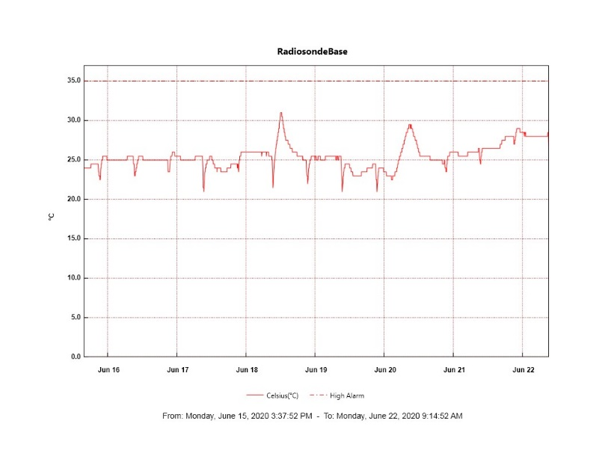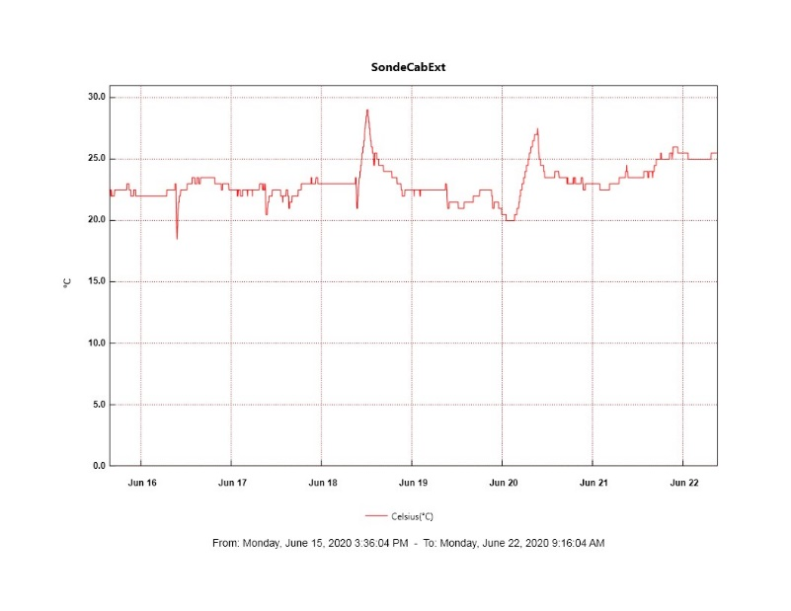

**MWR:**

* 2020-06-17 1100 – 1121Z: Rec. 1 temperature stability flag went red.
* HATPRO offsite for repairs. 150-90 online and operating normally.

**SODAR:**

* 2020-06-15 1216 – 1417Z: SODAR shutdown for snow removal.
* 2020-06-19 1144 – 1837Z: SODAR stand raised. Dishes cleaned and leveled.
* Operating normally.

**POSS:**

* Offline. Troubleshooting with manufacturer ongoing.

**MASC:**

* Operating normally.

**MMCR:**

* 2020-06-17 1200 – 1500Z: Radar monitor had DwellControl_Calibration error after daily calibration. Error cleared at 1455Z.
* 2020-06-20 0600Z: LapXM started getting recurring “Could not read calibration table NetCDF file” error messages.
* Operating normally. Monitoring transmitter power fluctuations.

**CAPABL:**

* 2020-06-18 1900 – 2030Z: Laser 2 flashlamp change.
* Operating normally.

**MPL:**

* 2020-06-15 1801 – 1833Z: Monthly afterpulse calibration completed.
* Operating normally. Monitoring laser energy fluctuations.

**CEILOMETER:**

* Operating normally.

**PAERI:**

* 2020-06-20: Outside air temperature thermistor replaced.
* Operating normally.

**IceCAM:**

* Operating normally.

**IcePIC:**

* No IcePICs taken this week.

**CLASP:**

* Offline.

**CPC:**

* Offline.

**MSF - OPC:**

* Operating normally.

**TAWO - OPC:**

* Operating normally.

**SKYOPC:**

* 2020-06-17 1713Z: Data acquisition restarted after new pump was installed.
* Operating normally.

**INP Freezing Assay:**

* 2020-06-17: Weekly experiments completed. Cold stages auto-calibrated.

**Fluxtower instrument suite:**

* Operating normally.

**Radiometers:**

* 2020-06-15: Completed weekly data download.
* Operating normally.