**ICECAPS-ACE Weekly Report**

June 22 – June 28, 2020

Ian Geraghty

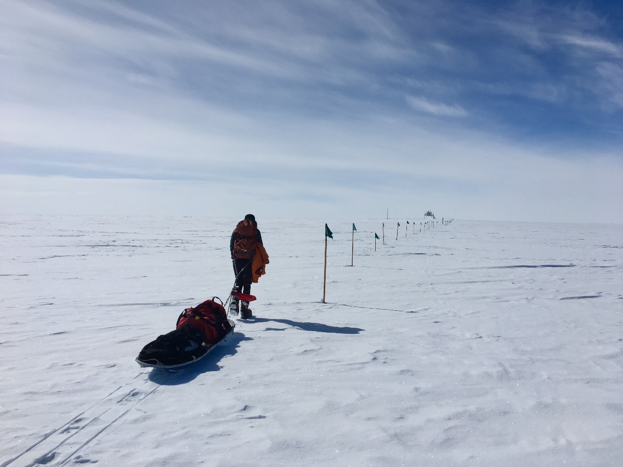

*Mara hauling tower equipment out to TAWO on June 26.*

**General Notes:**

Tower work for the summer season has commenced with the raising of the KT15 and some of the NOAA equipment.

**General Weather Observations:**

|  |  |  |  |  |  |  |  |
| --- | --- | --- | --- | --- | --- | --- | --- |
| **Date** | **Time (Z)** | **Wind** | **Weather** | **Visibility** | **Sky** | **Temp (C)** | **Notes** |
| 06-22 | 12 | 5kts from 045 | -SN | 4800 | OVC023 | -8 |  |
| 06-23 | 12 | 9kts from 045 | -SN | 9999 | OVC017 | -6 |  |
| 06-24 | 12 | 5kts from 155 | BR -SN | 4800 | BKN015  BKN064 | -10 |  |
| 06-25 | 12 | 16kts from 273 | BR -SN | 3200 | SCT015  BKN040 | -11 |  |
| 06-26 | 12 | 4kts from 134 | IC | 9999 | SCT032  BKN164 | -14 |  |
| 06-27 | 12 | 9kts from 128 |  | 9999 | FEW032  FEW064 | -17 | Clouds distant; height estimated |
| 06-28 | 12 | 12kts from 080 |  | 9999 | SCT082  BKN196 | -13 |  |

**Significant Weather Observations:**

* None

**MSF**

* None

**ICECAPS-ACE Data Management:**

* 06-22: Data transfer completed at 0453Z.
* 06-23: Data transfer completed at 0449Z.
* 06-24: Data transfer completed at 0540Z.
* 06-25: Data transfer completed at 0522Z.
* 06-26: Data transfer completed at 0551Z.
* 06-27: Data transfer completed at 0504Z.
* 06-28: Data transfer completed at 0449Z.

**TSI:**

* 2020-06-25: Software rebooted to reinitialize image processing.
* Operational.

**Radiosonde:**

* No SPS connectivity issues occurred this week.
* See charts below for temperatures inside and outside the radiosonde cabinet over the last week.

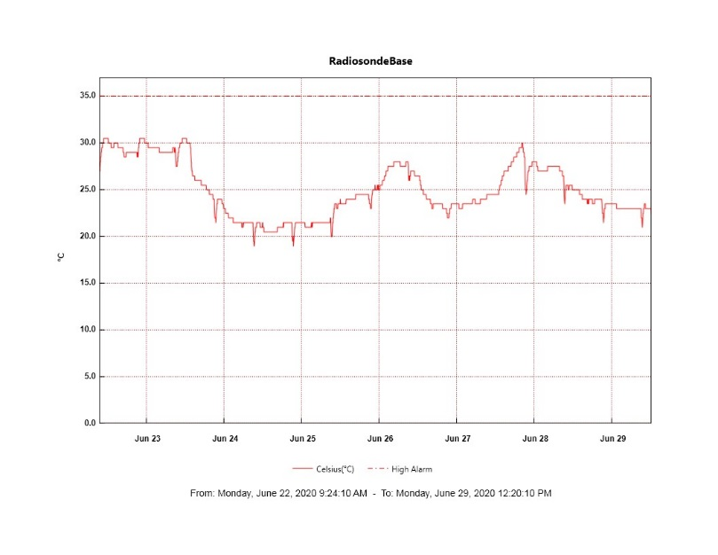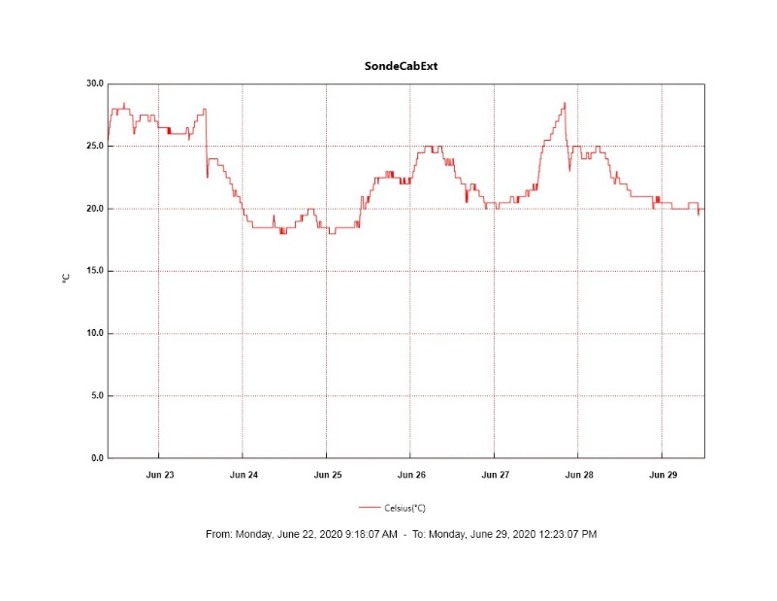

**MWR:**

* HATPRO offsite for repairs. 150-90 online and operating normally.

**SODAR:**

* 2020-06-22 1600 - 1608: Cleaned SODAR dishes.
* Operating normally.

**POSS:**

* 2020-06-27: POSS data cable passed continuity test.
* Offline. Troubleshooting with manufacturer ongoing.

**MASC:**

* Operating normally.

**MMCR:**

* 2020-06-22 1714 – 1850Z: Full system reboot to resolve NetCDF errors.
* Operating normally. Monitoring transmitter power fluctuations.

**CAPABL:**

* Operating normally.

**MPL:**

* Operating normally. Monitoring laser energy fluctuations.

**CEILOMETER:**

* Operating normally.

**PAERI:**

* Operating normally.

**IceCAM:**

* Operating normally.

**IcePIC:**

* No IcePICs taken this week.

**CLASP:**

* Offline.

**CPC:**

* Offline.

**MSF - OPC:**

* Operating normally.

**TAWO - OPC:**

* Operating normally.

**SKYOPC:**

* Operating normally.

**INP Freezing Assay:**

* 2020-06-24: Weekly experiments completed. Cold stages auto-calibrated.

**Fluxtower instrument suite:**

* 2020-06-26: KT15 raised.
* Operating normally.

**Radiometers:**

* 2020-06-22: Completed weekly data download.
* Operating normally.