**ICECAPS-ACE Weekly Report**

June 29 – July 5, 2020

Ian Geraghty

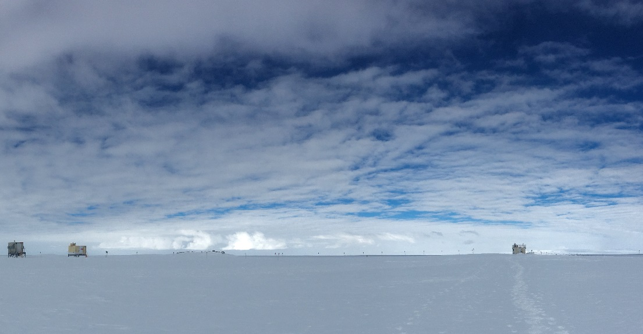

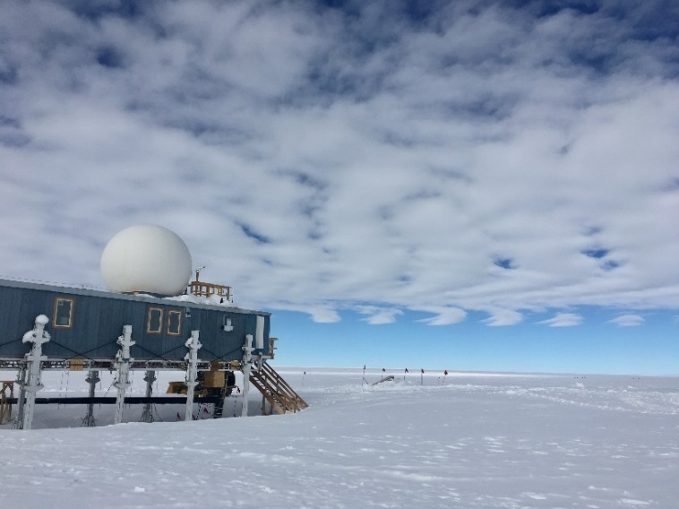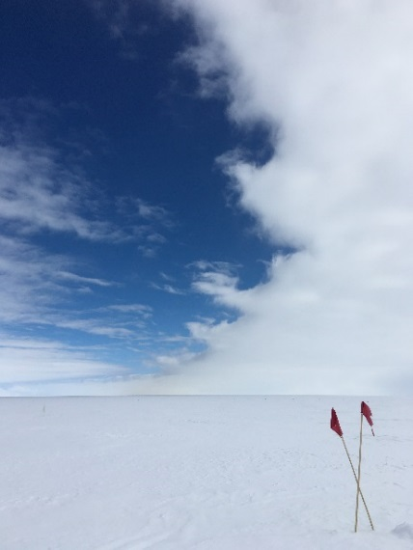

*Various low-level clouds seen throughout the week.*

**General Notes:**

Summit experienced its warmest temperatures so far this summer, with it reaching -1.7 °C on 2020-07-01. Tower work was postponed due to the possibility of an upcoming melt event.

**General Weather Observations:**

|  |  |  |  |  |  |  |  |
| --- | --- | --- | --- | --- | --- | --- | --- |
| **Date** | **Time (Z)** | **Wind** | **Weather** | **Visibility** | **Sky** | **Temp (C)** | **Notes** |
| 06-29 | 12 | 26kts at 136 | BR DRSN | 1600 | BKN017  BKN064 | -8 |  |
| 06-30 | 12 | 10kts at 112 |  | 9999 | BKN020 | -6 |  |
| 07-01 | 12 | 7kts at 358 |  | 9999 | SCT015  BKN035 | -3 |  |
| 07-02 | 12 | 3kts at 027 |  | 9999 | FEW015  BKN035 | -3.5 |  |
| 07-03 | 12 | 7kts at 193 |  | 9999 | BKN000 | -7 |  |
| 07-04 | 12 | 4kts at 223 |  | 9999 | BKN015 | -11 |  |
| 07-05 | 12 | 3kts at 213 | -SN | 9999 | FEW015  BKN064  BKN114 | -10 |  |

**Significant Weather Observations:**

* 2020-06-03 1000Z: Minor Kelvin-Helmholtz cloud seen at the boundary of a stratocumulus layer.

**MSF**

* None

**ICECAPS-ACE Data Management:**

* 06-29: Data transfer completed at 1314Z.
  + Network outage between 0600 – 0630Z. Transfer picked up again once connection was restored.
* 06-30: Data transfer completed at 0450Z.
* 07-01: Data transfer completed at 0602Z.
* 07-02: Data transfer completed at 0510Z.
* 07-03: Data transfer completed at 0452Z.
* 07-04: Data transfer completed at 0454Z.
* 07-05: Data transfer completed at 0502Z.

**TSI:**

* 2020-07-02: Software rebooted to reinitialize image processing.
* Operational.

**Radiosonde:**

* No SPS connectivity issues occurred this week.
* See charts below for temperatures inside and outside the radiosonde cabinet over the last week.

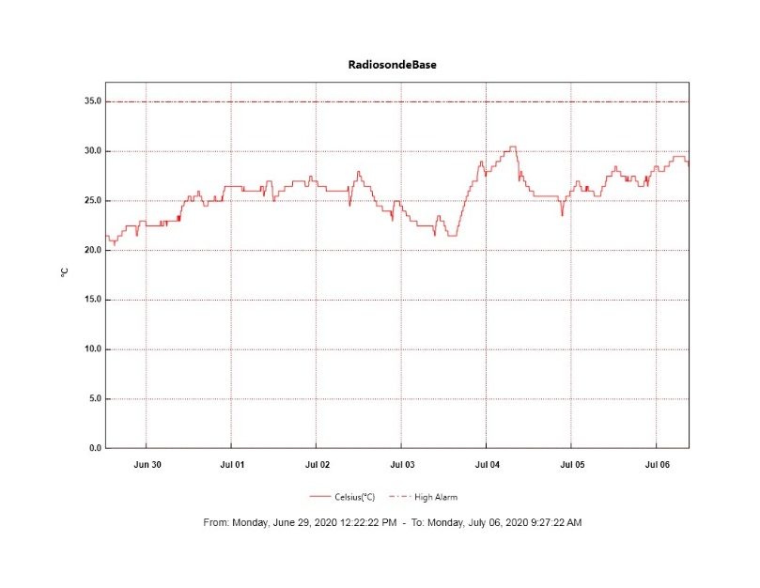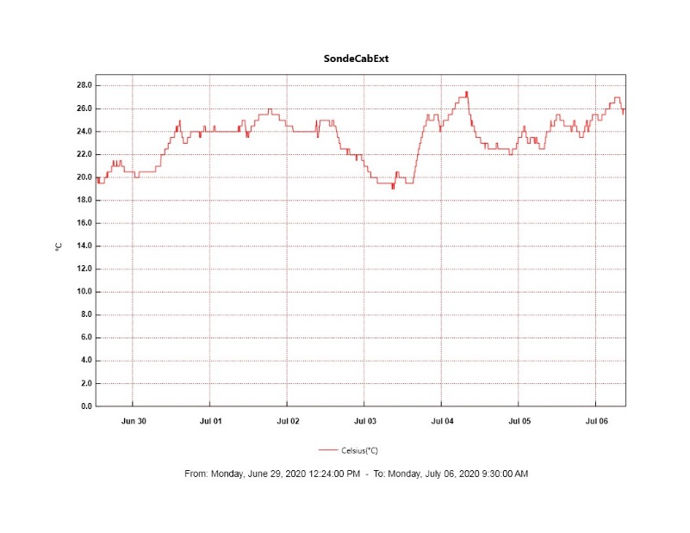

**MWR:**

* HATPRO offsite for repairs. 150-90 online and operating normally.

**SODAR:**

* 2020-06-29 1200 – 1208Z: Cleaned SODAR dishes.
* 2020-07-02 1336 – 1343Z: Cleaned SODAR dishes.
* Operating normally.

**POSS:**

* Offline. Troubleshooting with manufacturer ongoing.

**MASC:**

* 2020-07-02 1353Z: RunMASC restarted because of a few dropped images on camera 1.
* Operating normally.

**MMCR:**

* Operating normally. Monitoring transmitter power fluctuations.

**CAPABL:**

* Operating normally.

**MPL:**

* Operating normally. Monitoring laser energy fluctuations.

**CEILOMETER:**

* Operating normally.

**PAERI:**

* Operating normally.

**IceCAM:**

* Operating normally.

**IcePIC:**

* No IcePICs taken this week.

**CLASP:**

* Offline.

**CPC:**

* Offline.

**MSF - OPC:**

* Operating normally.

**TAWO - OPC:**

* Operating normally.

**SKYOPC:**

* Operating normally.

**INP Freezing Assay:**

* 2020-07-01: Weekly experiments completed.

**Fluxtower instrument suite:**

* Operating normally.

**Radiometers:**

* 2020-06-29: Completed weekly data download.
* Operating normally.