**ICECAPS-ACE Weekly Report**

July 6 – July 12, 2020

Ian Geraghty

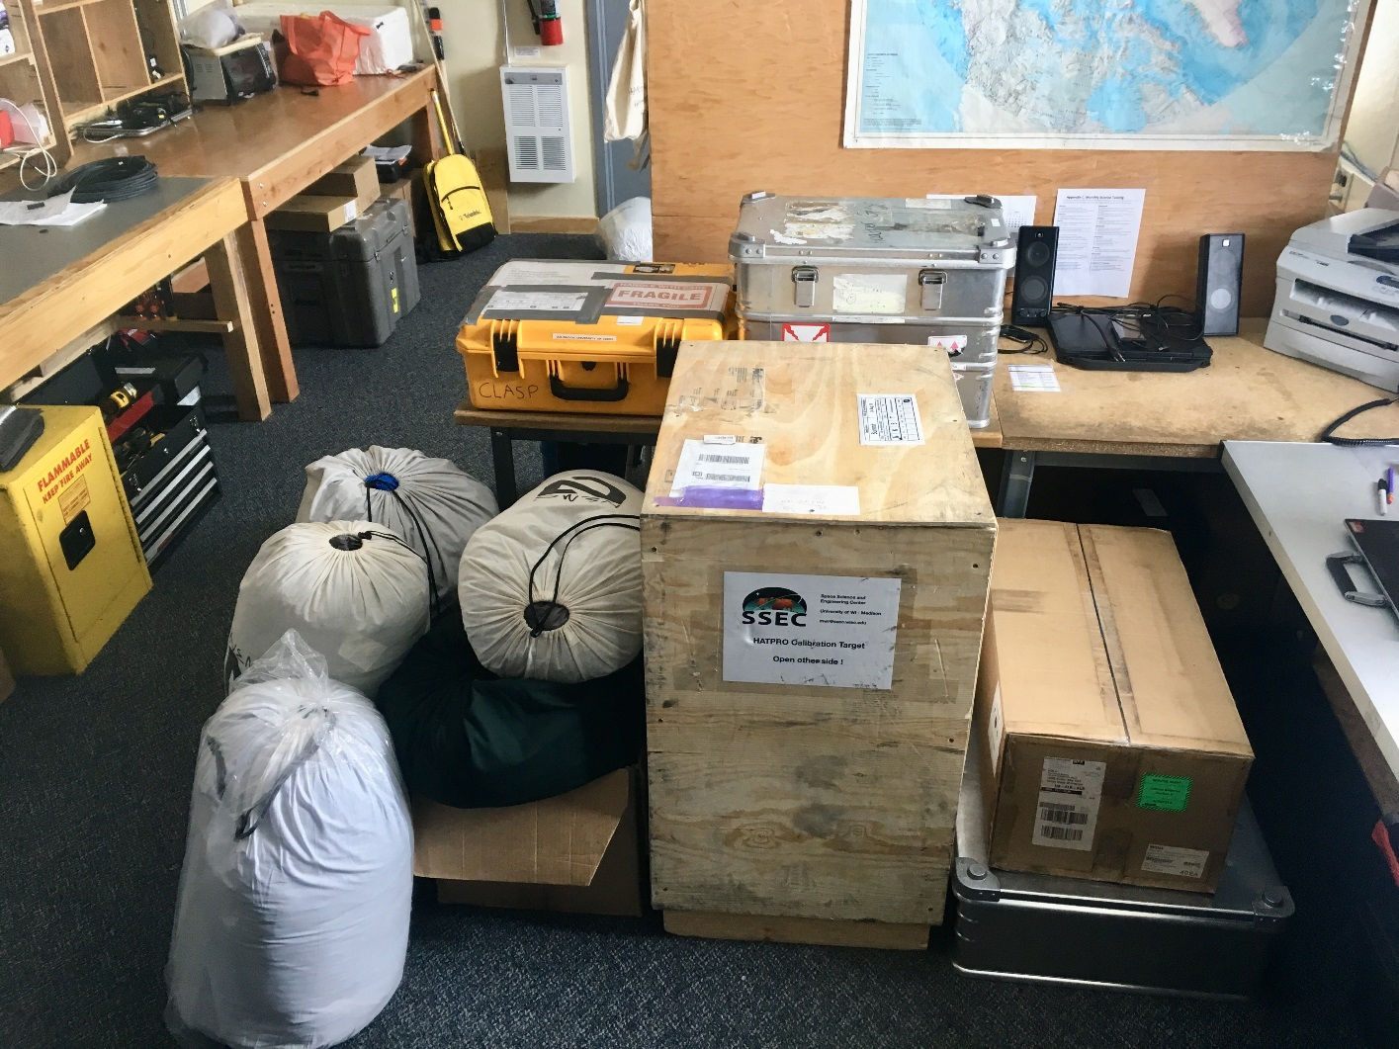

*Some of the southbound cargo staged at the MSF.*

**General Notes:**

This week the SnD and Metek1/HMP1/LiCOR booms on the MET tower were raised and southbound science cargo was prepared for retro.

**General Weather Observations:**

|  |  |  |  |  |  |  |  |
| --- | --- | --- | --- | --- | --- | --- | --- |
| **Date** | **Time (Z)** | **Wind** | **Weather** | **Visibility** | **Sky** | **Temp (C)** | **Notes** |
| 07-06 | 12 | 3kts at 1235 |  | 9999 | BKN061  BKN082 | -12 |  |
| 07-07 | 12 | 9kts at 114 |  | 9999 | BKN011 | -13 |  |
| 07-08 | 12 | 10kts at 064 |  | 9999 | BKN015 | -12 |  |
| 07-09 | 12 | 10kts at 160 | BR | 4800 | OCV008 | -10 |  |
| 07-10 | 12 | 10kts at 228 | BR | 4800 | SCT008  BKN065 | -6 |  |
| 07-11 | 12 | 17kts at 078 |  | 9999 | OVC010 | -5 |  |
| 07-12 | 12 | 15kts at 046 | IC | 1600 | BKN015  BKN050 | -11 |  |

**Significant Weather Observations:**

* None

**MSF**

* Consulting with Eaton technical support to diagnose “Bypass Unavailable” status of the UPS.

**ICECAPS-ACE Data Management:**

* 07-06: Data transfer completed at 0453Z.
* 07-07: Data transfer completed at 0450Z.
* 07-08: Data transfer completed at 0518Z.
* 07-09: Data transfer completed at 0448Z.
* 07-10: Data transfer completed at 0456Z.
* 07-11: Data transfer completed at 0538Z.
* 07-12: Data transfer completed at 0520Z.

**TSI:**

* 2020-07-06: Software rebooted to reinitialize image processing.
* 2020-07-08: Software rebooted to reinitialize image processing.
* 2020-07-12: Software rebooted to reinitialize image processing.
* Operational.

**Radiosonde:**

* See charts below for temperatures inside and outside the radiosonde cabinet over the last week.

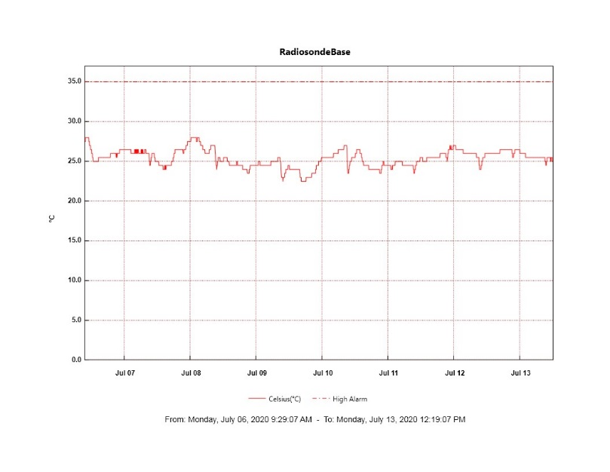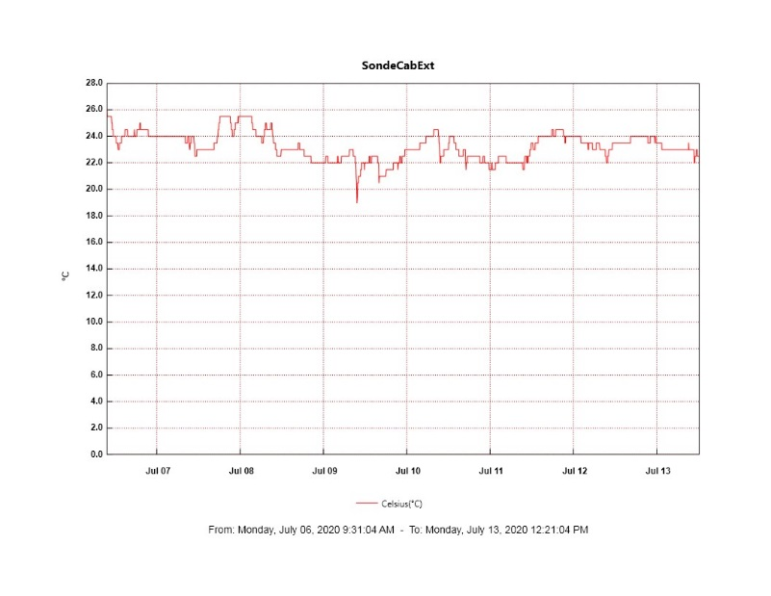

**MWR:**

* HATPRO offsite for repairs. 150-90 online and operating normally.

**SODAR:**

* Operating normally.

**POSS:**

* Offline. Troubleshooting with manufacturer ongoing.

**MASC:**

* Operating normally.

**MMCR:**

* 2020-07-08: TWTA desiccant cartridge replaced.
* 2020-07-08: Received LabView Error 7 “file not found”.
* 2020-07-10: Received LabView Error 7 “file not found”.
* Operating normally. Monitoring transmitter power fluctuations.

**CAPABL:**

* Operating normally.

**MPL:**

* Operating normally. Monitoring laser energy fluctuations.

**CEILOMETER:**

* Operating normally.

**PAERI:**

* Operating normally.

**IceCAM:**

* Operating normally.

**IcePIC:**

* No IcePICs taken this week.

**CLASP:**

* Offline. Staged for retro.

**CPC:**

* Offline. Staged for retro.

**MSF - OPC:**

* Operating normally.

**TAWO - OPC:**

* Operating normally.

**SKYOPC:**

* Operating normally.

**INP Freezing Assay:**

* 2020-07-08: Weekly experiments completed. Assay data and internal instrument data were sent to PI.

**Fluxtower instrument suite:**

* 2020-07-07 1645 – 2100Z: Raised the SnD and Metek1/HMP1/LiCOR booms to > 2m.
* Operating normally.

**Radiometers:**

* 2020-07-06: Completed weekly data download.
* Operating normally.