**ICECAPS-ACE Weekly Report**

July 13 – July 19, 2020

Ian Geraghty

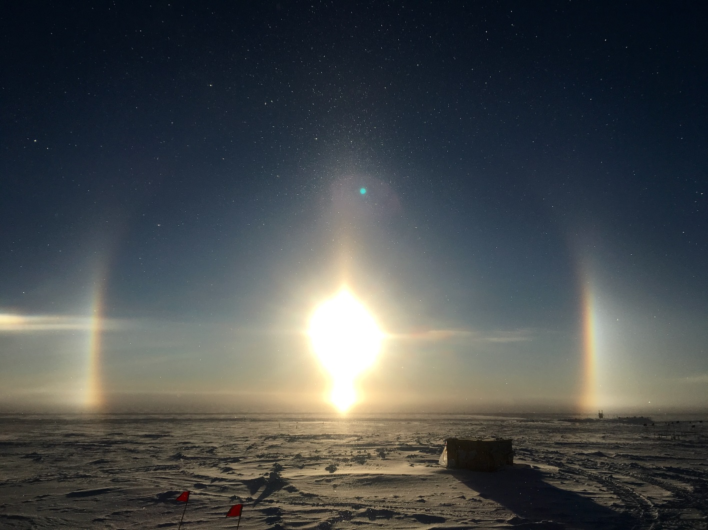

*A very scenic trash pallet during diamond dust event on 2020-07-15.*

**General Notes:**

With only a couple weeks left until flights start arriving, Mara and I are looking to tackle some big, remaining tasks like raising the POSS and albedo stand this week.

**General Weather Observations:**

|  |  |  |  |  |  |  |  |
| --- | --- | --- | --- | --- | --- | --- | --- |
| **Date** | **Time (Z)** | **Wind** | **Weather** | **Visibility** | **Sky** | **Temp (C)** | **Notes** |
| 07-13 | 12 | 18kts at 137 | FZFG DRSN | 1600 | SCT032  SCT064 | -14 | Clouds distant; height estimated |
| 07-14 | 12 | 7kts at 211 | FZFG IC | 1600 | SCT000  BKN075 | -14 | 22° halo, parhelia, and parhelic circle |
| 07-15 | 12 | 11kts at 032 |  | 9999 | BKN013 | -14 |  |
| 07-16 | 12 | 16kts at 052 | BR | 4800 | FEW016 | -14 |  |
| 07-17 | 12 | 12kts at 009 | BR DRSN | 4800 | FEW032  SCT064 | -15 | Clouds distant; height estimated |
| 07-18 | 12 | 8kts at 048 | DRSN | 9999 | FEW032 | -18 |  |
| 07-19 | 12 | 6kts at 345 |  | 9999 | FEW016  FEW032 | -13 |  |

**Significant Weather Observations:**

* 2020-07-14 1230Z: 22° halo with parhelia and faint parhelic circle.

**MSF**

* UPS testing planned for 2020-07-20.

**ICECAPS-ACE Data Management:**

* 07-13: Data transfer completed at 0520Z.
* 07-14: Data transfer completed at 0547Z.
* 07-15: Data transfer completed at 0457Z.
* 07-16: Data transfer completed at 0525Z.
* 07-17: Data transfer completed at 0455Z.
* 07-18: Data transfer completed at 0454Z.
* 07-19: Data transfer completed at 0447Z.

**TSI:**

* 2020-07-16: Software rebooted to reinitialize image processing.
* Operational.

**Radiosonde:**

* 2020-07-14 1200Z: SPS lost connection and radiosonde signal was lost multiple times during the flight. Sounding terminated at ~20km due to “weak or fading signal”.
* 2020-07-15 0000Z: SPS status lights were red upon arrival at SMG. After power cycling, SPS was ok for the sounding. After the sounding was complete, the SPS lost connection multiple times.
* See charts below for temperatures inside and outside the radiosonde cabinet over the last week.

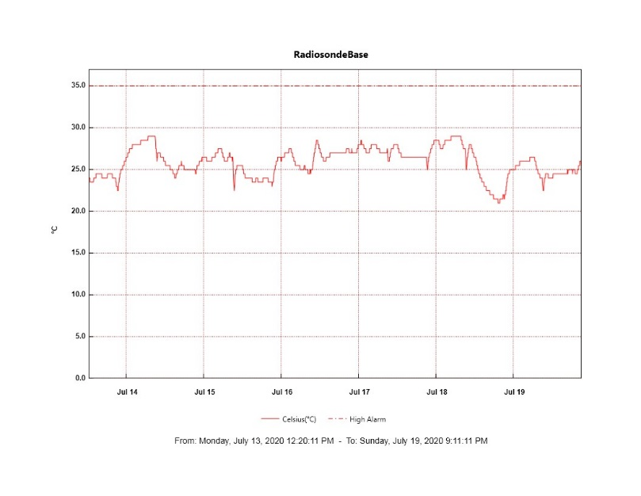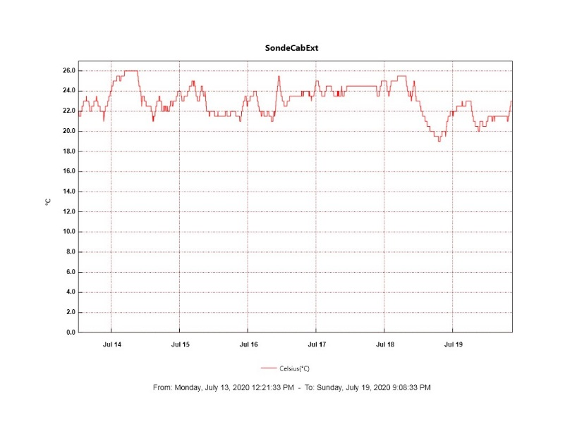

**MWR:**

* 2020-07-14: Anomaly caused change in computer date. Data between 0000Z and 1234Z is unaccounted for. Computer date and filenames were corrected on 2020-07-15.
* HATPRO offsite for repairs. 150-90 online and operating normally.

**SODAR:**

* 2020-07-13 1734 – 1747Z: Dishes cleaned and leveled.
* Operating normally.

**POSS:**

* Offline. Troubleshooting with manufacturer ongoing.

**MASC:**

* Operating normally.

**MMCR:**

* 2020-07-16: Received LabView Error 7 “file not found”.
* 2020-07-18: Received LabView Error 7 “file not found”.
* 2020-07-19: LapXM DwellControl_Calibration errors at 1230Z daily calibration due to Labview error on 2020-07-18 not being cleared yet. Daily calibration was skipped.
* Operating normally. Monitoring transmitter power fluctuations.

**CAPABL:**

* Operating normally.

**MPL:**

* 2020-07-15 1301 – 1329Z: Monthly afterpulse calibration.
* Operating normally. Monitoring laser energy fluctuations.

**CEILOMETER:**

* Operating normally.

**PAERI:**

* Operating normally.

**IceCAM:**

* Operating normally.

**IcePIC:**

* No IcePICs taken this week.

**CLASP:**

* Offline. Staged for retro.

**CPC:**

* Offline. Staged for retro.

**MSF - OPC:**

* Operating normally.

**TAWO - OPC:**

* Operating normally.

**SKYOPC:**

* 2020-07-15 ~0000Z: Pump failure. Instrument was powered off at 1041Z.
* Operating normally.

**INP Freezing Assay:**

* 2020-07-15: Weekly experiments completed. Assay data and internal instrument data were sent to PI.

**Fluxtower instrument suite:**

* Operating normally.

**Radiometers:**

* 2020-07-13: Completed weekly data download.
* Operating normally.