**ICECAPS-ACE Weekly Report**

July 20 – July 26, 2020

Ian Geraghty



*Downward propagating clouds with the Sun low in the sky on 2020-07-22.*

**General Notes:**

This week’s tests of the UPS showed that it had the functionality to make uninterrupted transfers to the batteries and station power. However, the UPS is still experiencing active bypass unavailable alarms and performing unwarranted battery tests. Currently, the plan is to use the unit through the winter with the knowledge that the bypass capabilities might be compromised.

**General Weather Observations:**

|  |  |  |  |  |  |  |  |
| --- | --- | --- | --- | --- | --- | --- | --- |
| **Date** | **Time (Z)** | **Wind** | **Weather** | **Visibility** | **Sky** | **Temp (C)** | **Notes** |
| 07-20 | 12 | 7kts at 249 |  | 9999 | SCT115 | -16 |  |
| 07-21 | 12 | 11kts at 261 |  | 9999 | BKN064 | -12 |  |
| 07-22 | 12 | 9kts at 041 |  | 9999 | BKN010 | -13 |  |
| 07-23 | 12 | 5kts at 344 |  | 9999 | SCT064  BKN115 | -14 |  |
| 07-24 | 12 | 6kts at 229 | -SN | 3200 | OVC032 | -12 |  |
| 07-25 | 12 | 7kts at 240 |  | 9999 | BKN015 | -11 |  |
| 07-26 | 12 | 6kts at 276 | IC | 9999 | BKN045  BKN150 | -12 |  |

**Significant Weather Observations:**

* None.

**MSF**

* 2020-07-20 1130 - 1600Z: UPS testing involved cutting the power to the UPS as a mock power outage and performing a maintenance bypass. The UPS was able to transfer to batteries and unconditioned station power without issue. Dataman, SODAR, MMCR, CAPABL, MPL, Ceilometer, and POSS were powered down prior to the tests and restarted afterwards.

**ICECAPS-ACE Data Management:**

* 07-20: Data transfer completed at 0457Z. Computer was powered down between 1148 – 1502Z for UPS testing.
* 07-21: Data transfer completed at 0446Z.
* 07-22: Data transfer completed at 0526Z.
* 07-23: Data transfer completed at 0528Z.
* 07-24: Data transfer completed at 0452Z.
* 07-25: Data transfer completed at 0456Z.
* 07-26: Data transfer completed at 0507Z.

**TSI:**

* 2020-07-20 1155 – 1440Z: Data acquisition stopped for UPS testing.
* Operating normally. No software reboots required.

**Radiosonde:**

* 2020-07-21 0000Z: Temperature sensor failed shortly after sounding began.
* 2020-07-22 0000Z: Radiosonde signal lost for ~1 hour during flight.
* 2020-07-24 0000Z: Radiosonde signal lost for ~1 minute during flight.
* See charts below for temperatures inside and outside the radiosonde cabinet over the last week.

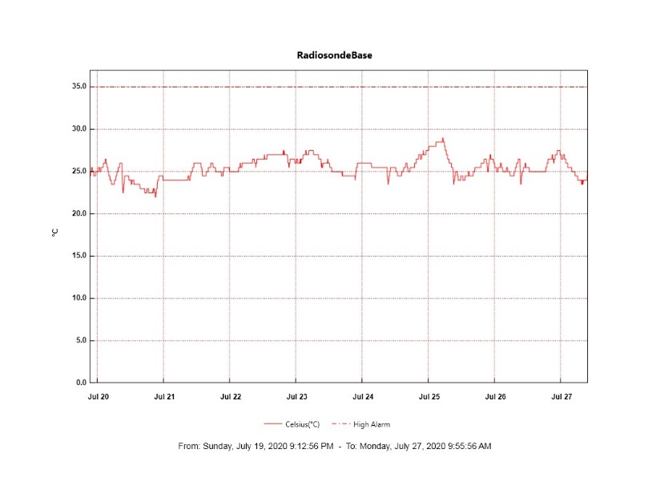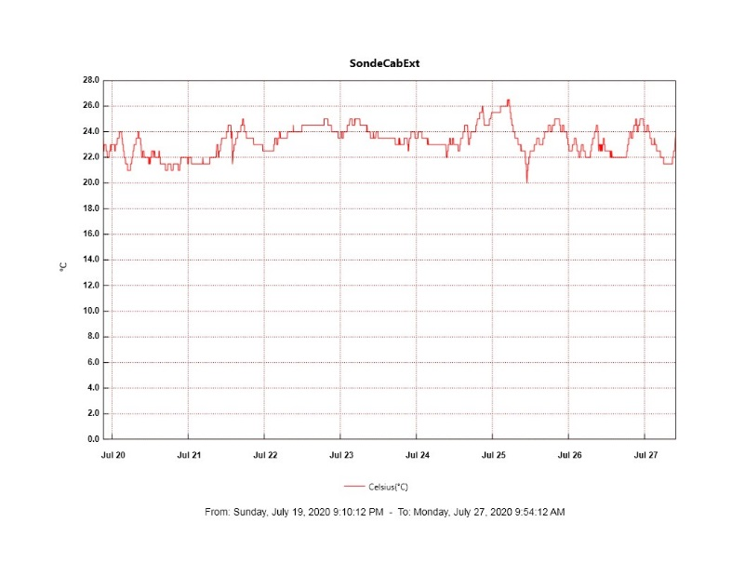

**MWR:**

* HATPRO offsite for repairs. 150-90 online and operating normally.

**SODAR:**

* 2020-07-20 1142-1509Z: Powered down for UPS testing.
* Operating normally.

**POSS:**

* 2020-07-20 1138 – 1528Z: Powered down for UPS testing.
* 2020-07-24: Instrument stand raised.
* Offline. Troubleshooting with manufacturer ongoing.

**MASC:**

* 2020-07-22 0338Z: Unidentified issue caused the MASC computer to shut down. RunMASC software was restarted at 1208Z.
* Operating normally.

**MMCR:**

* 2020-07-20 1315 – 1605Z: Powered down for UPS testing.
* 2020-07-22 1310 – 1355Z: System reboot. Transmitter power had been low (170 – 174W) and daily calibrations were failing since the MMCR had been restarted on 2020-07-20.
* Operating normally. Monitoring transmitter power fluctuations.

**CAPABL:**

* 2020-07-20 1218 – 1754Z: Powered down for UPS testing.
* Operating normally.

**MPL:**

* 2020-07-20 1203- 1449Z: Powered down for UPS testing.
* Operating normally. Monitoring laser energy fluctuations.

**CEILOMETER:**

* 2020-07-20 1156 – 1435Z: Powered down for UPS testing.
* Operating normally.

**PAERI:**

* 2020-07-25 0000 – 0006Z: Black body temperatures were erroneous following the daily software reboot.
* Operating normally.

**IceCAM:**

* Operating normally.

**IcePIC:**

* No IcePICs taken this week.

**CLASP:**

* Offline. Staged for retro.

**CPC:**

* Offline. Staged for retro.

**MSF - OPC:**

* Operating normally.

**TAWO - OPC:**

* Operating normally.

**SKYOPC:**

* 2020-07-15 ~0000Z: Pump failure.
* Offline.

**INP Freezing Assay:**

* 2020-07-22: Weekly experiments completed. Assay data and internal instrument data were sent to PI.

**Fluxtower instrument suite:**

* Operating normally.

**Radiometers:**

* 2020-07-20: Completed weekly data download.
* Operating normally.