**ICECAPS-ACE Weekly Report**

July 27 – August 02, 2020

Ian Geraghty

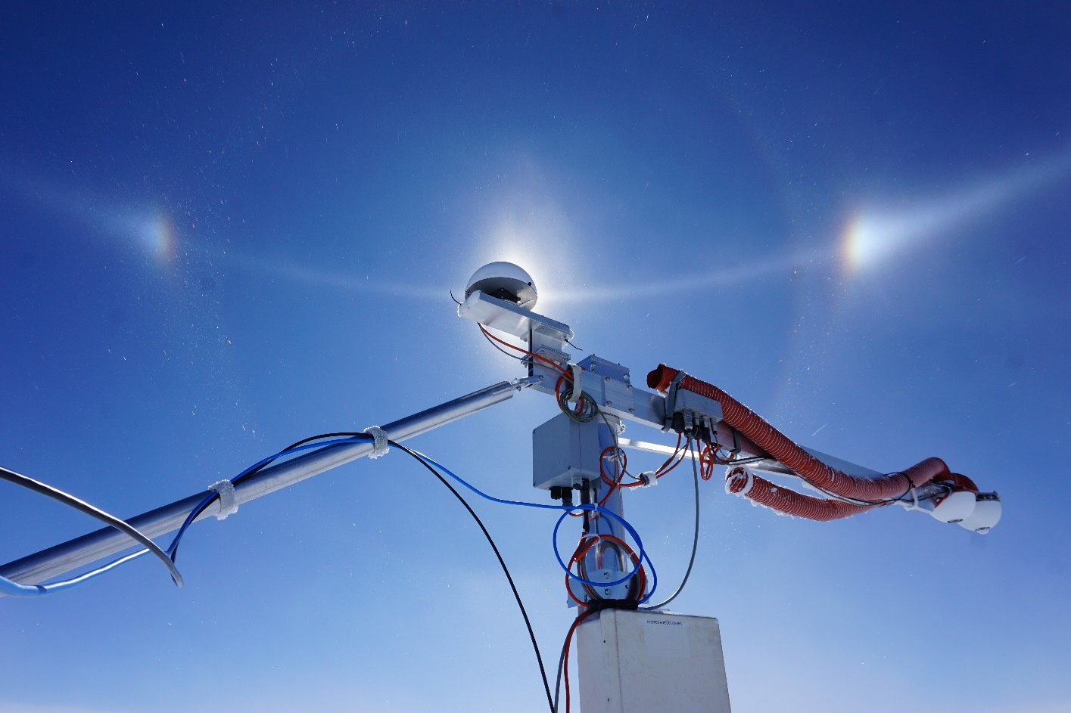

*Parhelic circle on 2020-07-31 framed behind the recently raised albedo stand.*

**General Notes:**

An epic hole was excavated at TAWO to raise the albedo stand. The stand was approximately 3.5m tall and required 4 people to relocate safely.

**General Weather Observations:**

|  |  |  |  |  |  |  |  |
| --- | --- | --- | --- | --- | --- | --- | --- |
| **Date** | **Time (Z)** | **Wind** | **Weather** | **Visibility** | **Sky** | **Temp (C)** | **Notes** |
| 07-27 | 12 | 5kts at 121 | BR | 4800 | OVC007 | -14 |  |
| 07-28 | 12 | 13kts at 120 | -SN | 4800 | SCT015  BKN160 | -13 | 22° halo |
| 07-29 | 12 | 13kts at 085 | -SN | 4800 | SCT015  BKN064 | -10 |  |
| 07-30 | 12 | 6kts at 143 | -SN | 4800 | SCT016  SCT060 | -14 |  |
| 07-31 | 12 | 11kts at 162 | IC BR | 3200 | FEW010  SCT064 | -19 |  |
| 08-01 | 12 | 7kts at 142 |  | 9999 | FEW032 | -20 |  |
| 08-02 | 12 | 18kts at 072 | BR -SN DRSN | 4800 | SCT015  SCT050  BKN115 | -15 |  |

**Significant Weather Observations:**

* 2020-07-31 1200 – 1530Z: 22° halo with parhelia and parhelic circle.

**MSF**

* None.

**ICECAPS-ACE Data Management:**

* 07-27: Data transfer completed at 0501Z.
* 07-28: Data transfer completed at 0450Z.
* 07-29: Data transfer completed at 0451Z.
* 07-30: Data transfer completed at 0502Z.
* 07-31: Data transfer completed at 0455Z.
* 08-01: Data transfer completed at 0446Z.
* 08-02: Data transfer completed at 0454Z.

**TSI:**

* Operating normally. No software reboots required.

**Radiosonde:**

* 2020-07-29 1200Z: Radiosonde signal lost for ~30s.
* See charts below for temperatures inside and outside the radiosonde cabinet over the last week.

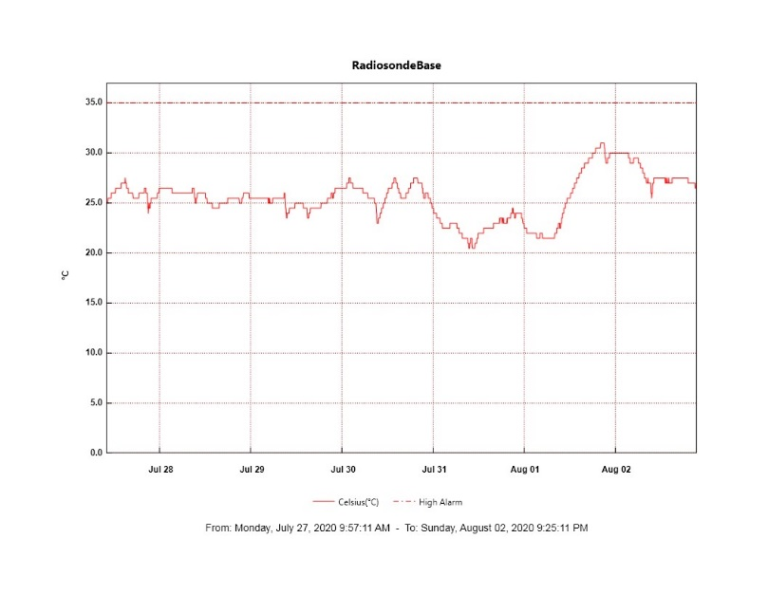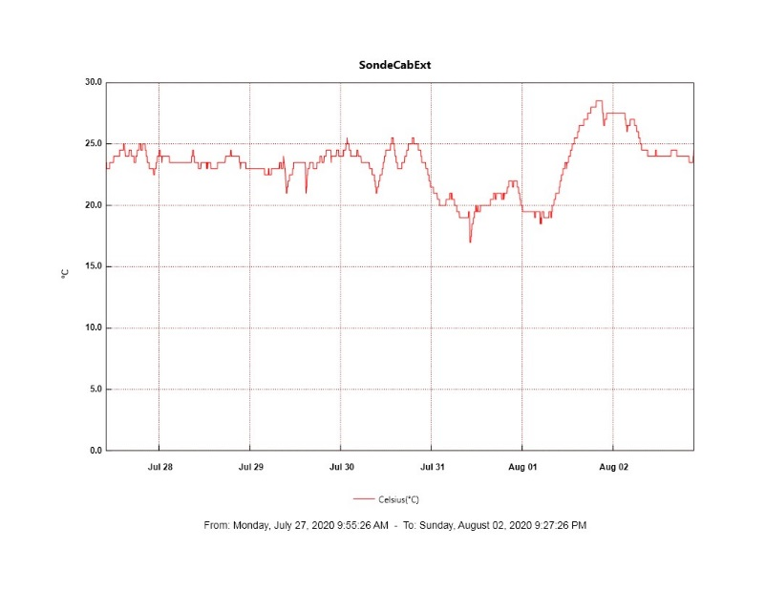

**MWR:**

* HATPRO offsite for repairs. 150-90 online and operating normally.

**SODAR:**

* 2020-07-27 1414-1426Z: Cleaned and leveled the SODAR dishes.
* Operating normally.

**POSS:**

* Offline. Awaiting arrival of replacement Telebyte.

**MASC:**

* 2020-07-28 0906Z: Single camera bus reset occurred.
* Operating normally.

**MMCR:**

* 2020-07-31 1900Z: LabView Error 7 “file not found”.
* 2020-08-01 1230Z: Daily calibration was skipped because LabView error from past day had not yet been cleared.
* Operating normally. Monitoring transmitter power fluctuations.

**CAPABL:**

* Operating normally.

**MPL:**

* Operating normally. Monitoring laser energy fluctuations.

**CEILOMETER:**

* Operating normally.

**PAERI:**

* Operating normally.

**IceCAM:**

* Operating normally.

**IcePIC:**

* No IcePICs taken this week.

**CLASP:**

* Offline. Staged for retro.

**CPC:**

* Offline. Staged for retro.

**MSF - OPC:**

* Operating normally.

**TAWO - OPC:**

* Operating normally.

**SKYOPC:**

* 2020-07-28 1350Z: Data collection restarted with refurbished pump.
* Operating normally.

**INP Freezing Assay:**

* 2020-07-22: Weekly experiments completed. Assay data and internal instrument data were sent to PI.

**Fluxtower instrument suite:**

* Operating normally.
* 2020-07-27: Fluxtower laptop was rebooted.
* 2020-07-28: LiCOR data missing after laptop reboot on the day prior. Communication was restored after the instrument was power cycled.

**Radiometers:**

* 2020-07-27: Completed weekly data download.
* 2020-07-30 1323 – 1906Z: Albedo stand raised from ~0.5m to ~2m.
* Operating normally.