**ICECAPS-ACE Weekly Report**

August 3 – August 9, 2020

Ian Geraghty



*First sunset on 2020-08-07.*

**General Notes:**

The first flight of FP5 arrived this weekend bringing with it the HATPRO, LN2, and SKYOPC pump equipment. The new crew made it to Summit on Sunday but were unable to land because of a crosswind.

**General Weather Observations:**

|  |  |  |  |  |  |  |  |
| --- | --- | --- | --- | --- | --- | --- | --- |
| **Date** | **Time (Z)** | **Wind** | **Weather** | **Visibility** | **Sky** | **Temp (C)** | **Notes** |
| 08-03 | 12 | 12kts at 139 | IC BR | 4800 | FEW015  SCT100 | -12 |  |
| 08-04 | 12 | 6kts at 119 | BR | 4800 | SCT015  BKN082 | -14 |  |
| 08-05 | 12 | 15kts at 130 | IC DRSN BR | 4800 | BKN032 | -13 |  |
| 08-06 | 12 | 24kts at 134 | BR | 3200 | SCT016  BKN130 | -9 |  |
| 08-07 | 12 | 17kts at 131 | BLSN | 1600 | BKN000  BKN064  BKN180 | -12 |  |
| 08-08 | 12 | 12kts at 100 | -SN DRSN | 1600 | BKN010  BKN123 | -12 |  |
| 08-09 | 12 | 13kts at 161 | FZFG DRSN | 1600 | BKN000  BKN070 | -17 |  |

**Significant Weather Observations:**

* None.

**MSF**

* 2020-08-08 1728Z: Changed the MSF UPS bypass high limit voltage from 1% to 10% of the nominal output of 120/208V. This is the default setting and what the TAWO UPS has been set at. This cleared the bypass unavailable message and the UPS proceeded to perform and pass a battery test.

**ICECAPS-ACE Data Management:**

* 08-10: Data transfer completed at 0500Z.
* 08-11: Data transfer completed at 0454Z.
* 08-12: Data transfer completed at 0451Z.
* 08-13: Data transfer completed at 0457Z.
* 08-14: Data transfer completed at 0455Z.
* 08-15: Data transfer completed at 0457Z.
* 08-16: Data transfer completed at 0502Z.

**TSI:**

* Operating normally. No software reboots required.

**Radiosonde:**

* 2020-08-06 00Z: Sounding terminated at a height of 24592m due to excessive missing GPS heights.
* 2020-08-06: Radiosonde R2128199 pressure sensor failed during ground check.
* Monitoring radiosonde signal dropouts. There were 3 soundings this week that lost signals for over 1 minute.
* See charts below for temperatures inside and outside the radiosonde cabinet over the last week.

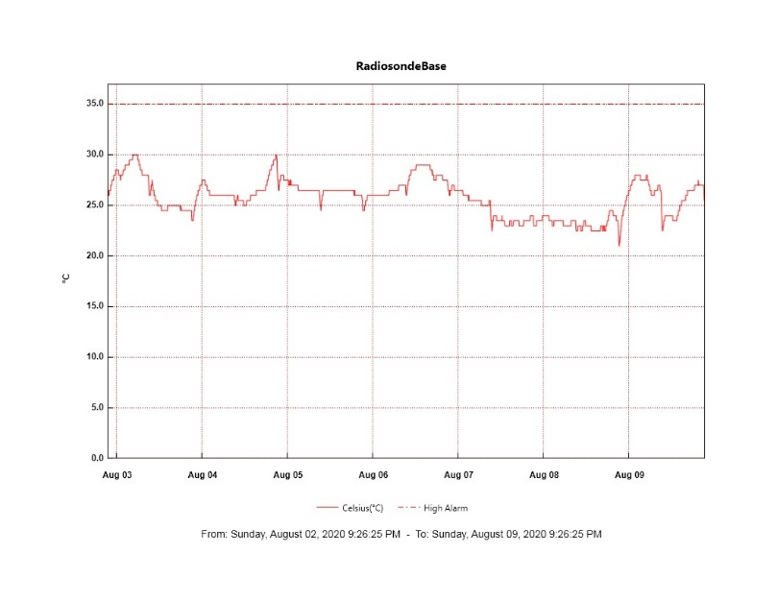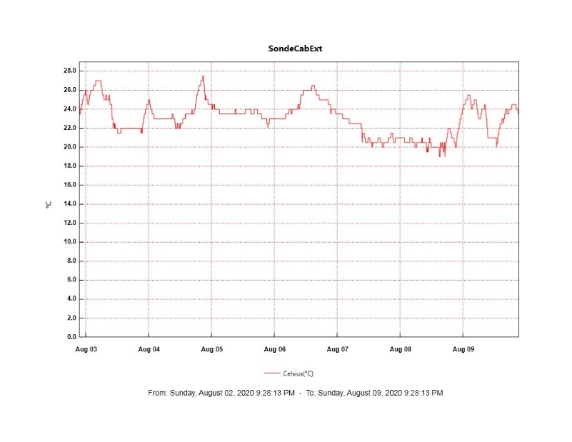

**MWR:**

* 2020-08-12 1735Z: HATPRO installed on the roof and data acquisition restarted with both radiometers.
* 2020-08-14 1609 – 1817Z: Performed LN2 calibrations for HATPRO and 150-90.
* Operating normally.

**SODAR:**

* 2020-08-12 1252-1325Z: Cleaned and leveled the SODAR dishes.
* Operating normally.

**POSS:**

* Offline. Awaiting arrival of replacement Telebyte.

**MASC:**

* 2020-08-13 1859Z: 2 camera bus resets occurred.
* Operating normally.

**MMCR:**

* 2020-08-14: Noticed a short transmitter power drop to 178 to 70W.
* Operating normally. Monitoring transmitter power fluctuations.

**CAPABL:**

* Operating normally.

**MPL:**

* 2020-08-15 1400 – 1430Z: Performed monthly afterpulse calibration.
* Operating normally. Monitoring laser energy fluctuations.

**CEILOMETER:**

* Operating normally.

**PAERI:**

* 2020-08-14 1310 - 1400Z: Cleaned scene mirror
* 2020-08-15 1328 - 1333Z: Cleaned scene mirror.

Operating normally.

**IceCAM:**

* Operating normally.

**IcePIC:**

* No IcePICs taken this week.

**CLASP:**

* Offline. Staged for retro.

**CPC:**

* Offline. Staged for retro.

**MSF - OPC:**

* Operating normally.

**TAWO - OPC:**

* Operating normally.

**SKYOPC:**

* 2020-08-08: New pump, service kit, and spare capacitors arrived at Summit.
* Operating normally.

**INP Freezing Assay:**

* 2020-08-07: Digitel sampler decommissioned at TAWO. Sampler is currently being packed for shipment.

**Fluxtower instrument suite:**

* Operating normally.

**Radiometers:**

* 2020-08-03: Completed weekly data download.
* Operating normally.