**ICECAPS-ACE Weekly Report**

August 17 – August 23, 2020

Heather Guy

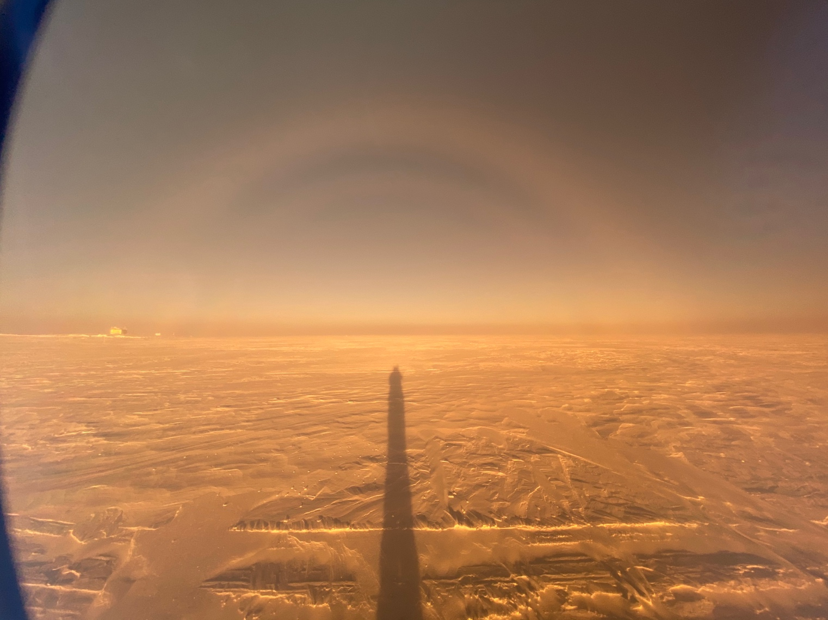

*Double fog bow shot through polarized lens 2020-08-17 2220z. MSF on lower left.*

*Photo: Jasper Thompson (TAWO science technician, winter 2020)*

**General Notes:**

A busy turnover week at Summit characterized by several days of low-level stratus clouds, leading to warm surface temperatures and the cancellation of several planned C-130 flights. All anticipated science cargo was received, and new helium cylinders and radiosonde supplies were staged in the SMG. MWR LN2 calibrations were completed and the small amount of remaining LN2 was used to make raspberry ice-cream that was enjoyed by all. The summer crew flew out on 2020-08-24. The 2020 winter crew consists of Station manager Perri Barbour, mechanics Justin Ryks and Wyatt Fletcher, and TAWO technician Jasper Thompson.

**General Weather Observations:**

|  |  |  |  |  |  |  |  |
| --- | --- | --- | --- | --- | --- | --- | --- |
| **Date** | **Time (Z)** | **Wind** | **Weather** | **Visibility** | **Sky** | **Temp (C)** | **Notes** |
| 08-17 | 12 | 19kts at 282 | BLSN | 800 | BKN006 | -14 | Plume of C130 exhaust blown over MSF was visible for several hours after the plane left. |
| 08-18 | 12 | 10kts at 283 |  | 9999 | FEW | -19 |  |
| 08-19 | 12 | 17kts at 302 |  | 1600 | BKN007, BKN049 | -9 | -SN am. Low-level liquid cloud all day. |
| 08-20 | 12 | 15kts at 348 |  | 4800 | BKN004 | -5 | Low-level stratus deck moved in around 09Z |
| 08-21 | 12 | 6kts at 352 |  | 9999 | BKN007 | -8 |  |
| 08-22 | 12 | 6kts at 228 |  | 9999 | BKN033 | -11 | -SN, stellar dendrites at 10Z.  Low-level liquid cloud all day, cleared at 22Z. After fog cleared a narrow dark cloud was visible – possibly from the exhaust plume of the plane circling pm. |
| 08-23 | 12 | 5kts at 2122 |  | 9999 | FEW130 | -20 | Possible tenuous cloud regime observed overnight; cloud dissipation coincident with a drop in surface aerosol concentrations. |

**Significant Weather Observations:**

* 2020-08-17 2200z: Fog bow - double fog bow when viewed through polarized lens (see photo).
* 2020-08-20 1650z: Upper and lower tangential arc coincident with ice crystal precipitation.
* 2020-08-22 1555z: Fata morgana observed, approx. 7 km from station during IceSat traverse.
* 2020-08-22 2100z: Fog bow.

**MSF**

* 2020-08-20 1708 – 1729Z: Planned station power outage. All instruments were supported by the UPS.
* 2020-08-21: It appears that after the power outage, the MSF HVAC system began operating more effectively. Since then, temperatures in the MSF have been below average (52 to 59°F) and I have been incrementally increasing the thermostat set point to try and maintain temperatures between 55°F and 63°F overnight.

**ICECAPS-ACE Data Management:**

* 08-17: Data transfer completed at 0453Z.
* 08-18: Data transfer completed at 0501Z.
* 08-19: Data transfer completed at 0502Z.
* 08-20: Data transfer completed at 0510Z.
* 08-21: Data transfer completed at 0459Z.
* 08-22: Data transfer completed at 0446Z.
* 08-23: Data transfer completed at 0459Z.

**TSI:**

* 2020-08-18: Software rebooted to reinitialize image processing.

**Radiosonde:**

* 2020-08-19: Radiosonde table plastic replaced; table cover cleaned. New helium and radiosonde supplies received and staged in MSF.
* 2020-08-23: Grey Davis inspected the antenna on the SMF roof, secured connections and tightened guy lines for the winter.
* No signal dropouts observed this week (coinciding with lower winds?)
* Horizontal distance travelled by radiosondes ~30 to 50 km.
* See chart below for temperatures inside and outside the radiosonde cabinet over the last week:



**MWR:**

* 2020-08-17 1204 – 1324Z: Performed LN2 absolute calibration for HATPRO and collected internal-external flop dataset.
* 2020-08-18 1259 – 1409Z: Performed LN2 absolute calibration for HATPRO and collected internal-external flop dataset.
* 2020-08-19 1311 – 1337Z: Performed LN2 absolute calibration. Replaced insulation on HATPRO.
* 2020-08-23: Found with error: ‘Slave elevation mirror does not respond’. Passed normal daily checks once error was cleared. PI’s contacted.

**SODAR:**

* 2020-08-17 1339-1353Z: Cleaned and leveled the SODAR dishes.
* 2020-08-20 1908-1919Z: SODAR amplifier powered down while cable run was raised.
* Operating normally.

**POSS:**

* 2020-08-19: Telebyte was replaced and POSS data collection restarted. Awaiting feedback on data quality.
* Operating normally.

**MASC:**

* Operating normally.

**MMCR:**

* 2020-08-23 1334: Labview error 7 and ‘Dwellcontrol_calibration’ errors cleared, daily calibration missed.
* Monitoring transmitter power fluctuations.

**CAPABL:**

* Operating normally.

**MPL:**

* Operating normally.

**CEILOMETER:**

* Operating normally.

**PAERI:**

* 2020-08-21: Cooler compressor temperature flag yellow; associated with cooler than normal temperatures in the MSF.
* Operating normally.

**IceCAM:**

* 2020-08-23 1445: IceCAM data cable was disconnected to allow for testing using a known working port on the network switch. Data collection was unaffected.
* Operating normally.

**IcePIC:**

* 2020-08-18: IcePICs hardware brought inside to defrost. Optics cleaned.
* No IcePICs taken this week.

**CPC:**

* Offsite for repairs.

**MSF - OPC:**

* Operating normally

**TAWO - OPC:**

* Operating normally.

**SKYOPC:**

* 2020-08-20 1708 – 1729Z: Powered down during planned station power outage.
* Operating normally.

**Fluxtower instrument suite:**

* 2020-08-21 1847 – 1932Z: Fluxtower suite powered down for cable maintenance. LiCOR enclosure raised on tower.
* 2020-08-22: Suspect data from HMP4 (14 m T/RH sensor), possible aspirated shield failure.

**Radiometers:**

* 2020-08-18: Solar tracker out of alignment after high winds.
* 2020-08-21 1917 - 2000Z: Solar tracker re-zeroed, alignment improved.
* Operating normally.