ICECAPS-ACE Weekly Report
September 21th – September 27th, 2020
Heather Guy

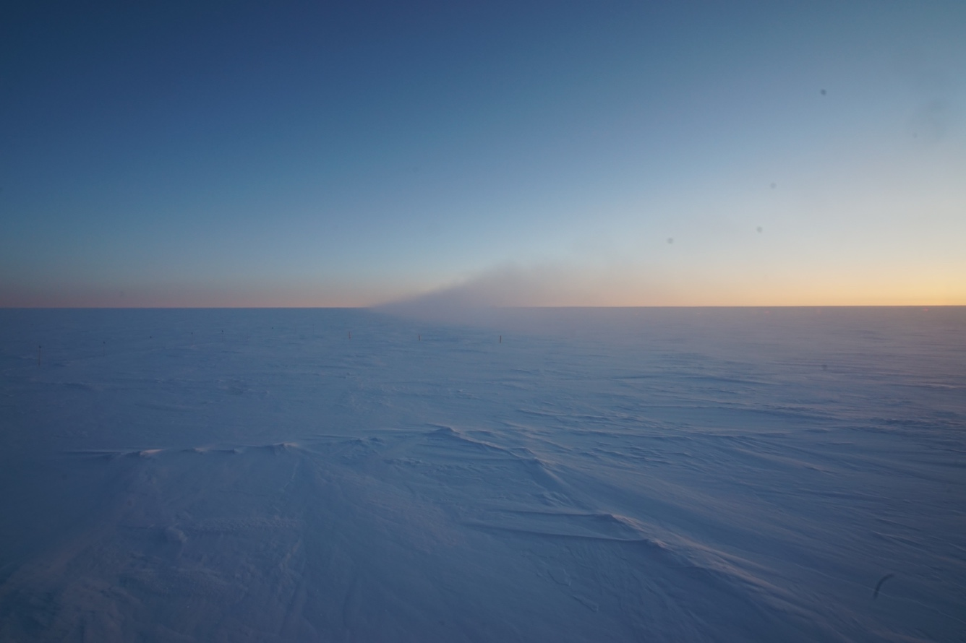

Localized fog event obscuring TAWO;
nucleated by the generator plume during north winds, 2020-09-21
Photo: Heather Guy

General Notes:

Much of this week was taken up performing the bi-annual station accumulation survey. Aside from that the TSI was taken offline and brought inside the MSF for the winter season, and the SPS power was transferred to the external 24VDC power supply. There were no instrument issues this week. We did enjoy some fantastic aurorae and large temperature swings, including an increase of greater than 25°C over just a few hours on September 25th.

General Weather Observations:

Date | Time (Z) | Wind | Weather | Visibility | Sky | Temp (C) | Notes
09-21 | 12 | 13 kts at 042 |  | 9999 | FEW | -41 | BLSN overnight
09-22 | 12 | 16 kts at 069 | DRSN | 1600 | OVC006 | -32
09-23 | 12 | 4 kts at 136 |  | 9999 | BKN006 | -30 | Low level liquid cloud, cleared 1645z. Low surface aerosol concs.
09-24 | 12 | 3 kts at 189 | BR | 4800 | SKC | -43
09-25 | 12 | 15 kts at 204 | FZFG | 600 | OVC005 | -29 | 25C increase in temperature, am. High winds and BLSN pm.
09-26 | 12 | 9 kts at 222 | -SN | 3200 | OVC016 | -24
09-27 | 12 | 10 kts at 199 | -SN | 4800 | VV014 | -30

Significant Weather Observations:
- 2020-09-21 2000-2200Z: Localized fog event obscuring TAWO, possibly nucleated by the generator plume during north winds.
- 2020-09-22 0930-1000Z: Parahelia & upper tangent arc.
- 2020-09-22 1800-1920Z: Parahelia and IC.
- 2020-09-25 0900-1000Z: Fog bow
- 2020-09-26 1045-1300Z: Halo, pillar and IC.
- 2020-09-27 1245-1300Z: Halo and IC.
- 2020-09-27 1830-1930Z: Fog bow

MSF
- Operating normally

ICECAPS-ACE Data Management:
- 09-21: Data transfer completed at 0440Z.
- 09-22: Data transfer completed at 0452Z.
- 09-23: Data transfer completed at 0441Z.
- 09-24: Data transfer completed at 0440Z.
- 09-25: Data transfer completed at 0440Z.
- 09-26: Data transfer completed at 0438Z.
- 09-27: Data transfer completed at 0457Z.

TSI:
- 2020-09-24 1205Z: TSI taken offline for the winter season.

Radiosonde:
- 2020-09-24 1630Z: SPS power transferred to external 24VDC supply.
- Once daily launches.
- See chart below for temperatures inside and outside the radiosonde cabinet over the last week:

MWR:
- Operating normally

SODAR:
- 2020-09-21 1237-1249Z: Cleaned and leveled the SODAR dishes.
- Operating normally.

POSS:
- Operating normally.

MASC:
- Offline for winter season.

MMCR:
- Operating normally.

CAPABL:
- Operating normally.

MPL:
- Operating normally.

CEILOMETER:
- Operating normally.

PAERI:
- Operating normally.

IceCAM:
- Operating normally.

IcePIC:
- 2020-09-26 1530-1540: Irregulars and bullets, 39 photos collected.
- 2020-09-27 1334-1350: Columns, bullets and bullet rosettes, 21 photos collected.

CPC:
- Offsite for repairs.

MSF - OPC:
- Operating normally

TAWO - OPC:
- Operating normally.

SKYOPC:
- Operating normally.

Fluxtower instrument suite:
- Operating normally

Radiometers:
- Solar tracker misalignment troubleshooting ongoing, otherwise operating normally.

