**ICECAPS-ACE Weekly Report**

October 12th – October 18th, 2020

Heather Guy

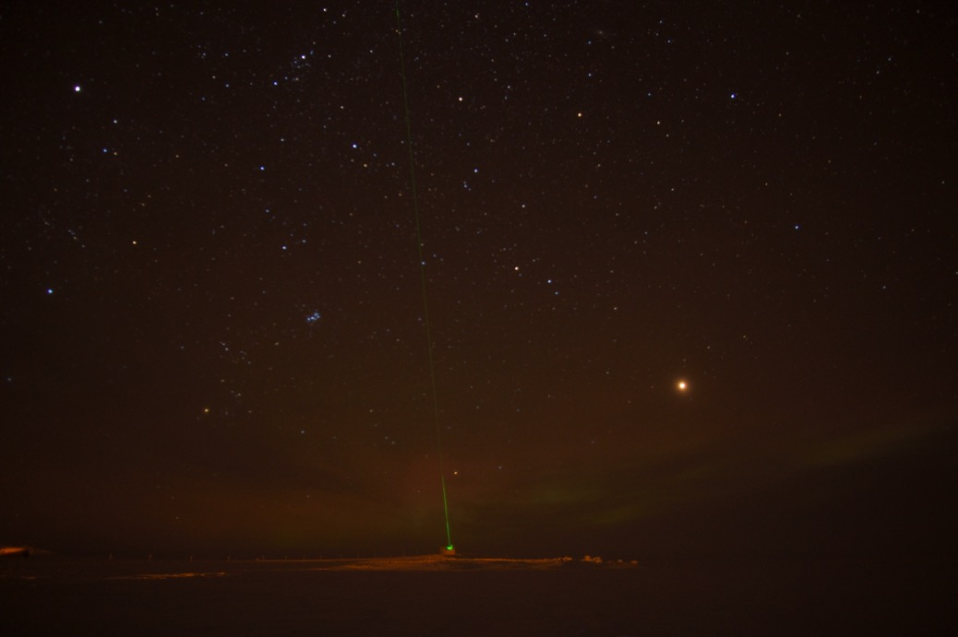

*The CAPABL laser on 2020-10-15, with Mars on the right, not far from its closest approach to Earth in 15 years.*

*Photo: Heather Guy*

**General Notes:**

Persistent low-level cloud this week kept temperatures unseasonably warm and allowed us to complete a straight-forward IceSat traverse on the 12th. The issue with the data transfer to Boulder was resolved and the backlog of data was transferred overnight on the 14th. Since then, there have been a few files that have not transferred each night due to a ‘lost connection’, I have been monitoring this closely and the files that were missed have all transferred the following day. On the 16th there was a very brief unplanned power outage, all instruments were supported by the UPS.

**General Weather Observations:**

|  |  |  |  |  |  |  |  |
| --- | --- | --- | --- | --- | --- | --- | --- |
| **Date** | **Time (Z)** | **Wind** | **Weather** | **Visibility** | **Sky** | **Temp (C)** | **Notes** |
| 10-12 | 12 | 6 kts at 209 |  | 4800 | OVC016 | -23 |  |
| 10-13 | 12 | 10 kts at 170 |  | 3600 | OVC002 | -16 | Intermittent SN. |
| 10-14 | 12 | 9 kts at 196 | -SN | 3600 | OVC032 | -16 |  |
| 10-15 | 12 | 11 kts at 170 |  | 3600 | OVC036 | -18 |  |
| 10-16 | 12 | 9 kts at 157 |  | 3600 | BKN059 | -22 | -SN pm, stellar dendrites |
| 10-17 | 12 | 14 kts at 216 | SN | 1600 | OVC008 | -15 |  |
| 10-18 | 12 | 9 kts at 305 | DRSN | 1000 | BKN020 | -20 | BLSN am, max wind 24 kts  Cloud cleared pm, some IC. |

**Significant Weather Observations:**

* Note: Sig Wx photos have now transferred to Boulder successfully.

**MSF**

* 2020-10-15 1209-1225Z: Drift maintenance around the MSF with the D953.
* 2020-10-16 1048Z: Unplanned power outage lasting < 1 minute. All instruments supported by UPS.
* Operating normally

**ICECAPS-ACE Data Management:**

* 10-12: No data sent to Boulder: Target destination not found.
* 10-13: No data sent to Boulder: Target destination not found.
* 10-14: Data transfer completed at 1432Z.
* 10-15: Data transfer completed at 0456Z, 6 files did not transfer due to ‘lost connection’.
* 10-16: Data transfer completed at 0450Z, 9 files did not transfer due to ‘lost connection’.
* 10-17: Data transfer completed at 0451Z, 11 files did not transfer due to ‘lost connection’.
* 10-18: Data transfer completed at 0501Z, 20 files did not transfer due to ‘lost connection’.
* Note: The files that are not being transferred are not the same each day – i.e. the files that were missed on one day are being transferred the following day.

**TSI:**

* Offline for the winter season.

**Radiosonde:**

* Once daily launches.
* See chart below for temperatures inside and outside the radiosonde cabinet over the last week:



**MWR:**

* Operating normally

**SODAR:**

* 2020-10-14 1331-1346Z: Cleaned and leveled the SODAR dishes.
* 2020-10-15 1257Z: SODAR restarted after it was accidently left offline following dish cleaning the previous day.
* Operating normally.

**POSS:**

* Operating normally.

**MASC:**

* Offline for winter season.

**MMCR:**

* 2020-10-17: Added automatic hourly time-sync to both PCs.
* Operating normally.

**CAPABL:**

* Operating normally.

**MPL:**

* 2020-10-15 1228-1250Z: Performed monthly afterpulse calibration.
* Note: Data mount at 94% capacity.
* Operating normally.

**CEILOMETER:**

* 2020-10-16 1229-1309Z: Found ceilometer computer frozen during daily checks. After a ‘crtl+alt+del’, the computer showed a black screen for 20 minutes. I performed a hard reboot and restarted data collection at 1309Z.
* Operating normally.

**PAERI:**

* Operating normally.

**IceCAM:**

* Operating normally.

**IcePIC:**

* 2020-10-14 1131-1346Z: Stars, plates and irregulars. 31 photos collected.
* 2020-10-17 1150-1220Z: Columns, bullets, plates and irregulars, 65 photos collected.

**CPC:**

* Offsite for repairs.

**MSF - OPC:**

* 2020-10-13 1236Z: Instrument back online.
* Operating normally.

**TAWO - OPC:**

* 2020-10-13 1200Z: Instrument back online.
* Operating normally

**SKYOPC:**

* Operating normally.

**Fluxtower instrument suite:**

* Operating normally

**Radiometers:**

* Solar tracker misalignment troubleshooting ongoing, otherwise operating normally.