**ICECAPS-ACE Weekly Report**

October 19th – October 25th, 2020

Heather Guy

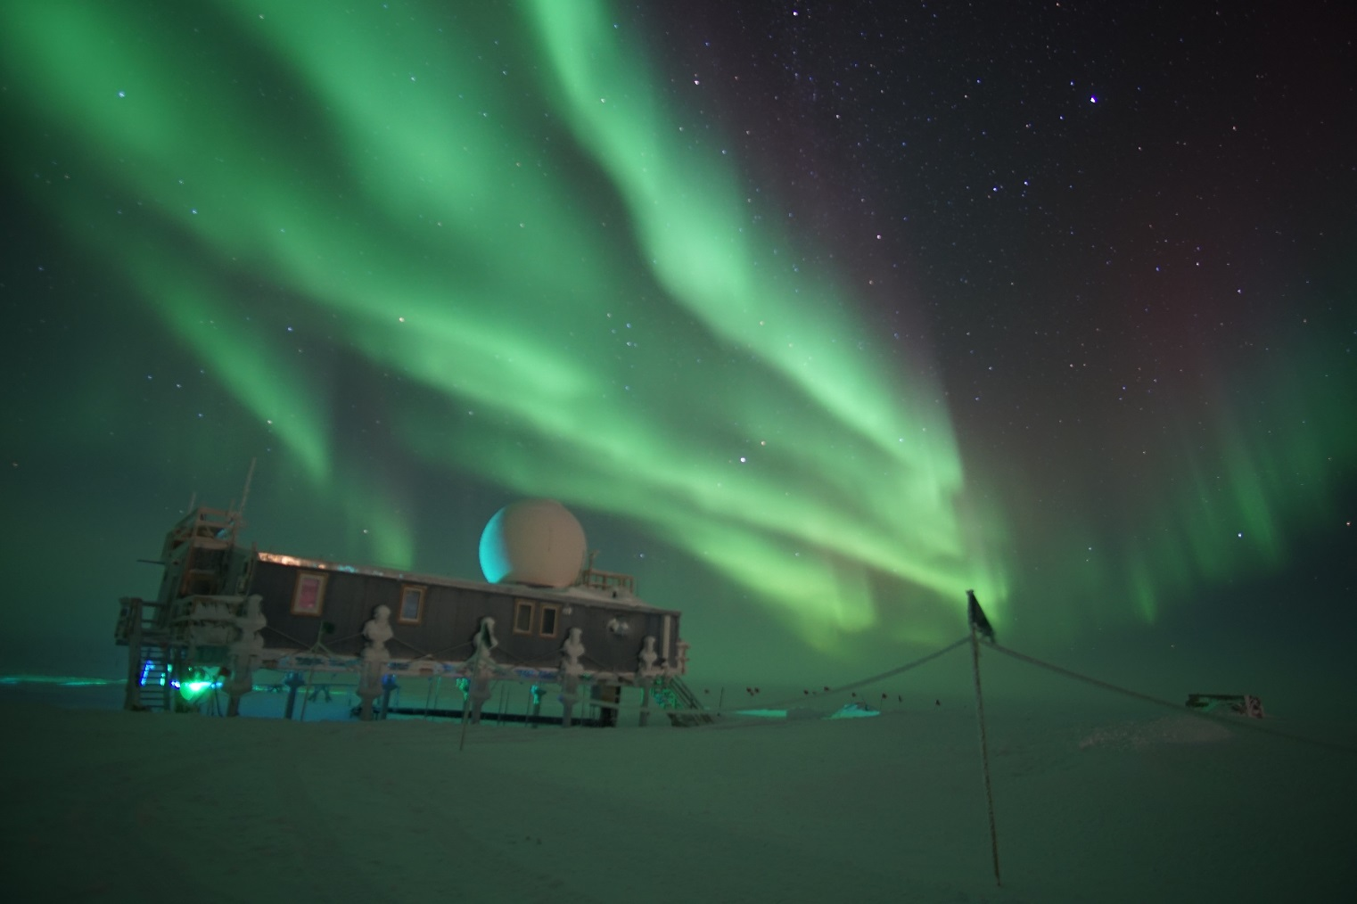

Full sky aurora show on 2020-10-23.

*Photo: Heather Guy*

**General Notes:**

This week saw temperatures drop back down to more seasonable low -30’s, and a noticeable reduction in daylight hours with our transition to “Daylight saving” time. There was a planned station power outage on 2020-10-20 to allow the mechanics to do some maintenance on the generator, the outage lasted 10 minutes and all instruments on UPS were unaffected. Otherwise it was a quiet week, featuring some drift and cable maintenance around the MSF and a successful MMCR reboot. The ‘lost connection’ issues with data transfer to Boulder have resolved.

**General Weather Observations:**

|  |  |  |  |  |  |  |  |
| --- | --- | --- | --- | --- | --- | --- | --- |
| **Date** | **Time (Z)** | **Wind** | **Weather** | **Visibility** | **Sky** | **Temp (C)** | **Notes** |
| 10-19 | 12 | 11 kts at 212 | SN | 800 | OVC007 | -21 | BLSN pm. |
| 10-20 | 12 | 6 kts at 203 | FZFG | 500 | BKN033 | -35 |  |
| 10-21 | 12 | 6 kts at 252 | FZFG | 500 | VV002 | -28 |  |
| 10-22 | 12 | 13 kts at 132 | BR | 3600 | FEW164 | -40 |  |
| 10-23 | 12 | 10 kts at 167 |  | 4800 | BKN019, FEW098 | -31 |  |
| 10-24 | 12 | 10 kts at 163 |  | 3600 | FEW | -39 | FZFG bank on horizon |
| 10-25 | 12 | 11 kts at 200 | BR | 3600 | FEW | -41 | FZFG bank on horizon |

**Significant Weather Observations:**

* 2020-10-20 1445Z: Upper tangent arc and light snow.
* 2020-10-21 1705Z: Brief parahelia.
* 2020-10-21 1815Z: very low level FZFG, the top half of the TAWO met tower is out the top of the fog.
* 2020-10-25 1200-1300Z: Fog bow.

**MSF**

* 2020-10-20 1227 -1237Z: Planned power outage to support generator maintenance. Instruments on UPS were unaffected.
* 2020-10-22 1200-1215Z: Drift maintenance around the MSF with the D953.
* Operating normally

**ICECAPS-ACE Data Management:**

* 10-19: Data transfer completed at 0515Z, 10 files did not transfer due to ‘lost connection’.
* 10-20: Data transfer completed at 0504Z, 9 files did not transfer due to ‘lost connection’.
* 10-21: Data transfer completed at 0445Z.
* 10-22: Data transfer completed at 0527Z.
* 10-23: Data transfer completed at 0415Z.
* 10-24: Data transfer completed at 0515Z.
* 10-25: Data transfer completed at 0412Z.

**TSI:**

* Offline for the winter season.

**Radiosonde:**

* 2020-10-21: SPS signal lost after launch termination, profile was unaffected.
* Once daily launches.
* See chart below for temperatures inside and outside the radiosonde cabinet over the last week:

**MWR:**

* Operating normally

**SODAR:**

* 2020-10-20 1319-1334Z: Cleaned and leveled the SODAR dishes.
* Operating normally.

**POSS:**

* Operating normally.

**MASC:**

* Offline for winter season.

**MMCR:**

* 2020-10-22 1640-1755Z: Performed MMCR reboot after persistent ‘NetCDF not found’ errors.
* Operating normally.

**CAPABL:**

* Operating normally.

**MPL:**

* Operating normally.

**CEILOMETER:**

* Operating normally.

**PAERI:**

* Operating normally.

**IceCAM:**

* Operating normally.

**IcePIC:**

* 2020-10-19 1100-1200Z: Plates, stellar plates, bullets and bullet rosettes. 59 photos collected.
* 2020-10-21 1245-1306Z: Columns and irregulars, 25 photos.

**CPC:**

* Offsite for repairs.

**MSF - OPC:**

* Operating normally.

**TAWO - OPC:**

* Operating normally

**SKYOPC:**

* 2020-10-20 1220-1238Z: Pump offline for planned power outage.
* Operating normally.

**Fluxtower instrument suite:**

* Operating normally

**Radiometers:**

* Solar tracker misalignment troubleshooting ongoing, otherwise operating normally.