**ICECAPS-ACE Weekly Report**

October 26th – November 1st, 2020

Heather Guy

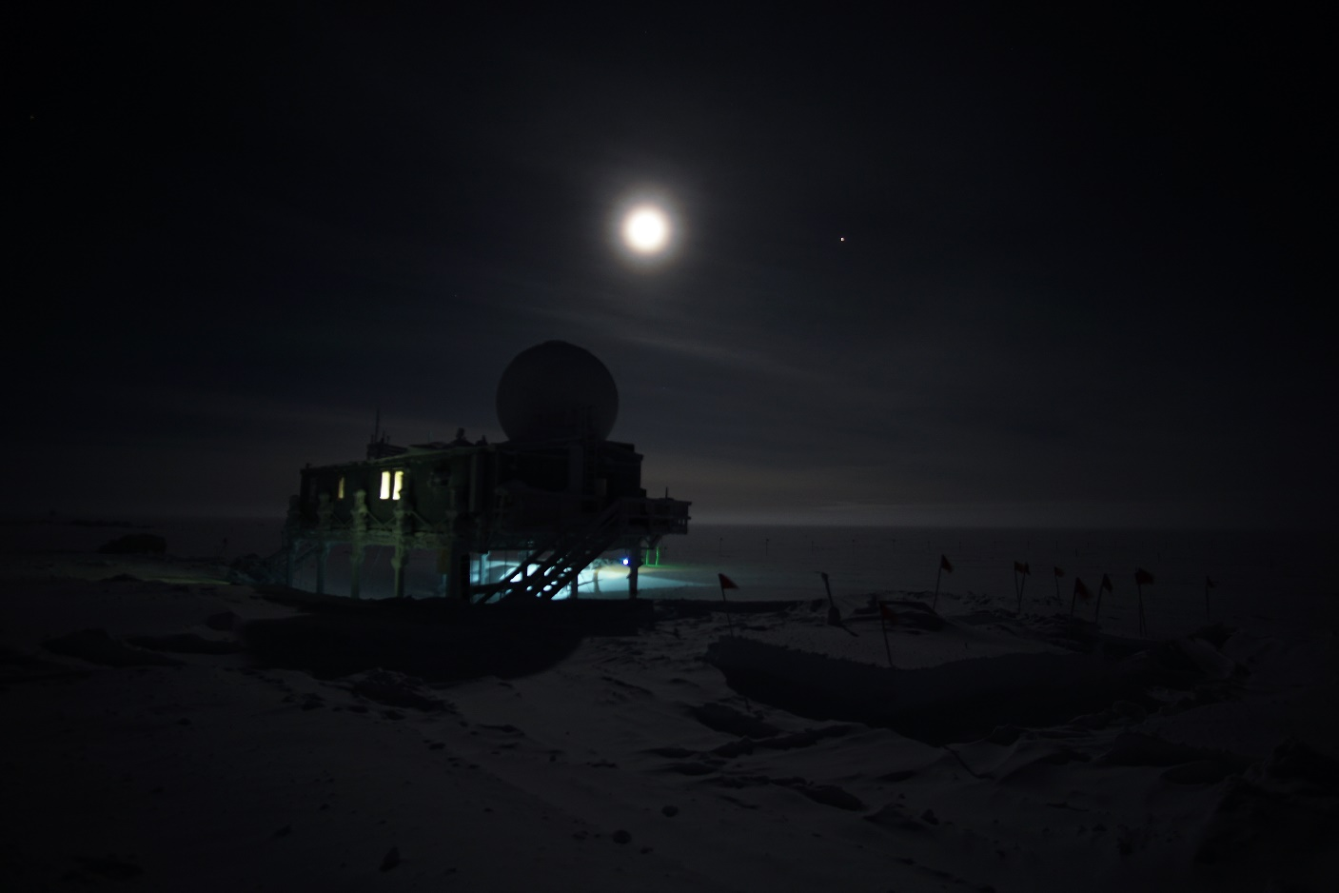

Halloween ‘blue’ moon above the big house, on 2020-10-30.

*Photo: Heather Guy*

**General Notes:**

It was a quiet and routine week at the MSF with all instruments operating normally and mild weather. There are only a few hours of daylight left and I’m starting to see some ‘rave ice’ events out behind the MSF. The SKYOC pump failed on Sunday evening due to a damaged carbon vane, repair is ongoing.

**General Weather Observations:**

|  |  |  |  |  |  |  |  |
| --- | --- | --- | --- | --- | --- | --- | --- |
| **Date** | **Time (Z)** | **Wind** | **Weather** | **Visibility** | **Sky** | **Temp (C)** | **Notes** |
| 10-26 | 12 | 16 kts at 200 | FZFG | 800 | BKN023 | -31 |  |
| 10-27 | 12 | 11 kts at 168 |  | 3200 | SCT065 | -37 |  |
| 10-28 | 12 | 9 kts at 159 | BR | 1000 | VV069 | -34 |  |
| 10-29 | 12 | 11 kts at 123 |  | 4800 | BKN131 | -33 |  |
| 10-30 | 12 | 7 kts at 166 |  | 9999 | SCT026 SCT196 | -29 |  |
| 10-31 | 12 | 18 kts at 080 | DRSN | 1600 | OVC066 | -28 |  |
| 11-01 | 12 | 13 kts at 123 |  | 4800 | OVC005 | -35 |  |

**Significant Weather Observations:**

* 2020-10-26 2000Z: Rave ice.
* 2020-11-01 1315Z: Fog bow

**MSF**

* Operating normally

**ICECAPS-ACE Data Management:**

* 10-26: Data transfer completed at 0414Z.
* 10-27: Data transfer completed at 0610Z.
* 10-28: Data transfer completed at 0438Z.
* 10-29: Data transfer completed at 0447Z.
* 10-30: Data transfer completed at 0437Z.
* 10-31: Data transfer completed at 0438Z.
* 11-01: Data transfer completed at 0438Z.

**TSI:**

* Offline for the winter season.

**Radiosonde:**.

* Once daily launches.
* See chart below for temperatures inside and outside the radiosonde cabinet over the last week:

**MWR:**

* Operating normally

**SODAR:**

* 2020-10-26 1429-1441Z: Cleaned and leveled the SODAR dishes.
* Operating normally.

**POSS:**

* Operating normally.

**MASC:**

* Offline for winter season.

**MMCR:**

* 2020-10-26: MMCR dataman mount down. The mmcr-dm computer was not connected to the internet. Connection was restored after a reboot of the router.
* Operating normally.

**CAPABL:**

* Operating normally.

**MPL:**

* Operating normally.

**CEILOMETER:**

* 2020-10-28: ‘No CT header’ error, cleared almost immediately.
* Operating normally.

**PAERI:**

* Operating normally.

**IceCAM:**

* Operating normally.

**IcePIC:**

* No IcePICs this week ☹

**CPC:**

* Offsite for repairs.

**MSF - OPC:**

* Operating normally.

**TAWO - OPC:**

* Operating normally

**SKYOPC:**

* 2020-11-01 1700z: SKYOPC pump failed due to broken carbon vanes. Repair ongoing.

**Fluxtower instrument suite:**

* Operating normally

**Radiometers:**

* Solar tracker misalignment troubleshooting ongoing, otherwise operating normally.