**ICECAPS-ACE Weekly Report**

November 2nd – November 8th, 2020

Heather Guy

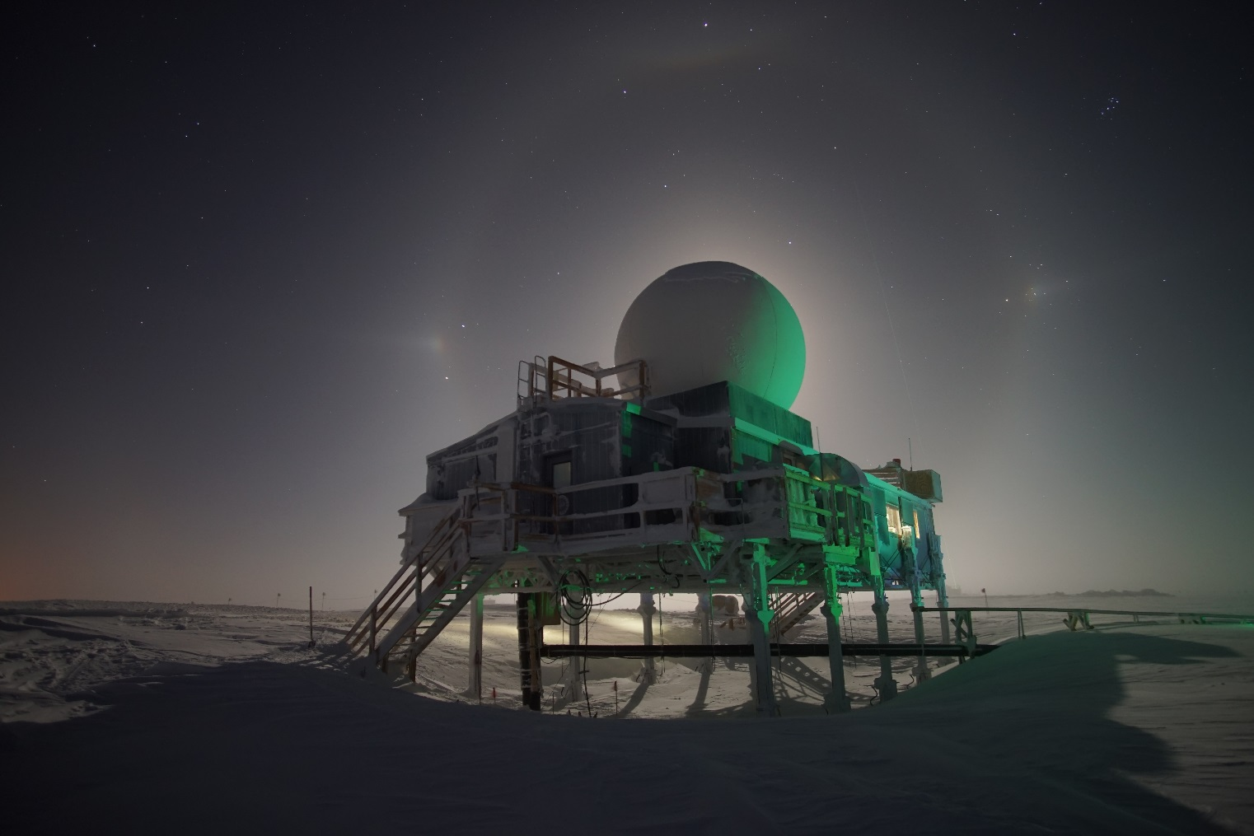

Moon halo and Parahelia behind the Big House, on 2020-11-04.

*Photo: Heather Guy*

**General Notes:**

**General Weather Observations:**

|  |  |  |  |  |  |  |  |
| --- | --- | --- | --- | --- | --- | --- | --- |
| **Date** | **Time (Z)** | **Wind** | **Weather** | **Visibility** | **Sky** | **Temp (C)** | **Notes** |
| 11-02 | 12 | 24 kts at 052 | SN, BLSN | 800 | VV023 | -31 |  |
| 11-03 | 12 | 15 kts at 132 |  | 4800 | SCT187 | -35 | Low cloud / fog on horizon. |
| 11-04 | 12 | 16 kts at 229 | BR, DRSN | 800 | OVC082 | -27 |  |
| 11-05 | 12 | 7 kts at 098 | BR | 4800 | SCT029, FEW131 | -38 |  |
| 11-06 | 12 | 9 kts at 193 |  | 3200 | SCT033 | -42 |  |
| 11-07 | 12 | 19 kts at 199 | BLSN | 500 | VV010 | -35 |  |
| 11-08 | 12 | 16 kts at 191 |  | 9999 | FEW | -52 | Mist patches on horizon. BLSN overnight. |

**Significant Weather Observations:**

* 2020-11-03 1400Z: Parahelia.
* 2020-11-04 2330Z: Moon halo, upper tangent arc and parhelic circle.
* 2020-11-06 1420Z: Sun halo.
* 2020-11-06 1517Z: Parahelia.
* 2020-11-07 1348Z: Thick fog forming downwind of SMG generator plume. Otherwise good visibility.

**MSF**

* Operating normally

**ICECAPS-ACE Data Management:**

* 11-02: Data transfer completed at 0440Z.
* 11-03: Data transfer completed at 0418Z.
* 11-04: Data transfer completed at 0458Z.
* 11-05: Data transfer completed at 0416Z.
* 11-06: Data transfer completed at 0421Z.
* 11-07: Data transfer completed at 0416Z.
* 11-08: Data transfer completed at 0431Z.
* Note: Dataman external hard drive archive is 84% full.

**TSI:**

* Offline for the winter season.

**Radiosonde:**.

* Once daily launches.
* 2020-11-06: Towards the end of the sounding logged several “Received frame from wrong radiosonde” warnings. Followed by “PTU filtering has been stopped” error. Sounding otherwise looked OK.
* See chart below for temperatures inside and outside the radiosonde cabinet over the last week:

**MWR:**

* 2020-11-03 1249z: Cleared MWR ‘Slave elevation mirror not responding’ error. 150-90 receiver 1 & 2 temperature stability flags were briefly red.
* 2020-11-03 2344z: Error: ‘Communication problem with radiometer detected’. Software is not able to detect HATPRO.
* 2020-11-04 1517z: Rebooted computer and MWRs, still unable to detect HATPRO, ‘Baud rate programming failed, communication not established’.
* 2020-11-04 1621z: Replaced HAPRO data cable, communication issue persists.
* 2020-11-05: Attempted another full reboot and tried rebooting with the spare server. Attempted switching power cables. Communication issue persists.
* 2020-11-06: Attempted switch ports on the computer and moving using the data cable from the 150-90 to talk to the HATPRO. Communication issue persists.

Troubleshooting is ongoing, we are in the process of planning to remove the HATPRO from the roof to continue troubleshooting inside the MSF.

*Question*: Can I restart data collection just on the 150-90 so we are at least getting some data?

**SODAR:**

* 2020-11-02 1724-1738Z: Cleaned and leveled the SODAR dishes.
* Operating normally.

**POSS:**

* Operating normally.

**MASC:**

* Offline for winter season.

**MMCR:**

* 2020-11-06 1510Z: Adjusted data cable positioning after finding unrealistic outdoor temperature. All values (including +5v #1 and +5V #2) are now in range.
* Operating normally.

**CAPABL:**

* 2020-11-03 1322z: Full system reboot due to low Licel voltage, error code 1000, and no data being recorded. Instrument back online at 1340z.
* 2020-11-04 1230z: Same issue as yesterday, this time Neely fixed remotely by aborting and restarting data collection.
* Operating normally.
* Note: Email functionality on CAPABL software is not functional due to incorrect SMTP settings.

**MPL:**

* Operating normally. See plot below for changes in laser energy:

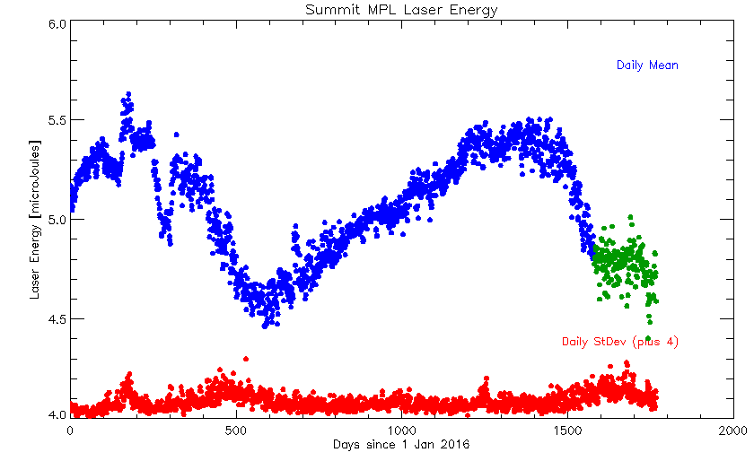

**CEILOMETER:**

* Operating normally.

**PAERI:**

* 2020-11-02 1704z: Cleaned PAERI scene mirror after blowing snow.
* Operating normally.

**IceCAM:**

* Operating normally.

**IcePIC:**

* 2020-11-02 1738-1900z: Small irregular shards, bullets and columns, 22 photos.
* 2020-11-05 1334-1429Z: Bullets, columns and bullet rosettes, 21 photos.

**CPC:**

* Offsite for repairs.

**MSF - OPC:**

* 2020-11-04 1300z: Performed hard reboot of ACE computer due to unresponsive screen.
* Operating normally.

**TAWO - OPC:**

* Operating normally

**SKYOPC:**

* 2020-11-04: Cleaned inlet, outlet and measurement chamber with compressed air.
* 2020-11-06 1615-1709Z: Tested SKYOPC with NOAA’s spare diaphragm pump, but it was not able to pull a suitable vacuum.
* 2020-11-06 2028Z: SKYOPC back online with repaired VTE6 pump.
* Operating normally.

**Fluxtower instrument suite:**

* 2020-11-06: Collected enclosure temperature data, temperatures have ranged between -11°C and 29°C since 2020-08-26.
* Operating normally

**Radiometers:**

* 2020-11-06: Switched solar tracker back from sun mode to clock mode.
* Solar tracker misalignment ongoing, otherwise operating normally.