ICECAPS-ACE Weekly Report
November 9th – November 15th, 2020
Heather Guy

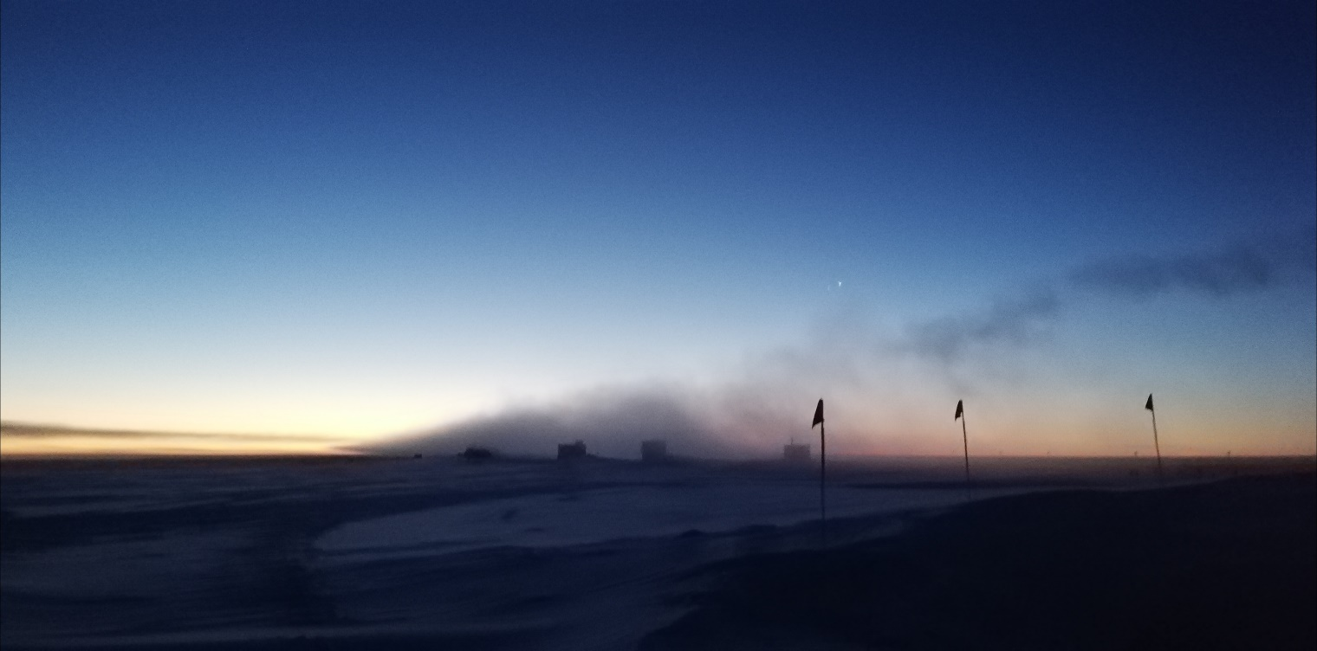

SMG generator plume resulting in smog sitting over the MSF on 2020-11-14.
Photo: Heather Guy

General Notes:
Lots of time and energy went towards our ICESat traverse this week as marginal weather conditions resulted in a couple of aborted attempts. We finally completed the traverse on 2020-11-13, in some of the coldest conditions we have seen so far this season. Otherwise planning for the HATPRO removal is ongoing; we have retrieved and inspected the crate from the winter berm, and I have removed the GPS receiver and reviewed the manual and protocols. We are hoping to complete the removal by the end of this week. The SKYOPC experienced some more pump issues on 2020-11-15, likely because the exhaust line was blocked with ice. The pump does not appear damaged and the instrument is back online; planning for how to mitigate this in the future is in progress.

General Weather Observations:
Date | Time (Z) | Wind | Weather | Visibility | Sky | Temp (C) | Notes
11-09 | 12 | 27 kts at 184 | BLSN | 500 | VV004 | -22 | Max wind 41 knots at 0820Z
11-10 | 12 | 18 kts at 135 | BLSN | 800 | VV032 | -25
11-11 | 12 | 3 kts at 196 | FZFG | 800 | FEW065 | -45
11-12 | 12 | 13 kts at 224 | BR | 1600 | FEW | -49
11-13 | 12 | 11 kts at 132 |  | 4800 | FEW | -49
11-14 | 12 | 10 kts at 321 |  | 9999 | FEW | -46
11-15 | 12 | 2 kts at 148 | BR | 4800 | SKC | -41 | Mist below head height.

Significant Weather Observations:
- 2020-11-14 0900 to 1330Z: Generator plume sitting over MSF.

MSF
- Operating normally

ICECAPS-ACE Data Management:
- 11-09: Data transfer completed at 0421Z.
- 11-10: Data transfer completed at 0416Z.
- 11-11: Data transfer completed at 0434Z.
- 11-12: Data transfer completed at 0436Z.
- 11-13: Data transfer completed at 0440Z.
- 11-14: Data transfer completed at 0437Z.
- 11-15: Data transfer completed at 0440Z.

TSI:
- Offline for the winter season.

Radiosonde:
- Once daily launches.
- See chart below for temperatures inside and outside the radiosonde cabinet over the last week:

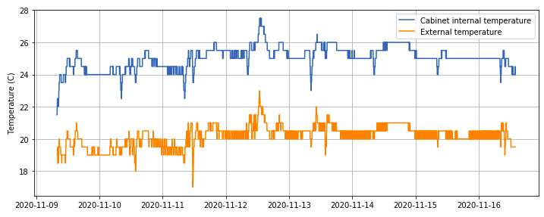

MWR:
- 2020-11-10 1354Z: RPG 150-90 logging data independent of HATPRO.
- Planning to remove the HATPRO from the MSF continues; we are aiming for the end of this week but are working around a couple of other weather dependent tasks.

SODAR:
- 2020-11-10 1409-1354Z: Cleaned and leveled the SODAR dishes.
- Operating normally.

POSS:
- Operating normally.

MASC:
- Offline for winter season.

MMCR:
- Operating normally.

CAPABL:
- Email functionality resumed.
- Operating normally.

MPL:
- 2020-11-15 1428 to 1450Z: Performed monthly after-pulse calibration.
- Operating normally.

CEILOMETER:
- Operating normally.

PAERI:
- 2020-11-09 1328Z: Cleaned PAERI scene mirror after blowing snow.
- Operating normally.

IceCAM:
- Operating normally.

IcePIC:
- No IcePICs this week.

CPC:
- Offsite for repairs.

MSF - OPC:
- 2020-11-12 1500z: Removed entrenched ice from inlet.
- Operating normally.

TAWO - OPC:
- Operating normally

SKYOPC:
- 2020-11-15 1440Z: Pump disconnected after I found it making unusual noises. Outlet line was blocked with ice. I defrosted the outlet line and inspected the pump, it looks healthy. Left offline overnight to cool.

Fluxtower instrument suite:
- 2020-11-09: Ice formed on one of the 3D sonic sensor heads after blowing snow. Measurements resumed once ice was cleared.
- Operating normally

Radiometers:
- Solar tracker misalignment persists, otherwise operating normally.

