**ICECAPS-ACE Weekly Report**

November 16th – November 22nd, 2020

Heather Guy

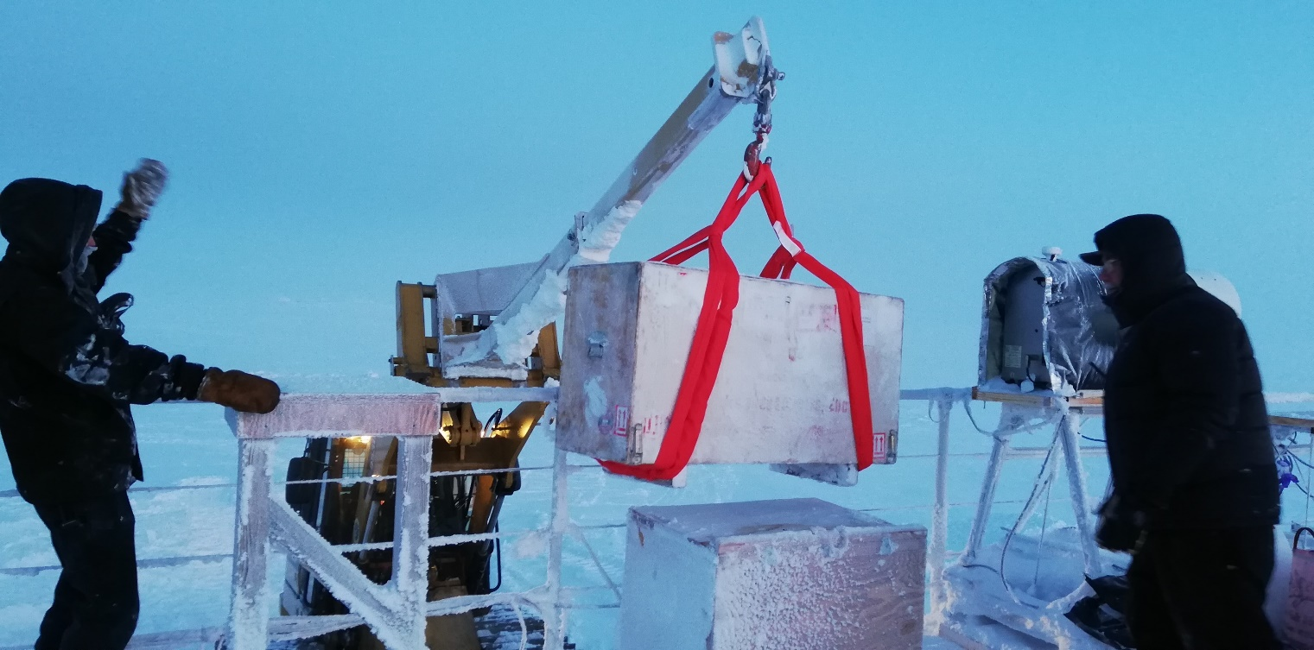

Removing the HATPro from the MSF roof for troubleshooting, 2020-11-20.

*Photo: Heather Guy*

**General Notes:**

Our big projects this week were bringing the HATPro inside from the MSF roof and completing our second November ICESat traverse. The weather was mostly calm and clear, allowing both items to be completed successfully and on schedule. Initial trouble-shooting of the HATPro inside the MSF revealed that it was receiving power but I was not able to connect to the instruments internal computer using a monitor and keyboard. I am awaiting further instructions from RPG on how to proceed with troubleshooting the internal computer.

**General Weather Observations:**

|  |  |  |  |  |  |  |  |
| --- | --- | --- | --- | --- | --- | --- | --- |
| **Date** | **Time (Z)** | **Wind** | **Weather** | **Visibility** | **Sky** | **Temp (C)** | **Notes** |
| 11-16 | 12 | 11 kts at 255 |  | 9999 | FEW131 | -51 |  |
| 11-17 | 12 | 14 kts at 232 | DRSN, BR | 800 | VV001 | -43 |  |
| 11-18 | 12 | 12 kts at 212 |  | 9999 | SCT229 | -36 |  |
| 11-19 | 12 | 12 kts at 207 |  | 9999 | SCT131 | -43 | Thick fog pm. |
| 11-20 | 12 | 15 kts at 088 |  | 9999 | SCT196, FEW098 | -39 |  |
| 11-21 | 12 | 12 kts at 217 |  | 4800 | SKC | -41 | 1215z: visibility dropped to 500 m in FZFG.  1240z: visibility back at 4800 |
| 11-22 | 12 | 11 kts at 268 | BR | 1600 | FEW | -49 |  |

**Significant Weather Observations:**

* 2020-11-20 2030Z: Rave ice.

**MSF**

* 2020-11-17 1241-1300Z: Drift maintenance around MSF with D953 in preparation for HATPro removal.
* 2020-11-18 1350-1420Z: HATPro crate lifted onto MSF roof with D953.
* 2020-11-20 1240-1345Z: D953 at MSF for HATPro removal.
* Operating normally

**ICECAPS-ACE Data Management:**

* 11-16: Data transfer completed at 0442Z. Installed new archive external hard drive.
* 11-17: Data transfer completed at 0430Z.
* 11-18: Data transfer completed at 0453Z.
* 11-19: Data transfer completed at 0448Z.
* 11-20: Data transfer completed at 0440Z.
* 11-21: Data transfer completed at 0440Z.
* 11-22: Data transfer completed at 0438Z.

**TSI:**

* Offline for the winter season.

**Radiosonde:**

* Once daily launches.
* See chart below for temperatures inside and outside the radiosonde cabinet over the last week:

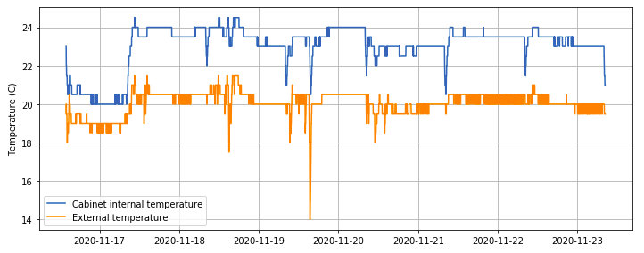

**MWR:**

* 2020-11-20 1223Z: HATPro disconnected and moved inside MSF.
* Testing inside the MSF reveals that the HATPro is receiving power but communication with the internal computer cannot be established. Awaiting further instructions from RPG about trouble-shooting the computer.
* RPG-150-90 operating normally.

**SODAR:**

* 2020-11-16 1442-1500Z: Cleaned and leveled the SODAR dishes.
* Operating normally.

**POSS:**

* Operating normally.

**MASC:**

* Offline for winter season.

**MMCR:**

* Operating normally.

**CAPABL:**

* Operating normally.

**MPL:**

* Operating normally.

**CEILOMETER:**

* Operating normally.

**PAERI:**

* Operating normally.

**IceCAM:**

* Operating normally.

**IcePIC:**

* No IcePICs this week.

**CPC:**

* Offsite for repairs.

**MSF - OPC:**

* Operating normally.

**TAWO - OPC:**

* Operating normally

**SKYOPC:**

* 2020-11-16 1236Z: SKYOPC pump reconnected.
* Operating normally.

**Fluxtower instrument suite:**

* Operating normally.

**Radiometers:**

* Solar tracker misalignment persists, otherwise operating normally.