**ICECAPS-ACE Weekly Report**

November 23rd – November 29th, 2020

Heather Guy

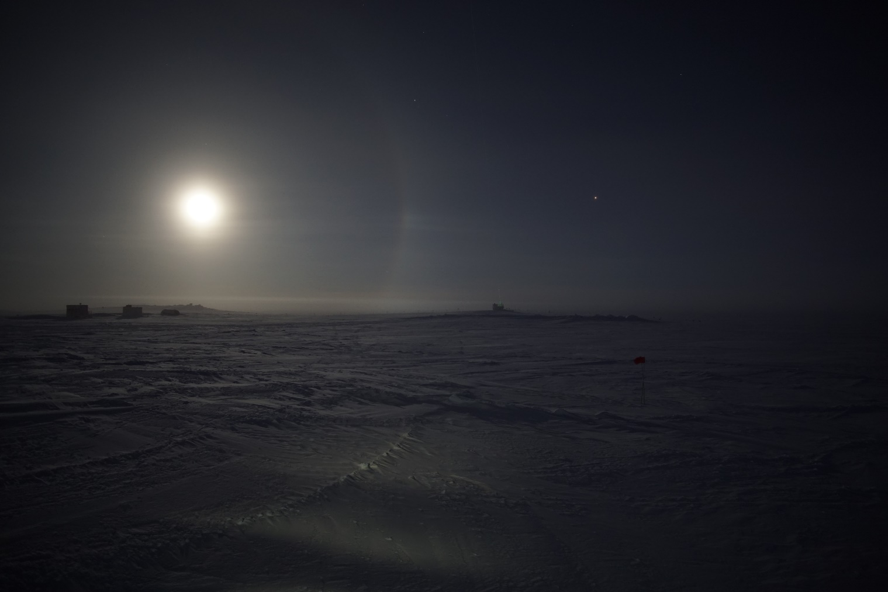

Moon halo alongside the MSF, 2020-11-29.

*Photo: Heather Guy*

**General Notes:**

A quiet week in the MSF with the exception of CAPABL requiring a couple of reboots. The crew worked together on some station-wide upkeep tasks and drift maintenance after an exciting mid-week snow storm. Unfortunately, I still did not get any IcePICs due to the high winds. A team effort Thanksgiving dinner was enjoyed by the whole crew on Friday.

**General Weather Observations:**

|  |  |  |  |  |  |  |  |
| --- | --- | --- | --- | --- | --- | --- | --- |
| **Date** | **Time (Z)** | **Wind** | **Weather** | **Visibility** | **Sky** | **Temp (C)** | **Notes** |
| 11-23 | 12 | 10 kts at 219 |  | 3200 | BKN131, BKN032 | -45 |  |
| 11-24 | 12 | 17 kts at 070 | BR | 800 | BKN026 | -45 | DRSN pm. |
| 11-25 | 12 | 20 kts at 165 | BLSN, SN | 300 | VV006 | -35 |  |
| 11-26 | 12 | 15 kts at 159 | BLSN, SN | 500 | VV043 | -30 |  |
| 11-27 | 12 | 15 kts at 315 | DRSN | 800 | VV026 | -45 |  |
| 11-28 | 12 | 12 kts at 075 |  | 1600 | BKN115 | -50 |  |
| 11-29 | 12 | 13 kts at 223 | IC, BR | 1600 | SCT032 | -50 |  |

**Significant Weather Observations:**

* 2020-11-27 0000Z: Moon halo. BR & IC.
* 2020-11-29 1800Z until at least 0000Z: Moon halo and ice fog.

**MSF**

* Operating normally

**ICECAPS-ACE Data Management:**

* 11-23: Data transfer completed at 0435Z.
* 11-24: Data transfer completed at 0436Z.
* 11-25: Data transfer completed at 0522Z.
* 11-26: Data transfer completed at 0436Z.
* 11-27: Data transfer completed at 0502Z.
* 11-28: Data transfer completed at 0438Z.
* 11-29: Data transfer completed at 0437Z.

**TSI:**

* Offline for the winter season.

**Radiosonde:**

* Once daily launches.
* See chart below for temperatures inside and outside the radiosonde cabinet over the last week:

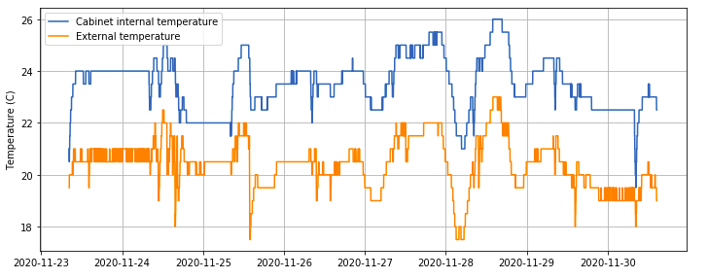

**MWR:**

* RPG-150-90 operating normally. HATPro troubleshooting ongoing.

**SODAR:**

* 2020-11-23 1502-1513Z: Cleaned and leveled the SODAR dishes.
* Operating normally.

**POSS:**

* Operating normally.

**MASC:**

* Offline for winter season.

**MMCR:**

* Operating normally.

**CAPABL:**

* 2020-11-27 1217Z: Rebooted CAPABL software due to low Licel voltage. Missing data since 1732Z on the 26th.
* 2020-11-28 1422Z: Found CAPABL was not cycling through polarizations channels correctly and carried out the following troubleshooting steps:
  + Stopped program and power cycled Meadowlark controller. Upon restart ‘LabView encountered an error and needed to close’.
  + Full computer power cycle including Meadowlark, Licel, PC and lasers. Received same LabView error upon restart.
  + Power cycled motors. Labview came back online but DAQ cycles were not incrementing.
  + Neely logged on and started and stopped an alignment scan. Data collection returned to normal at 1504Z.
* Operating normally.

**MPL:**

* Operating normally.

**CEILOMETER:**

* Operating normally.

**PAERI:**

* 2020-11-27 1315Z: Cleaned PAERI scene mirror after blowing snow event.
* 2020-11-29: Periodic short-lived ‘MaxSampleStdDev’ red flags due to extreme cold (-56C) temperatures. Data quality unaffected.
* Operating normally.

**IceCAM:**

* Operating normally.

**IcePIC:**

* No IcePICs this week.

**CPC:**

* Offsite for repairs.

**MSF - OPC:**

* Operating normally.

**TAWO - OPC:**

* Operating normally

**SKYOPC:**

* Operating normally.

**Fluxtower instrument suite:**

* Operating normally.

**Radiometers:**

* Solar tracker misalignment persists, otherwise operating normally.