**ICECAPS-ACE Weekly Report**

November 30th – December 6th, 2020

Heather Guy

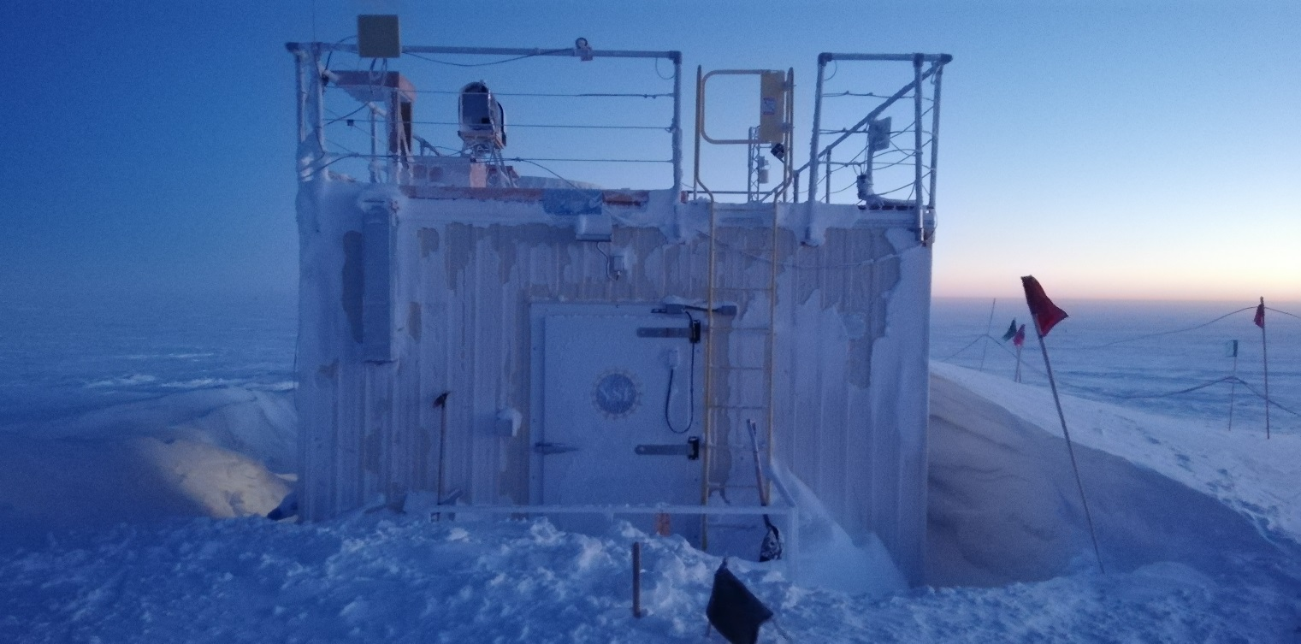

Drifts building up around the MSF, 2020-12-02.

*Photo: Heather Guy*

**General Notes:**

I made some progress at the beginning of the week dismantling the HATPro with the goal of removing the internal computer for further troubleshooting, I’m now awaiting further instructions from RPG on how to proceed. Jasper and I worked together on Thursday to deep clean the radiosonde base station enclosure and balloon launch table. The only new issue is a persistent error window on the dataman computer, under Matt’s instructions I will attempt a reboot of that system this week.

**General Weather Observations:**

|  |  |  |  |  |  |  |  |
| --- | --- | --- | --- | --- | --- | --- | --- |
| **Date** | **Time (Z)** | **Wind** | **Weather** | **Visibility** | **Sky** | **Temp (C)** | **Notes** |
| 11-30 | 12 | 12 kts at 192 | BR | 800 | BKN035 | -46 |  |
| 12-01 | 12 | 13 kts at 134 | -SN | 800 | BKN049 | -40 |  |
| 12-02 | 12 | 15 kts at 336 |  | 1600 | FEW | -54 |  |
| 12-03 | 12 | 11 kts at 328 |  | 9999 | SKC | -45 |  |
| 12-04 | 12 | 24 kts at 207 | SN BLSN | 200 | VV004 | -34 |  |
| 12-05 | 12 | 19 kts at 220 | BLSN | 500 | VV016 | -29 |  |
| 12-06 | 12 | 12 kts at 212 | FZFG | 600 | VV013 | -39 |  |

**Significant Weather Observations:**

* 2020-11-30 1800Z: Moon halo & rave ice.
* 2020-12-01 1730-2100Z: Moon halo.

**MSF**

* Operating normally

**ICECAPS-ACE Data Management:**

* 11-30: Data transfer completed at 0436Z.
* 12-01: Data transfer completed at 0449Z.
* 12-02: Data transfer completed at 0501Z.
* 12-03: Data transfer completed at 0505Z.
* 12-04: Data transfer completed at 0451Z.
* 12-05: Data transfer completed at 0438Z.
* 12-06: Data transfer completed at 0546Z.
* 2020-12-03: Persistent error window on dataman computer reads: “Problem connecting to a software source, cannot find a valid baseurl for repo: base”. Issue ongoing.

**TSI:**

* Offline for the winter season.

**Radiosonde:**

* Once daily launches.
* 2020-12-03: Changed radiosonde table plastic and cleaned base station enclosure.
* See chart below for temperatures inside and outside the radiosonde cabinet over the last week:

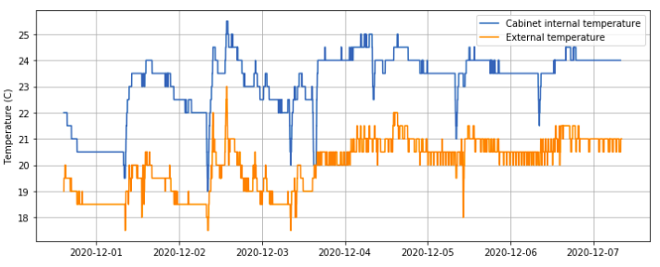

**MWR:**

* RPG-150-90 operating normally.
* HATPro troubleshooting ongoing: Awaiting further instruction from RPG on how to remove the internal computer.

**SODAR:**

* 2020-11-30 1403-1422Z: Cleaned and leveled the SODAR dishes.
* Operating normally.

**POSS:**

* Operating normally.

**MASC:**

* Offline for winter season.

**MMCR:**

* Operating normally.

**CAPABL:**

* Operating normally.

**MPL:**

* Operating normally.

**CEILOMETER:**

* Operating normally.

**PAERI:**

* Operating normally.

**IceCAM:**

* Operating normally.

**IcePIC:**

* 2020-12-01 1220-1300Z: Bullets, columns, needles and tiny hexagonal plates. 25 photos.

**CPC:**

* Offsite for repairs.

**MSF - OPC:**

* Operating normally.

**TAWO - OPC:**

* Operating normally

**SKYOPC:**

* 2020-11-30 1226-1249Z: Pump disconnected to install new pump exhaust filter.
* Operating normally.

**Fluxtower instrument suite:**

* Operating normally.

**Radiometers:**

* Solar tracker misalignment persists, otherwise operating normally.