**ICECAPS-ACE Weekly Report**

December 7th – December 13th, 2020

Heather Guy

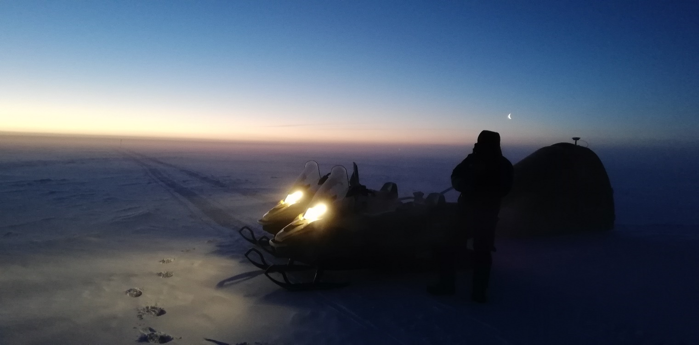

Science Technician Jasper adjusts his gear while taking a break from survey measurements during the darkest ICESat traverse of the year, 2020-12-10*. Photo: Heather Guy*

**General Notes:**

This week’s big achievement was successfully completing our darkest ICESat traverse of the year – they can only get easier from here right? I also rebooted the MMCR and dataman computer to clear persistent error messages. There are no new instrument issues this week, I’m still waiting on further instructions for HATPro troubleshooting.

**General Weather Observations:**

|  |  |  |  |  |  |  |  |
| --- | --- | --- | --- | --- | --- | --- | --- |
| **Date** | **Time (Z)** | **Wind** | **Weather** | **Visibility** | **Sky** | **Temp (C)** | **Notes** |
| 12-07 | 12 | 9 kts at 178 |  | 1600 | SCT091 | -45 |  |
| 12-08 | 12 | 14 kts at 192 | FZFG | 600 | VV001 | -49 |  |
| 12-09 | 12 | 11 kts at 221 | BR | 800 | BKN032 | -48 |  |
| 12-10 | 12 | 9 kts at 202 |  | 1600 | BKN031 | -39 |  |
| 12-11 | 12 | 16 kts at 100 | BR | 800 | SKC | -38 |  |
| 12-12 | 12 | 16 kts at 151 |  | 1600 | BKN042 | -29 |  |
| 12-13 | 12 | 13 kts at 122 | BR | 800 | SCT | -36 |  |

**Significant Weather Observations:**

* No significant weather obs this week. Lots of thin ice fog and stratus clouds.

**MSF**

* Operating normally

**ICECAPS-ACE Data Management:**

* 12-07: Data transfer completed at 0502Z.
* 12-08: Data transfer completed at 0451Z.
* 12-09: Data transfer completed at 0439Z.
* 12-10: Data transfer completed at 0439Z.
* 12-11: Data transfer completed at 0434Z.
* 12-12: Data transfer completed at 0439Z.
* 12-13: Data transfer completed at 0450Z.
* 2020-12-07 1730Z: Rebooted dataman computer to try and clear persistent error windows. The reason for the errors is that Redhat are no longer supporting dataman’s operating system. Kelly Healy was able to log in and disable the repositories causing the error message.

**TSI:**

* Offline for the winter season.

**Radiosonde:**

* Once daily launches.
* See chart below for temperatures inside and outside the radiosonde cabinet over the last week (the battery ran out on the external logger on the 10th).

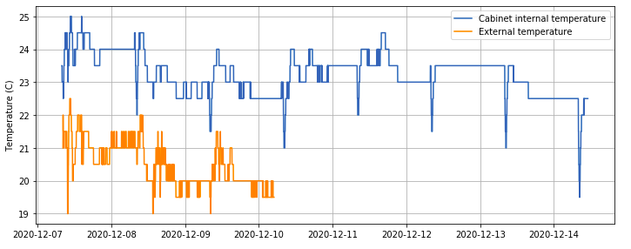

**MWR:**

* RPG-150-90 operating normally.
* HATPro troubleshooting ongoing: Awaiting further instruction from RPG on how to remove the internal computer.

**SODAR:**

* 2020-12-07 1334-1353Z: Cleaned and leveled the SODAR dishes.
* Operating normally.

**POSS:**

* 2020-12-07 1730-1839Z: POSS offline during dataman reboot.
* Operating normally.

**MASC:**

* Offline for winter season.

**MMCR:**

* 2020-12-07 1728-1751Z: Performed normal MMCR reboot to clear persistent NetCDF errors.
* Operating normally.

**CAPABL:**

* Operating normally.

**MPL:**

* Operating normally.

**CEILOMETER:**

* Operating normally.

**PAERI:**

* Operating normally.

**IceCAM:**

* Operating normally.

**IcePIC:**

* No IcePICs this week ☹

**CPC:**

* Offsite for repairs.

**MSF - OPC:**

* 2020-12-13 1655Z: Removed from roof to defrost.

**TAWO - OPC:**

* Operating normally

**SKYOPC:**

* Operating normally.

**Fluxtower instrument suite:**

* Operating normally.

**Radiometers:**

* Solar tracker misalignment persists, otherwise operating normally.