**ICECAPS-ACE Weekly Report**

December 14th – December 20th, 2020

Heather Guy

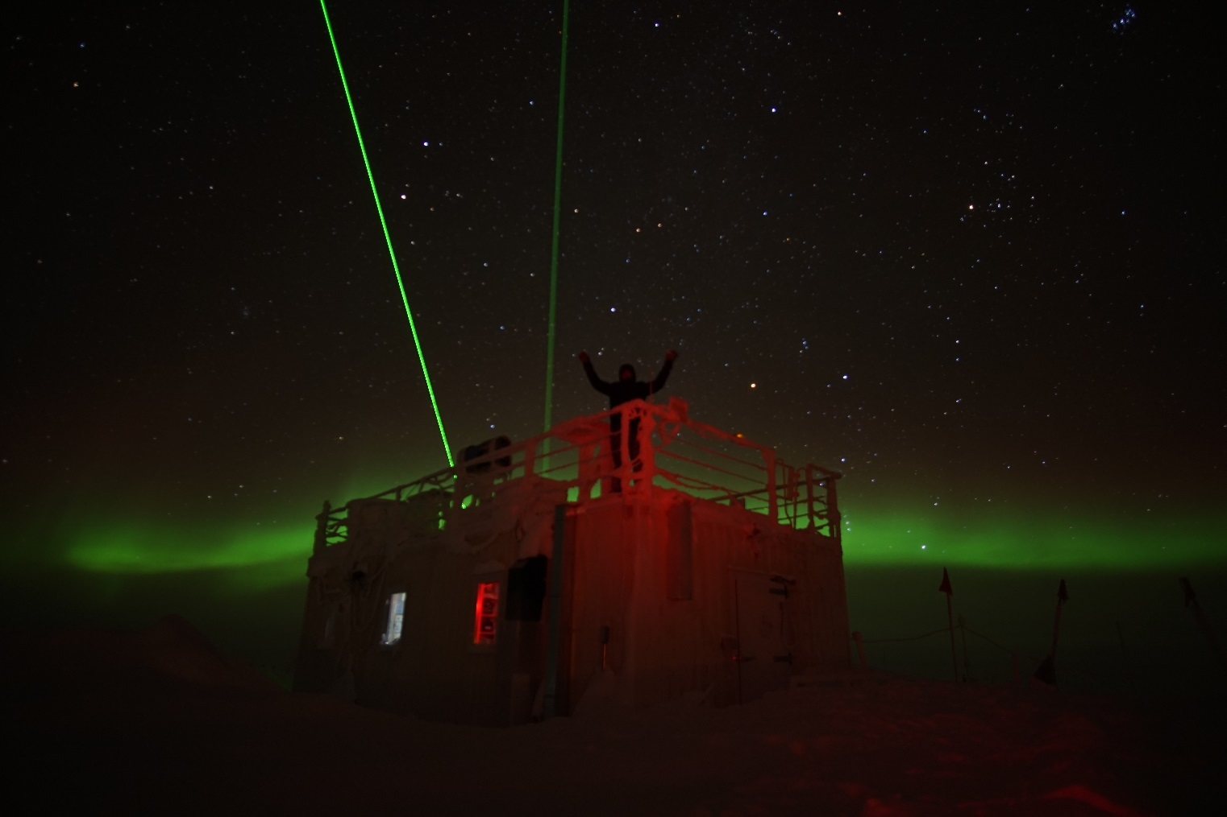

Station manager Perri Barbour enjoying a clear night sky from the MSF roof, 2020-12-19*.*

*Photo: Heather Guy*

**General Notes:**

The weather has been calm and “warm” this week, with persistent freezing fog. The fog events were associated with near zero aerosol concentrations and some interesting wave patterns in the SODAR images. The frost accumulation during fog events has been impressive, with > 2 inches of new growth for several days in a row. As a result, I had to cover the PAERI hatch to clear the frost, and power down CAPABL to clear its window. CAPABL would not come back online after the window cleaning and upon closer inspection, a ‘fault’ light was illuminated on the Laser 2 power supply. With guidance from Neely I switched to the back up power supply and was able to reestablish normal data collection.

I received more information from RPG regarding HATPro troubleshooting, and with their reassurance I was able to remove the computer base plate, however it does not look possible to remove the computer from the heat sink / fan assembly as we hoped – I’m awaiting further advice again here.

**General Weather Observations:**

|  |  |  |  |  |  |  |  |
| --- | --- | --- | --- | --- | --- | --- | --- |
| **Date** | **Time (Z)** | **Wind** | **Weather** | **Visibility** | **Sky** | **Temp (C)** | **Notes** |
| 12-14 | 12 | 9 kts at 175 | FZFG | 500 | VV | -38 |  |
| 12-15 | 12 | 14 kts at 079 | FZFG | 800 | VV002 | -35 |  |
| 12-16 | 12 | 10 kts at 190 | FZFG | 500 | SCT131 | -40 |  |
| 12-17 | 12 | 10 kts at 185 | FZFG | 500 | FEW | -44 |  |
| 12-18 | 12 | 9 kts at 066 | FZFG | 500 | SKC | -45 |  |
| 12-19 | 12 | 15 kts at 134 |  | 1600 | FEW | -48 |  |
| 12-20 | 12 | 8 kts at 140 |  | 800 | OVC033 | -38 | FZFG 13Z onwards. |

**Significant Weather Observations:**

* 2020-12-15 1435Z: Rave ice.
* 2+ inches of frost accumulation daily during thick and persistent FZFG for the first half of this week.

**MSF**

* Operating normally

**ICECAPS-ACE Data Management:**

* 12-14: Data transfer completed at 0435Z.
* 12-15: Data transfer completed at 0425Z.
* 12-16: Data transfer completed at 0620Z.
* 12-17: Data transfer completed at 0437Z.
* 12-18: Data transfer completed at 0431Z.
* 12-19: Data transfer completed at 0438Z.
* 12-20: Data transfer completed at 0444Z.

**TSI:**

* Offline for the winter season.

**Radiosonde:**

* Once daily launches.
* See chart below for temperatures inside the radiosonde cabinet over the last week.

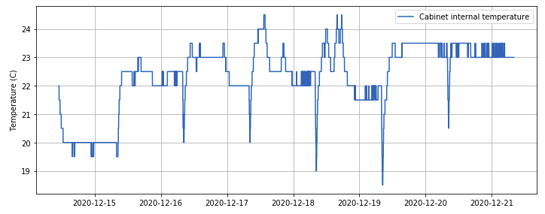

**MWR:**

* RPG-150-90 operating normally.
* HATPro troubleshooting ongoing: The computer base plate is now removed, but it doesn’t look possible to remove the computer from the heat sink/ fan assembly as hoped. Awaiting further instructions.

**SODAR:**

* 2020-12-15 1442-1454Z: Cleaned and leveled the SODAR dishes.
* Lots of interesting waves in the SODAR images this week associated with the FZFG.
* Operating normally.

**POSS:**

* Operating normally.

**MASC:**

* Offline for winter season.

**MMCR:**

* Operating normally.

**CAPABL:**

* 2020-12-16 1305Z: Laser powered down to clear frost from on and around CAPABL window.
* 2020-12-16 1500Z: Attempted full system reboot after laser would not come back online normally. Issue persisted; ‘fault’ light illuminated on Laser 2 power supply.
* 2020-12-17 1513Z: System powered down while all cables and water lines associated with Laser 2 were moved from the original (right hand side) power supply to the back up supply. Back up supply powered up OK and water lines left to circulate overnight.
* 2020-12-18 1230Z: Laser powered up OK on new power supply. Original laser power supply left offline and labelled as faulty.
* Operating normally.

**MPL:**

* 2020-12-15 1303-1324Z: Performed monthly afterpulse calibration.
* Operating normally.

**CEILOMETER:**

* Operating normally.

**PAERI:**

* 2020-12-16 1317Z: Briefly covered PAERI hatch to clear frost and rime from around window.
* Operating normally.

**IceCAM:**

* Operating normally.

**IcePIC:**

* 2020-12-15 1400-1435Z: Small columns and plates associated with FZFG and rave ice. 12 photos collected.

**CPC:**

* Offsite for repairs.

**MSF - OPC:**

* 2020-12-14 1723Z: OPC back online.
* Operating normally.

**TAWO - OPC:**

* 2020-12-17 1110Z: TAWO OPC offline for defrost.
* 2020-12-18 1455Z: TAWO OPC back online
* Operating normally

**SKYOPC:**

* Operating normally.

**Fluxtower instrument suite:**

* Operating normally.

**Radiometers:**

* Solar tracker misalignment persists, otherwise operating normally.