**ICECAPS-ACE Weekly Report**

December 21st – December 27th, 2020

Heather Guy

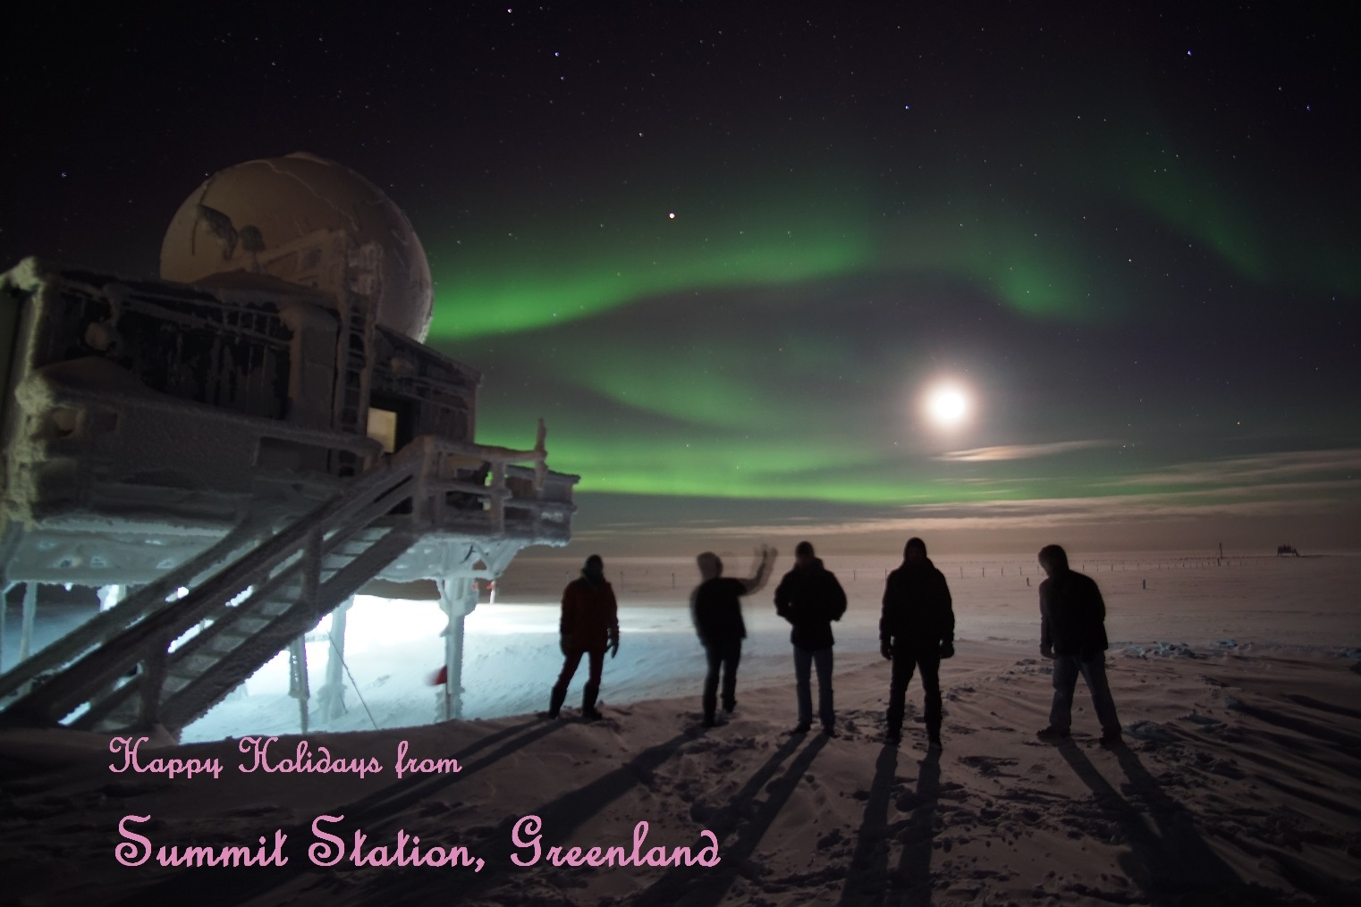

Happy Holidays from all of us at Summit!

We finally got some good auroras again in time for the winter solstice, 2020-12-21*.*

*Photo: Heather Guy*

**General Notes:**

A few snowy days and a Christmas northerly wind storm put down a fair amount of drift and snow accumulation around camp, and resulted in the PAERI requiring several scene mirror cleanings this week. Station-wide intermittent internet connectivity issues starting around 2020-12-22 slowed down data transfer and led to me resetting the internet connection on a couple of ICECAPS computers, we’re working with PFS-IT to diagnose the ongoing issue. I was able to remove the HATPro flash storage card, but as of yet have not been able to find a computer with a suitable IDE port on which to test it.

**General Weather Observations:**

|  |  |  |  |  |  |  |  |
| --- | --- | --- | --- | --- | --- | --- | --- |
| **Date** | **Time (Z)** | **Wind** | **Weather** | **Visibility** | **Sky** | **Temp (C)** | **Notes** |
| 12-21 | 12 | 10 kts at 207 | -SN | 800 | OVC011 | -31 |  |
| 12-22 | 12 | 10 kts at 225 | FZFG | 800 | VV002 | -45 |  |
| 12-23 | 12 | 12 kts at 172 | -SN DRSN | 800 | OVC098 | -31 | BLSN pm. |
| 12-24 | 12 | 18 kts at 163 | SN, BLSN | 300 | VV017 | -23 |  |
| 12-25 | 12 | 10 kts at 035 | DRSN | 500 | VV018 | -34 | BLSN pm |
| 12-26 | 12 | 30 kts at 059 | BLSN | 200 | VV004 | -32 | Max wind, 37 knots at 0826. |
| 12-27 | 12 | 5 kts at 077 |  | 1600 | SKC | -37 |  |

**Significant Weather Observations:**

* 2020-12-21 1240Z: Rave ice. (see associated IcePICs)
* 2020-12-25 1245Z: Christmas rave ice (see associated IcePICs)

**MSF**

* 2020-12-21st, 22nd and 26th: Manual drift maintenance on south side of MSF and around door.
* Operating normally

**ICECAPS-ACE Data Management:**

Station-wide intermittent internet connectivity this week is responsible for the slower than usual data transfers. Diagnostics are ongoing.

* 12-21: Data transfer completed at 0440Z.
* 12-22: Data transfer completed at 0736Z.
* 12-23: Data transfer completed at 0829Z.
* 12-24: Data transfer completed at 0604Z.
* 12-25: Data transfer completed at 0848Z. 12 files not transferred due to ‘lost connection’.
* 12-26: Data transfer completed at 0855Z. All files caught up.
* 12-27: Data transfer completed at 0903Z. 16 files not transferred due to ‘lost connection’.

**TSI:**

* Offline for the winter season.

**Radiosonde:**

* Once daily launches.
* See chart below for temperatures outside radiosonde cabinet over the last week. There is a problem with the temperature logger inside the cabinet that meant I couldn’t download the data, I will replace it this week.

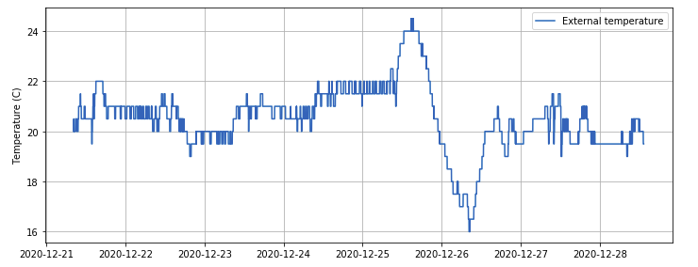

**MWR:**

* RPG-150-90 operating normally.
* HATPro troubleshooting ongoing: I identified and removed the flash storage drive from the internal computer, but have so far been unsuccessful in locating a computer with a 40-pin IDE port to test it.

**SODAR:**

* 2020-12-21 1352-1410Z: Cleaned and leveled the SODAR dishes.
* Operating normally.

**POSS:**

* Operating normally.

**MASC:**

* Offline for winter season.

**MMCR:**

* 2020-12-26: Power cycled router after internet connection was lost.
* Operating normally.

**CAPABL:**

* 2020-12-26 1602-1618Z: Powered down laser to clear snow from window.
* Operating normally.

**MPL:**

* 2020-12-26: Disconnected / reconnected ethernet cable after internet connection was lost.
* 2020-12-27: Identified cracked MPL window – photos sent to Dave. Cause unknown.
* Operating normally.

**CEILOMETER:**

* Operating normally.

**PAERI:**

* 2020-12-23 1939Z: Replaced the external PAERI fan after the bearings failed in the original.
* 2020-12-23 1941Z: Cleaned scene mirror after blowing snow.
* 2020-12-24 1349Z, 1428Z: Cleaned scene mirror after blowing snow.
* 2020-12-26 1611Z: Cleaned scene mirror after blowing snow.
* Operating normally.

**IceCAM:**

* Operating normally.

**IcePIC:**

* 2020-12-21 1240-1330Z: Plates, needles and columns, 14 photos collected.
* 2020-12-25 1250-1310Z: Needles, columns, plates and bullets, 21 photos collected.

**CPC:**

* Offsite for repairs.

**MSF - OPC:**

* 2020-12-26 0400-1600Z: Offline during high winds.
* Operating normally.

**TAWO - OPC:**

* Operating normally

**SKYOPC:**

* Operating normally.

**Fluxtower instrument suite:**

* Operating normally.

**Radiometers:**

* Solar tracker misalignment persists, otherwise operating normally.