**ICECAPS-ACE Weekly Report**

December 28th – January 3rd, 2021

Heather Guy

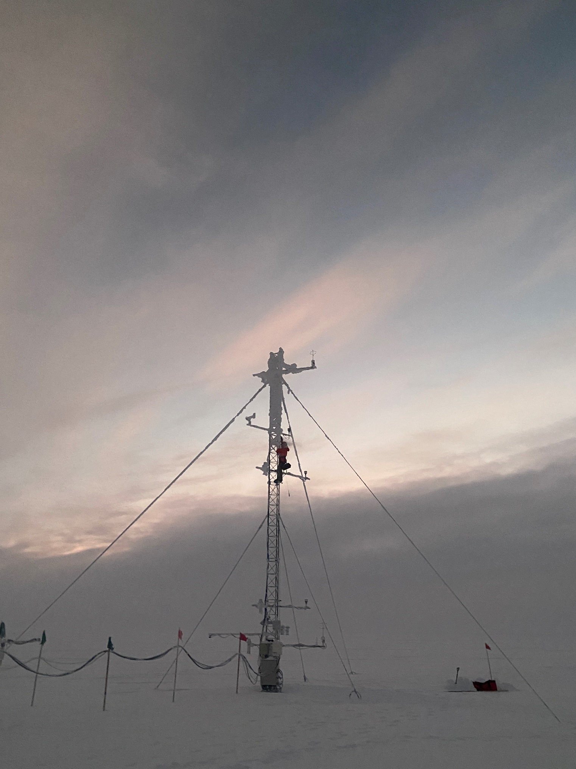

Clearing ice build-up from the TAWO Met tower on 2020-12-29*.*

*Photo: Jasper Thompson*

**General Notes:**

Happy New Year from Summit! It has been a warm snowy week and we used the opportunity to clear the ice build up from the TAWO Met tower and instruments on 2020-12-29. Our intermittent internet issues worsened over the New Year but seem to have improved as of the 2021-01-02. All the backlog of ICECAPS data has transferred OK, with the exception of the IceCAM images which have not transferred since the 2021-01-01 due to an unrelated SCP ‘No such file or directory’ issue. I’m ready to test the HATPro flash drive this week after locating a suitable IDE port on the back-up SODAR computer and constructing a power connector. I also repaired and re-installed the failed PAERI fan. A discussion about the cracked MPL window with the station facilities staff is ongoing but initial assessments suggest the risk of the window failing into the MSF is very low.

**General Weather Observations:**

|  |  |  |  |  |  |  |  |
| --- | --- | --- | --- | --- | --- | --- | --- |
| **Date** | **Time (Z)** | **Wind** | **Weather** | **Visibility** | **Sky** | **Temp (C)** | **Notes** |
| 12-28 | 12 | 10 kts at 190 |  | 800 | BKN055 | -35 | -SN, FZFG 1300z onwards |
| 12-29 | 12 | 12 kts at 060 |  | 1500 | BKN044 | -30 | SN 1300z onwards |
| 12-30 | 12 | 9 kts at 285 | BR | 800 | FEW032, BKN131 | -40 |  |
| 12-31 | 12 | 15 kts at 145 | BLSN | 500 | SCT032, SCT229 | -37 |  |
| 01-01 | 12 | 13 kts at 132 | -SN | 800 | SCT046 | -32 |  |
| 01-02 | 12 | 16 kts at 145 | FZFG, DRSN | 300 | OVC006 | -35 |  |
| 01-03 | 12 | 12 kts at 159 | -SN | 800 | OVC032 | -36 |  |

**Significant Weather Observations:**

* 2020-12-28 1452Z: Rave ice.
* 2020-12-31 1100Z: Moon halo.
* 2021-01-01 0000Z: Moon halo.
* 2021-01-01 1200Z: Rave ice.
* 2021-01-02 1000Z: Moon halo.
* 2021-01-02 1220Z: Rave ice.

**MSF**

* Operating normally

**ICECAPS-ACE Data Management:**

Station-wide intermittent internet connectivity this week is responsible for the slower than usual data transfers. This appears to have improved as of 2021-01-02. IceCAM files have not been transferring since the new year due to an SCP ‘No such file or directory’ error.

* 12-28: Data transfer completed at 0930Z. 6 files not transferred due to ‘lost connection’.
* 12-29: Data transfer completed at 0840Z.
* 12-30: Data transfer completed at 0934Z.
* 12-31: Data transfer completed at 1043Z. 27 files not transferred due to ‘lost connection’.
* 01-01: Data transfer completed at 2044Z. 152 files not transferred due to ‘lost connection’.
* 01-02: Data transfer completed at 0535Z. IceCAM files not transferring since new year.
* 01-03: Data transfer completed at 0455Z. IceCAM files not transferring since new year.

**TSI:**

* Offline for the winter season.

**Radiosonde:**

* Once daily launches.
* See chart below for temperatures outside radiosonde cabinet over the last week.

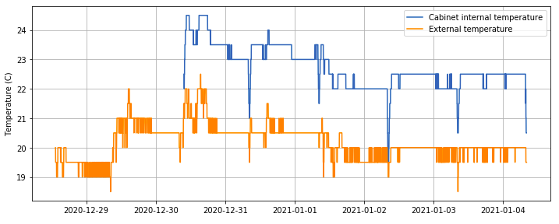

**MWR:**

* RPG-150-90 operating normally.
* HATPro troubleshooting ongoing: I identified a suitable IDE port to test the flash drive on the spare SODAR computer. After a few more failed attempts to find a suitable 2-pin DC power connector for the flash drive, I was able to construct one by soldering wires to individual female pins and insulating with heat shrink. Everything is now ready to go to test the flash-drive; hopefully we will have a result this week.

**SODAR:**

* 2020-12-28 1409-1452Z: Cleaned and leveled the SODAR dishes.
* Operating normally.

**POSS:**

* Operating normally.

**MASC:**

* Offline for winter season.

**MMCR:**

* Operating normally.

**CAPABL:**

* 2020-12-29 2011-2018Z: Powered down laser to clear snow from window.
* Operating normally.

**MPL:**

* I discussed the crack in the MPL window with Sam and our on-site construction expert Perri. We share the opinion that the risk of the window falling into the MSF is very low, and that working on the window from the inside could do more harm then good, but are happy to discuss further.
* Operating normally.

**CEILOMETER:**

* 2020-12-31 1333-1458Z: Powered down computer to look for parts to help with HATPro troubleshooting.
* Operating normally.

**PAERI:**

* 2021-01-01 1315Z: Cleaned scene mirror after snow.
* 2021-01-01 1710-1809Z: Switched PAERI fan for the repaired original and updated logs.
* Operating normally.

**IceCAM:**

* Operating normally, but images are not transferring to Boulder since the new year.

**IcePIC:**

* 2020-12-28 1408-1453Z: Columns, needles, plates and irregular fragments, 11 photos.
* 2021-01-01 1245-1305Z: Bullets, columns and irregulars, 31 photos.

**CPC:**

* Offsite for repairs.

**MSF - OPC:**

* Operating normally.

**TAWO - OPC:**

* Operating normally

**SKYOPC:**

* Operating normally.

**Fluxtower instrument suite:**

* 2020-12-29 1255-1400Z: Climbed Met tower to clear ice build-up.
* Operating normally.

**Radiometers:**

* Solar tracker misalignment persists, otherwise operating normally.